The grandfather-father-son (GFS) backup method

The grandfather-father-son (GFS) backup method is a widely used rotation-based schedule that involves creating daily(son), weekly(father) and monthly(grandfather) backups (Oteng-Boateng, 2011). The GFS system enables data to be restored from the past week, any week in the past month or from any month since the system began which allows for a fail safe for if one of the sets fails there are other backups in place (Murphy, 1996). In comparison to other backup methods the GFS provides the most resilience to failure and data loss due to it using a variety of storage media and a combination of both full and incremental backups (Cumbie, 2007). This range of backup options provides a greater range of options than other backup options but can require a significant number of tapes.

Figure 1: GFS Rotation System (Oteng-Boateng, 2011)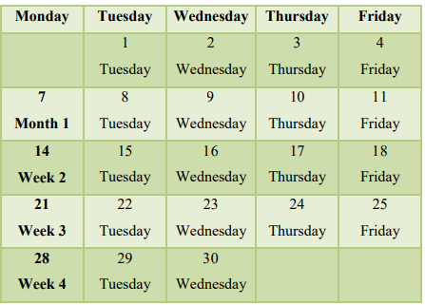

Cumbie, B. (2007) *The essential components of disaster recovery methods: A Delphi study* , *Americas Conference on Information Systems (AMCIS)*. Available at: https://www.semanticscholar.org/paper/The-Essential-Components-of-Disaster-Recovery-A-Cumbie/e55fa30d195812e4a297b6f4cc57d07b693a585c (Accessed: 11 July 2023).

Murphy, M. (1996) *Backup strategy*, *ACM Digital Library*. Available at: https://dl.acm.org/doi/fullHtml/10.5555/324979.324980 (Accessed: 11 July 2023).

Oteng-Boateng, M.L. (2011) ‘ DATA BACKUP SECURITY: BEST PRACTICES FOR K-12 INTERNATIONAL SCHOOLS IN SOUTH KOREA ’, *LEWIS UNIVERSITY* [Preprint]. Available at: http://cs.lewisu.edu/mathcs/msis/projects/msis595_MonicaOtengBoateng.pdf.