**Assignment 1**

**COMP3341 (Advanced Web Application Development)**

**Assignment 1**

**Semester 1 - 2016/17**

**Student number = XXXXXXX**

**Final Deliverable (2): Design Specification report (1500-word equivalent)**

1. **Rationale**

Benefit Booking aims to provide conference rooms for various uses such as meetings, consultancy and social events. (Teem, 2016: Online) is a website that offers a similar service to Benefit Booking. However, with a cluttered website, registration format and confusing navigation the process of booking a conference room is extended for potential clients. Benefit Booking will make the process of booking a specific room for business a quicker and easier process, clients can view rooms based on size and view reviews, features that the room has and pictures associated. Business clients are often very proactive and use mobile devices frequently to complete tasks; this web application will aim to be mobile-friendly and will encourage a fast booking process by giving clients enough information about conference rooms to make an informed decision.

1. **Analysis of ‘best practice’ design features**

(Cisco 2016: Online) studied the mobile network throughout 2015 and found that “Fourth-generation (4G) traffic exceeded third-generation (3G) traffic for the first time in 2015” and that “Global mobile devices and connections in 2015 grew to 7.9 billion, up from 7.3 billion in 2014.” These statistics provide an interesting view on the rapid growth of the mobile network that is continually advancing.

With such a widespread use of mobile devices, it is important to adapt development to accommodate mobile devices in terms of functionality and user experience. (Zakas, 2013) stated that in earlier years, developers would prioritise development around desktop computers and not consider mobile devices. However, in recent years, developers have begun to emphasise the importance of accommodating other devices. (Gascho Rempel & Bridges, 2013) expressed the importance of responsive design by stating that it provides users with an interface and experience which is predictable across multiple devices. When considering both desktop and portable device users during development, the display of content is important, techniques such as progressive disclosure, minimalistic design and using icons can help to alleviate clutter. (Salvesen, 2016: Online) states that consumers have a shorter attention span when using mobile devices, they use their phone at certain intervals and spend less time on specific content. On the other hand, (Budiu, 2016: Online) argues that responsive design can be expensive and require more advanced knowledge in comparison to developing a dedicated mobile-optimised application.

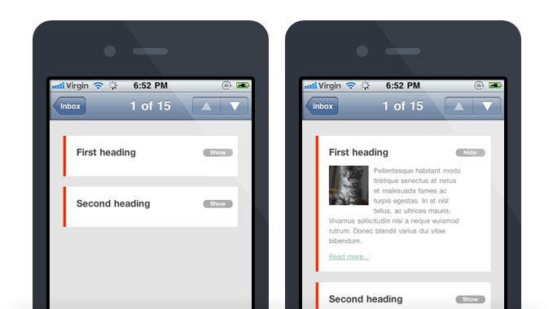

(Campaign Monitor, n.d.)

Hamburger menus are used on an array of websites such as University of Worcester, Facebook and Apple iOS to collapse menus and other content into a recognisable icon.



(Icon Finder, n.d.)

Hamburger menus, while notoriously controversial, have their benefits. “It provides a clean, uncluttered look. It allows for reuse of menus with responsive design.” (Fichter, 2016) while other users argue that the hamburger menu adds unnecessary extra clicks to view content and hurts the user-experience of a website. (McDowell, 2016). Despite the controversy regarding the hamburger menu in web design, many large organisations still utilise the menu to make displaying content for mobile devices more appealing.

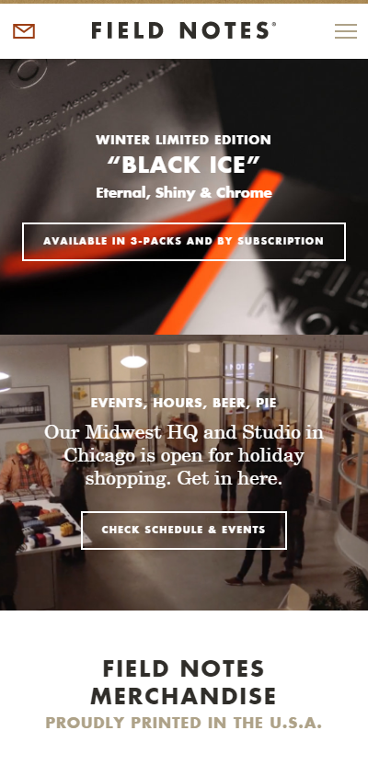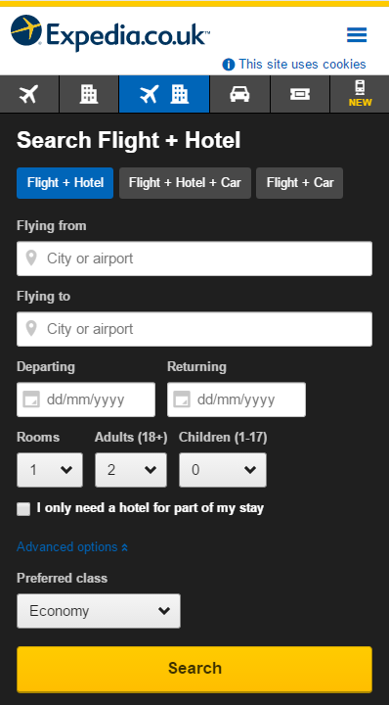

(Field Notes Brand, 2016) (Expedia, 2016)

1. **Analysis of design issues and identification of preventative measures.**

The concern regarding implementation of additional menus and progressive disclosure in Benefit Booking arises when considering the ‘three click rule’. Extra menus and progressive disclosure may mean that visitors must carry out more actions to complete a task. For example, for a client to change their e-mail address using a mobile device, the path to do so may be “Select Hamburger Menu > Select Dropdown -> Select ‘My Account’ > Select ‘Account Details’ > Change e-mail address”. While this may appear inefficient at first, there has been controversy regarding the three click rule.

(Hamill, 2009: Online) mentioned that while the three click rule made sense during the early years of web design, the rule has come under scrutiny in terms of usability and user experience. In more recent years, strictly adhering to the three click rule introduced problems. Furthermore, (Thurow, 2014: Online) said that “If information scent is strong and increases, users will continue to click or tap.” When implementing techniques such as progressive disclosure or a hamburger menu, maintaining a logical structure of menus, links and pages should be considered to keep clients engaged and productive. Progressive disclosure is necessary for Booking Benefits due to the vast amount of information available on each room. Fields will be allocated to accommodate previous customer reviews, room information and features, if there is too much information in a field that will cause clutter when displayed, progressive disclosure will help to minimise the amount of information on the screen at a given time.

1. **Design documentation**

**Logo creation**

All logos were created using Logomakr.com

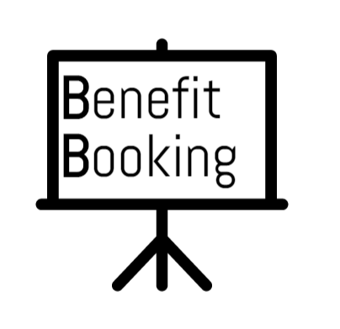

**Benefit Booking Logo:** This logo was very basic and caused issues when using coloured backgrounds, the logo appeared white and looked unprofessional, even when made transparent.

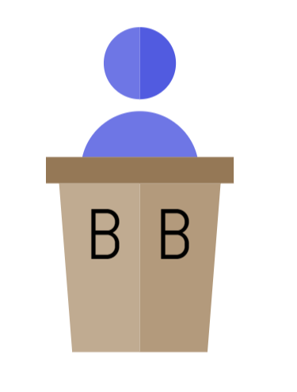

**Benefit Booking Logo 2 – Iteration 1:** The second logo was much more successful and could be made transparent to place on a coloured background. However, it did not entirely represent ‘Benefit Booking’.

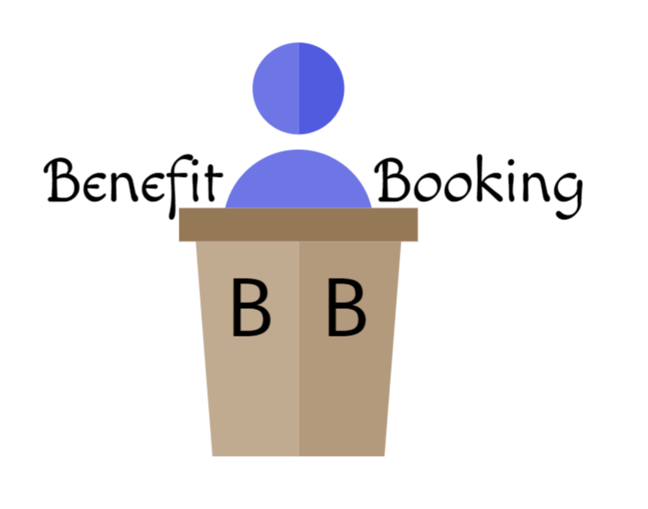

**Benefit Booking Logo 3 – Iteration 2:** Made the logo more distinguishable as ‘Benefit Booking’.

**Mood Board**

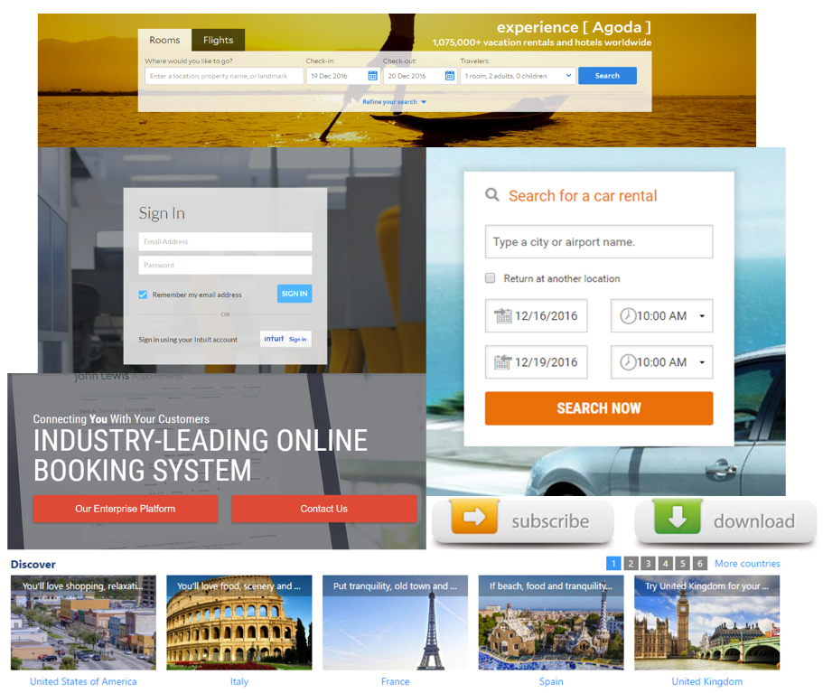

**Wireframes**

Wireframes were designed using Moqups.com

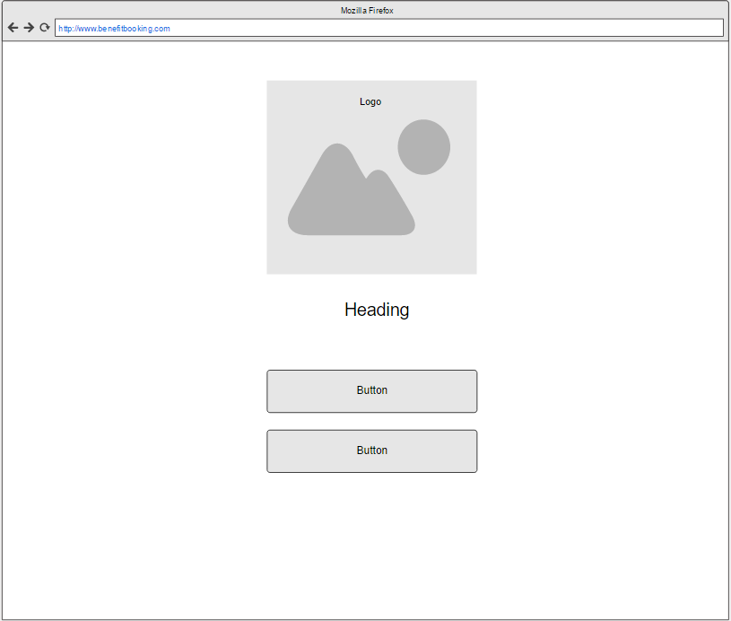

**Wireframe 1 – Landing Page**

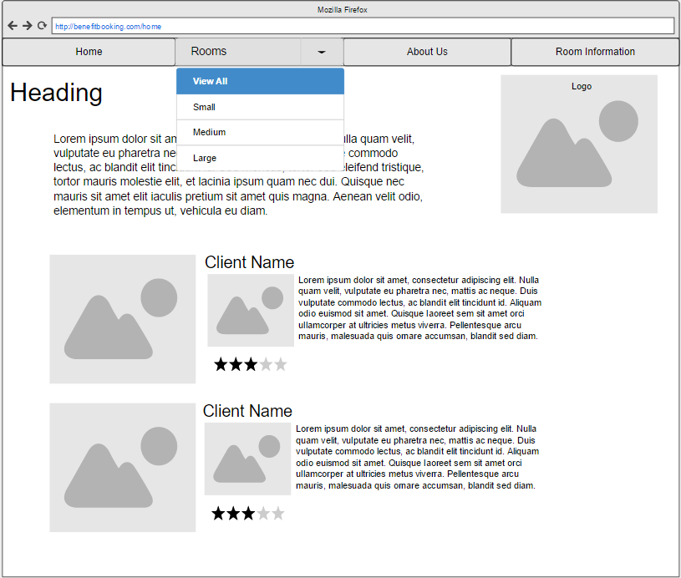

**Wireframe 2 – Home page (Iteration 1).** This original idea showcased reviews from previous clients that had a pleasant experience using a room.

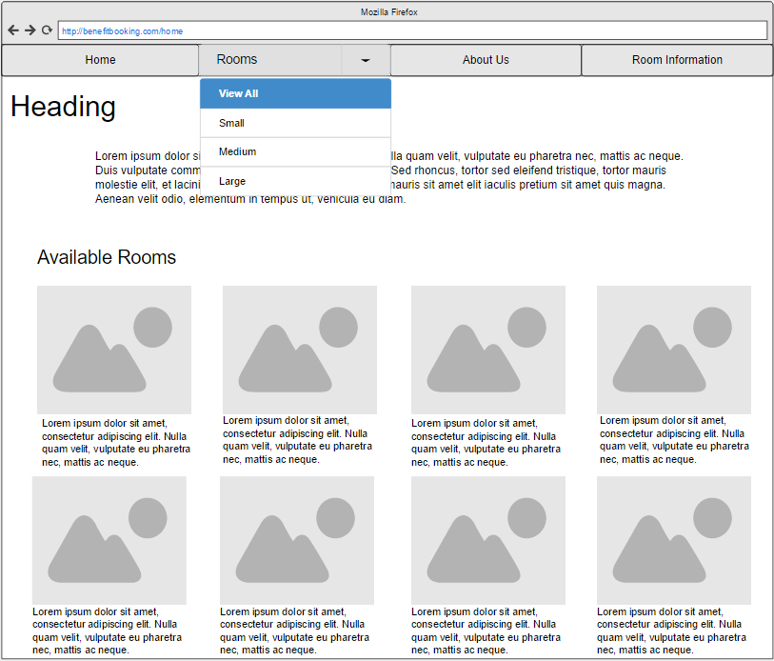

**Wireframe – Home page (Iteration 2):** The second iteration of the homepage showcased available rooms rather than previous client reviews. The second iteration reduced the amount of clutter on the home page and showcased rooms in a more presentable fashion.

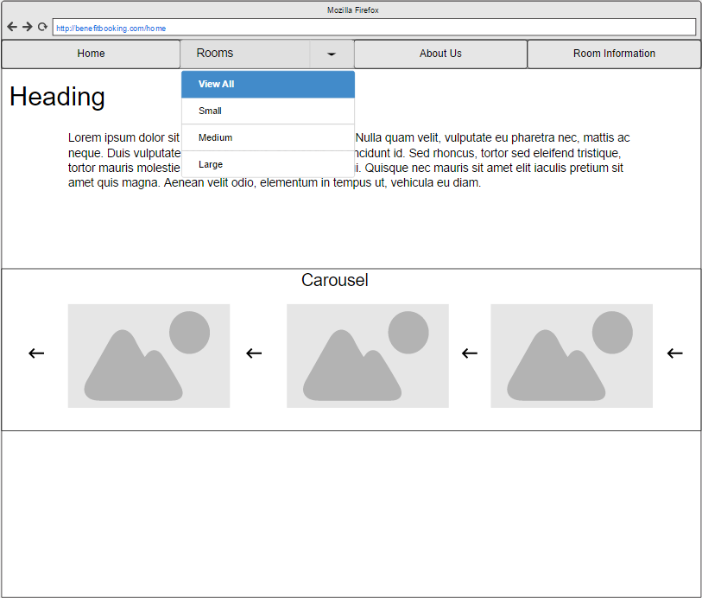

**Wireframe – Home Page (Iteration 3):** Changed the available rooms to be a carousel, this allows for more content to be added in the future without encountering issues with clutter.

**Style Tiles**

Style tiles were created using a template from styletil.es

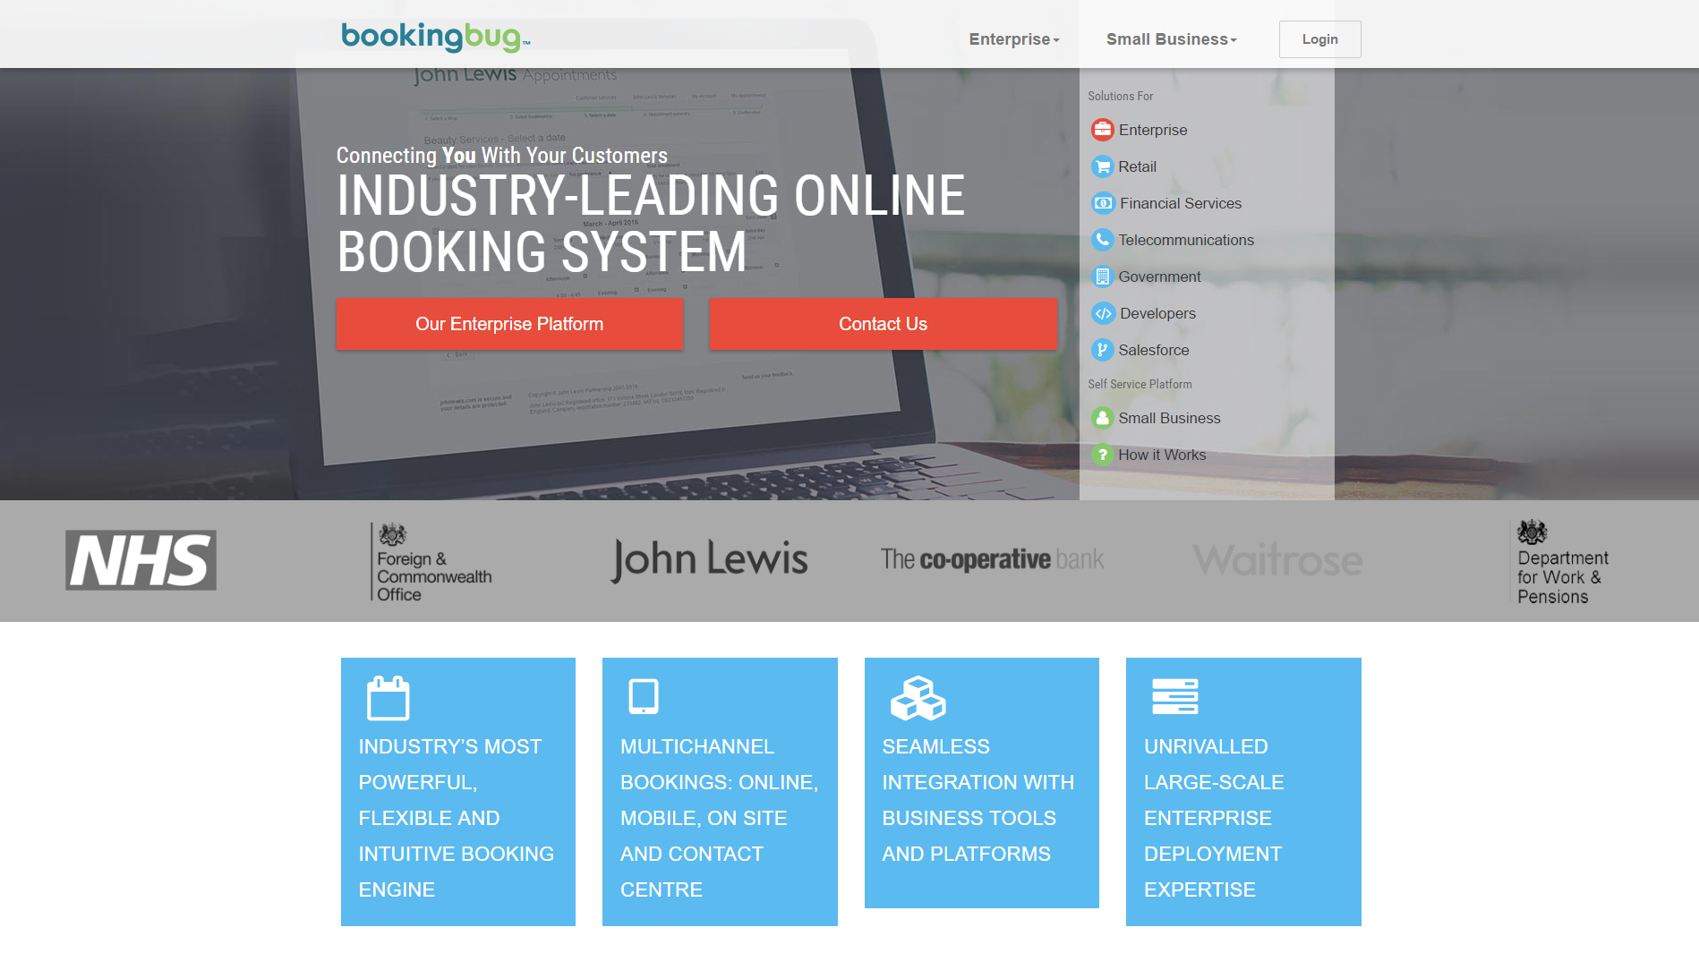

(BookingBug.co.uk, 2016)

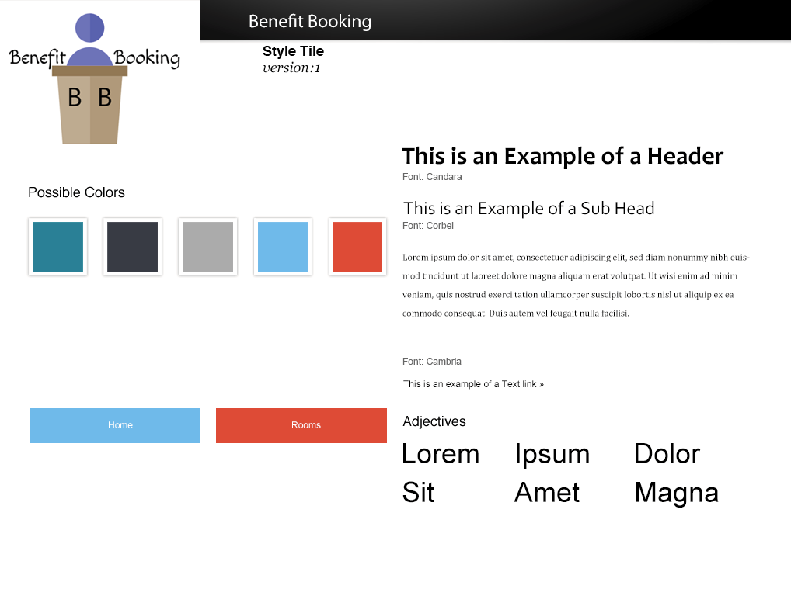

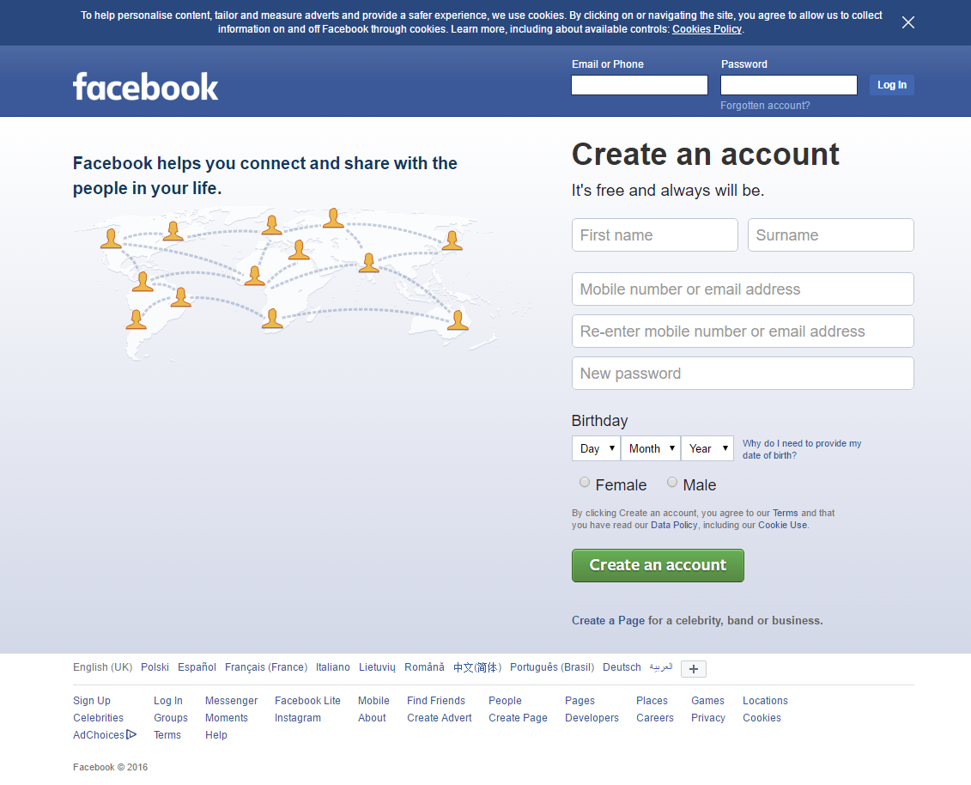

(Facebook, 2016)

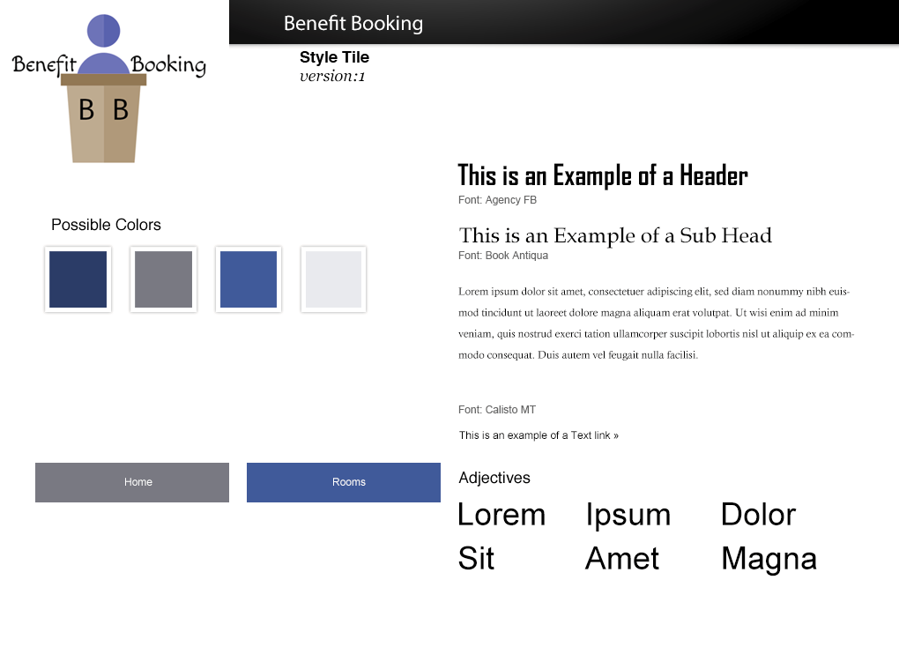

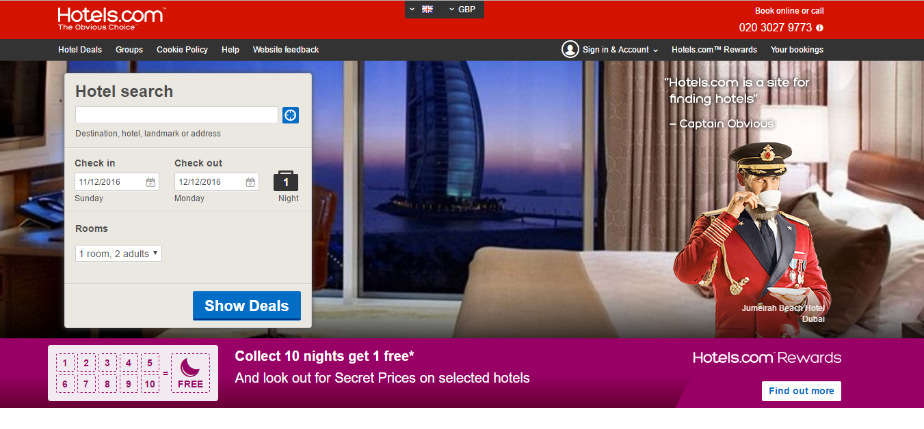

(Hotels.com, 2016)

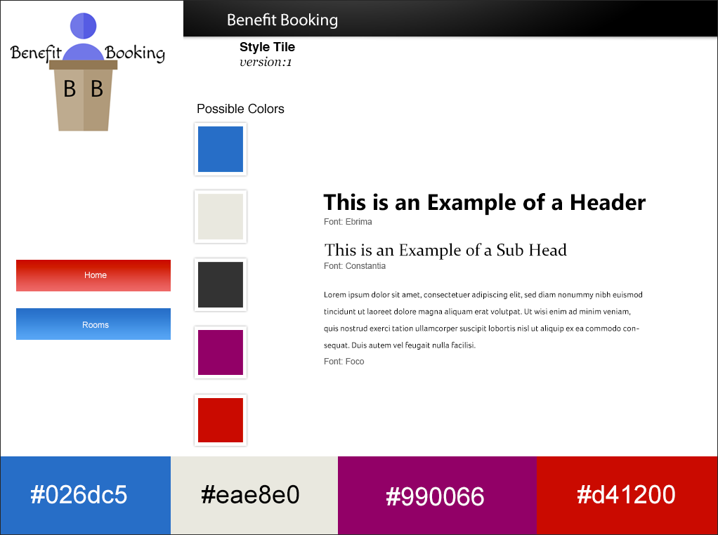

The style tiles showcased features of each website, 2/3 of the websites utilised blue buttons which gave the website a clean and professional appearance.

1. **Prototype**

Prototypes were designed using Moqups.com

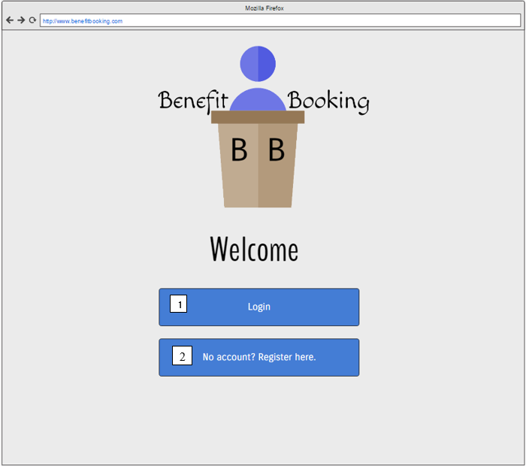

Landing Page

1. Redirect user to Login Page
2. Redirect user to Register Page

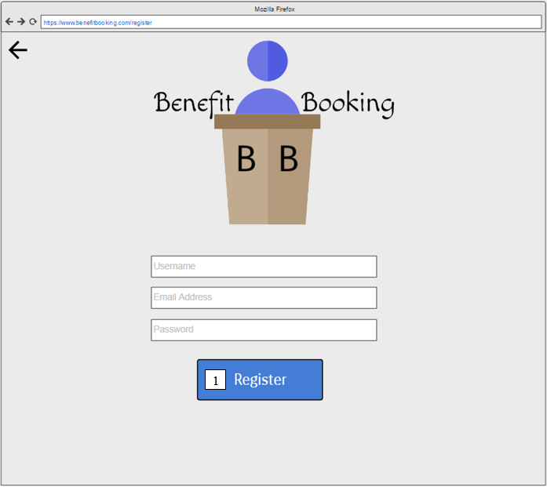

Register

1) Register User, store details in Database and redirect user to login page.

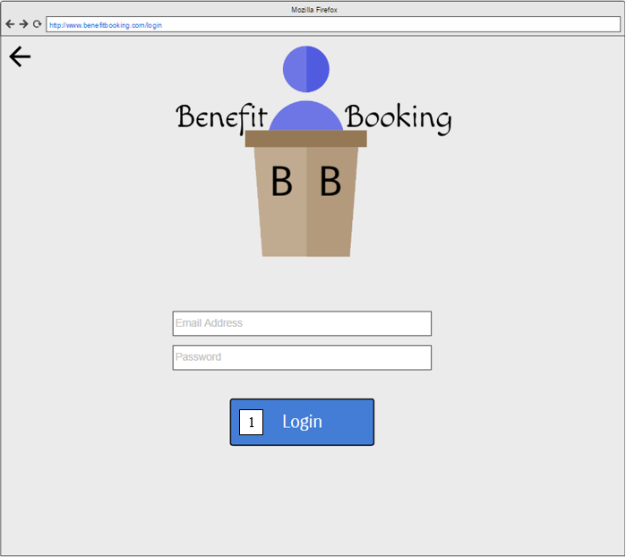

Login

1) Check input against database records; If details are correct, log the user in. Else display “Please check your Email Address and Password and try again.”

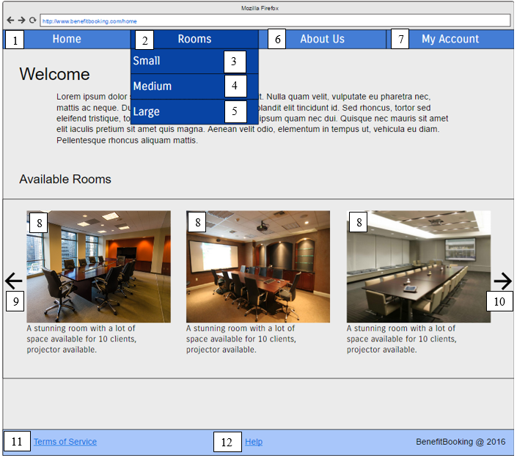

Home Page

1) Redirect to ‘Home Page’

2) Show all rooms

3) Show ‘small’ rooms

4) Show ‘medium’ rooms

5) Show ‘large’ rooms

6) Redirect to About Us Page

7) Redirect to My Account

8) Redirect to chosen room

9) Move carousel left

10) Move Carousel right

11) Show Terms of Service

12) Show Help page

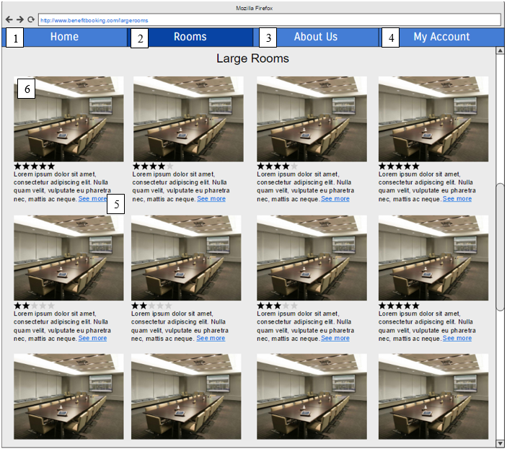

Rooms (Large) Page

1) Redirect to Home Page

2) Show all rooms (On click) **OR** show dropdown contents (On hover)

3) Redirect to About Us Page

4) Redirect to My Account

5) Show more content (Progressive Disclosure)

6) Redirect to chosen room -> Booking Page

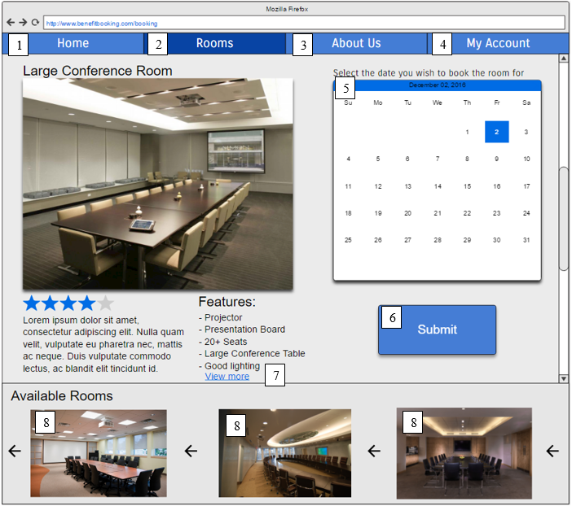

Booking Page

1) Redirect to Home Page

2) Show all rooms (On click) OR show dropdown contents (On hover)

3) Redirect to About Us Page

4) Redirect to My Account

5) Select a day to book the room for, if the room is already booked for a specific day, it will be greyed out and the option to click will be disabled.

6) Submit booking -> Store ‘**e-mail address, room chosen + day in Database**’

7) Show more content (Progressive disclosure)  
8) Select room -> Booking Page

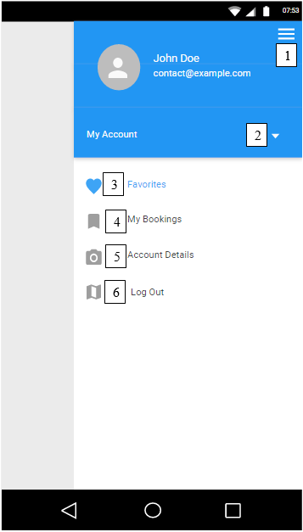

My Account (Mobile)

This example demonstrates how the menu will appear on a mobile device. The hamburger menu is used on the right side to make the menu easy to access, even with large devices. Putting the menu on the left side of the screen will make it difficult to reach, particularly if visitors have smaller hands.

1) Hamburger menu -> Close menu

2) Open dropdown (Options: **Home, Rooms, About Us, My Account**)

3) View favourite bookings (Database: Check if user has favourited pages)

4) View booked rooms and previous bookings stored in database. (Used for meeting minutes if nobody takes note of the room and for remembering which room has been booked)

5) Navigate to account details page (Change e-mail address, personal details and update database accordingly)

6) Log Out and return to Login page.

**User Personas**



Andrew

* 28
* Project Manager
* He has a busy schedule and does not have time to view and book rooms during work hours.

Nancy

* 34
* Events Co-ordinator
* Works mostly from an office tending to calls so must resort to online bookings in her free time.

Steve

* 23
* CEO of his own company
* Usually moving between the business overseeing activity. Does not usually have access to a desktop computer so instead uses his mobile phone.

1. **References**

Bookingbug.co.uk. (2016). BookingBug: Online Booking & Appointment Scheduling Software. [online] Available at: https://www.bookingbug.co.uk/ [Accessed 5 Dec. 2016].

Budiu, R. (2016). Mobile Websites: Mobile-Dedicated, Responsive, Adaptive, or Desktop Site?. [online] Nngroup.com. Available at: https://www.nngroup.com/articles/mobile-vs-responsive/ [Accessed 4 Dec. 2016].

Campaign Monitor, (n.d.). Progressive Disclosure. [image] Available at: https://i3.campaignmonitor.com/assets/images/guides/mobile/showhide.png [Accessed 4 Dec. 2016].

Cisco (2016). Cisco Visual Networking Index: Global Mobile Data Traffic Forecast Update [Online] Available from: http://www.cisco.com/c/en/us/solutions/collateral/service-provider/visual-networking-index-vni/mobile-white-paper-c11-520862.html [Accessed 21 November 2016]

Expedia (2016) [Online] Available from: https://www.expedia.co.uk/ [Accessed 21 November 2016]

Facebook. (2016). Facebook - Log In or Sign Up. [online] Available at: http://www.facebook.com [Accessed 4 Dec. 2016].

Fichter, D. (2016). Emotional Design, Storytelling, 'Slippiness,' and Understandable Icons. Online searcher (Medford, N.J.), 40(1), p.74.

Field Notes. (2016). Home | Field Notes. [online] Available at: https://fieldnotesbrand.com/ [Accessed 4 Dec. 2016].

Gascho Rempel, H. & Bridges, L. (2013). That Was Then, This Is Now: Replacing the Mobile-Optimized Site with Responsive Design. Information technology and libraries. 32 (4), p8-24.

Hamill, D. (2009). Stop Counting Clicks | UX Booth. [online] Uxbooth.com. Available at: http://www.uxbooth.com/articles/stop-counting-clicks/ [Accessed 4 Dec. 2016].

Hotels.com. (2016). Hotels.com - Earn Free Nights on Cheap Hotels Near You. [online] Available at: http://hotels.com [Accessed 4 Dec. 2016].

Icon Finder, (n.d.). Hamburger Menu. [image] Available at: https://www.iconfinder.com/icons/134216/hamburger_lines_menu_icon [Accessed 3 Dec. 2016].

McDowell, W. (2016). Making A Case For The Desktop Hamburger Menu. [online] Usabilitygeek.com. Available at: http://usabilitygeek.com/making-case-for-desktop-hamburger-menu/ [Accessed 4 Dec. 2016].

Salvesen, A. (2016). 7 Myths Of Responsive Web Design | Marketing Insider Group. [online] Marketing Insider Group. Available at: https://marketinginsidergroup.com/mobile/7-myths-of-responsive-design/ [Accessed 4 Dec. 2016].

Smashing Magazine, (2016). Colour shades. [image] Available at: https://www.smashingmagazine.com/wp-content/uploads/2016/03/02-color-characteristics-preview-opt.jpg [Accessed 4 Dec. 2016].

Teem. (2016). Meeting Room Management & Workplace Analytics Platform | Teem. [online] Available at: https://teem.com/ [Accessed 4 Dec. 2016].

Thurow, S. (2014). User Experience Myth Or Truth: The Three-Click (Or Tap) Rule. [online] Marketing Land. Available at: http://marketingland.com/user-experience-myth-truth-three-click-tap-rule-104760 [Accessed 4 Dec. 2016].

Zakas, N. (2013). The evolution of web development for mobile devices. Communications of the ACM. 56 (4), p42-48.

**Appendix 1: Project Specification form- Milestone 1.**

|  |  |  |
| --- | --- | --- |
|  | **COMP3341**  **Application Specification Form**  **Student Number: XXXXXXX**  **DATE:** **14/10/16** | |
| **Instructions:** This form must be submitted in the milestone 1 submission box on Blackboard by **Monday 7th November 2016.**  You will then need to attached the approved copy (given as written feedback by your module tutors) into the appendices section in assignment 1. | | |
| **PROJECT NAME/BRAND:** | Conference room booking system | |
| **INDUSTRY/MARKET:** | Booking systems | |
| **TARGET MARKET:** | Event organisers and small businesses | |
| **END USER CONSIDERATIONS (UX):** | Simplistic design that requires minimal clicks to get to a booking screen. The application will have considerations towards colour, accessibility and overall design. (e.g. Using placeholders rather than text next to input fields) | |
| **BRIEF DESCRIPTION OF YOUR APPLICATION (100 words max):**  The application is designed to allow small businesses to book a conference room in a hotel on a specific date. Rather than the conference room being booked for periods of 1-2 hours, it will be booked for the entire day. The application will ensure that small-medium businesses can reserve the conference room for meetings, events or consultancy. Booking the conference room should be a simple and “pain-free” process and will require a minimal amount of information upon registration. Necessary information required will be username, name password and an e-mail address. | | |
| Enter information of your application here: The application requires a small amount of data to work upon registration (Name, Username, Password). It will be more effective to keep the visitor engaged and completing a short and simple form rather than asking for unnecessary information such as their address, age, email address, phone number and other personal details. Once the user has entered their details, they will be able to book a day in the conference room. | | |
| **KEY APPLICATION FEATURES:** | | |
| 1. To be able to register  2. To be able to book the conference room on a specific date  3. To be able to cancel the reservation | | 4. Provide accessibility for peripherals and users  5. **For potential expandability**: provide a search tool allow users to filter through different rooms  6. To send receipt of booking via e-mail or through an ‘bookings’ section. |
| **DO YOU HAVE ANY CONCERNS?**  The design of the application should be simplified to keep both the registration and booking process fast and easy to use, even for users that are less experience with technology. Accessibility should be considered, including the peripherals certain users may be restricted to (i.e. mouse only, keyboard only) and could include a well-designed tab index for users that are restricted to keyboard only and other input methods for users that are restricted to mouse only. The web application should show support for a range of devices and adaptability will be considered when developing the web application. | | |
| Enter any concerns (for design or development) here:   If two users with the same name register on the web application and book the conference room, distinguishing between users will become an issue. To address this, it may be feasible to provide users with a unique identifier upon registration to make distinguishing between multiple users with the same name. Issues regarding users forgetting their unique identifier may arise but can be dealt with using personal details or an e-mail to confirm successful bookings. I will also be addressing the use of placeholder text (e.g. Username and Password in input fields) over using text alongside the fields to determine which method is more appropriate, easy to use and suitable for the application. I will be researching colour theory in booking systems to keep the web application appealing to view and accommodate font colour accordingly. | | |
| **Will you be using Frameworks?** Yes [X] No [_] | | |
| **If so, which Frameworks will you be using?** e.g. BootStrap / Angular / Laravel etc | | |
| Enter chosen Frameworks here: **-** BootStrap - jQuery (?) | | |
| **LECTURER APPROVAL (You don’t need to do anything here)** | | |
| **Approved by:** D:\Dropbox\sig.jpg | **Date:13/11/2016** | |
| **Lecturer formative comments:**  **Excellent idea. To get around your concern regarding user IDs I would instead get the user to login with their email address. This would ensure every user is unique and they don’t need to remember a unique ID. I’m glad you have chosen to arrange bookings on a per day basis rather than per hour, this will make things a lot easier! Great idea and very achievable within the given timeframe.**  **When you attach this document to your final report please remove your full name from the top to ensure your submission stays anonymous.** | | |