1. 共享单车

程序运行的过程：

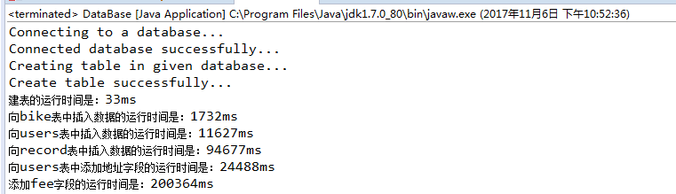

1、创建表的JAVA代码

//创建共享单车表

**public** **static** **final** String ***bike***="CREATE TABLE bike"+

"(bike_id integer not null," +

"primary key(bike_id))ENGINE=myisam DEFAULT CHARSET=utf8";

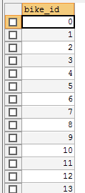

//创建用户表

**public** **static** **final** String ***users***="create table users"+

"(user_id integer not null,"+

"name varchar(255) not null," +

"phone_number varchar(15) not null," +

"balance float not null," +

"primary key(user_id))ENGINE=myisam DEFAULT CHARSET=utf8";

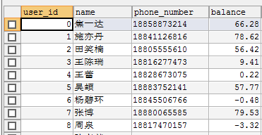

//创建记录信息表

**public** **static** **final** String ***record***="create table record" +

"(user_id integer not null," +

"bike_id integer not null," +

"start varchar(255) not null," +

"start_time datetime not null," +

"end varchar(255) not null," +

"end_time datetime not null," +

"primary key(user_id,bike_id,start_time))ENGINE=myisam DEFAULT CHARSET=utf8";

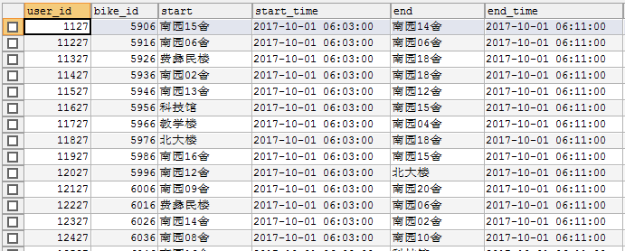

2、估计用户家庭住址

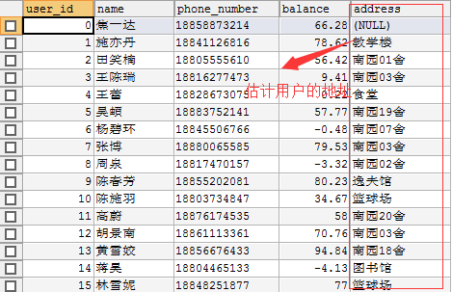

3、计算费用

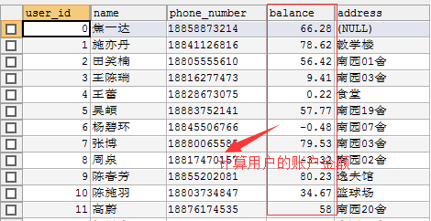

4、维护车辆

