Week 1 Assignment

Shaun Hoadley

CST 304: Software Requirements & Analysis

Professor Robert Key

March 9, 2021

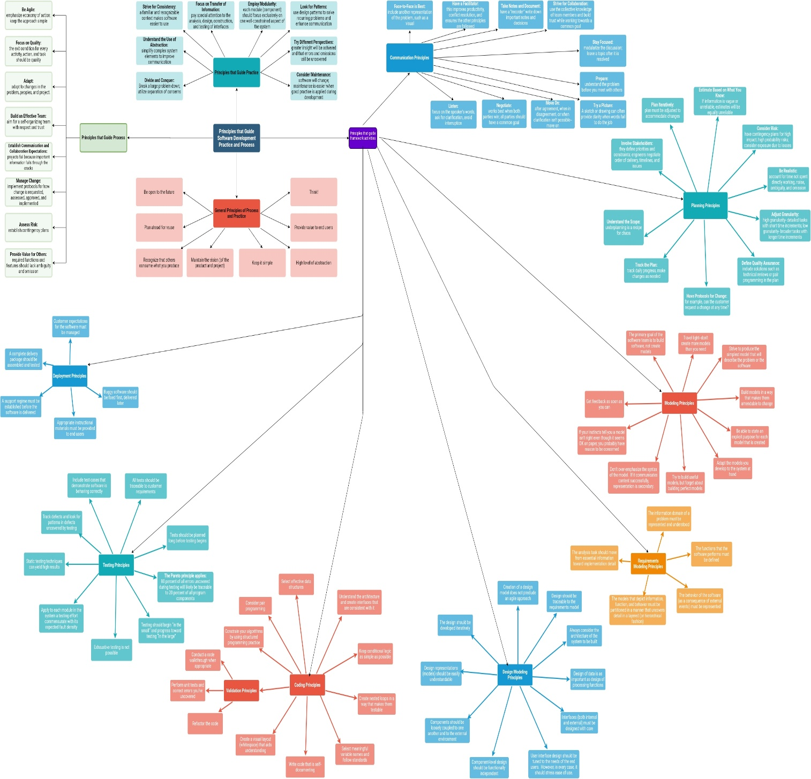

**References**

Pressman, R. S., & Maxim, B. R. (2015). [*Software engineering: A practitioner's approach*](https://ashford.instructure.com/courses/81372/modules/items/4111209) (8th ed.). Retrieved from https://www.vitalsource.com