**Week 2 Assignment**

**Shaun Hoadley**

**CST 304: Software Requirements & Analysis**

**Professor Robert Key**

**March 22, 2021**

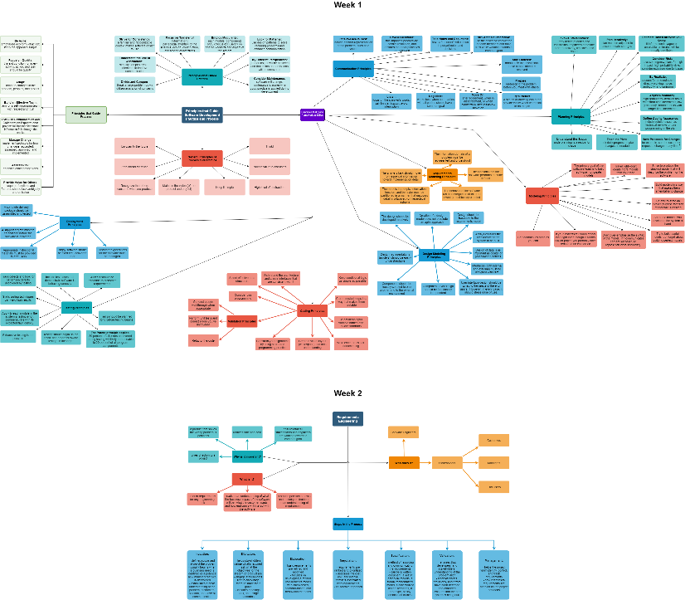

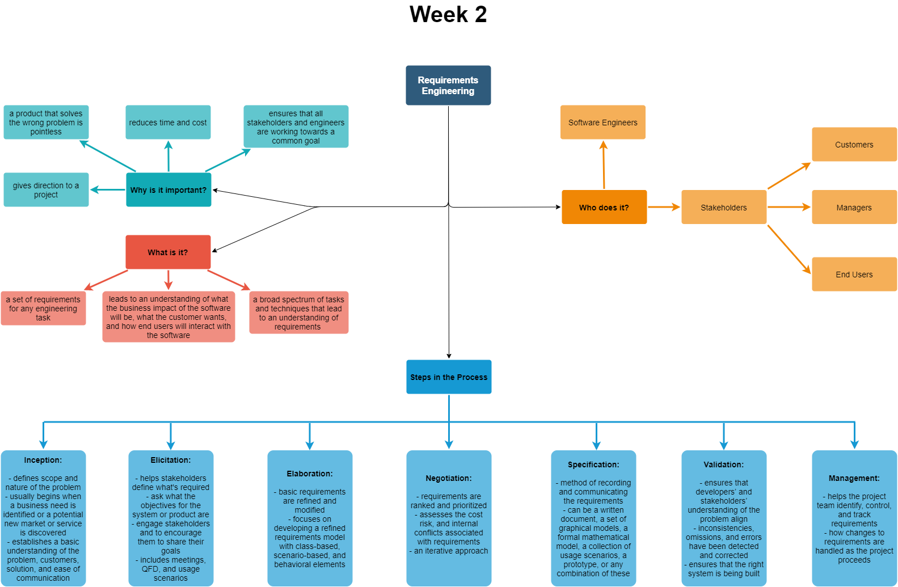

* **Summarize the process of eliciting the requirements to include collaborative requirements gathering.**

The process of eliciting requirements for a project is one of the most challenging aspects of software engineering. It is the elicitation phase where each stakeholder provides their take on what functionality is needed, what can be added later, and what timetable is available with which to work. There are a variety of methods used to elicit the requirements; not all work for every project, and often several are used in conjunction. Some of those methods are interviews, brainstorming sessions, quality function deployment (QFDs), and use cases.

* **Explain the quality function deployment (QFD), usage scenarios, and eliciting work products.**

QFD is an elicitation technique used to attempt to translate the unspoken needs and goals into requirements (Pressman & Maxim, 2015, p. 141-142). Usage scenarios are used to describe how each function of the software is to be used in order to get an overview of how the software should work. Eliciting work products are the resulting consequences from the requirements elicitation, such as the list of stakeholders involved, user stories, etcetera (Pressman & Maxim, 2015, p. 146-147).

* **Discuss how to write and develop effective use cases.**

According to Pressman and Maxim, the first step to writing and developing effective use cases is to define a set of actors for the story (2015, p. 149). The actors are people and devices that interact with and within the system. Once the actors are established, the stories can begin to be written to show what the actors are doing and how they relate to each other. In the changing environment of requirements engineering, not all actors may appear from the beginning of the project.

* **Illustrate the main elements of the analysis model to include the elements of the analysis model, scenario-based elements, and class-based elements.**

An analysis model provides descriptions of the various domains in a system, informational, functional, and behavioral. Scenario-based elements are best used in scenario-based methods, such as use case scenarios because they are focused on the point-of-view of the actors. These elements are often the first part of the model developed. Class-based elements are the objects that the actors manipulate. In software engineering, analysis models are depicted using UML diagrams and notation.

* **Summarize what is meant by negotiating the requirements to include the requirements monitoring and validating the requirements.**

Negotiating the requirements is essentially gathering stakeholders to determine the best balance of the requirements to be delivered versus the allotted budget and time constraints. Additionally, the negotiation dictates how the development is monitored and tested (validated) throughout the process.

**References**

Pressman, R. S., & Maxim, B. R. (2015). [*Software engineering: A practitioner's approach*](https://ashford.instructure.com/courses/81372/modules/items/4111209) (8th ed.). Retrieved from https://www.vitalsource.com