**Week 3 Assignment**

**Shaun Hoadley**

**CST 304: Software Requirements & Analysis**

**Professor Robert Key**

**March 29, 2021**

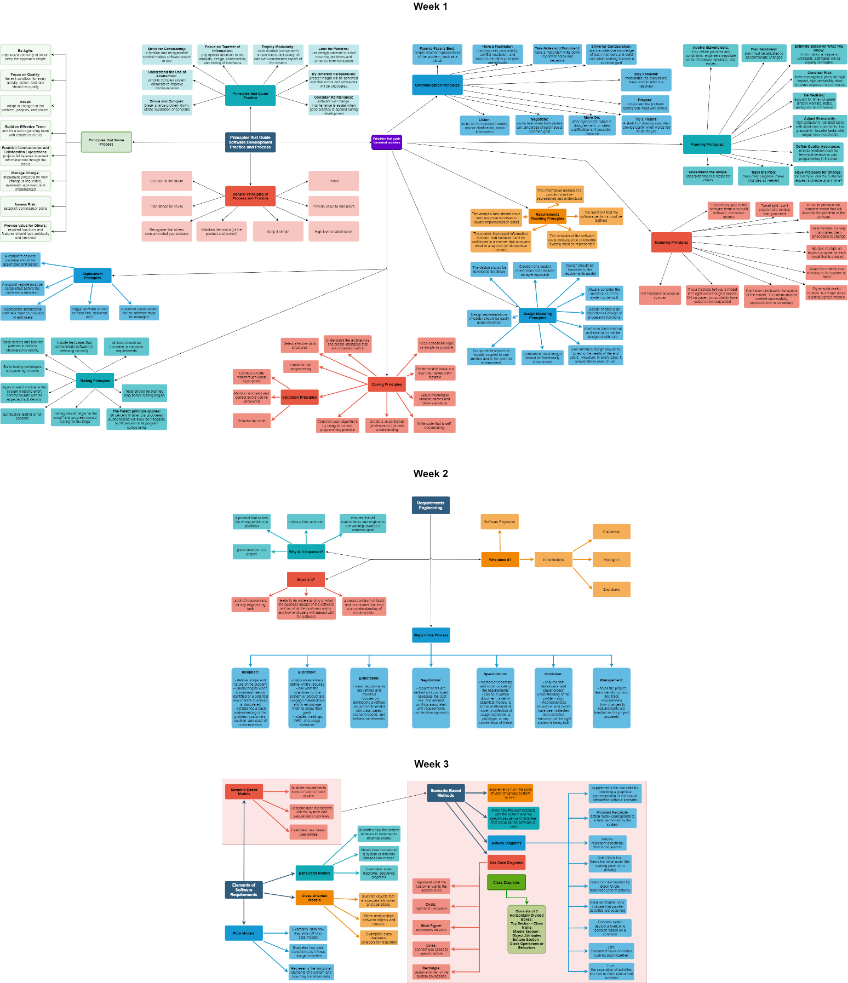

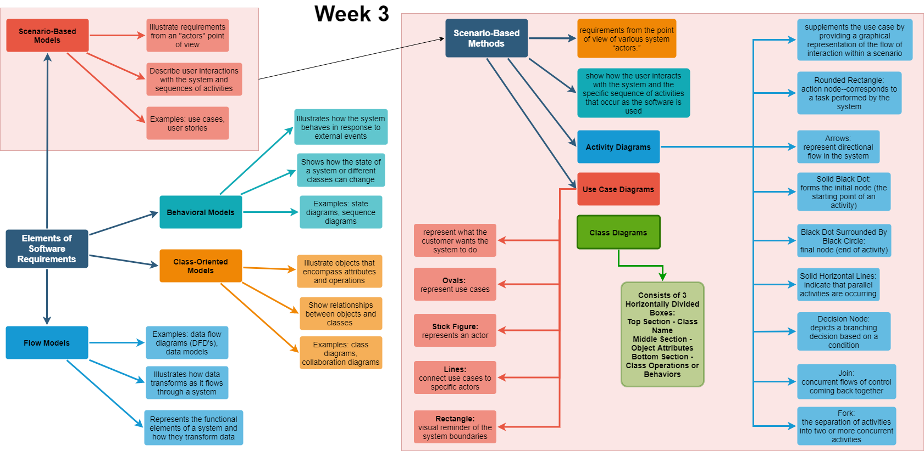

The three UML diagrams I have chosen to focus on are Use-Case, Class, and Activity diagrams. As a truck driver, I am responsible for keeping an accurate electronic logbook with a graph of my duty status throughout the day. For my model examples, I am going to focus on the part of the software that updates the duty status to the graph. For my first UML diagram, we are going to look at use-case diagrams. Pressman and Maxim explain use-case diagrams as being an overall picture, rather than the specific details, from the customer's perspective (2015, p.875). They allow you to picture what happens in a broad view. According to Filipova and Nikiforova (2019, p.75), "Use cases represent what the customer wants system to do, in other words, customer system requirements. At the high level of abstraction, use cases show which purposes the developed system is meant for." For use-case diagrams, in UML, actors (person or device) are represented by stick figures, ovals represent use-cases, and rectangles are used to signify, visually, the system boundaries (Pressman & Maxim, 2015, p.875). The use-cases are put in the rectangle, but actors never are. The actors connect to the use-cases they carry out by the use of lines.

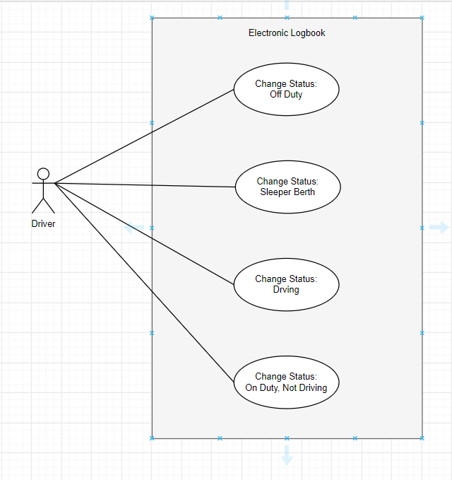

The next UML diagram represented in this paper is the Class Diagram. Class diagrams are not dynamic but rather a static or structural view of objects in a system. Class diagrams are used for modeling the classes along with their attributes, operations, relationships, and associations. Class diagrams are boxes that are divided into three horizontal parts. The top part of the box contains the class name. The middle section of the box includes the attributes of the class. The bottom portion of the box shows the behaviors and operations associated with the class (Pressman & Maxim, 2015, p.870).

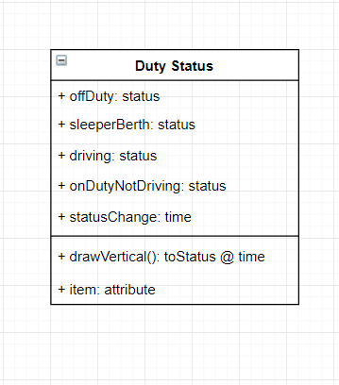

The last UML diagram in this paper is the activity diagram. Activity diagrams represent the dynamic behavior and information flow of a system. The starting node of an activity diagram is shown by a black dot, which represents the preconditions to the activity. Action nodes are displayed using rounded rectangles. When one action node leads to two or more action nodes that work concurrently, the *fork* is represented by a solid black horizontal bar with one arrowed line entering the bar with arrowed lines exiting for each branch of the fork. Decision-making nodes are shown as a diamond with an arrowed line entering as the input and arrowed lines leaving for each possible output choice.

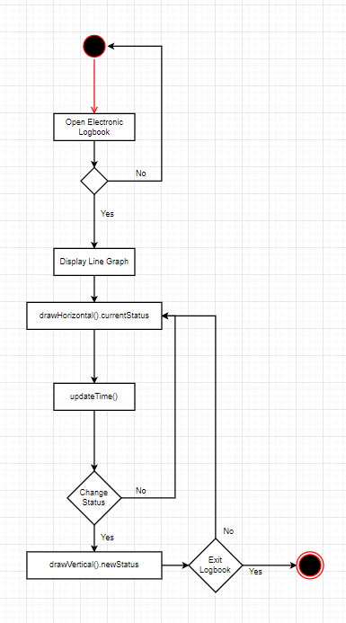

**References**

Filipova, O., & Nikiforova, O. (2019). Definition of the Criteria for Layout of the UML Use Case Diagrams. Applied Computer Systems, (1), 75. https://doi-org.proxy-library.ashford.edu/10.2478/acss-2019-0010

Pressman, R. S., & Maxim, B. R. (2015). *Software engineering: A practitioner's approach* (8th ed.). Retrieved from https://www.vitalsource.com