**Week 5 Assignment and Final Project**

**Shaun Hoadley**

**CST 304: Software Requirements & Analysis**

**Professor Robert Key**

**April 12, 2021**

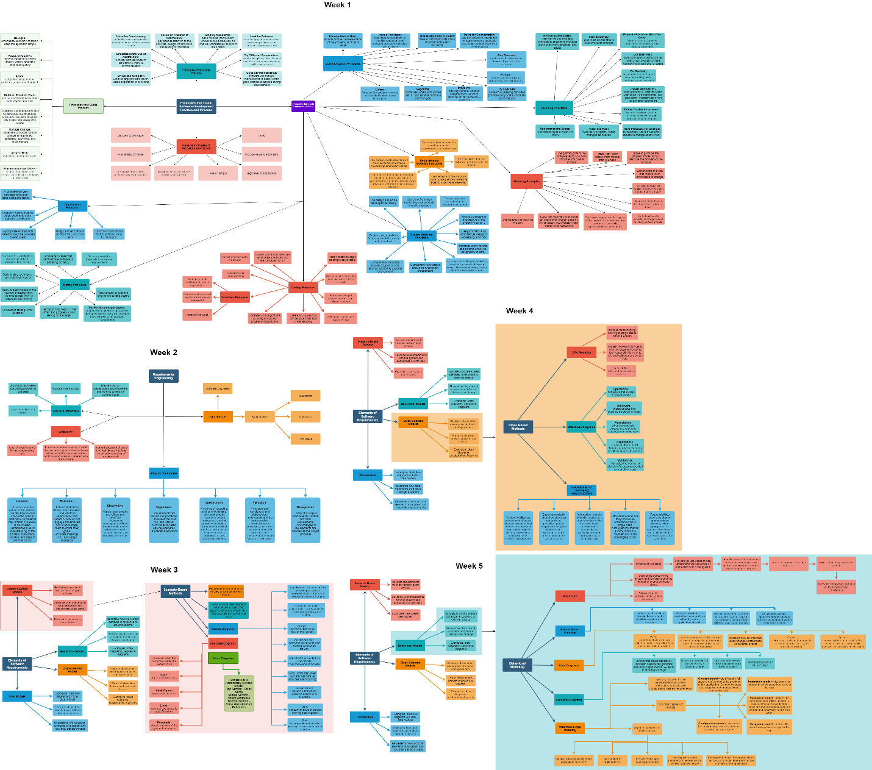

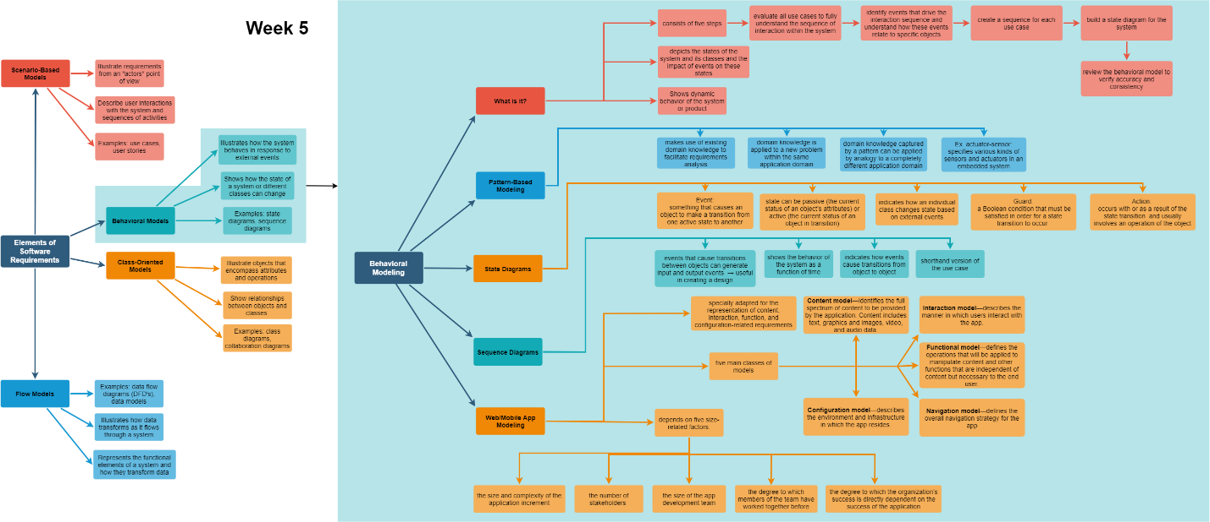

Requirements modeling of behavior gives stakeholders a way to visually identify how a system is going to react under the specific circumstances. Behavior patterns in requirements modeling is kind of a shortcut for system design. Why reinvent the wheel if you have a library that has similar functions to what you are looking for. The purpose of modular programming, or object oriented programming is to create code that is reusable, it is this reusability that allows us to begin to see the patterns. These patterns often cross over to multiple domains. In mobile/web apps, requirements modeling are specially adapted for the representation of content, interaction, function, and configuration-related requirements and rely on five size related factors.

The various components of requirements modeling consists of scenario-based models, class-based models, behavioral models, and flow-models. Each type of model shows a system from a different perspective allowing the development team and other stakeholders to see a more complete picture of how things should work together to address the problem the software is being designed to handle, generally even before any code is written.

I have attempted in my concept map to demonstrate how each component of requirements modeling works, both independently and with each other to identify the problem to be solved, meaningfully deal with said problem and discover the potential pitfalls that may need to be addressed along the way.

**References**

Pressman, R. S., & Maxim, B. R. (2015). [*Software engineering: A practitioner's approach*](https://ashford.instructure.com/courses/81372/modules/items/4111209) (8th ed.). Retrieved from https://www.vitalsource.com