**Week 1 Interactive Assignment: Software Quality Attributes**

Shaun Hoadley

CST307: Software Architecture & Design

Professor Amr Elchouemi

November 18, 2021

**Software Quality Attributes**

**Week One Concept Map**

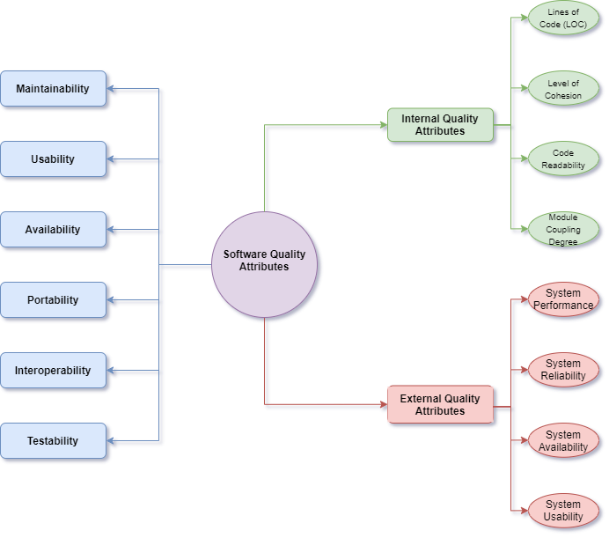

**Define each software quality.**

Ingeno points out that quality attributes are important in software and should be considered throughout the software development life cycle (2018). It was stated by Aydin, “quality attributes were presented within two categories that are executional and evolutionary” (2020, pg. 2511).

**Executional Quality Attributes:**

* **Availability**

This is the degree that software will work properly at the time it is needed.

* **Portability**

This is how adaptable the software is across multiple platforms.

* **Interoperability**

This represents how effective and efficient the software can exchange and use information from other software systems.

* **Testability**

Testability is the degree that, in its given context, software can support testing. The higher the testability, the easier it is to test software and its components.

**Evolutionary Quality Attributes:**

* **Maintainability**

Maintainability represents the ease in which software is updated and maintained.

* **Usability**

Usability is the ease of use of the software for the required task by users and directly affects user satisfaction.

**External and Internal Software Qualities**

External software qualities measure if the stakeholder needs and requirements are fulfilled. The following are external software qualities: Accuracy, adaptability, correctness, efficiency, integrity, reliability, and robustness.

Internal software qualities determine the ability to proceed on a project; With a high internal quality, software is easier to change, test, and extend. Internal software qualities include: Flexibility, maintainability, portability, readability, reuseability, testability, and understandability.

**References**

Aydin, A. A. (2020) Prominent quality attributes of crisis software systems: a literature review. *Turkish Journal of Electrical Engineering & Computer Sciences, 28(5),* 2507-2522. <https://doi-org.proxy-library.ashford.edu/10.3906/elk-1911-5>

Ingeno, J. (2018). *Software architect’s handbook: Become a successful software architect by implementing effective architecture concepts.* Retrieved from https://www.vitalsource.com/