**Week 2 Interactive Assignment:** **Software Architecture Terminology**

Shaun Hoadley

CST307: Software Architecture & Design

Professor Amr Elchouemi

November 27, 2021

**Software Architecture Terminology**

**Week Two Concept Map**

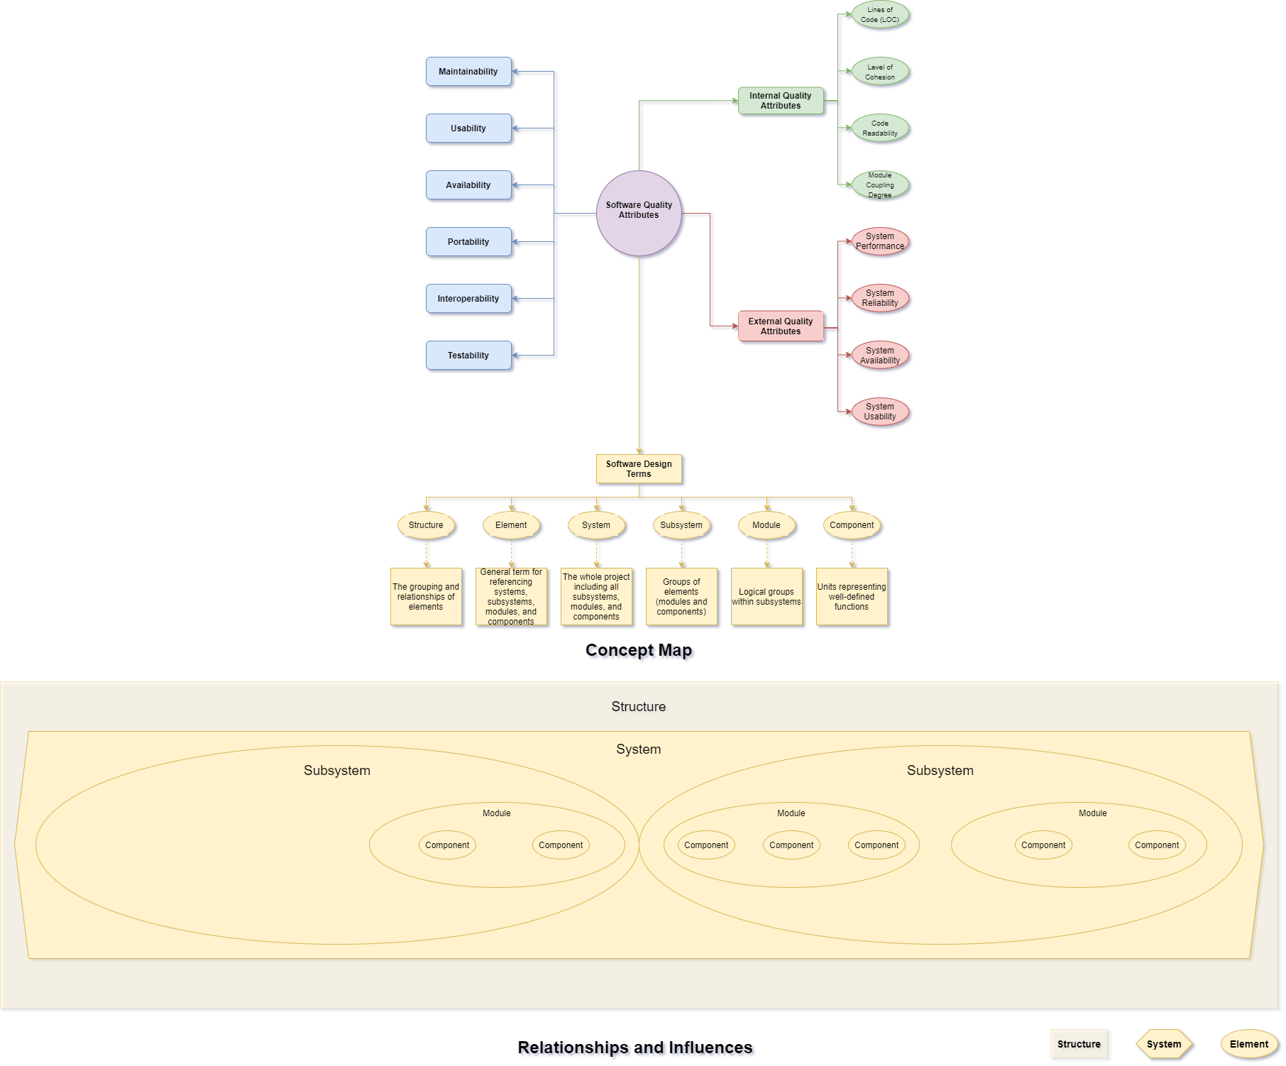

**Architecture Terms Defined**

**Structure –** The grouping of elements and their relationships

**Element –** Generic term used when describing systems, subsystems, modules, and/or components

**System –** Completed project containing all subsystem elements

**Subsystem –** Groups of module elements within a system

**Module –** Groups of component elements within subsystems

**Component –** Well defined functional elements within modules

**Relationship Between Terms and Their Influence Upon Each Other**

As for the relationships between the terms, they are all elements except for structure and system. Structure, as defined above, is the grouping of all elements and their relationships. The structure is the BIG PICTURE as to how everything fits together, breaking down into smaller pieces to satisfy all of the requirements. All of the elements affect the structure of a software architecture design. An element refers to any part of a system, they are the building blocks. Whether the architecture uses a top-down or bottom-up approach to the design, the influence on a system by the elements goes from the smallest pieces upward.

A system, in terms of software architecture, is the completed software project. The system is influenced by the structure from a requirements perspective and by all of the elements that make up the system on the design side. An example of a system we use everyday is an operating system, or OS, such as Windows 10 by Microsoft. A system is made up of smaller elements called subsystems. These subsystems influence the system as a whole. Continuing with the same example, our Windows 10 system is comprised of many subsystems such as the executive subsystem, system and services subsystem, and environment subsystem to name a few. If any of the subsystems are not functioning properly, the system will not function properly.

Each subsystem element is made of and influenced by module elements. Just as the system is affected by the subsystems, the subsystems are affected by the modules within them. The executive subsystem from the example is made up of the kernel and device driver modules. If either module has problems, the executive subsystem will be affected because these modules are a part of the subsystem. While modules from other subsystems can affect the system as a whole, they do not affect the executive subsystem.

Module elements are influenced by and comprised of component elements. As far as the software architecture goes, component elements are the smallest pieces of a system or structure. As with the way modules only affect the subsystem to which they belong, components from one module do not affect other modules. Back to the example, the kernel module contains component elements for operating system synchronization, interrupt and exception dispatching, and thread-handling functions. None of the kernel module component elements affect the device driver module.

**References**

Ingeno, J. (2018). *Software architect’s handbook: Become a successful software architect by implementing effective architecture concepts.* Retrieved from https://www.vitalsource.com/