**Week 3 Interactive Assignment:** **Software Development Best Practices**

Shaun Hoadley

CST307: Software Architecture & Design

Professor Amr Elchouemi

December 3, 2021

**Software Development Best Practices**

**Week Three Concept Map**

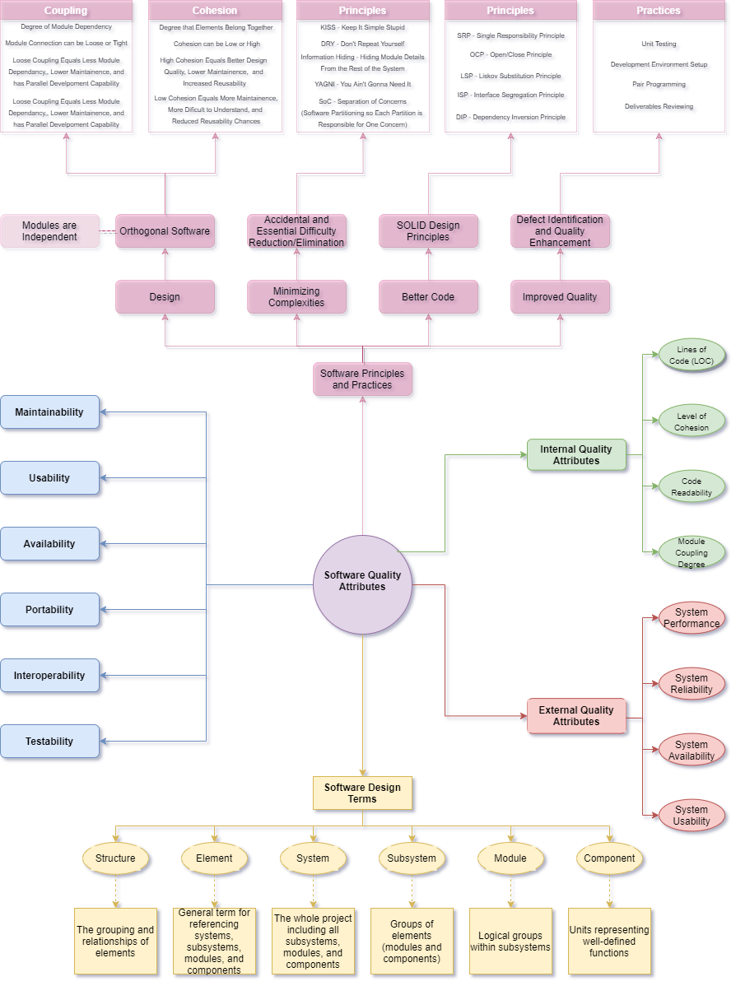

**Best Practices**

The best practice that I feel is the most important is in the design, specifically in designing the project to be orthogonal software. Orthogonal software is software that is designed so that modules operate independently from each other (Ingeno, 2018). When modules are created to serve one purpose, they will have low coupling and high cohesion. Modules that perform one task can be reused across multiple, similar projects, allowing one to save time and improve the efficiency of the system overall. Designs of this nature allow for easier long-term maintenance, simpler and more efficient modifications or extensions, and provide easier testing.

**References**

Ingeno, J. (2018). *Software architect’s handbook: Become a successful software architect by implementing effective architecture concepts.* Retrieved from https://www.vitalsource.com/