**Week 4 Assignment: Object-Oriented Design**

Shaun Hoadley

CST307: Software Architecture & Design

Professor Amr Elchouemi

December 13, 2021

**Object-Oriented Design**

I decided upon doing a login system for the software system I have selected to design. As will be seen in the following image, I clearly need more practice with my UML, but I think it gets my idea across.

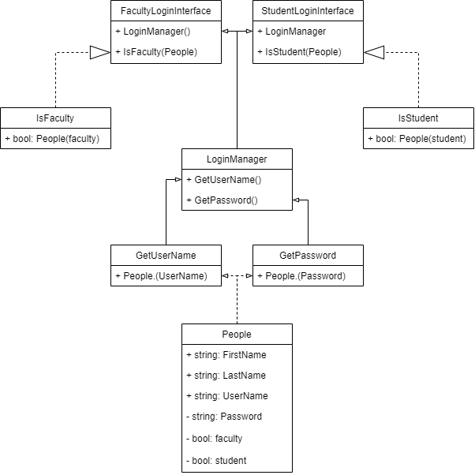

If I had more time for the assignment, I would obviously add separate subclasses of People for faculty and students that would demonstrate inheritance and the Liskov substitution principle (LSP). I do feel that the image shows encapsulation and coding to an interface. With the exception of the People class, I believe I have done a decent, though rudimentary, job of illustrating the single responsibility principle (SRP), as well as the principle of least knowledge (PLK). As an initial pitch with only a couple of hours to put something together and my need to work on my UML significantly more, I feel this is a good start for academic purposes. Still, it is nowhere near acceptable in a real-world scenario.

**References**

Dooley, J. F. (2017). *Software development, design, and coding: With patterns, debugging, unit testing, and refactoring* (2nd ed.). Retrieved from https://www.vitalsource.com/