**Week 4 Interactive Assignment:** **Software Design Process**

Shaun Hoadley

CST307: Software Architecture & Design

Professor Amr Elchouemi

December 11, 2021

**Software Design Process**

**Week Four Concept Map**

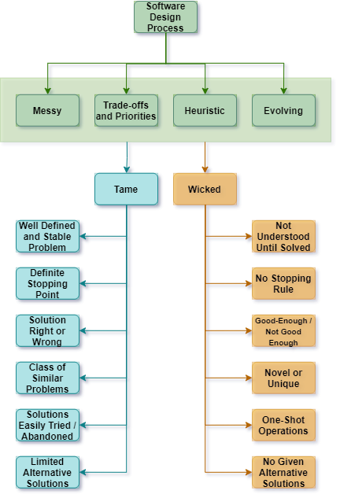

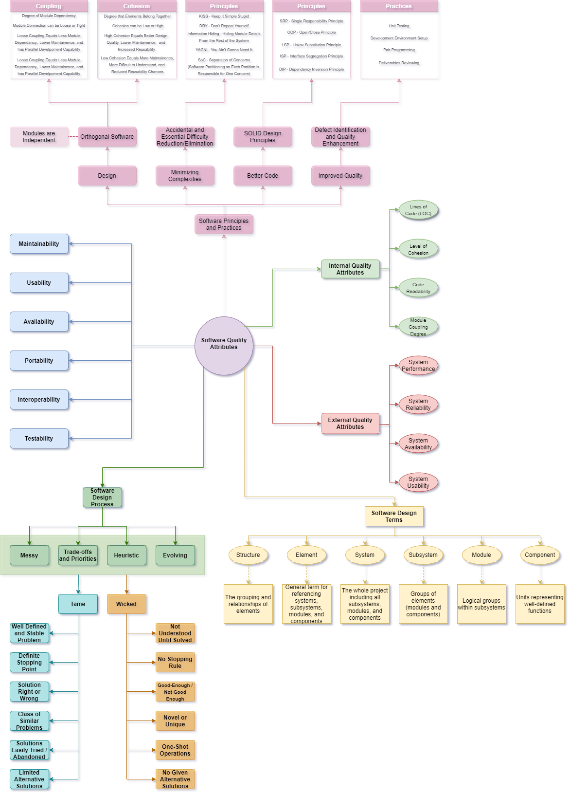

**Software Design Process**

According to Dooley, software problems can be divided into upper layers, where wicked problems lie, and lower layers that house the tame problems (2017). The most significant difference in the design of wicked problems and tame problems relies on tame problems having a known solution. Tame problems have the advantage of being either right or wrong; if it is wrong, it gets reworked until it is right. With a wicked problem, the solution develops alongside the problem. Wicked problems are in a constant state of flux, thus can only be good enough or not good enough but never complete. Tame problems can reuse solutions from similar problems, whereas wicked problems will have different solutions everytime.

**References**

Dooley, J. F. (2017). [*Software development, design, and coding: With patterns, debugging, unit testing, and refactoring*](https://ashford.instructure.com/courses/94102/modules/items/4766032) (2nd ed.). Retrieved from https://www.vitalsource.com/