**Week 2 Discussion 2: Design Metrics**

Shaun Hoadley

CST499: Capstone for Computer Software Technology

Professor Amr Elchouemi

January 20, 2022

**Design Metrics**

**Describe new and traditional design metrics. Explain how these metrics can be used to evaluate the quality of the design. Discuss how the metrics relate to one another. Evaluate the concepts of completeness and consistency related to software requirements.**

Earlier metrics took different approaches to analyze source code for complexity as a measure of quality. The Halstead Complexity Metric measures the number of operators and operands of the source code and the sum of the operators and operands. McCabe's Cyclomatic Complexity uses control flow diagrams to determine the number of edges, nodes, and connected components of the code for measuring its complexity, and thus its quality. Henry-Kafura Information Flow analyzes the complexity of the source code through the input or output data, or the fan-in and fan-out, of the modules as a measure of its quality. Both Halstead and McCabe are intramodular structural metrics. While Henry-Kafura is also a structural metric, it is an intermodular metric. Card and Glass also uses a fan-in/fan-out approach to measuring complexity that also considers the data being passed in both the program-level and inter-program-level (Tsui et al., 2018).

Newer metrics revolve around the concept of cohesion and coupling. Cohesion and coupling are not that different than the complexity measurements of the earlier metrics. Like that of Halstead and McCabe, Cohesion addresses intramodular characteristics, while coupling addresses intermodular characteristics as Henry-Kafura and Card and Glass did (Tsui et al., 2018).

**Week 2 Concept Map**

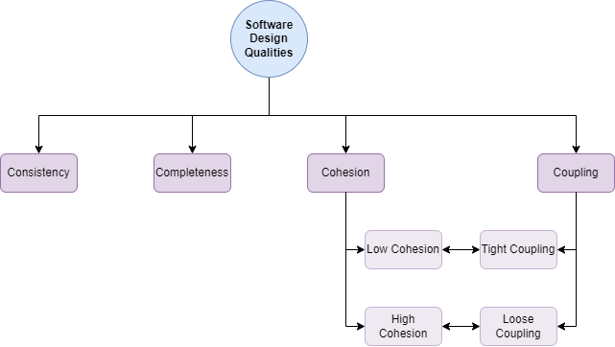

**References**

Tsui, F., Karam, O., & Bernal, B. (2018). Essentials of software engineering (4th ed.). Jones & Bartlett Learning.