**Week 4 Assignment: Database Development and Class Registration**

Shaun Hoadley

CST499: Capstone for Computer Software Technology

Professor Amr Elchouemi

February 9, 2022

**Database Development and Class Registration**

**Introduction**

For week 4, the objective is to create the rest of the databases for the project and the webpages for viewing the course schedule, course search and registration. Unfortunately, I am still fighting with my project to get it to log a user in correctly. Until I get that right, the rest will not work properly. I do have the databases complete as well as a profile page (which I realized was not required after I finished it) with the values artificially inserted (shown below).



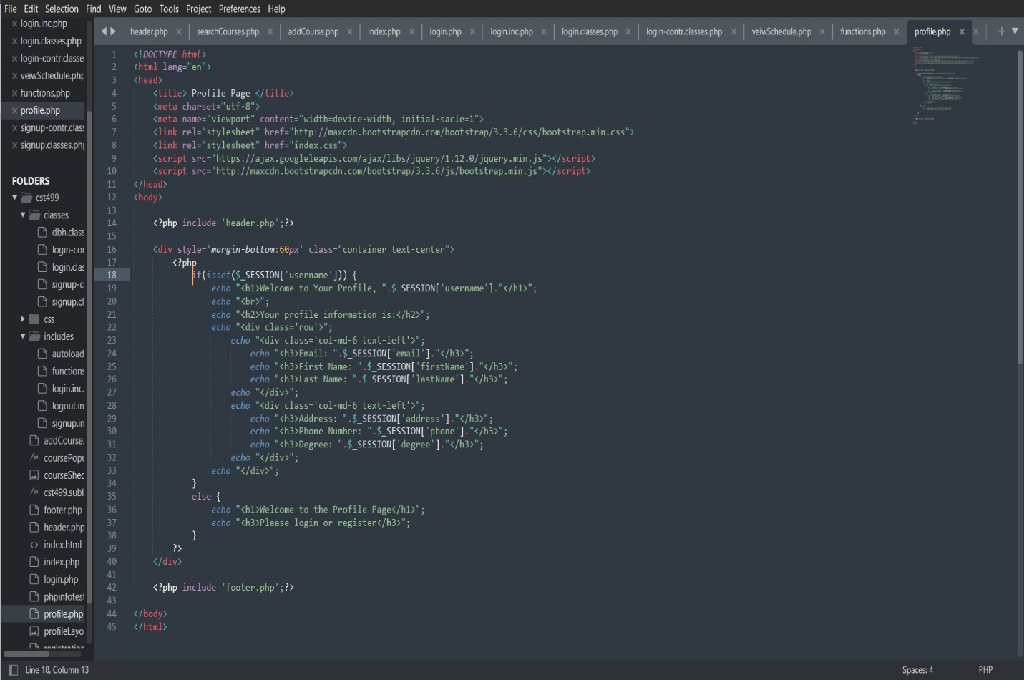

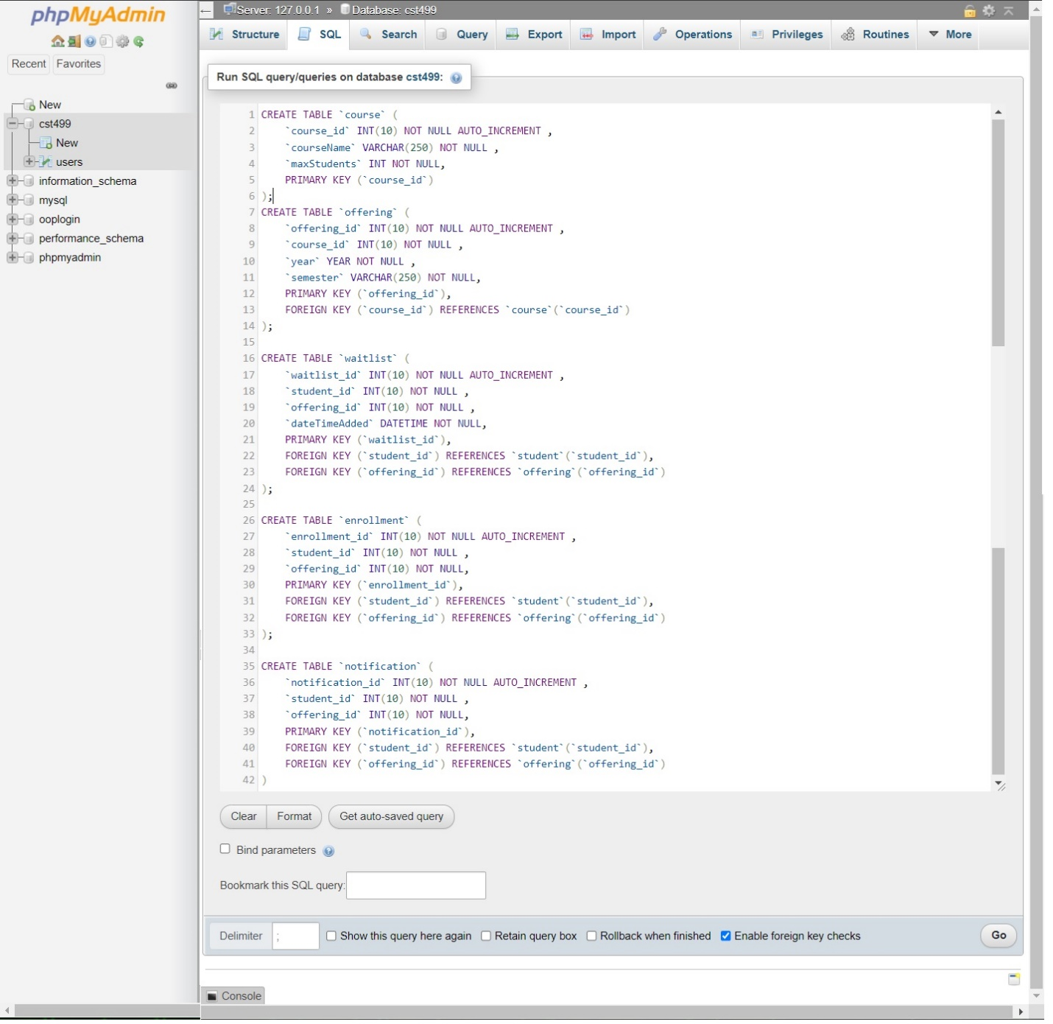

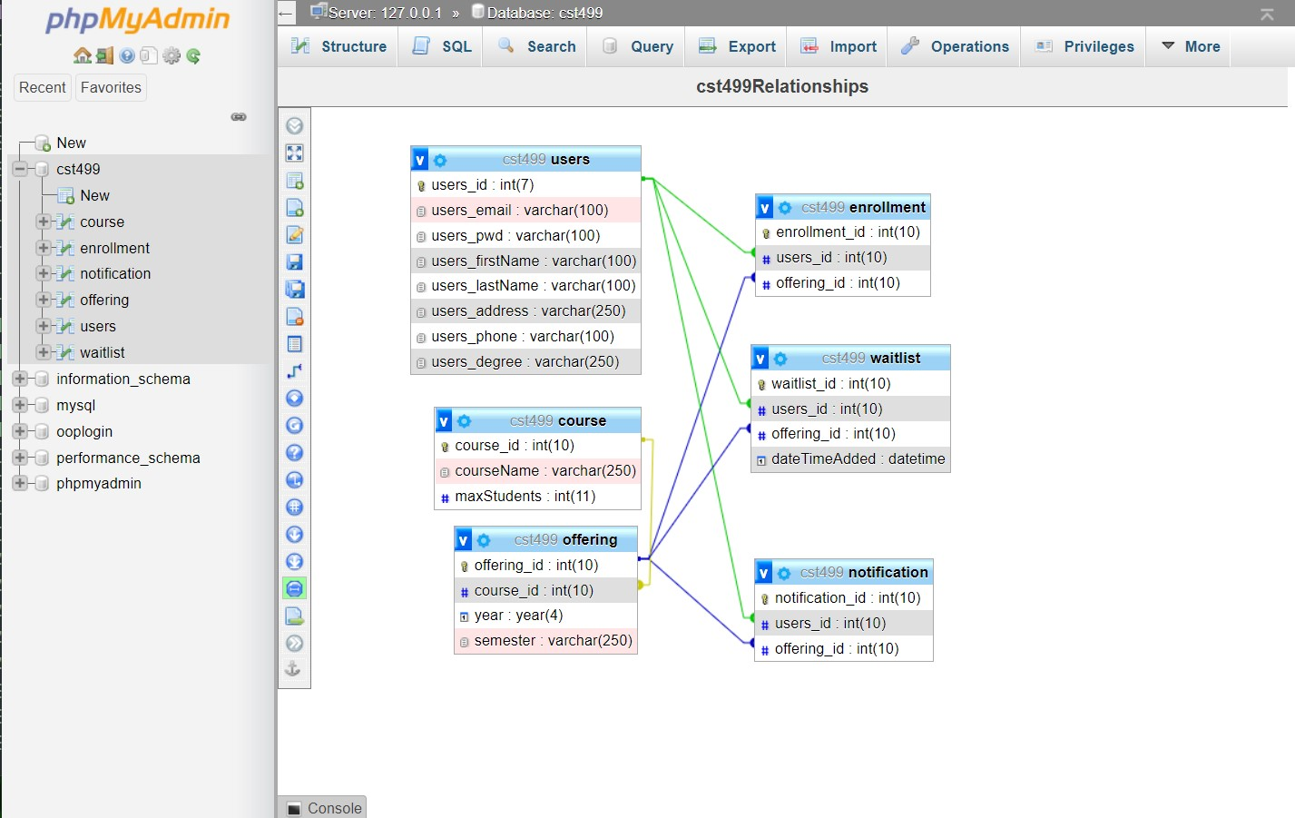

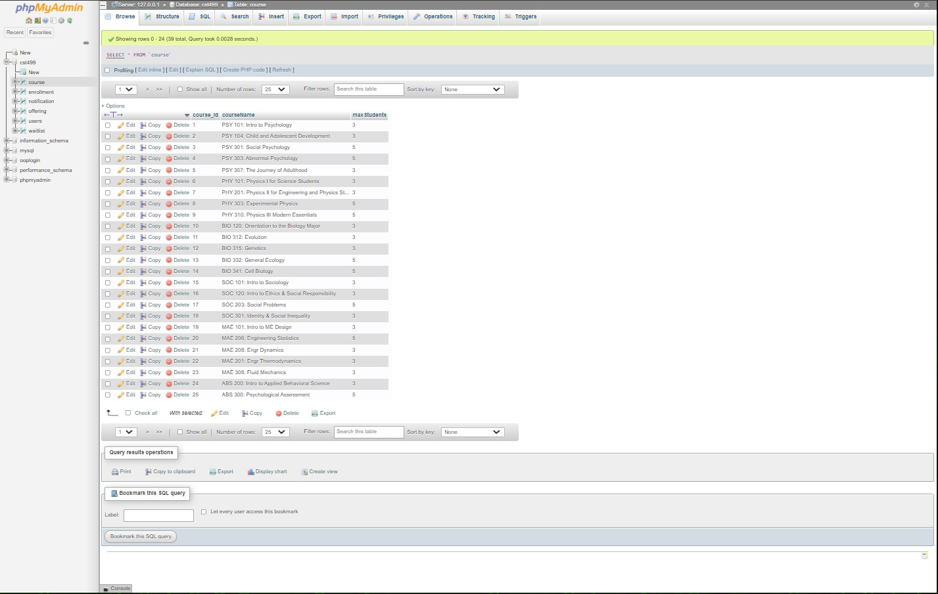

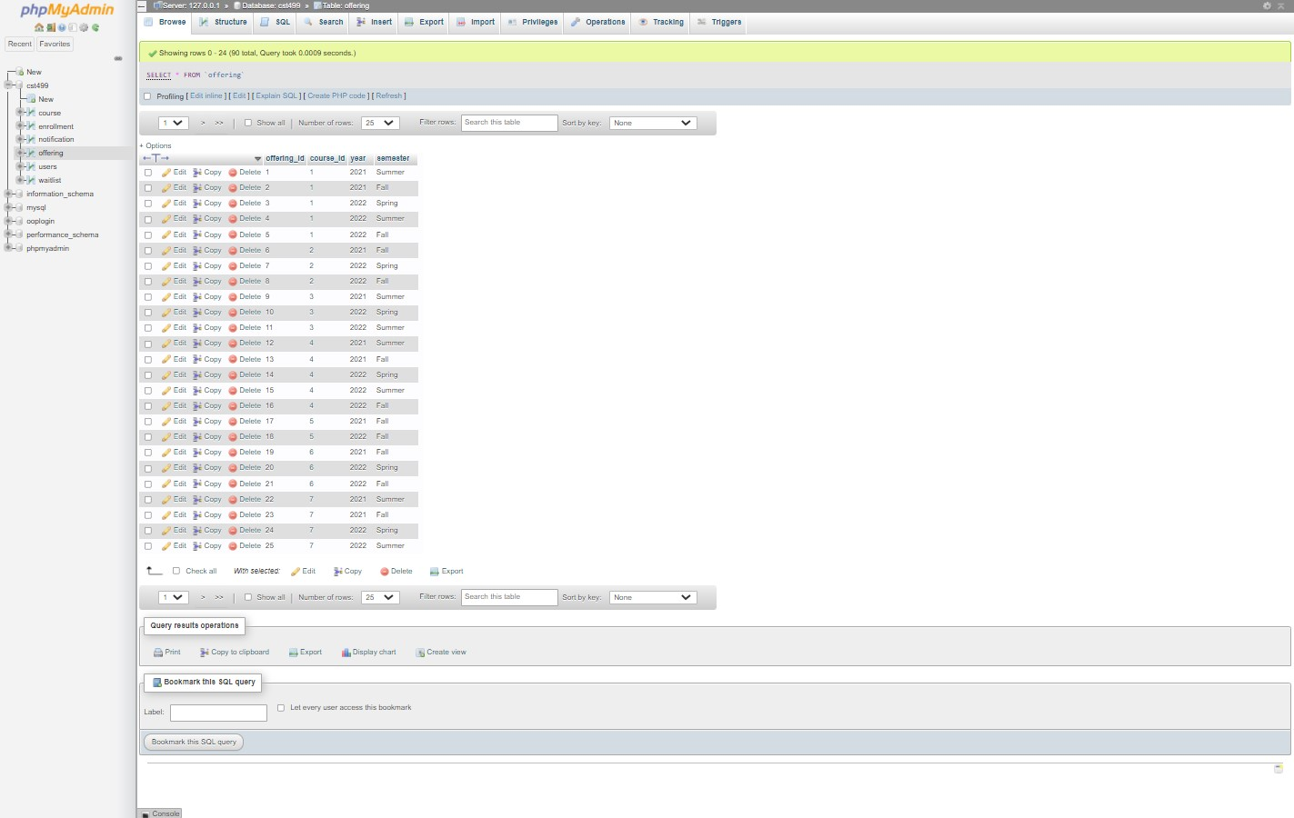

I have also written most of the code for the layout of the other pages but have not been able to test them and therefore have not taken screenshots. This is the best I can do until I figure out my problem with my login system. Sorry that this paper is as late as it is for as little as it contains.