**Describe how software projects can use an effective incident management strategy to control testing activities. Explain how that strategy will ensure quality before the software is finally released.**

The use of an effective incedent management strategy can help control testing activities by organizing and prioritizing the incidents. There are essentially five basic phases in incident management: Identification and Logging, Clasification and Prioitzation, Investigation and Analysis, Resolution and Recovery, and Incident Closure. The following figures are the IEEE 829-1998 incident tracking template and instructions.

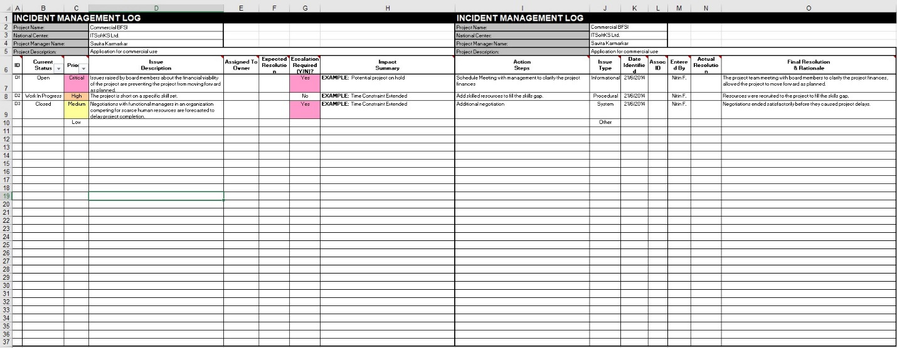

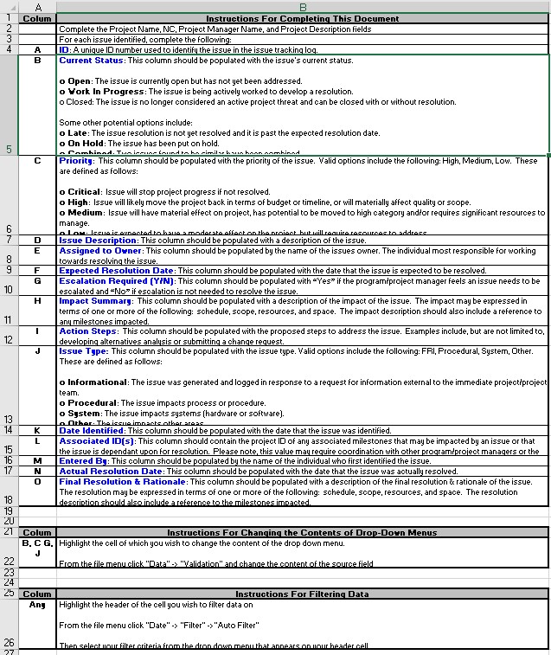

This template can certainly be modified to suit the specific needs of a company or industry but it provides an excellent basis concerning the incident management process. While this document is manually filled out, it would be relatively easy to use a script to fill it out from a form submitted by the tester or anyone else who uses the system and discovers an incident. By using such a strategy, it is easier to locate problems earlier where they will be easier to correct. Incident management strategies, in turn, help ensure the quality of a project by providing tracability of issues from their reporting through their correction and closure.