Memory Allocation Alogrithms

Shaun Hoadley

CPT304: Operating Systems Theory and Design

Joshua Reichard

June 27, 2020

According to Silberschatz, Galvin, and Gagne (2014, 7.3), while there are many solutions to dynamic storage allocation, the three most commonly used are First-Fit, Best-Fit, and Worst-Fit. For each of the three solutions, the provided eight processes must be used, terminating in the order of 21 KB, 77 KB, 199 KB, 380 KB, 489 KB, 212 KB, 139 KB, and 302 KB. There is an available memory block of 2,464 KB. The sizes of the ten partitions of the memory are, in order, 150 KB, 275 KB, 425 KB, 300 KB, 80 KB, 117 KB, 500 KB, 35 KB, 313 KB, and 269 KB.

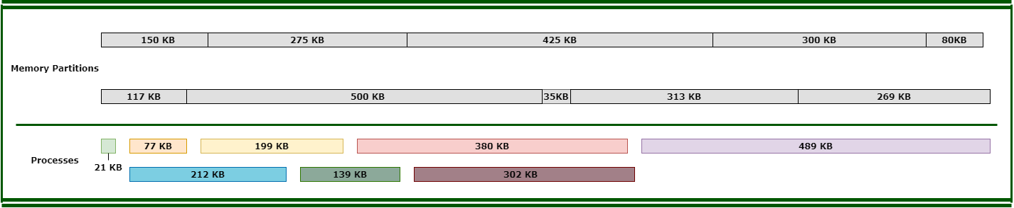

First-fit memory allocation is the fastest of the three solutions. With the first-fit allocation, the process is assigned to the first hole available that is large enough for the process to fit in (Silberschatz, Galvin, & Gagne, 2014, 7.3). The first process is 21 KB; as this is smaller than the 150 KB of the first partition, it gets assigned there, leaving 129 KB free in the first partition. The second process, being 77 KB, is still smaller than the free space in the first partition, so it too is assigned to there, leaving 52 KB available. Process number three has a size of 199 KB. Since process three will not fit in the free space in the first partition, it moves to the next partition. With a partition size of 275 KB, process three will indeed fit, leaving 76 KB of free space. Process four has a size of 380 KB; therefore, it will not fit in either of the first two partitions. Process four will, however, fit in partition three, as it has a size of 425 KB available. Afterward, the remaining free space in partition three is 45 KB. The next process is 489 KB, the first memory partition available that is large enough to contain it is partition number seven. After process five is assigned to partition seven, there is still 11 KB of free space in that partition. Process number six is 212 KB. Partition number four, being the first one with enough free space available, at 300 KB, is then assigned process six. Partition four is left with 88 KB of space free. Process number seven, having a size of 139 KB, gets assigned to partition nine because it is now the first partition with enough memory available to contain it, with 174 KB still remaining free. The final process, number eight, cannot be allocated. Process eight is 302 KB, and there are no longer any memory partitions available that have a large enough available free space to contain it.

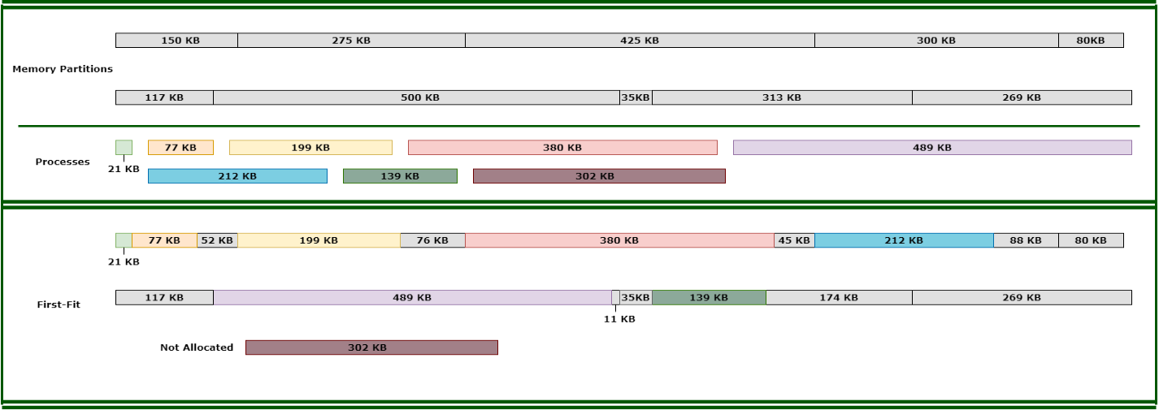

The next dynamic memory allocation solution is best-fit. The best-fit solution must search the entire list of memory locations for each process to locate the smallest hole available that the process will fit in. The first process gets allocated to partition number eight, leaving 14 KB available. The second process gets allocated to partition number five, leaving 3 KB available. The third process gets allocated to partition number two, leaving 11 KB available. The fourth process gets allocated to partition number three, leaving 45 KB available. The fifth process gets allocated to partition number seven, leaving 11 KB available. The sixth process gets allocated to partition number ten, leaving 57 KB available. The seventh process gets allocated to partition number one, leaving 11 KB available. The eighth process gets allocated to partition number nine, leaving 11 KB available. The best-fit allocation solution leaves the smallest amount of available free space left in each partition.

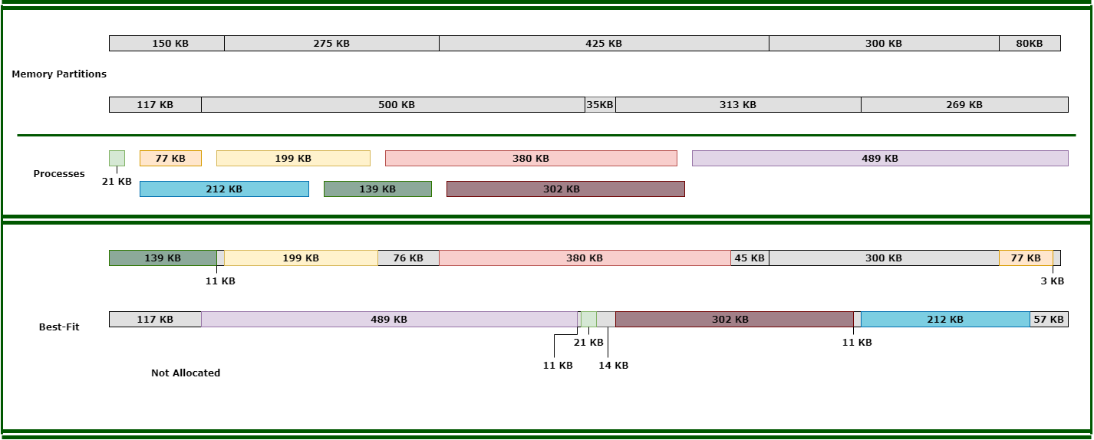

The third dynamic memory allocation solution is the worst-fit solution. The worst-fit algorithm is used to assign each process to the partition with the largest hole available the process will fit in. In the worst-fit solution, process one is assigned to partition number seven, leaving 479 KB of free space in that partition. Process number two is also assigned to partition seven because 479 KB of free space in there is still the largest hole available, leaving 402 KB remaining. Process number three is placed in partition three because 425 KB is now the largest available hole that it will fit in. Next, process four, with a size of 380 KB is assigned to partition seven. The reason being the 402 KB available there is the largest hole left that its 380 KB size can occupy. Process number five cannot be allocated because there are no partitions with enough free space to hold it. Partition six gets assigned to partition nine as the largest available space to hold the 212 KB size of the process, leaving 101 KB remaining. Next, process number seven is put in partition four with 161 KB of free space left afterward. Lastly, process number eight, with a size of 302 KB, cannot be allocated due to no partitions remaining with enough free space to contain it.

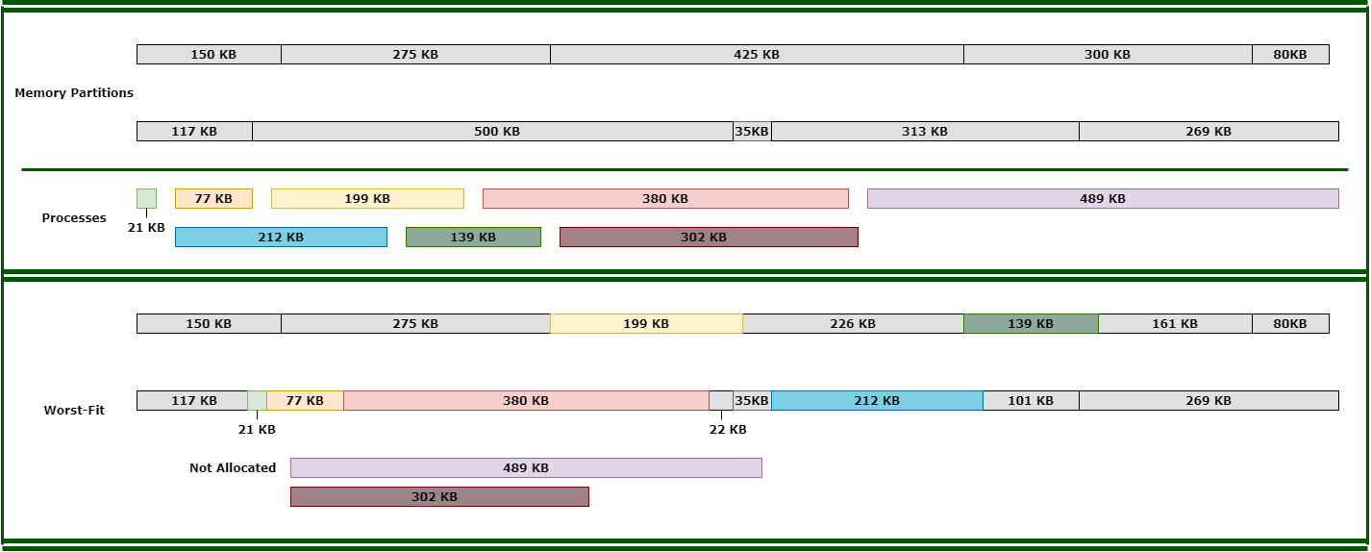

**References**

Silberschatz, A., Galvin, P. B., & Gagne, G. (2014). [Operating system concepts essentials](https://ashford.instructure.com/courses/66667/modules/items/3374055)(2nd ed.). Retrieved from https://redshelf.com/