Scheduling Models

Shaun Hoadley

CPT304: Operating Systems Theory and Design

Joshua Reichard

June 28, 2020

With the First-Come-First-Served (FCFS) scheduling algorithm, the first program to request access is the first to receive access to the drive I/O. FCFS is the simplest scheduling model and managed by a First-In-First-Out (FIFO) queue. With the drive head starting at cylinder 51, and an I/O request queue for cylinders 72, 56, 103, 111, 17, 189, 236, 198, and 88, has a total head movement of 569 cylinders ((C51 C72 = 21) + (C72 C56 = 16) + (C56 C103 = 63) + (C103 C111 = 8) + (C111 C17 = 94) + (C17 C189 = 172) + (C189 C236 = 47) + (C236 C198 = 38) + (C198 C88 = 110) = 569).

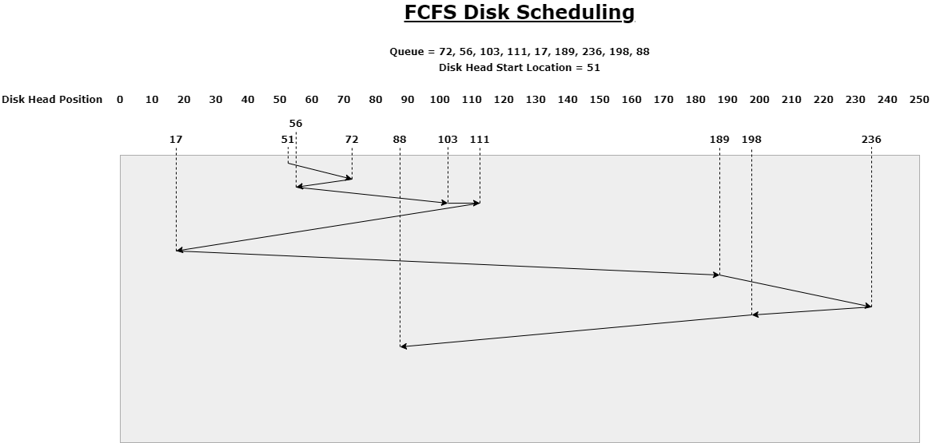

The Shortest-Seek-Time-First (SSTF) disk scheduling algorithm pulls the I/O requests from the queue based on which job has the shortest seek time from its current position. Using the same starting position and queue from the FCFS example, the SSTF algorithm yields a total head movement of 404 cylinders ((C51 C56 = 5) + (C56 C72 = 16) + (C72 C88 = 16) + (C88 C103 = 15) + (C103 C111 = 8) + (C111 C189 = 78) + (C189 C198 = 9) + (C198 C236 = 38) + (C236 C17 = 219) = 404). The difference in seek time from FCFS to SSTF is 165 cylinders.

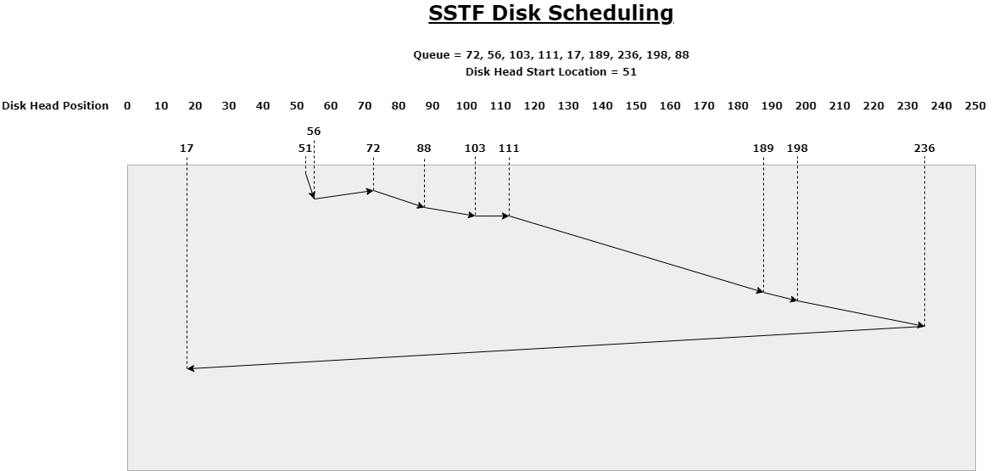

Lastly, we have the SCAN disk scheduling algorithm. With the SCAN algorithm, the drive head moves from its starting position in one direction, either inside or out, fulfilling the I/O requests in the order it comes across them in that direction. When the head reaches the end of the direction, it was traveling, reverses direction, and fills the remaining I/O requests as it reaches them in that direction. Again, using the same queue from the previous two examples, the drive head starts from cylinder 51. Since we also need to know which direction it is moving from the starting cylinder, we will assume it was moving toward cylinder 0. Beginning at cylinder 51, the head moves to 17 then to 0. Having reached 0, the head changes direction and moves to cylinder 56, progressing toward cylinder 299, processing each request as it reaches them. When the drive head gets to the end of the queue, the total number of cylinders it traveled was 287 ((C51 C17 = 34) + (C17 C0 = 17) + (C0 C56 = 56) + (C56 C72 = 16) + (C72 C88 = 16) + (C88 C103 = 15) + (C103 C111 = 8) + (C111 C189 = 78) + (C189 C198 = 9) + (C198 C236 = 38) = 287). Using the SCAN algorithm, it moved 117 fewer cylinders than with SSTF, and 282 fewer cylinders than with the FCFS algorithm. If more I/O requests are added to the queue ahead of the drive head in the direction it is moving, they will be processed as soon as the head reaches them. If the new I/O requests are at cylinders behind the drive head, they will not be processed until the head reaches the end of the current direction of travel and reverses; at which time, the new requests are processed as the head progresses back that direction.

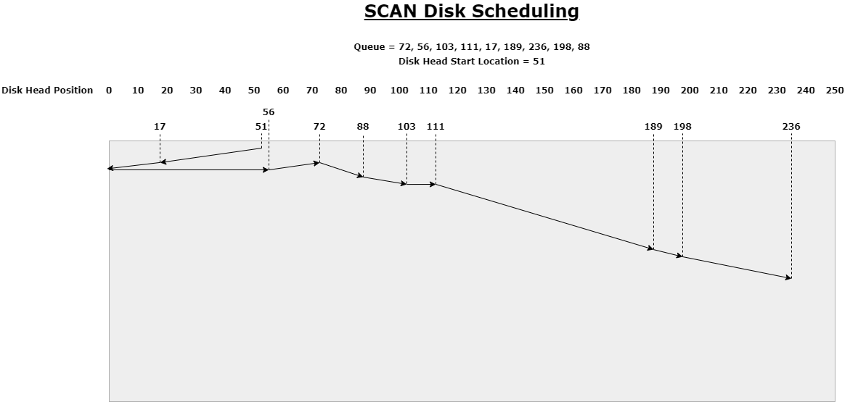

The general descriptions of each of these algorithms used in this paper are based on my understanding of chapter 9.4 in *Operating System Concepts Essentials* (2nd ed.) written by Silberschatz, Galvin, and Gagne (2014).

**References**

Silberschatz, A., Galvin, P. B., & Gagne, G. (2014). [Operating system concepts essentials](https://ashford.instructure.com/courses/66667/modules/items/3374055)(2nd ed.). Retrieved from https://redshelf.com/