Week One Assignment: Calculate Pay Program

Shaun Hoadley

CPT-307 Data Structures and Algorithms

Dr. Pete Limon

July 11, 2020

I had used initially println() to output the results; however, the results of the calculations had far more decimal places than I needed. I, therefore, had to find out how to round the values to two decimal places. I found a YouTube video from [KelliKOnline](https://www.youtube.com/channel/UCjlUtPi1th2rBHcwFM6nEeg) on [formatting decimals in java](https://www.youtube.com/watch?v=G7IbADolOl4) (2017). In her video, she describes how to format decimals using either the Decimal Class or the printf() method. I elected to use the printf() method to perform the rounding and to output the results in a formatted display. I wanted the three employee records to display side-by-side with the fields listed in the first column in a report style. The main method of the program first instantiates three objects of the Payroll class. Each instance initializes with the arguments to be used for that employee and inherits the methods to calculate the gross pay, total amount of deductions, and the net pay for that employee from the Payroll class. Finally, using a combination of println() and printf() functions from java’s System class to format the output display (manually), using the results encapsulated in each object. Hence, they line up in rows and columns of equal size. See the figures below for the results from compiling and executing the program.

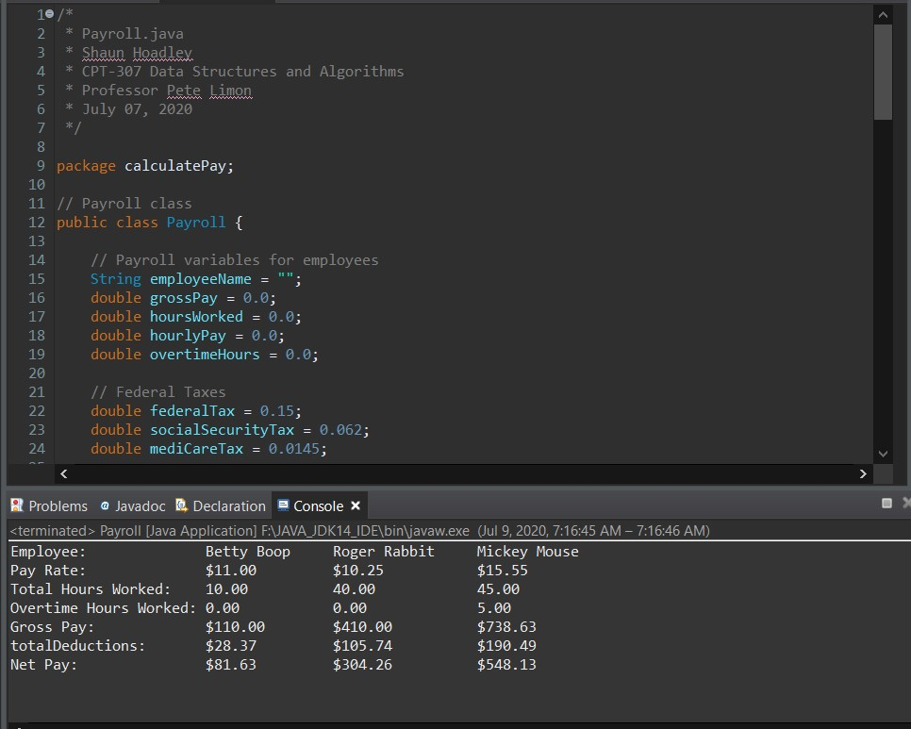

**Figure 1: Payroll.java compiled and executed in Eclipse**

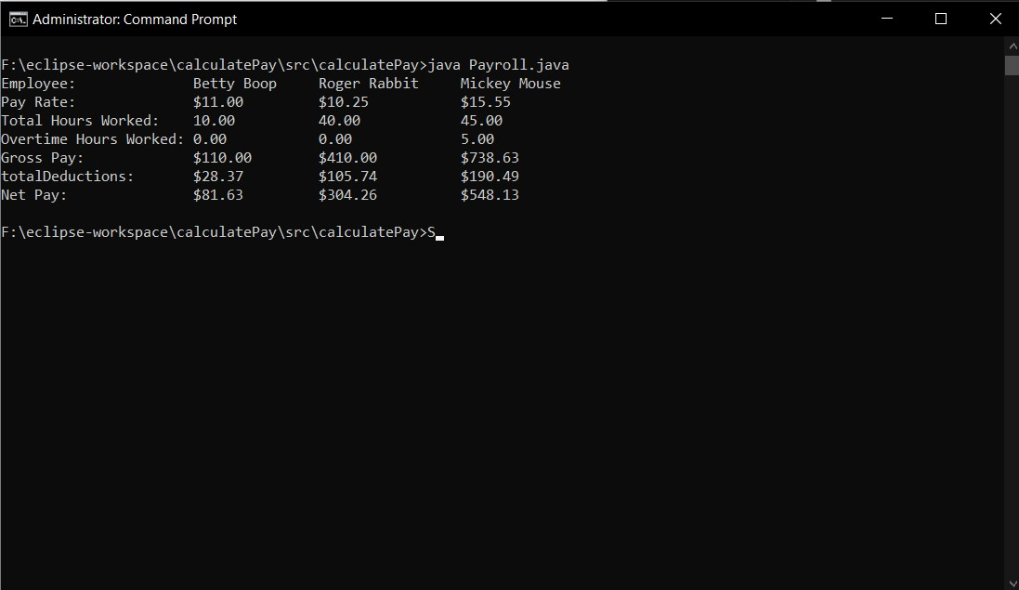

**Figure 2: Payroll.java compiled and executed in the Windows 10 command prompt**

**References:**

KelliKOnline. (2017, January 17). *Formatting Decimals in Java.* [video]. YouTube. <https://www.youtube.com/watch?v=G7IbADolOl4>