Week Two Assignment: Binary Search Program

Shaun Hoadley

CPT-307 Data Structures and Algorithms

Dr. Pete Limon

July 17, 2020

In this week’s assignment, the objective was to program a binary search of a sorted array of integers. As the list is already sorted, it was not necessary to include a sorting algorithm in the program. For the search algorithm, I used a while loop containing some IF/ELSE statements to do a divide and conquer search. For each iteration of the loop, it determines the length of the array and finds the midpoint element. If it determines the value in the midpoint element is greater than the value being searched for, it moves the pointer for the first array element to the next element after the midpoint and goes back to the start of the loop. If the value is equal to that being searched, it notifies the user that it has matched and breaks out of the loop. If the value is less than that of the midpoint, it changes the pointer for the last array element to the element before the midpoint and returns to the start of the loop again. The loop continues to execute until it finds a match or runs out of elements, in which it displays to the user it could not find the value being searched for.

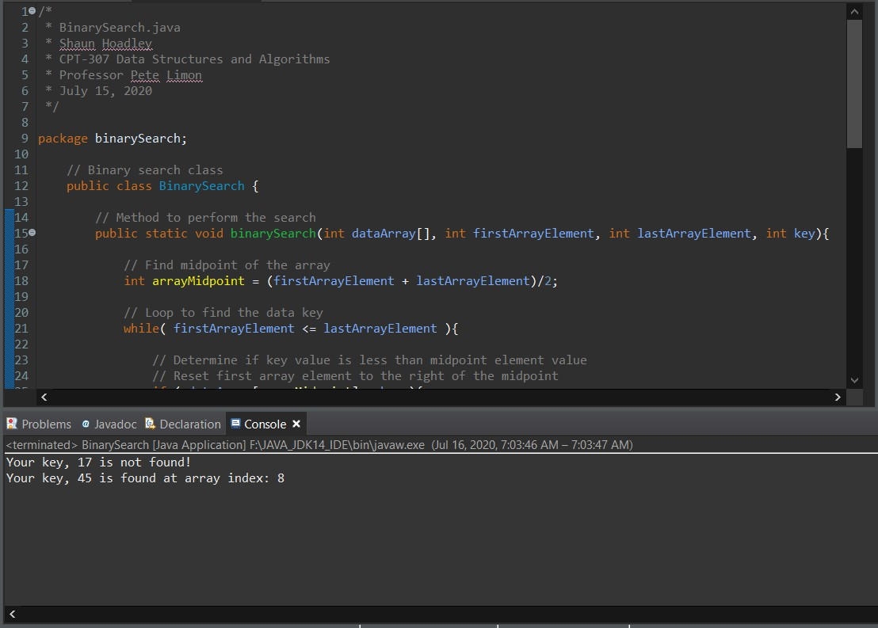

**Figure 1: Screenshot of Binary Search Program in Eclipse Console**

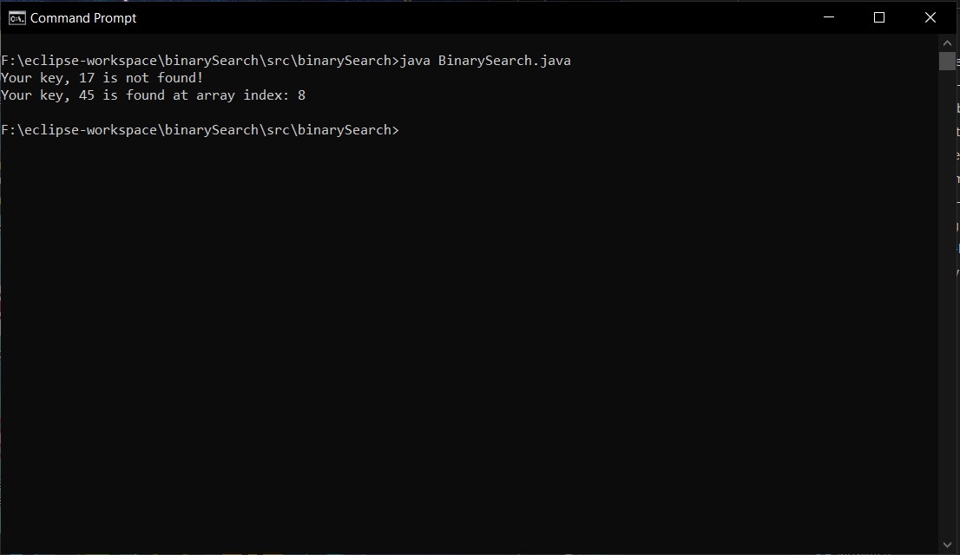

**Figure 2: Screenshot of Binary Search Program in Command Prompt**