Week Three Assignment: Sorted List Program

Shaun Hoadley

CPT-307 Data Structures and Algorithms

Dr. Pete Limon

July 26, 2020

For this week, we were supposed to write a Java program that utilizes a linked list to insert and remove items. Admittedly, I went a bit overboard on this assignment. If I were doing this for an actual job, I would have strictly adhered to the requirements. As we are learning here though, I took it a bit further to learn a bit more. One way I accomplished this was by adding a sleep (time delay) function to make the output a bit more fluid. I used the Thread.sleep() method I found in the Java Tutorials (Oracle, 2015). Additionally, rather than add each item of the original list of some of my favorite games individually, I used the Arrays.asList() method to populate the linked list all at once. I chose to scramble the order of the initial list as well, because I wanted to experiment with sorting the linked list rather than just entering the data in order from the start. So, after making and sorting my linked list, I used the add() method to add another game to the head of the list, sent it to the display, resorted it, and sent it to the display again. Next, I used the remove() method to pull one of the other games from the list. Finally, I sent the final sorted linked list to the display.

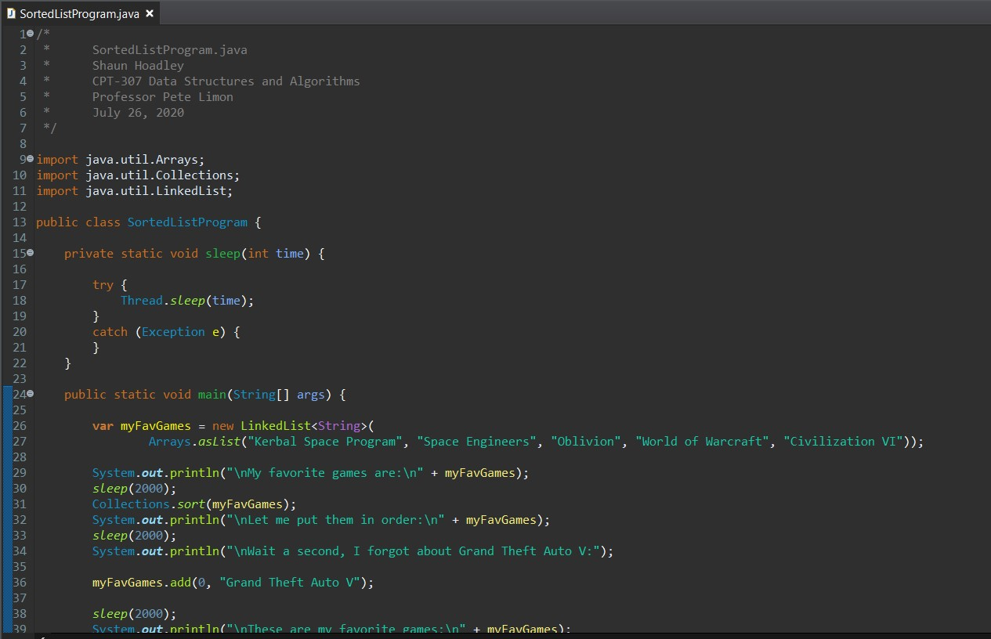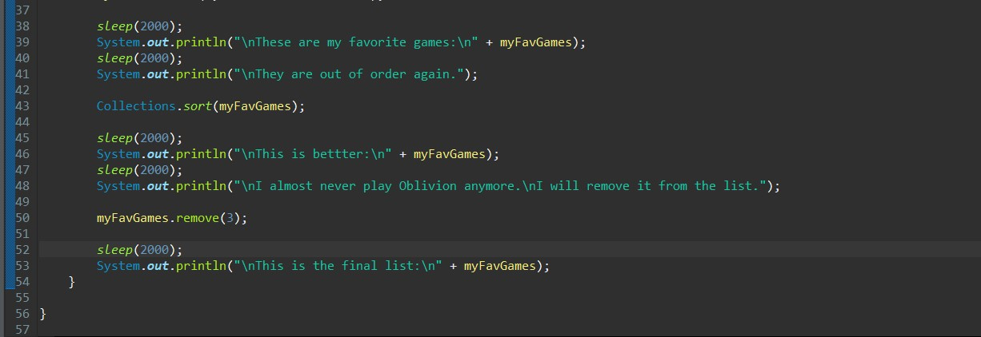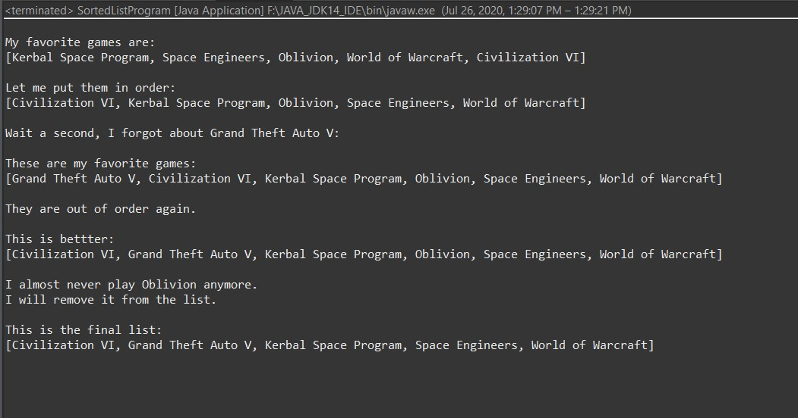

**References**

Oracle. (2015). *Pausing Execution with Sleep.* The Java tutorials. <https://docs.oracle.com/javase/tutorial/essential/concurrency/sleep.html>