For the week four interactive assignment, the two recursive problems from the Recursion-1 webpage (Parlante, 2016) I elected to tackle are the Fibonacci sequence and the power of N. To do a recursive algorithm, according to Shaffer, requires having two parts. You must have a **base case** and a **call to itself**, or recursive call. The base case is the part of the algorithm that solves a simple input without the recursive call. The recursive call is simply a call to itself (2013, ch.2, section 2.5).

First is the Fibonacci sequence. Most people have heard of the Fibonacci sequence from somewhere, even if only in a movie (Da Vinci Code and 21 both come to mind for me). What is the Fibonacci sequence, though? It is a series of numbers, starting with zero and one, where each of the next numbers in the sequence equals the sum of the previous two numbers.

0, 1, 1, 2, 3, 5, 8, 13, 21, …

0, 1, 0+1=1, 1+1=2, 1+2=3, 2+3=5, 3+5=8, 5+8=13, 8+13=21, …

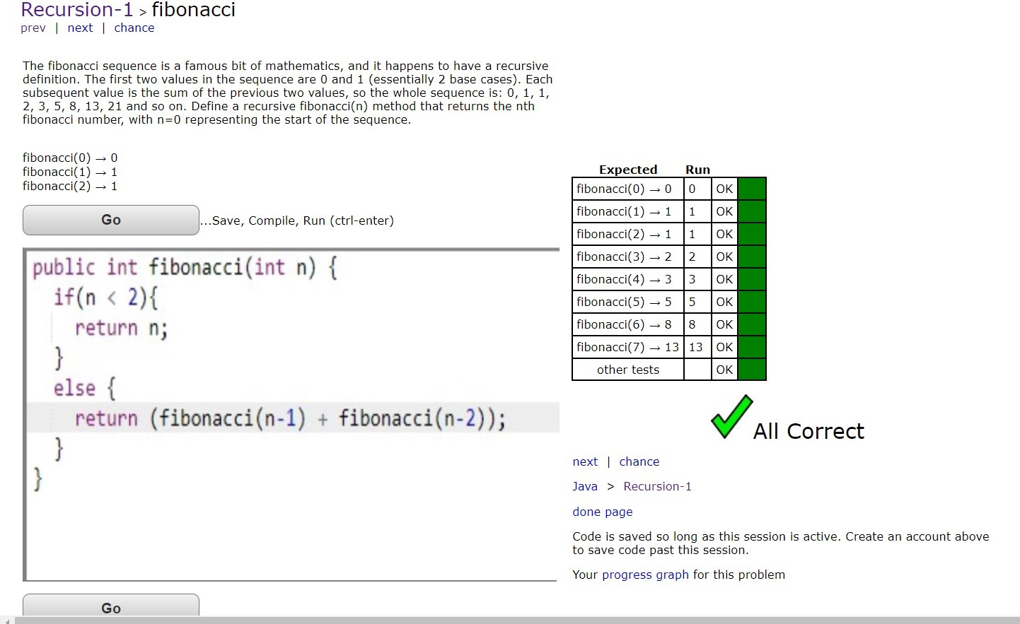

The second problem I chose is to solve for the value of a given base to the Nth power, or basen. A few examples being 22 = 4, 54 = 625, and 34 = 81.

22 = 2*2 = 4, 54 = 5*5*5*5 = 625, 34 = 3*3*3*3 = 81

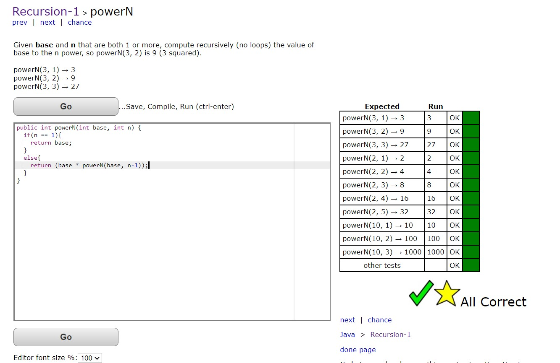

**References**

Parlante, N. (2016). Recursion-1. Retrieved from http://codingbat.com/java/Recursion-1

Shaffer, C. A. (2013). [*Data structures and algorithm analysis*](http://people.cs.vt.edu/~shaffer/Book/JAVA3elatest.pdf) (Edition 3.2). Retrieved from http://people.cs.vt.edu/~shaffer/Book/JAVA3elatest.pdf