Like a stack, a queue is an abstract data type (ADT). In a stack, as we recall, all items went in and came out of the same end with the last item in being the first item out (LIFO). Unlike the stack, items enter the queue in one end and come out of the other in the same order with the first item in being the first item out (FIFO) (Lysecky et al., 2015, section 2.14). Another difference between stacks and queues, rather than pushing or poping an item, you add or poll items to a queue.

Usually, I would write this code using a loop for emptying the queue. The reason I did not this time was so I could use both the remove() and poll() methods, as well as both the peek() and element() methods. The only difference between remove() and poll() is poll will return null if the queue is empty and remove() will throw an error code. The same goes with peek() and element(), where peek() returns null, and element() will throw an error code.

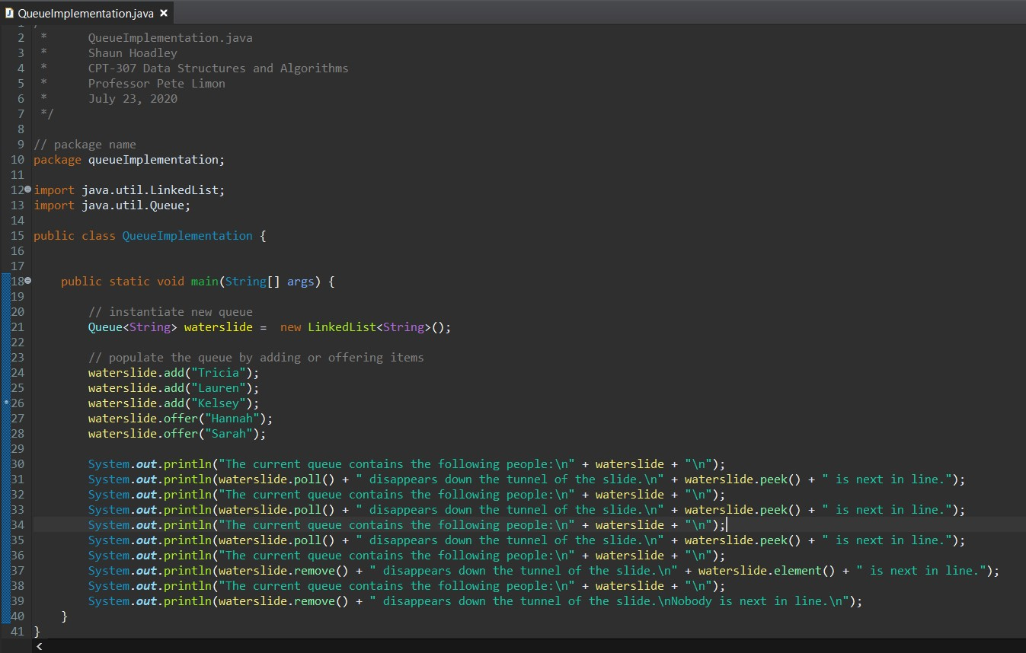

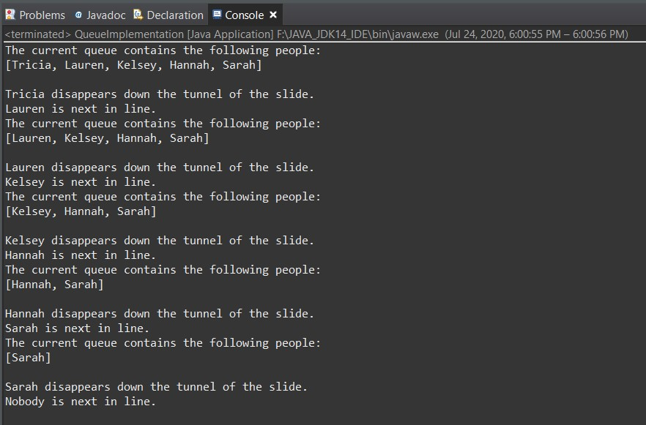

**References**

Lysecky, R., Vahid, F., Lysecky, S., & Givargis, T. (2015). [Data structures essentials](https://ashford.instructure.com/courses/68707/modules/items/3478669). Retrieved from https://zybooks.zyante.com/#/zybook/ DataStructuresEssentialsR25/chapter/1/section/3