Week 2 Assignment: Online Food Ordering Database – Task 2

Shaun Hoadley

CPT310 Database Systems and Management

Augustine Ohwobete

November 9, 2020

**Chen Diagram**

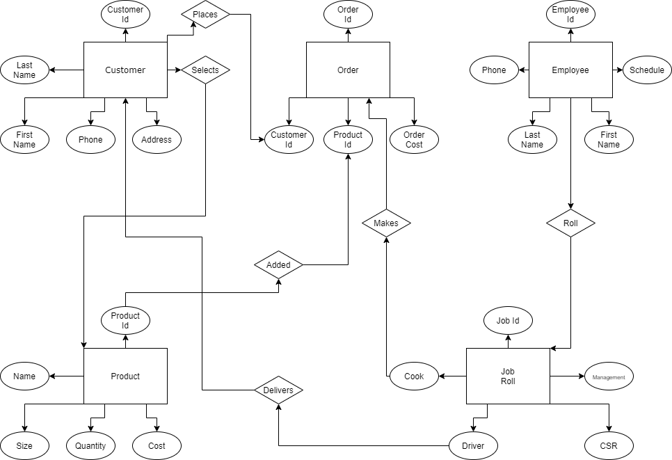

**Stakeholders and Attributes**

Customer (c_id, c_lastName, c_firstName, c_phone, c_address)

Order (o_id, c_id, p_id, o_cost)

Product (p_id, p_name, p_size, p_quantity, p_cost)

Employee (e_id, e_firstName, e_lastName, e_phone, e_schedule)

Job Role (j_id, j_management, j_CSR, j_cook, j_driver)

**Table: Customer**

|  |  |  |  |  |  |
| --- | --- | --- | --- | --- | --- |
| Field | Type | Null | Key | Default | Length |
| Id | int | No | Pri |  | 7 |
| Last Name | Varchar | No |  |  | 255 |
| First Name | Varchar | No |  |  | 255 |
| Phone | Varchar | No |  |  | 255 |
| Address | Varchar | No |  |  | 255 |

**Table: Order**

|  |  |  |  |  |  |
| --- | --- | --- | --- | --- | --- |
| Field | Type | Null | Key | Default | Length |
| Id | Int | No | Pri |  | 255 |
| Customer | Int | No | Foreign |  | 255 |
| Product | Int | No | Foreign |  | 255 |
| Cost | Varchar | No |  |  | 255 |

**Table: Product**

|  |  |  |  |  |  |
| --- | --- | --- | --- | --- | --- |
| Field | Type | Null | Key | Default | Length |
| Id | Int | No | Pri |  | 255 |
| Name | Varchar | No |  |  | 255 |
| Size | Varchar | No |  |  | 255 |
| Quantity | Varchar | No |  |  | 255 |
| Cost | Varchar | No |  |  | 255 |

**Table: Employee**

|  |  |  |  |  |  |
| --- | --- | --- | --- | --- | --- |
| Field | Type | Null | Key | Default | Length |
| Id | Int | No | Pri |  | 255 |
| Last Name | Varchar | No |  |  | 255 |
| First Name | Varchar | No |  |  | 255 |
| Phone | Varchar | No |  |  | 255 |
| Schedule | Varchar | No |  |  | 255 |

**Table: Job Roll**

|  |  |  |  |  |  |
| --- | --- | --- | --- | --- | --- |
| Field | Type | Null | Key | Default | Length |
| Id | Int | No | Pri |  | 255 |
| Management | Varchar | No |  |  | 255 |
| CSR | Varchar | No |  |  | 255 |
| Cook | Varchar | No |  |  | 255 |
| Driver | Varchar | No |  |  | 255 |

According to Coronel and Morris, Peter Chen introduced the entity-relationship model in 1976 (2019, ch.2, p. 44). The Chen model is used for conceptualizing the relationships between tables in relational databases. The most significant advantage of the Chen model is that you can see how the various entities interact with one another. The most significant disadvantage of the Chen model is that it takes a considerable amount of space.

**References**

Coronel, C., & Morris, S. (2019). *Database systems: Design, implementation, and management* (13th ed.). Retrieved from <https://www.vitalsource.com>