For this week's interactive assignment, I have the following Chen Entity Relationship Diagram (ERD).

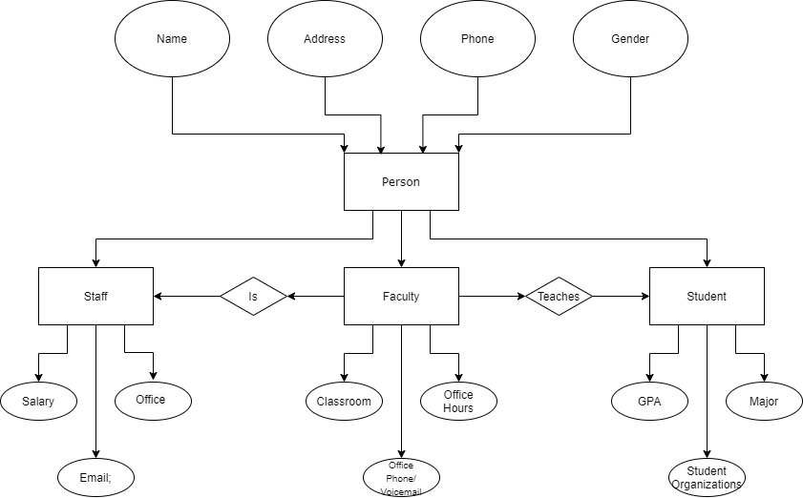

With the Chen ERD, we can see how relationships between the entities and their super and subclasses, along with some attributes associated with them.  All students, faculty, and staff are people, but not all people are students, staff, or faculty.  All faculty are staff, but not all staff are faculty.  The faculty teach the students.