Week 5 Interactive Assignment

Shaun Hoadley

CPT310: Database Systems & Management

Austine Ohwobete

November 25, 2020

The first task for this week’s interactive assignment was to create a new table called tbl_employee_audit. Tbl_employee_audit contains two fields, id and audit data.

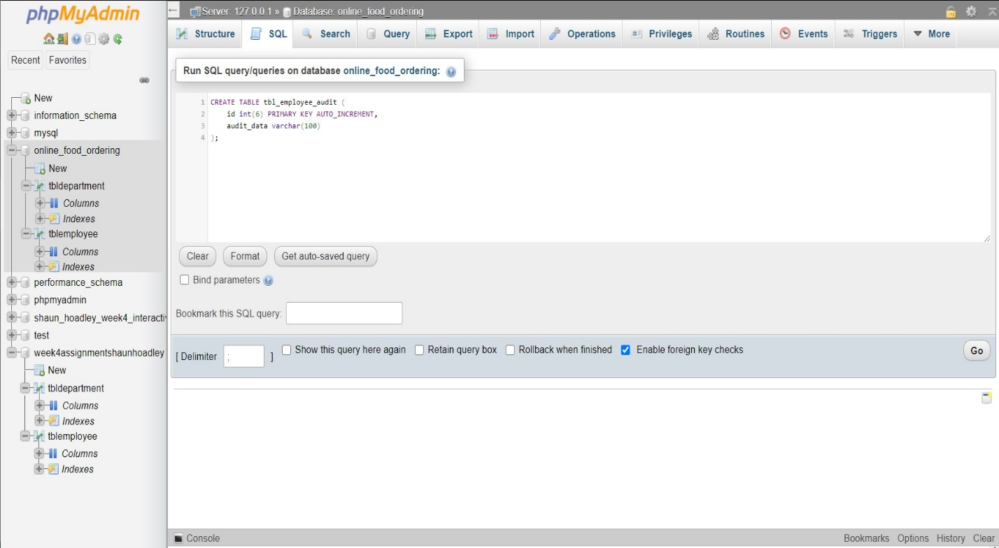

Next, I had to create two triggers. The first trigger adds audit information to the tbl_employee_audit table whenever a new row (new employee) is added to the tblemployee table. The second trigger adds audit information to the tbl_employee_audit table whenever a row is deleted (employee is removed) from the tblemployee table.

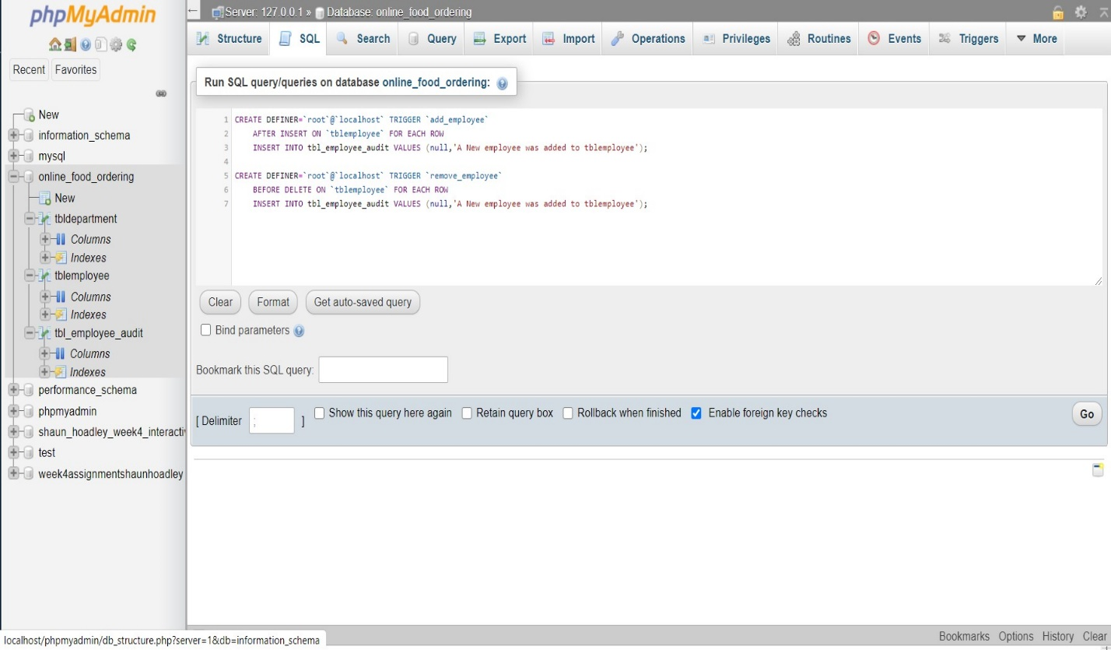

Here is the new entity relationship diagram from last week with the new table.

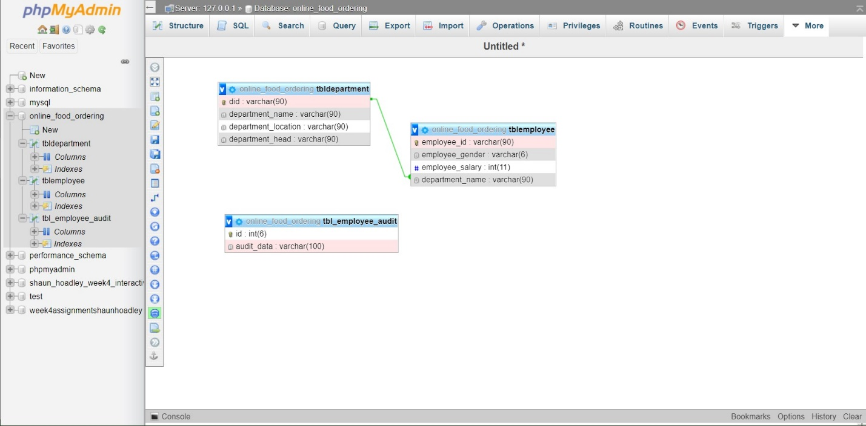

The next thing I did was query the tblemployee and tbl_employee_audit tables to show the current state of each before adding or deleting records. There are five employee records in the first query and the second returns an empty result-set.

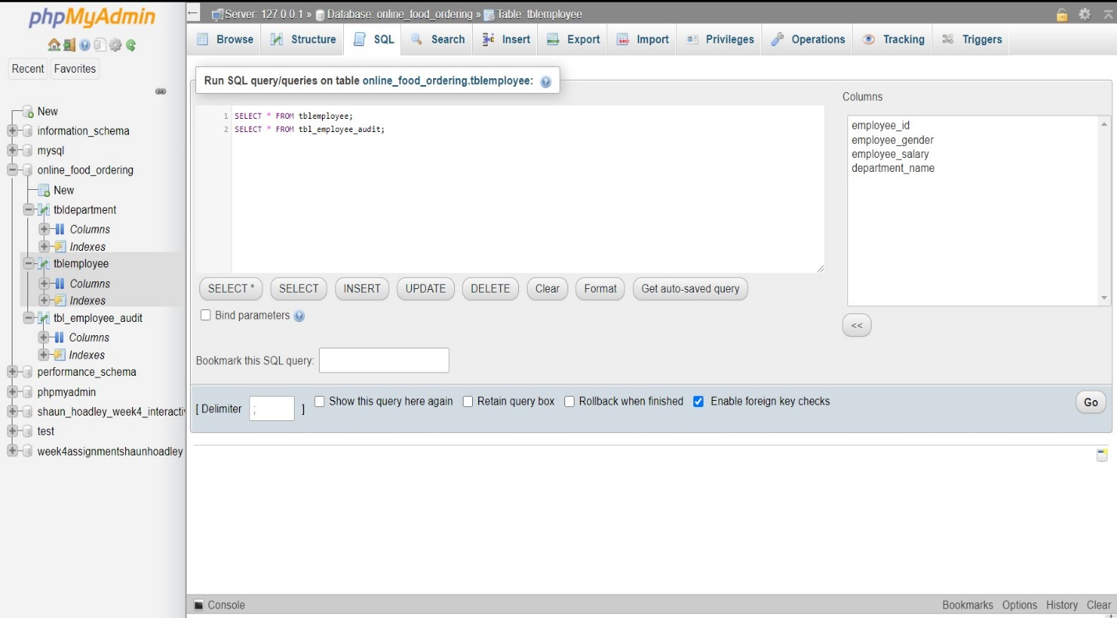

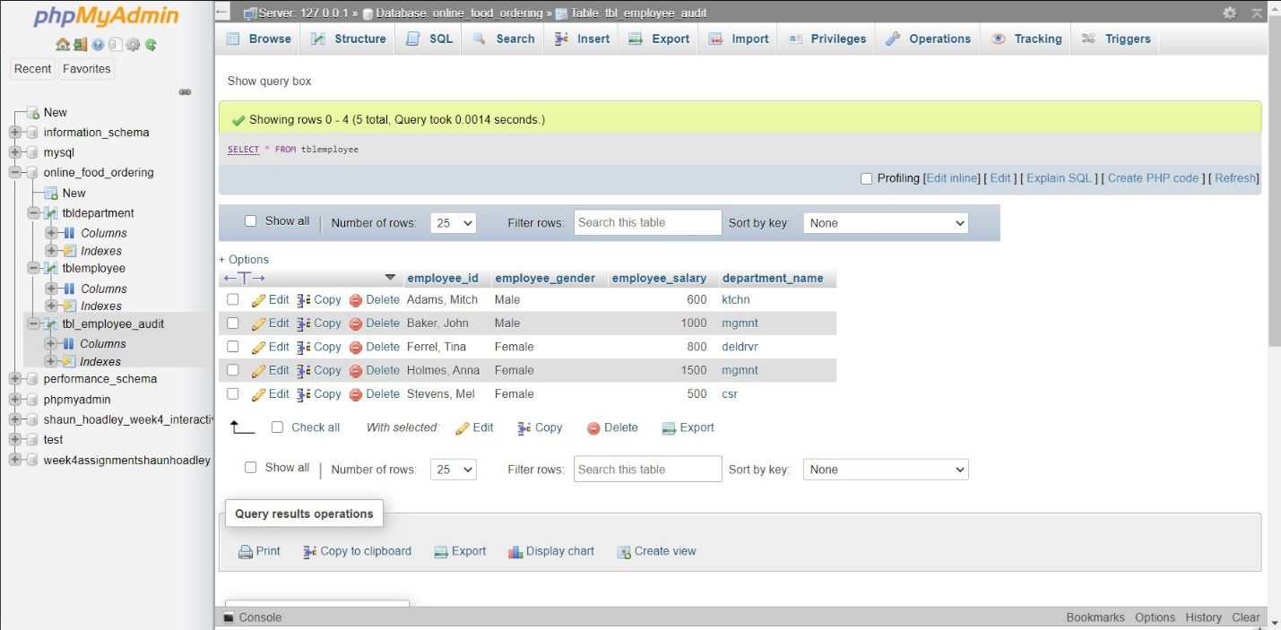

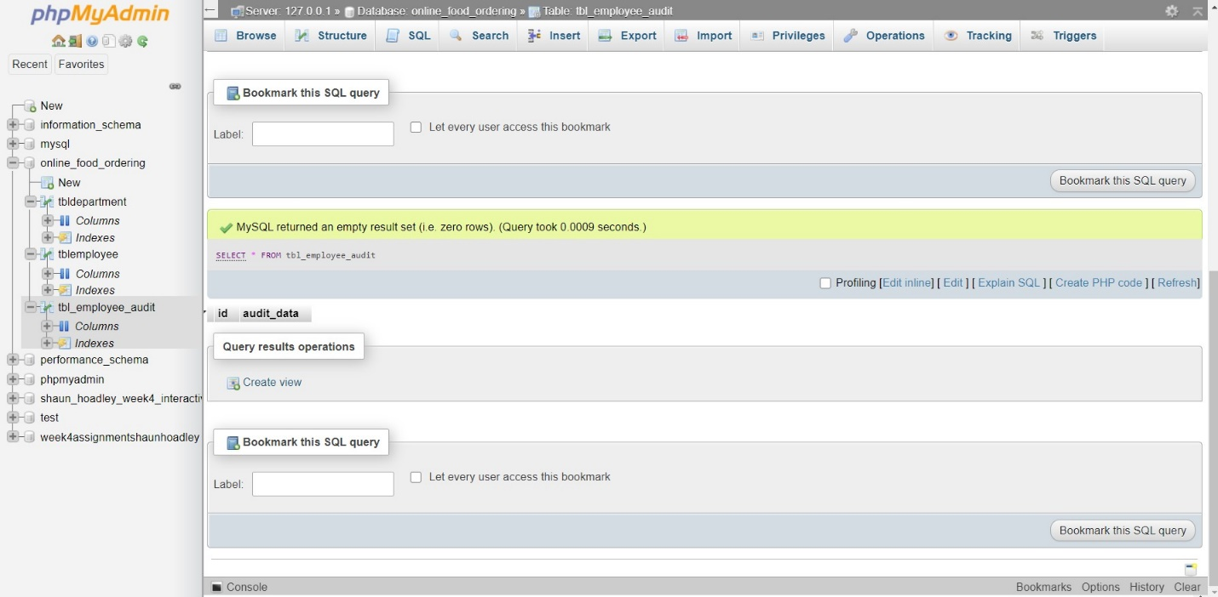

After those initial queries, I added an employee and removed an employee from the tblemployee table, followed by a new query of each of the two tables again.

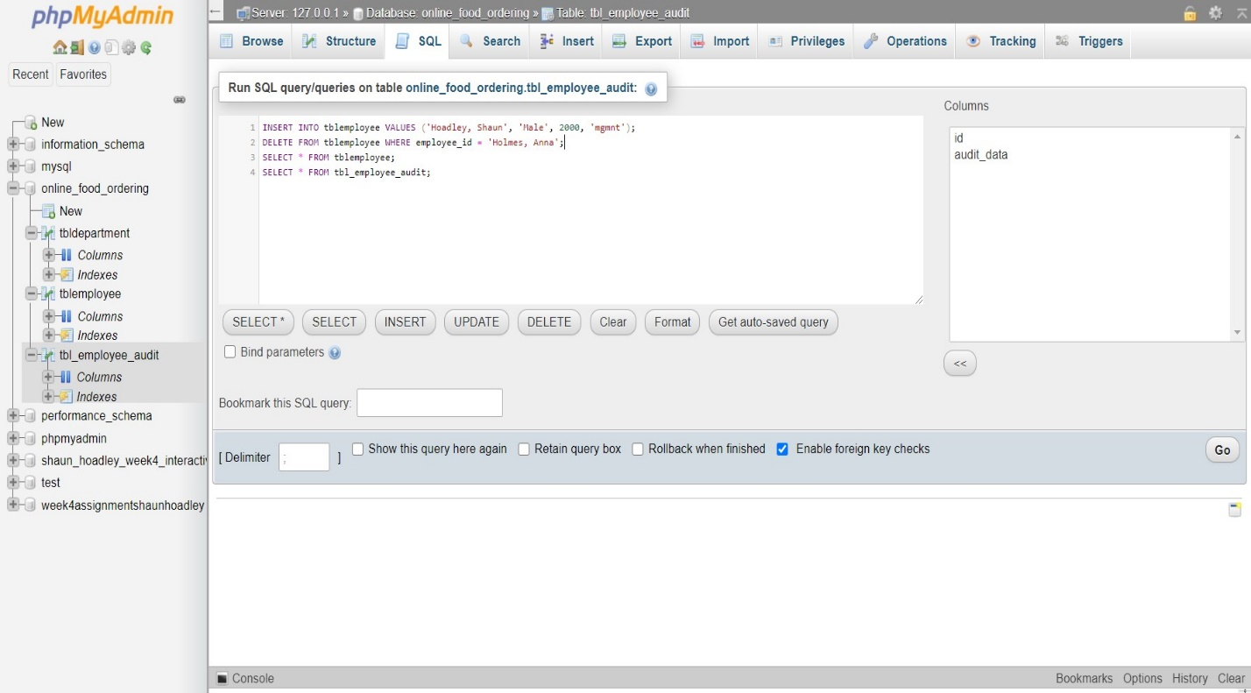

As seen below, employee Anna Holmes was removed and Shaun Hoadley was added to the tblemployee table. Additionally, both triggers activated placing audit data into the tbl_employee_audit table.

