Week 3 Assignment—E-Commerce Website Testing Strategies

Shaun Hoadley

CST313: Software Testing

Michael Hayden

06/21/2021

**Overview of Review Stategies**

**Walkthroughs**

First, here is an overview of each of the review strategies, walkthrough, inspection, technical review, and informal review. The walkthrough, according to Spillner, Linz, and Schaefer, is an informal review strategy used for finding “defects, ambiguities, and problems in written documents” (2014). The goal of a walkthrough is to educate the audience about the project and is generally lead by the author of the documents. “The main objectives of a walkthrough are mutual learning, development of an understanding of the review object, and error detection.” (Spillner, Liz, & Shaefer, 2014). There is usually no time limit in the meeting, little preparation is required, and questions from the audience is spontaneous.

**Inspections**

Inspections are a formal review with rules, protocols, checklists, and clearly defined roles for the audience (Spillner, Liz, & Shaefer, 2014). In planning an inspection, the primary focus is defining the objectives of the meeting. Facilitating the meeting is a moderator who is tasked with following a clear agenda and keeping the meeting moving smoothly and on point. Spillner, Linz, and Schaefer state the goals of an inspection as “finding unclear items and possible defects, measuring review object quality, and improving the quality of the inspection process and the development process” (2014). Below is a sample checklist template for an inspection (Fox, 1999).

**Technical Reviews**

For technical reviews, the author is not usually present and a recorder is present to take notes and consolidate feedback from the reviewers. The recorder also generates the final results of the meeting. The goal for technical reviews is ensure that the test objects meet the specifications of the project (Spillner, Liz, & Shaefer, 2014). Prior to the meeting, the reviewers do considerable preparation going over the test objects and organize their feedback concerning it. The reviewers should have a certain level of technical expertise with the parts they are reviewing in order to have a successful meeting. During the meeting, discussions take place about the feedback the reviewers prepared, proposals for alternatives, and errors and defects. Below are some templates from Carnegie Melon for technical reviews (1991).

**Informal Reviews**

Informal reviews, as described by Spillner, Linz, and Shaefer, are less formal technical reviews initiated by the author. The author selects the reviewers and gives them the time to present their feedback (2014). Because no real meeting is scheduled, there are no templates involved and results are not generally recorded. As these reviews mostly involve sending messages amongst the reviewers, little effort is required and costs are low.

**Recommended Review Strategies**

As for the E-commerce website, all of review strategies are recommended except inspections. While inspections would be beneficial, they require significant amounts of time, coordination, and expertise. The other three review types should provide sufficient methods for verifying requirements, readability, maintainability, locating defects, and improving code quality at a reduced cost of time and money.

**Static Testing Strategies**

**Tools**

For the E-commerce project static testing, the tools that will be needed are an IDE or text editor, a compiler, and a linter. According to Spillner et al., these tools help developers and testers check interface consistency, identify syntax errors, locate dead code, cross-reference program elements, detect undeclared variables, and check data types (2014). Additionally, these tools will aid in debugging and help ensure the code is readable and consistent.

**Conventions and Standards**

"Compliance to conventions and standards can also be checked with tools. For example, tools can be used to check if a program follows programming regulations and standards." (Spillner, Linz, & Shaefer, 2014). There are tools within IDEs and linters that should be used for implementing rules that enforce proper conventions and standards for coding. Additionally, there are style guides available for the various programming languages like the Google Java Style Guide (Google, n.d.).

**Dataflow Analysis**

The purpose of dataflow analysis on the E-commerce site is to reveal defects in the code. This type of analysis, according to Spillner et al, "checks the usage of every single variable", including variables that are defined, referenced, or undefined (2014). Dataflow analysis is also used for revealing dataflow anomalies. Spillner et al states “An anomaly is an inconsistency that can lead to failure but does not necessarily do so. An anomaly may be flagged as a risk” (2014).

**Control Flow Analysis**

Control flow analysis is also used to locate defects by using graphs to analyize program execution represented from a sequence of statements. Control flow diagrams are used for visualizing changes in the execution of the program caused in the logic of conditionals and loops. “Due to the clarity of the control flow graph, the sequences through the program can easily be understood and possible anomalies can be detected.” (Spillner et al, 2014). While anomalies may not cause a program failure, addressing them helps ensure compliance and standards are maintained. Following are some example diagrams from GeeksForGeeks (n.d.).

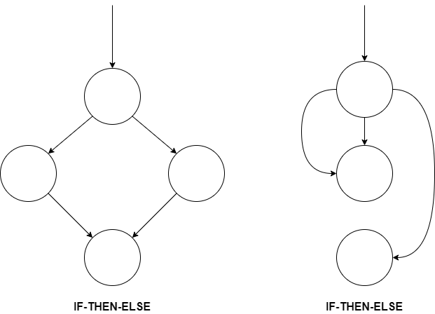

**Dynamic Testing Strategies**

**Blackbox Testing**

Aimed at verifying test objects, blackbox testing includes a group of techniques that ensures the test objects meet the specifications and that specified inputs result in expected outputs. Using blackbox testing techniques on the E-commerce site is crucial because, as stated by Spillner et al, the goal of these strategies is “the verification of the functionality of the test object. It is indisputable that the highest priority is that the software work correctly. Thus, black box techniques should always be applied.” (2014). For the E-commerce site, the following blackbox techniques should be used, equivalence class partitioning, boundary value analysis, state transition testing, and use-case-based testing.

**Whitebox Testing**

Whitebox testing techniques will be used for the E-commerce site because they are aimed at testing the source code directly. These testing techniques are used to evaluate branching logic, conditionals, and loops. The whitebox testing techniques that should be utilized are statement testing, decision/branch testing, and the testing of conditions.

**Experience-Based Testing**

Experience-based (or intuitive-based) testing should be used in conjunction with whitebox and blackbox testing techniques. These tests take advantage of the experience and skill of developers and testers to generate tests that might have been overlooked in the systematic testing.

**References**

Carnegie Mellon Software Engineering Institute. (1991). The Software Technical Review Process. Retrieved April 18, 2020 from https://apps.dtic.mil/dtic/tr/fulltext/u2/a236122.pdf

Fox, C. (1999). Java Inspection Checklist. Retrieved April 18, 2020 from <http://www.cs.toronto.edu/~sme/CSC444F/handouts/java_checklist.pdf>

GeeksForGeeks.com. (n.d.). Software Engineering: Control Flow Graph (CFG). Retrieved April 18, 2020 from https://www.geeksforgeeks.org/software-engineering-control-flow-graph-cfg/

Google. (n.d.). Google Java Style Guide. Retrieved April 18, 2020 from https://google.github.io/styleguide/javaguide.html

Spillner, A., Linz, T., & Schaefer, H. (2014). [*Software testing foundations: A study guide for the certified tester exam* (4th ed.)](https://ashford.instructure.com/courses/86077/modules/items/4350686). Rocky Nook.