Week 3 Interactive Assignment: Concept Map and Security of a Service

Shaun Hoadley

CYB 300: System Administration and Security

Carl Marquez

September 9, 2021

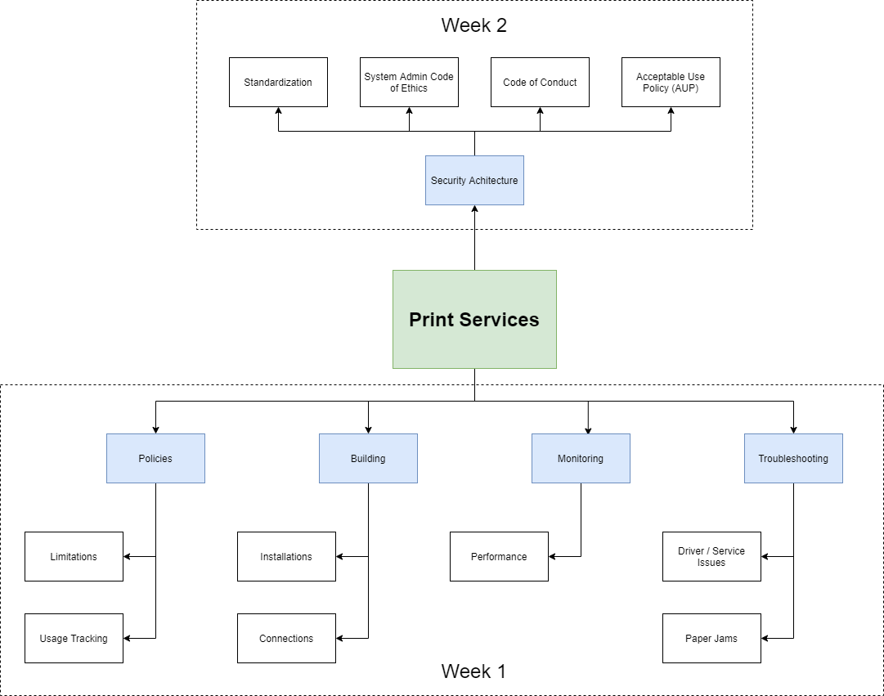

**Week2**

**Security Architecture**

**As discussed in week one, as part of the Policies, usage tracking software is also a part of the security architecture. This section will focus on the new security architecture features added to the concept map: privacy policy and hardware issues.**

* **Standardizations**

**Standardization of equipment is important for the company. While access to equipment is limited, the system administrators need to maintain the standardization protocols when installing or replacing printers or other equipment.**

**Any software downloaded and installed on equipment is strictly prohibited by anyone other than system administrators and management. The purpose of restricting software this way limits the risk of piracy (intentional or unintentional), incorrect (or inappropriate) software, and introducing malicious software.**

* **Acceptable Use Policy (AUP)**

**The acceptable use policy of the company must be read and signed by all employees upon being hired and whenever the policy is updated with changes. Having an AUP that is clearly stated and understood ensures (for the most part) that the risk to the company, employees, and clients is minimized for all services, including printing services.**

* **Code of Conduct**

**The company’s code of conduct discusses how one acts and presents themselves while representing the organization. The code of conduct is in place to protect the company and its employees from liabilities, as well as the proper protocols and procedures to follow when dealing with law enforcement. The code of conduct must be read and signed by all employees upon being hired and whenever the policy is updated with changes.**

* **System Administrator Code of Ethics**

**The system administrator code of ethics must be read and signed by everyone working in the technology services department, not just the system administrators. It covers the way the system administrators (and other IT members) conduct themselves day-to-day in a manner that promotes integrity and professionalism within the company and when dealing with clients.**

**Week 1**

**Policies**

The company has implemented policies to encourage best practices for its employees while managing printing costs.

* **Limitations**

Using printers for personal use is strictly prohibited and cause for disciplinary action without supervisor authorization.

When printing documents, black and white mode should be used unless color printing is absolutely necessary. If color printing is required, supervisor authorization must be first obtained.

When printing multiple pages, printing should be done in duplex or double-sided mode. If the print job requires more than ten sheets, it should be sent to the copy center and put on the company account after obtaining supervisor approval.

* **Usage Tracking**

The company uses printing monitoring software that keeps detailed logs of all print jobs. The software tracks which device initiates the job, the number of pages, and whether it uses black and white or color mode.

**Building**

The same equipment is used at all company locations for consistency and ease of support.

* **Installation**

All printers are installed using the installation manual and configured for use with the print monitoring software.

* **Connections**

Connection to the printers can be made through Bluetooth, wifi, or wired connection.

**Monitoring and Troubleshooting**

All printers can be monitored through the onboard display or remotely to prevent unnecessary interruptions.

* **Performance**

The status of the printers directly affects the performance of the printer. Through monitoring, toner level, paper level, and error messages may be viewed, and action is taken when necessary. All users will be responsible for replacing toner or paper, and instructions will be available to clear paper jams. Error messages not relating to those three items must be referred to the system administrators.

* **Drivers and Service**

System administrators will handle any driver or service issues.

* **Paper Jams**

Detailed instructions will be kept near the printer on how to clear a paper jam, along with replacing the toner and refilling the paper trays.

**References**

Limoncelli, T. A., Hogan, C. J., & Chalup, S. R. (2017). The practice of system and network administration: Vol. 1. DevOps and other best practices for enterprise IT (3rd ed.). Addison-Wesley.