Employee Portal – Task 1

Shaun Hoadley

CST 310: Software Development

Professor Joseph Issa

May 3, 2021

**Provide screenshots of the HTML5 layout you created for the employee portal website.**

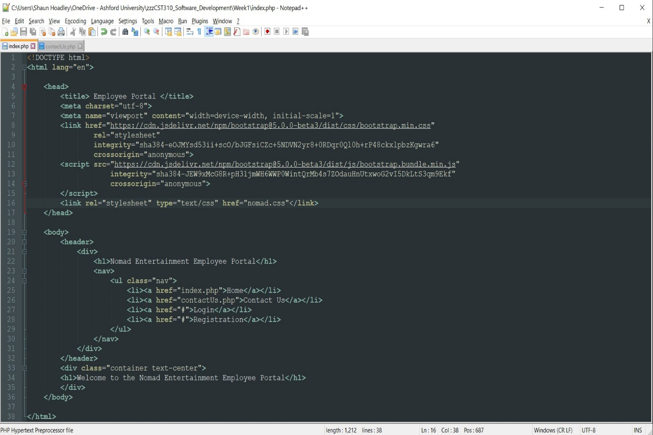

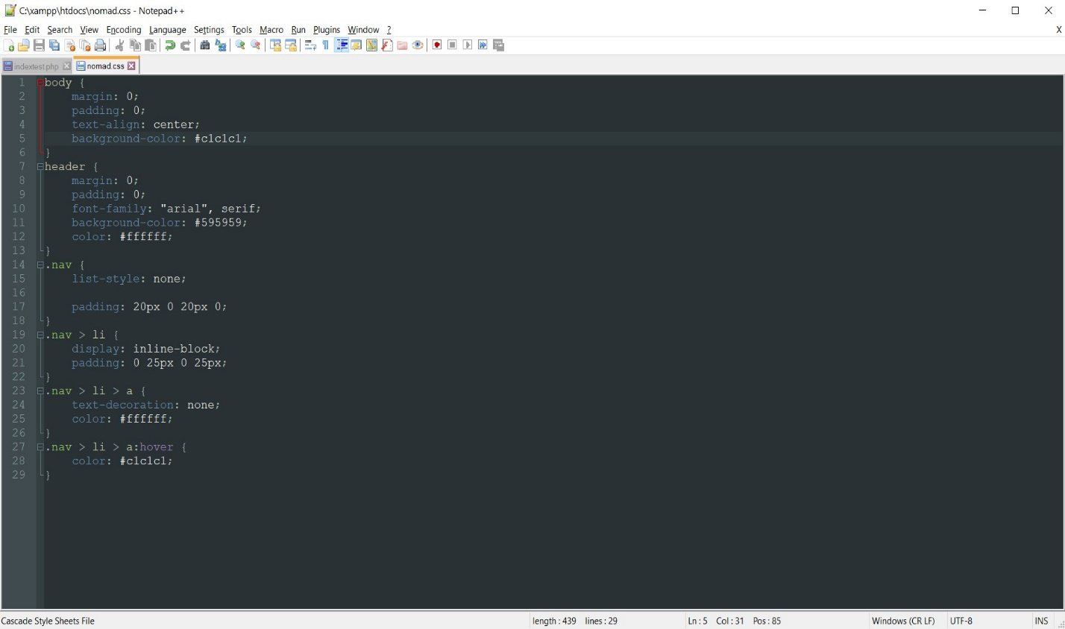

**Explain how to run a PHP file in XAMPP.**

This explanation assumes a successful installation of XAMPP using the blog post by Kasia Mikoluk. In order to run a PHP file, first, start the XAMPP control panel and be sure that Apache is running. I will have to look into setting a path for a specified folder for operating your pages, for now, they should be in the htdocs folder in the XAMPP installation folder. Open your browser of choice and enter localhost/(name of your PHP file) in the navigation bar. Your page should then be displayed in your browser.

**Explain the main use of the following HTML5 tags: head, title, meta, link, script, div, nav, h1, ul, ui.**

My explanations of the following HTML5 tags are primarily referenced from our textbook (Connolly & Hoar, 2018). I would also like to point out, I was unable to find anything on <ui> and believe that last tag listed should be li, though I could be wrong.

* **head** – the <head> tag (while optional in HTML5) is used to contain the descriptive elements of a web page.
* **title –** the <title> tag shows what will be displayed on the browser tab or for bookmarks and can be used by search engines in their search results.
* **meta –** the <meta> tag is used for metadata, such as defining the character set or a document-level name that applies to the whole page. E.g., “viewport” referencing the browser window.
* **link** – the purpose of the <link> tag is to provide a hyperlink that can be used to jump to another location, either within the webpage or external to it.
* **script –** the <script> tag tells the system to run a script from the location provided. E.g., incorporating Bootstrap into a website for its scaling functionality.
* **div** – the <div> tag is used to break related content into groups, essentially a container, to keep things ordered properly.
* **nav** – the <nav> tag works in the same way as the <div> tag but is generally reserved for the purpose of navigation. E.g., links to other pages of the website like Home, Contact Us, etc.
* **h1** – there are six levels of headings, <h1> is the tag for the first level of heading. Headings are used for accentuating particular areas to draw attention, such as the title of a blog post.
* **ul** – the <ul> tag is used for creating an unordered list of items. If not modified by CSS, the list is by default a bullet-point list.
* **li** – the tag <li> is used to place the individual items in a list, whether it be an unordered list (<ul>) or an ordered list (<ol>).

In summary, I feel I have a decent grasp of how to execute a PHP file in XAMPP, understand the purpose of many of the commonly used HTML tags, and have provided screenshots for my initial homepage layout.

**References**

Connolly, R., & Hoar, R. (2018). [Fundamentals of web development (2nd ed.)](https://ashford.instructure.com/courses/84200/modules/items/4256321). Retrieved from https://www.vitalsource.com

Mikoluk, K. (2013, September 18). [XAMPP tutorial: How to use XAMPP to run your own web server](https://blog.udemy.com/xampp-tutorial/) [Blog post]. Retrieved from <https://blog.udemy.com/xampp-tutorial>