Employee Portal – Task 2

Shaun Hoadley

CST 310: Software Development

Professor Joseph Issa

May 11, 2021

* **Provide a screenshot of the registration page layout.**

Below are the screenshots of the registration page, navigation bar page, and my CSS file.

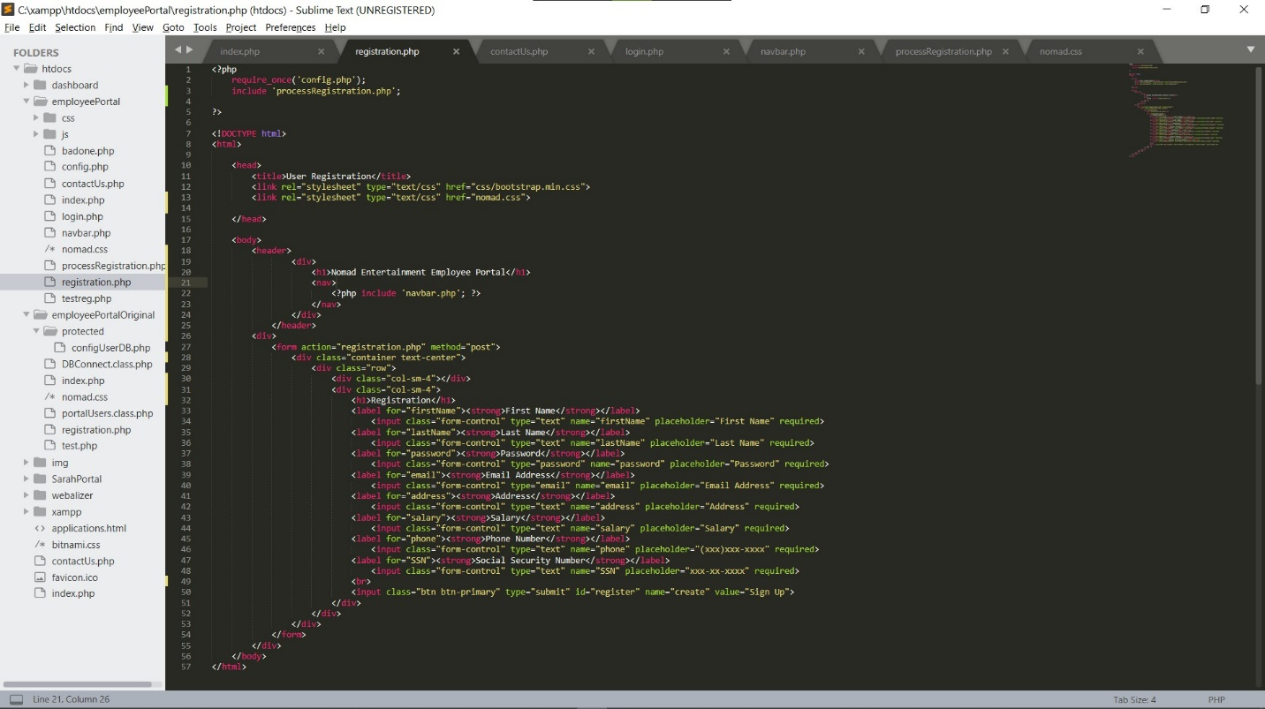

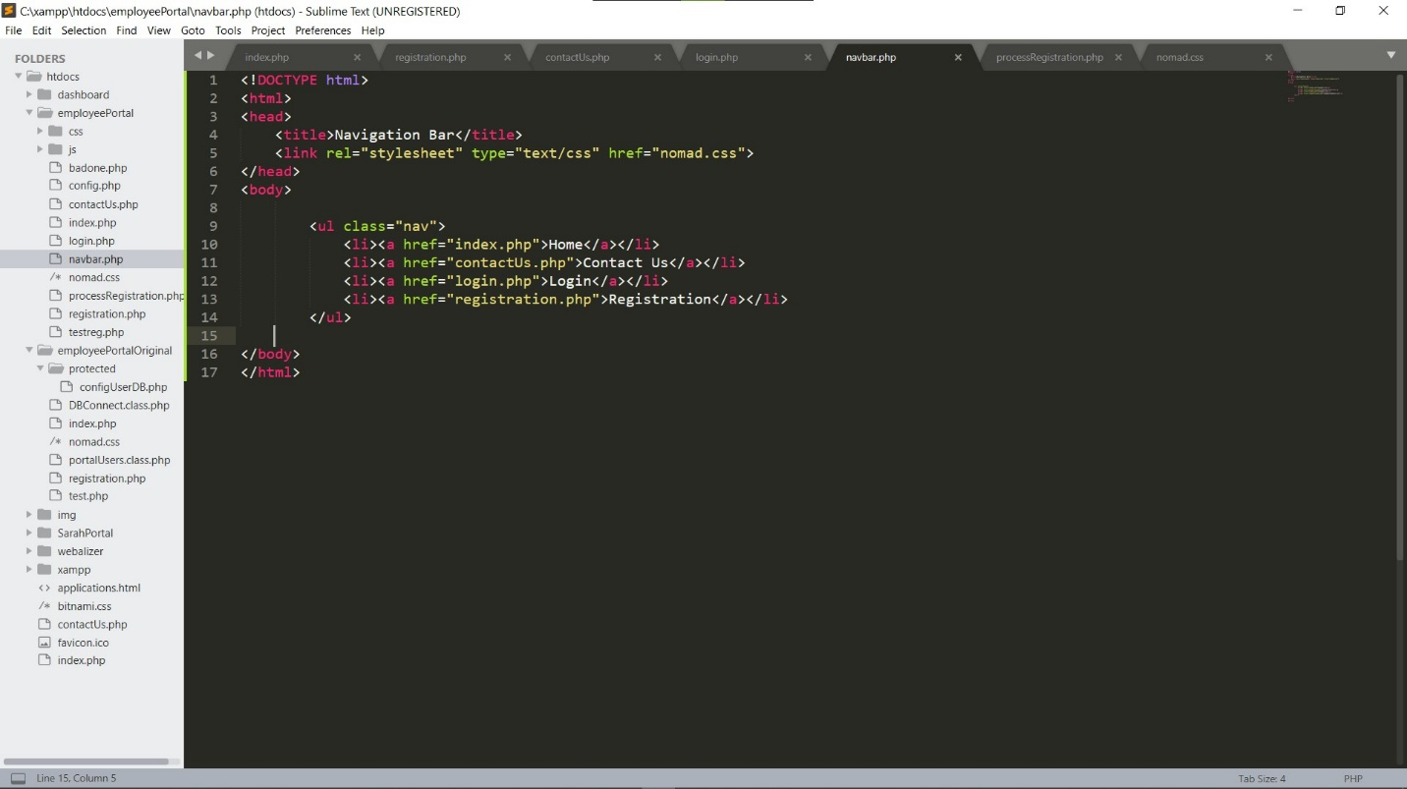

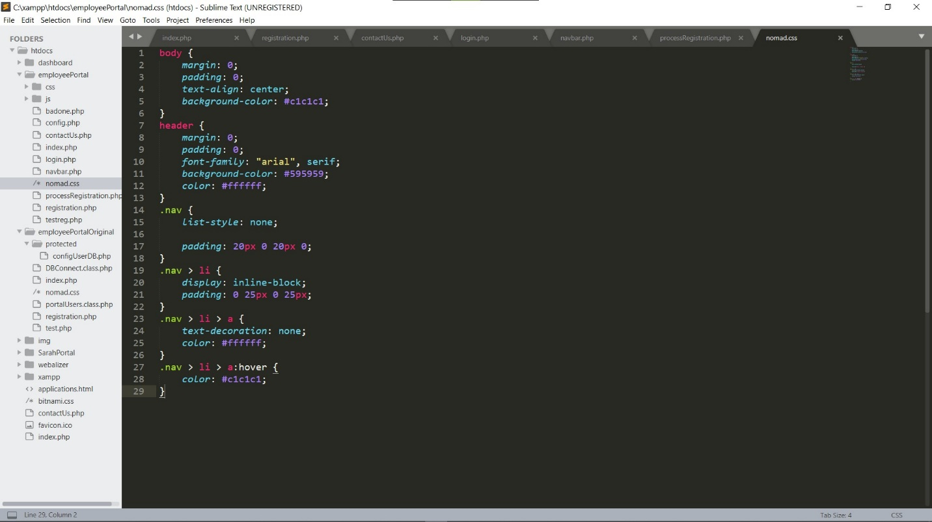

* **Provide a screenshot of the registration page PHP source code.**

The following screenshots are my PHP files for processing the registration page and the connection config.

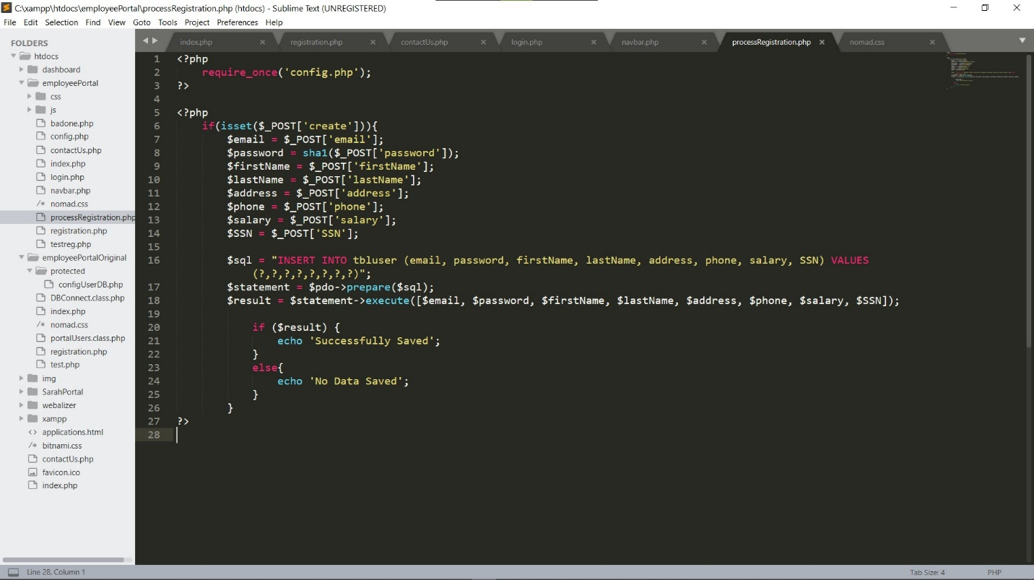

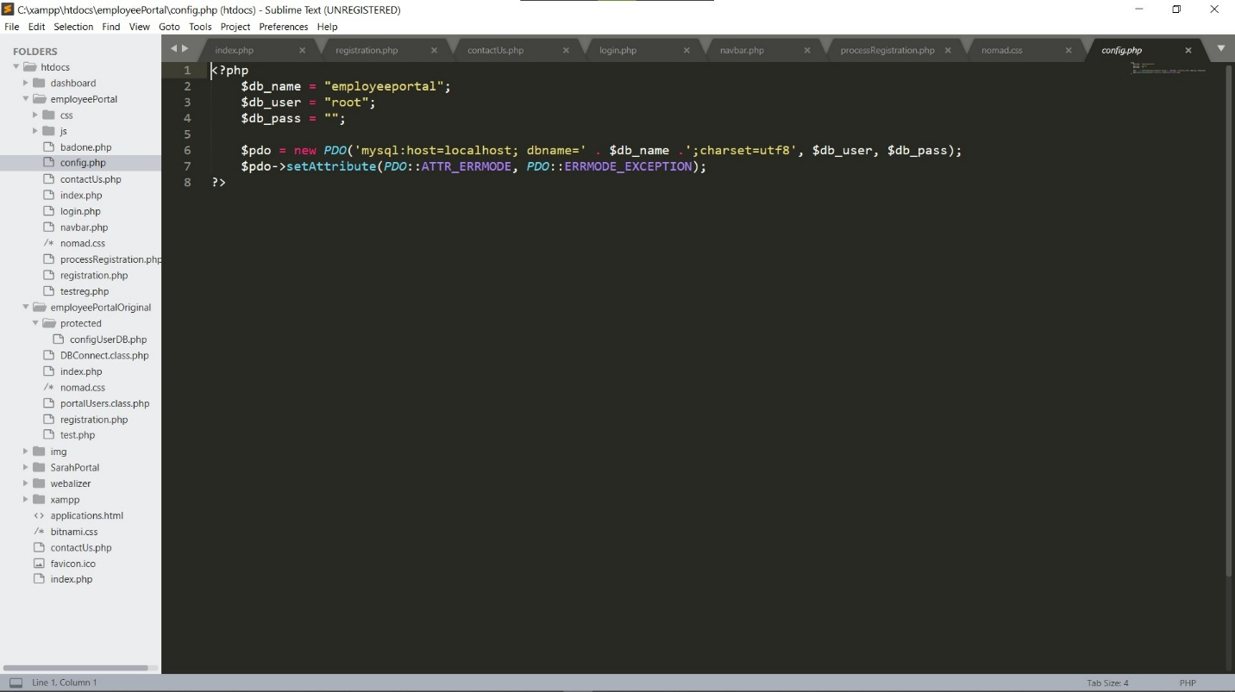

* **Provide a screenshot of the table after saving the user information in the database.**

The next screenshots include my database table and the registration page. The first is the table with two entries already populated, before I added the password encryption seen in the code above.

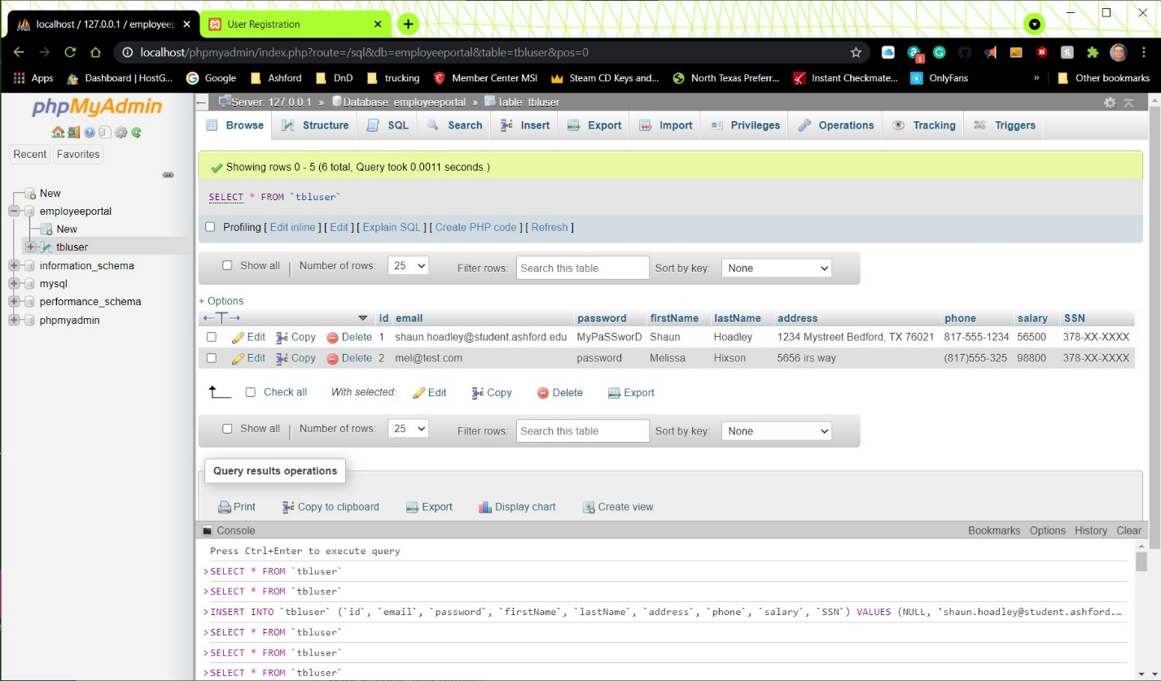

This next screenshot is of the web page with the form filled out, followed by one after clicking sign up showing it successfully saved.

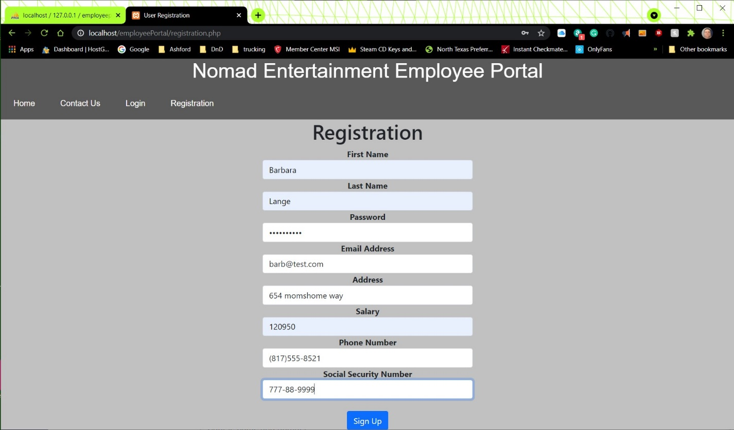

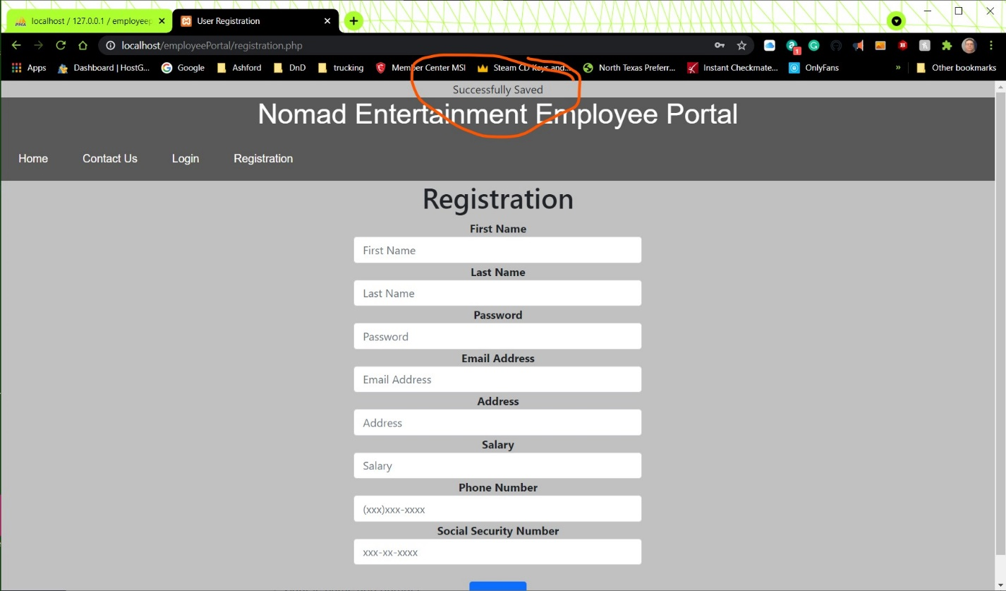

Next is the database table after clicking the sign up button. For the third entry, I used the same password as the first entry.

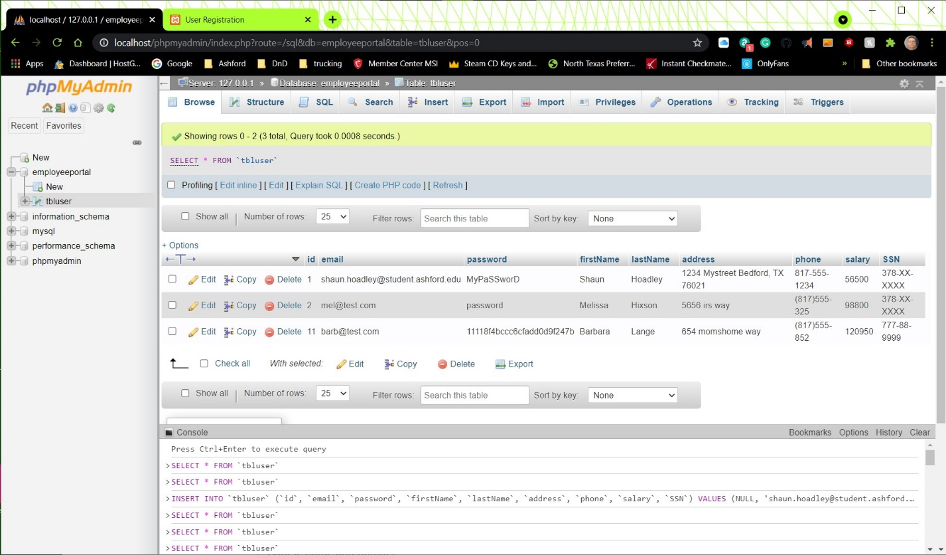

* **Explain the steps taken to create the registration page and saving the user information in the database.**

First, I had to create the HTML page layout for the registration page, adding in an HTML form to fill out, the include statements for the PHP files it would access and the CSS stylesheets for the overall look of the site. I then created the connection configuration PHP file that allows the page to establish the database connection. Next, I had to create the PHP file that processes the data entered in the form to save to the database and return a message that it saved successfully. Throughout the process of coding the HTML and PHP files I continually referenced our textbook (Connolly & Hoar, 2018). For the special features added by the bootstrap library, like the grid system, I also frequently referred to the bootstrap tutorial (Oh, n.d.).

**References**

Connolly, R., & Hoar, R. (2018). [Fundamentals of web development (2nd ed.)](https://ashford.instructure.com/courses/84200/modules/items/4256321). Retrieved from <https://www.vitalsource.com>

Oh, S. (n.d.). [*Bootstrap: Tutorial 7*](http://www.cs.toronto.edu/~mashiyat/csc309/Tutorial/6/Bootstrap.pdf) [Presentation slides]. Retrieved from http://www.cs.toronto.edu/~mashiyat/csc309/Tutorial/6/Bootstrap.pdf