Week 2 Interactive Assignment

Shaun Hoadley

CST 310: Software Development

Professor Joseph Issa

May 8, 2021

For the interactive assignment for this week, we first had to use phpMyAdmin to create a MySQL database for our employee portal website. There are several ways that you can go about this task. Rather than use the simple click buttons in phpMyAdmin to create and use the database and table, I elected to use the actual SQL statements to perform these tasks, more for practice than a need to do so. The following are the screenshots of this task:

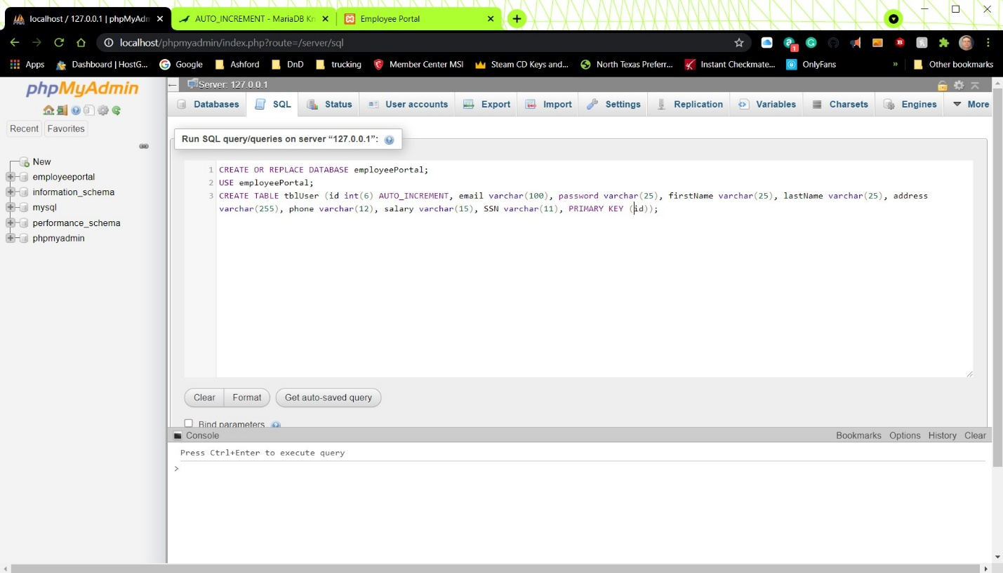

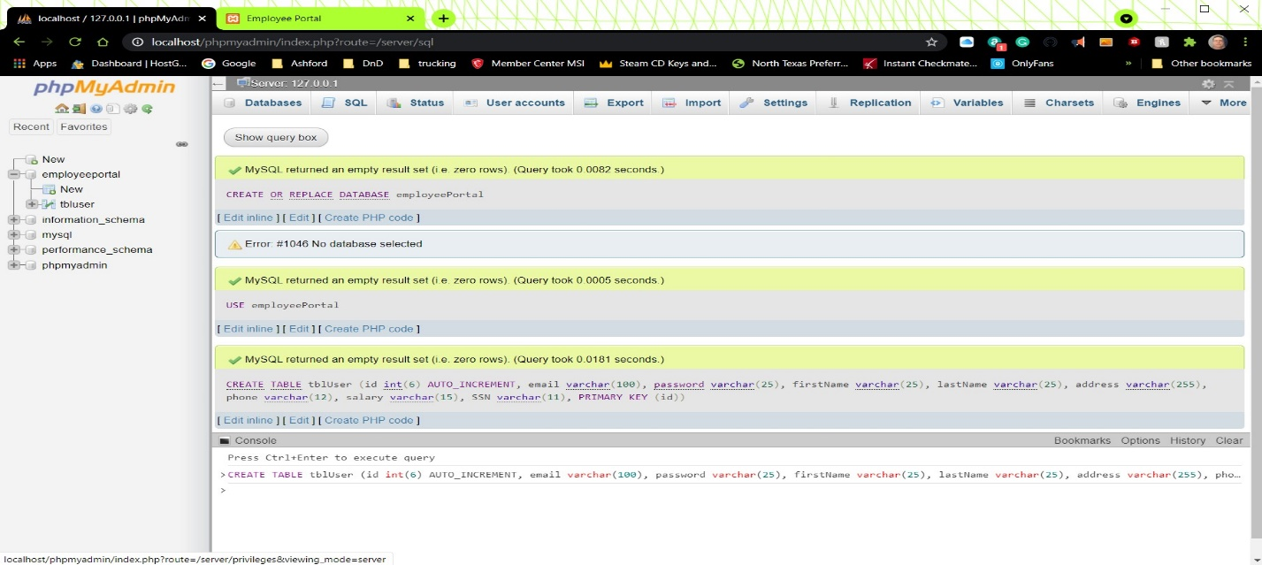

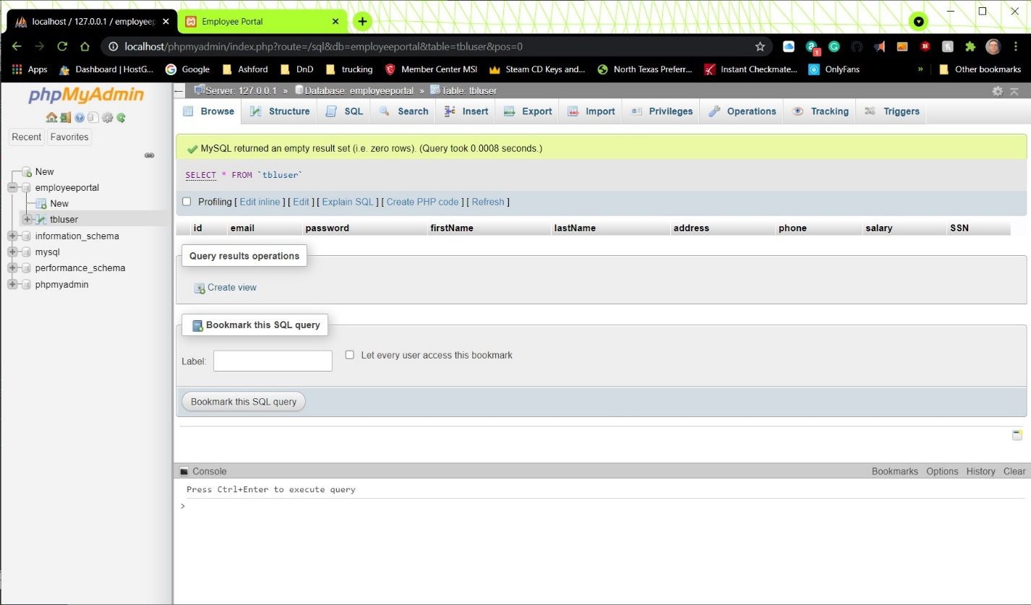

The next task for this interactive assignment is to create the PHP class that manages the communication to the database from the website. This class will establish the connection, contain the methods (or functions) executeSelectQuery and executeQuery, and close the connection when finished to release the resources used. Unfortunately, this is already as late as it can be, and I am still having trouble with it, but I have to work on the big assignment for the week. Following is what I have for screenshots:

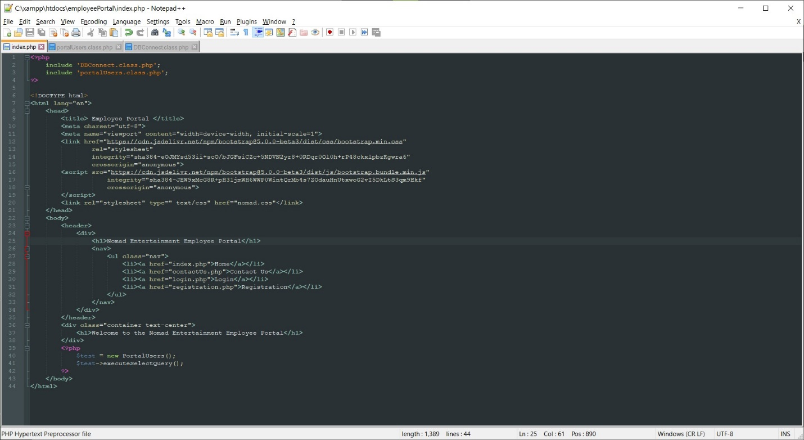

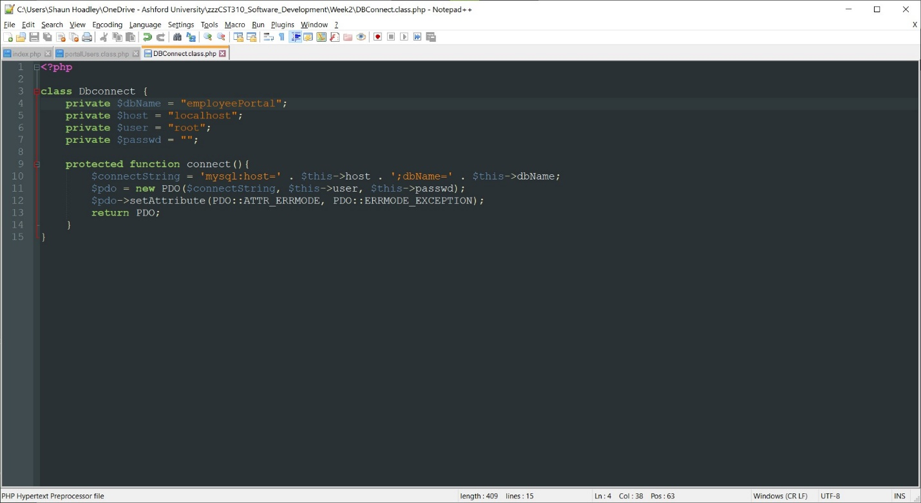

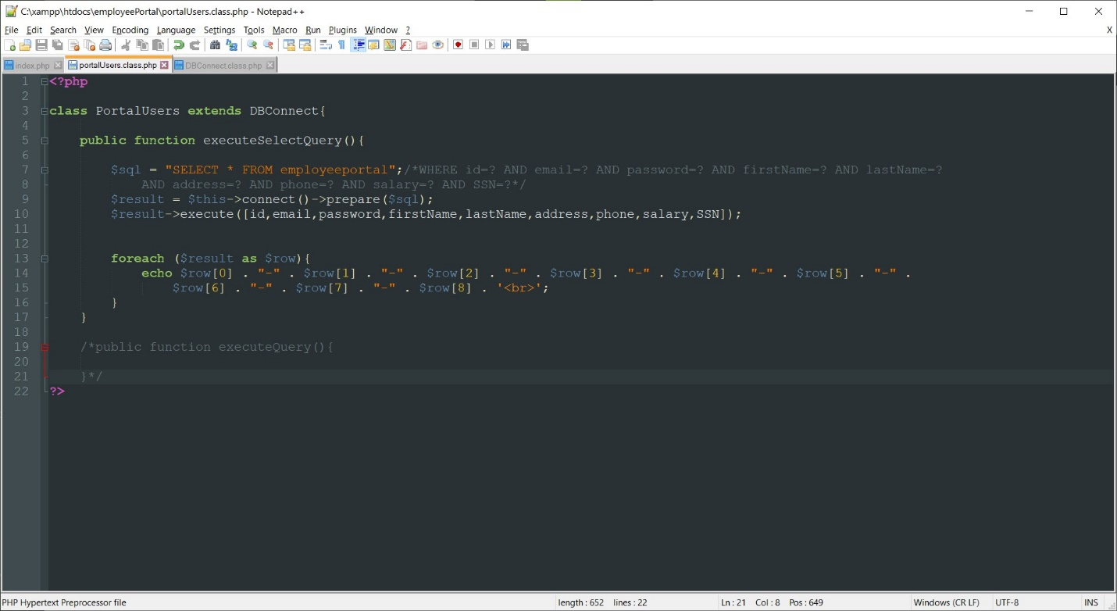

**References**

Connolly, R., & Hoar, R. (2018). [Fundamentals of web development (2nd ed.)](https://ashford.instructure.com/courses/84200/modules/items/4256321). Retrieved from https://www.vitalsource.com