Employee Portal – Task 3

Shaun Hoadley

CST 310: Software Development

Professor Joseph Issa

May 17, 2021

* **Provide a screenshot of the login page layout.**

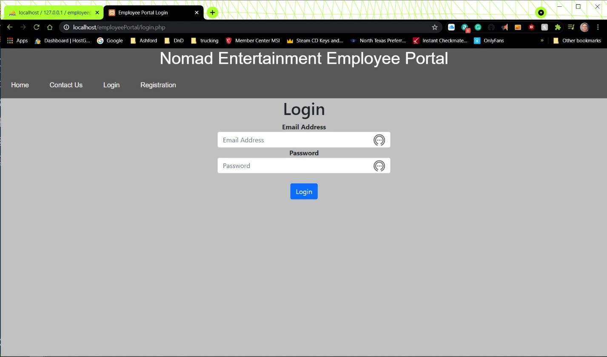

* **Provide a screenshot of the login PHP source code.**

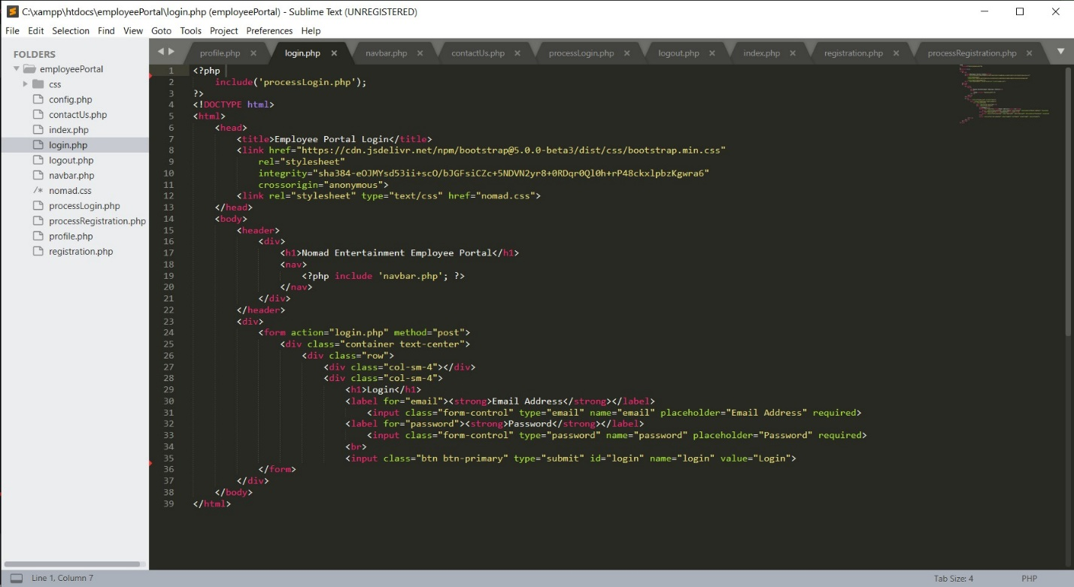

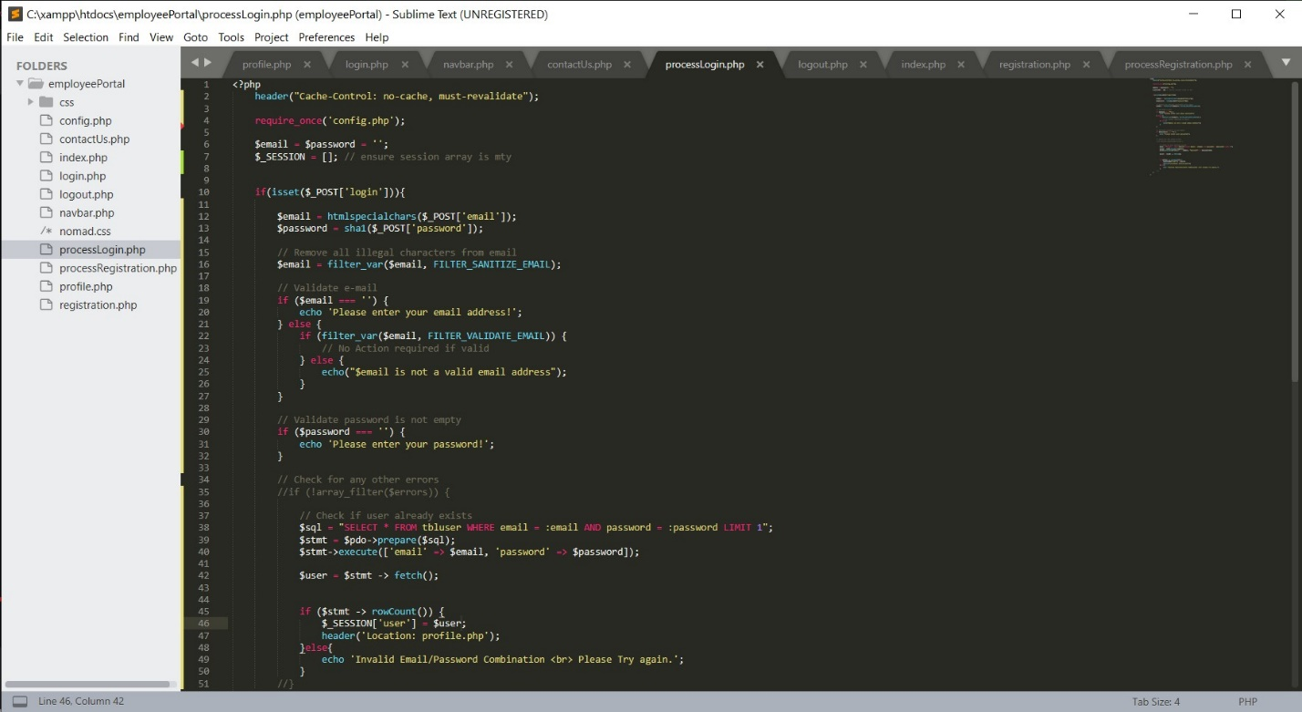

* **Explain the steps taken to create the login page and retrieving the user information from the database.**

After creating HTML for the Login page, I created the login processing PHP file. In the processing file, I establish the connection to the database. It is then supposed to query the database for the email and password that matches what the user entered in the login form. If it matches, it is supposed to redirect the user to the profile page. I had that working until I started adding the session function that hides the login and registration buttons on the navbar. Then I made a variety of other changes that broke my login function and I have not yet been able to figure out how to fix it. Time is up for this assignment, so I am submitting what I have for the time being. I will, obviously, continue working on it until I fix the problem for the final project.

**References**

Connolly, R., & Hoar, R. (2018). [Fundamentals of web development (2nd ed.)](https://ashford.instructure.com/courses/84200/modules/items/4256321). Retrieved from <https://www.vitalsource.com>