Week 3 Interactive Assignment

Shaun Hoadley

CST 310: Software Development

Professor Joseph Issa

May 13, 2021

* **Determine which superglobal function can be used to send files from client browsers to the web server.**

The suerglobal that can be used to send files from a client browser to the web server is $_FILES (Connolly & Hoar, 2018).

* **Describe the process on how you can send files to the server.**

First, you need to create a form in the HTML to allow the file to be selected (or, optionally, entered manually). You need to set the form action to the name of the PHP file that will manage the upload, the method to POST, and the enctype (encoding type) to multipart/form-data, thus letting the form know it will be handling binary data. Next you set the input type to file and the name to something that makes sense to you. Afterwards, add a button to submit the form data, aka the file to be uploaded. Next, you want to create the PHP file that will process the form request and upload the file to the server. For the PHP file, first (while it is not necessary for the actual upload, it is inadvisable to omit, as you want to control what the user is allowed to upload) you want to add in the error handling and validation of the file being uploaded. If the file fails to meet the validation and error handling, inform the user (e.g., file size too large, invalid file type, etc.). After passing the validation and error handling, direct the file to the location it will be stored and provide some way of informing the user of a successful upload.

* + **Provide the code you created to develop the upload functionality.**

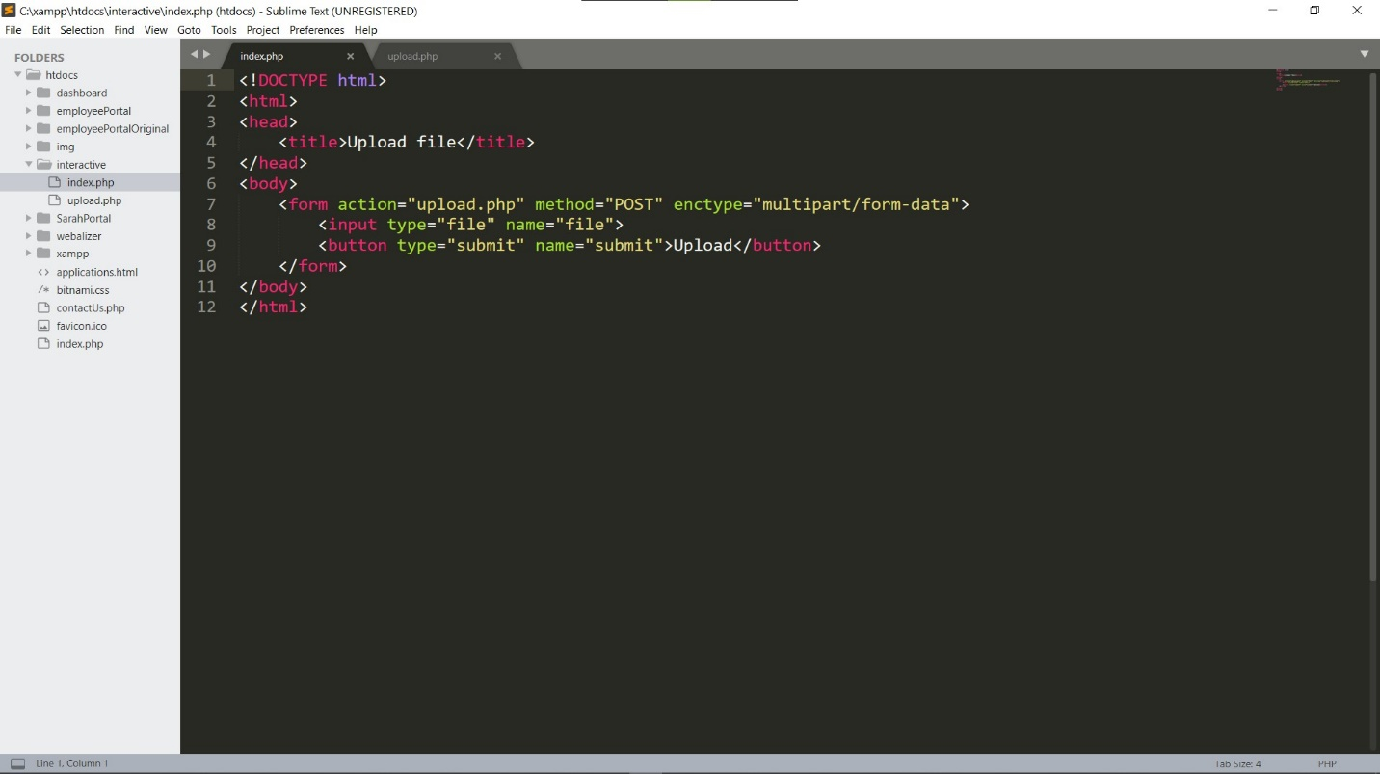

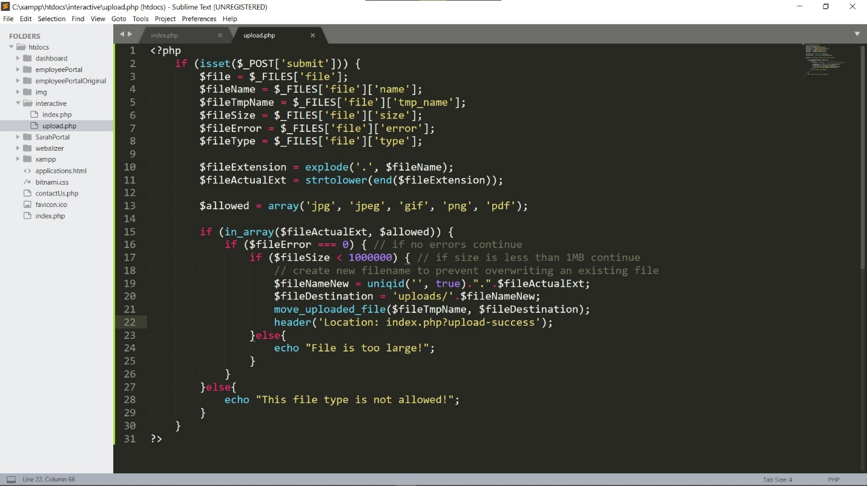

* **Explain what the first thing you should do—as a web developer—to handle the file after you upload it to the server.**

The first thing you should do as a web developer to handle a file after uploading it is to verify it uploaded, and is error free.

**References**

Connolly, R., & Hoar, R. (2018). [Fundamentals of web development (2nd ed.)](https://ashford.instructure.com/courses/84200/modules/items/4256321). Retrieved from <https://www.vitalsource.com>