Employee Portal – Task 4

Shaun Hoadley

CST 310: Software Development

Professor Joseph Issa

May 31, 2021

* **Provide a screenshot of the profile page layout.**

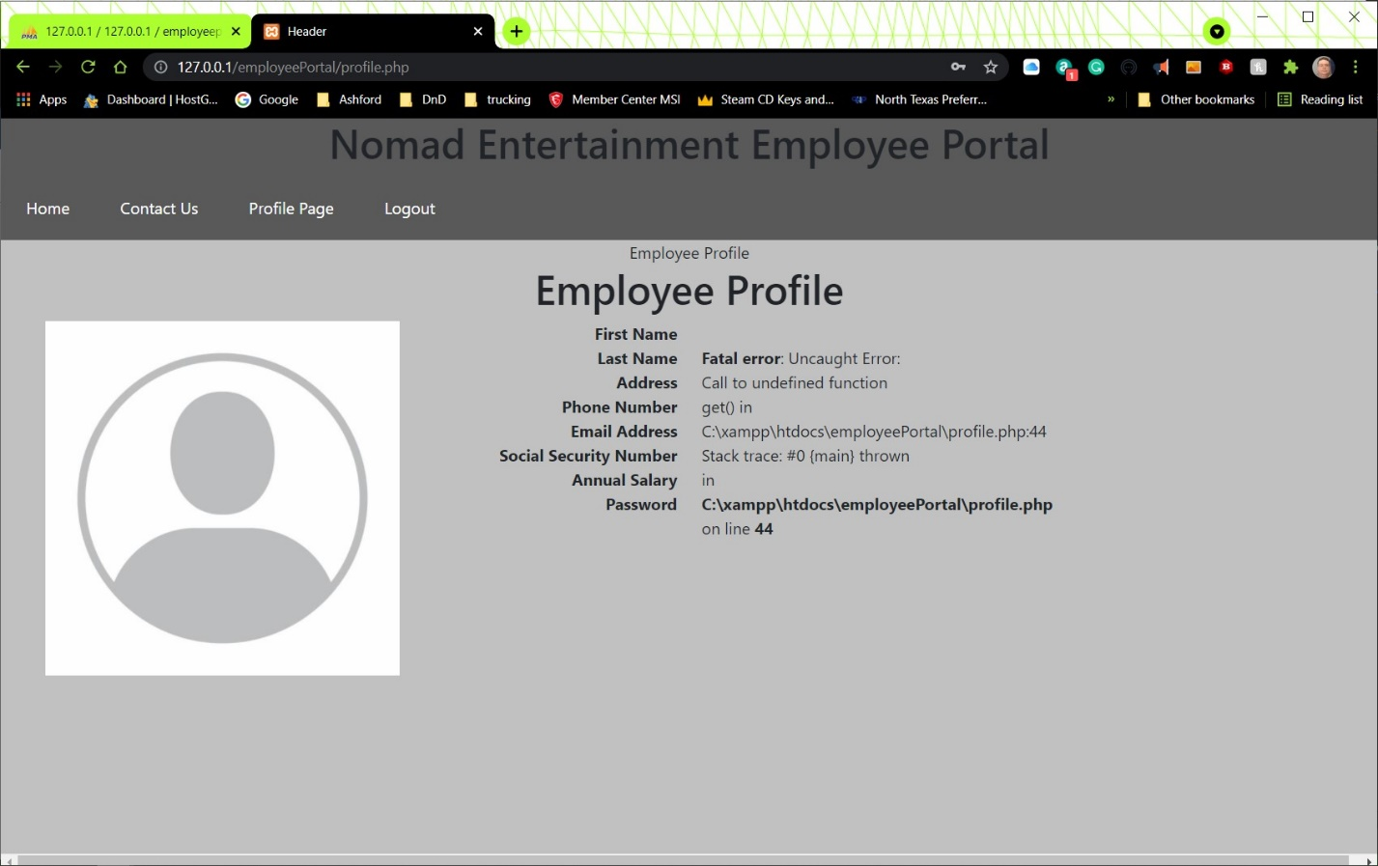

* **Provide a screenshot of the profile PHP source code.**

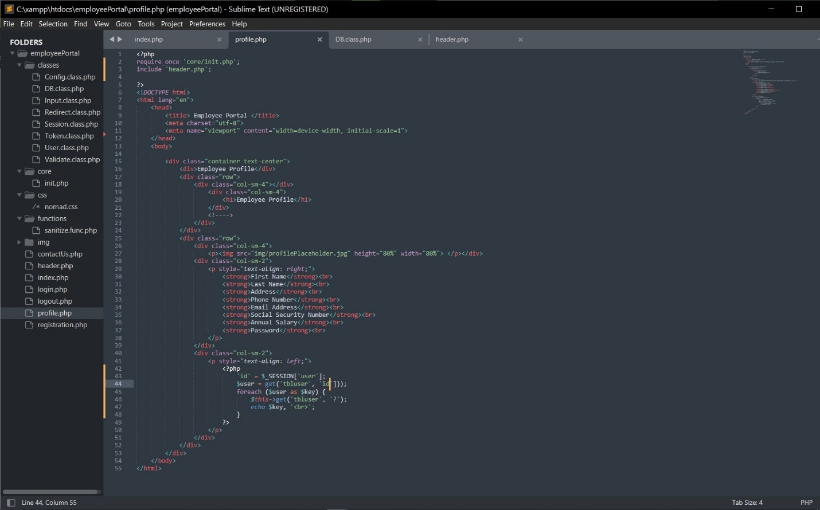

* **Explain the steps taken to create the login page and retrieving the user information from the database.**

After creating HTML for the Profile page, I added the PHP processing. As can be seen, I still have not managed to get the processing of the profile page complete. This assignment is way overdue, and in fact, my final project is also late at this point.Being that class has technically ended, I am submitting what I have, though I do not expect to receive credit on this one at all. I just have a problem with not having it submitted at all.

**References**

Connolly, R., & Hoar, R. (2018). [Fundamentals of web development (2nd ed.)](https://ashford.instructure.com/courses/84200/modules/items/4256321). Retrieved from <https://www.vitalsource.com>