Employee Portal – Final Project

Shaun Hoadley

CST 310: Software Development

Professor Joseph Issa

May 31, 2021

* **Screenshots of all the functionalities of the employee portal website, along with their descriptions.**

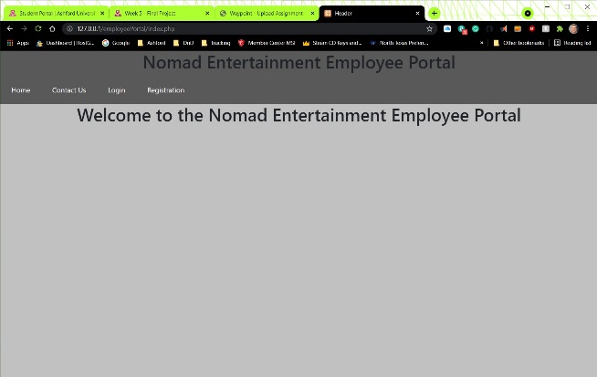 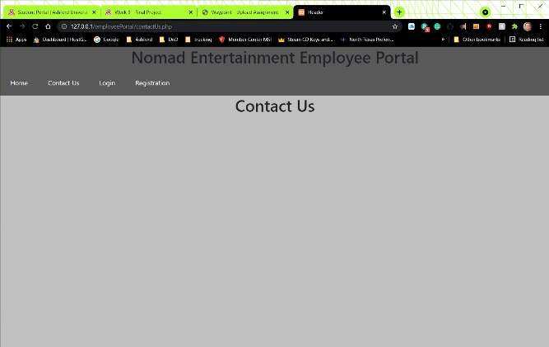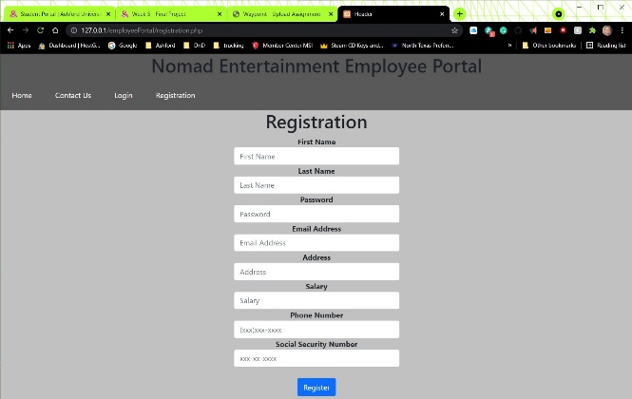 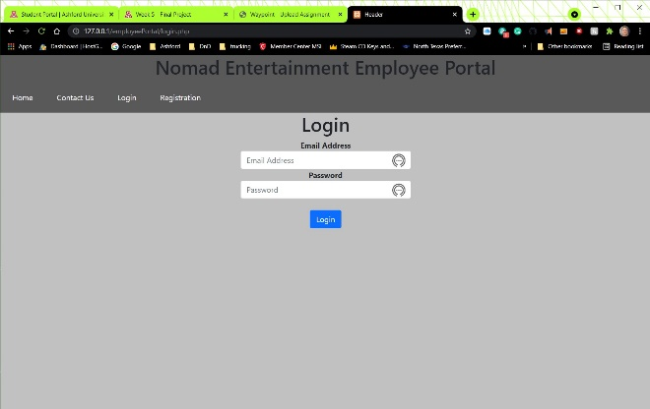

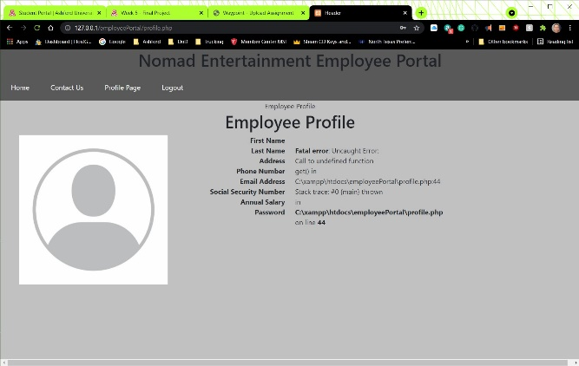 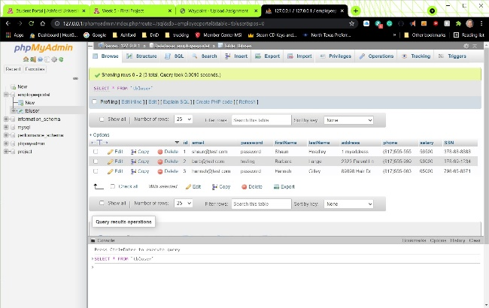

The first two screenshots are the home (index) page and the contact us page. Aside from the navigation bar, the only functionality of these two pages is to represent the website layout. The third image is of the registration page. The registration page hosts the form used to register a new user to the database. After filling out the form and pressing the register button, the site redirects the user to the login page so then can log into the system. The fourth image is the login page. After the user enters their credentials and selects the login button, two things happen. First they are redirected to their user profile page (which I am still unable to get working completely), shown in the fifth image. Second, the login and registration buttons on the navigation bar are replaced with profile and logout. When the logout button is selected from the navbar, the session is terminated, the user is redirected to the home page, and the profile/logout buttons revert back to login/register. The final image is that of the database that stores all of the user data for the website.

* **An explanation of the steps you took to combine all the functions into one single application.**

As for the steps I took to combine all the functions into one application, I started from the beginning and simply built on to the site. At no time did I think I was working on individual projects, though I did start over from scratch on more than one occasion. One of the first things I do at the start of each course is to look at the final project for the course, so I may try to work my way to that goal by using the assignments leading up to it. From the very first line of code I put down, I took and object-oriented approach rather than develop each individual piece as not being a part of a whole. In that regard, I attempted to organize related functions together for both this project and as reusable code for any future projects.

* **A brief description of the purpose of the employee portal website.**

The purpose of this website is to provide practical knowledge to developing a site that a company might have for the use of their employees.

**References**

Connolly, R., & Hoar, R. (2018). [Fundamentals of web development (2nd ed.)](https://ashford.instructure.com/courses/84200/modules/items/4256321). Retrieved from <https://www.vitalsource.com>