**Project Proposal**

**[“Touch of genius”]**

**ITP272 (Sensor Technologies and Project)**

**Diploma in Engineering Informatics**

**Academic Year 2016 Semester 2**

|  |  |  |
| --- | --- | --- |
| Team ID | ITP272-05 | Module Grp: ITP272-02 |
| Role | Admin No: | Name: |
| Leader | 154433K | Thomas Lee |
| Member | 151719K | Shaun Lim |
| Member | 154548K | Clynton Loh |
| Member | 152978G | Wafiy Yazid |

#### Design Thinking Outcome

#### Wicked Problem

How might we use minimum 3* sensors to create a useful and smart solution to improve our lifestyle?

#### Knows and Don’t Knows (at least 15)

#### [Picture of Post It Notes with Knows 1 side and Don’t know 1 side]

***Know:***

1. Sensors are used in Internet of Things
2. Sensors can be used in daily life
3. Sensors can improve daily life
4. Singapore government is promoting IOT
5. Singapore is technically advanced
6. Sensors given to us
7. Types of sensors given to us
8. How many sensors provided
9. Sensors can improve efficiency of businesses
10. Companies trying to improve efficiency of their businesses through the advancement of technology
11. Price of the sensors
12. Current trend of technology
13. Speed of advancement of technology
14. Applications of current technology
15. Scale and scope of the project

***Don’t Know:***

1. Extent of the technologies of current sensors
2. All the current uses of sensors
3. Current status of sensors in the market
4. Demand for sensors in daily life
5. Current niche markets of sensors
6. Uses of IOT in daily life
7. Ease of use of IOT
8. Ease of integration of sensors in daily life
9. Variety of sensors available
10. Capabilities of current advancement of technologies
11. Processes involved in the integration of sensors
12. Financial feasibility of integrating sensors
13. Software available that interface with current sensors
14. Difficulty in creating software to interface with sensors
15. Cost of developing software for sensors

#### Plan and conduct User Research

**Proposed Solutions:**

1. Smart Library
2. Smart Home Automation System
3. Smart Bus
4. Smart Traveller System

**Researched Solutions:**

1. ***Smart Library***

This solution uses sensors, RFID tags and readers in library management system for faster and more efficient book transactions, as well as a faster issuing, returning and reusing of books. This solution can help recording and keeping track of the current status of the book. It will be able to automate the librarians job of checking book status a much easier process as well the people that patronise and use the library services.

RFID tags can be embedded into the library books which will allow them to be tracked and monitored by the library’s database. It will be able to record the date of issue, dates of return and calculate if there is an outstanding fine.

Security will also be better as there will be sensors placed at all entrances and exit point of the library. It will detect and be able to scan if the RFID tag located in the book has been issued a borrower’s ID number. If the ID number is present, the alarm will not sound as the book has already been checked out with the recipient’s necessary details. The alarm will sound in the event where a borrower’s ID number is not detected. It would indicate that the book has not been checked out properly and thus require the person to proceed to redo the check-out process. This is to ensure that all the books are accounted for, and the books will eventually return to the library.

RFID readers can also track the location of the RFID tags located in the books and in the event that the books have not been returned, library management will send appropriate personals to retrieve the book from its location.

Motion sensors can also be installed all around the library and detect movement in the library. It will be able to find optimal locations in the library for conducive studying and reading spots. As there are lesser movement in that area, it will imply that the area is less crowded where some users prefer.

1. ***Smart Home Automation System***

This solution serves to provide potential users to have a one-stop installation to upgrade their homes to a “Smart Home”. This solution uses a plethora of sensors that can be easily installed in the homes to make it a future proof home. We plan to have sensors that can control the lights, fans, air-conditioning system as well as TVs. There will also be a built-in security system that will be running 24/7 as well as a smoke detector sensor. All of which will also be able to controlled using a RFID card.

Temperature sensors can be set in the house to detect the current temperature in the house and suggest to the user appropriate actions. If it is in the afternoon recording a very high average temperature, it may suggest the user to turn on the air-conditioning and set to 18°**C**. After 30minutes, it may suggest to the user to turn up the air-conditioning to >= 25°**C** as the average recorded temperature is much lower. Vice versa, if the average temperature at night after a rain is low the system may suggest to the user to turn off the air-conditioning and open the windows for a light breeze.

Ultrasonic sensors can be used to adjust the fan and light level intensity replacing the old button and knobs. We believe in future most home appliance will use these sensors as standard. Problems that this implementation tackles are in cases where you are eating, your hands may still be dirty but you would like to turn up the fans or turn off the lights. This sensor will be a neat feature to have. Cases where we still have to remind people to not touch the switch while their hands are wet will be a thing of the past.

Our smart home system aims to be an all rounded home system. Hence it also features a number of features which is dedicated to solely for home security.

A smoke detector sensor is something we believe every home should have installed. The smoke sensor used in our project differs from other smoke detectors as ours can be remotely configured from the computer. The user will also be able to set a time limit with the sensor which will automatically file a report to the nearest fire station.

Motion sensors and small cameras will be setup around the house to detect movement when the home owner is not at home. It can be configured to turn on after the owner has left the house. If there is movement detected, the owner will be notified via app. He can use the app to snap a photo of the room where the sensor was triggered. He will then have evidence of a break-in and can alert the nearby police department via our app. If it is not a burglar, he can disregard the photo and continue on with his work.

Finally, the last feature of our Smart home system will have a session saver feature. This will allow the user to save a preference setup for when he uses his RFID card to turn on the home system. It will be placed near the main door, so when the user comes home from work he/she doesn’t have to waste anytime flipping any switch to on the lights or air-conditioner. With the RFID tagging, it will detect if the owner is home and if the RFID card matches, the home system will turn on all the appliances that is saved in the preference. This RFID system will also be able to save a number of user’s different configuration based on their RFID card.

1. ***Smart Bus***

This solution will primarily be used, on top of the current sensors already implemented on public busses in Singapore. The busses now come preinstalled with infra-red photosensors. Located at the exit doors on the inside of the bus, these sensors enable accurate sensing of objects and better coverage of alighting passengers. The doors of the bus will not close if the sensors detect an object at the doors. Another set is fitted on the external of the bus above the centre of the exit door arch., This sensor ensures that the doors do not close on alighting passengers.

We plan to install similar light sensors pointed at the stairs in double decker bus. It is not uncommon that you see commuters during peak hours, standing on the stairs despite it posing as a safety hazard. The bus driver has to shout and remind the passengers to move in or not stand on the stairs. This may be acceptable 10 years ago, but we believe that our solution will bring forth a new era that will propel Singapore to become the 1st smart nation in the world.

Ultrasonic sensors will also be placed at the back and in the middle of the carriage. This setup is to detect if there are empty spaces during peak hour. Connected to the busses audio system, it will play a recording to remind the passengers on board to move in. The audio system will also have a microphone located at the bus captain’s area. An alternative to shouting, it will be for the bus captain if he wishes to address a specific person on the bus for being unruly, or standing on the stairs.

Motion sensors can also be setup on the 2nd floor of double decker busses on top of the camera which is already installed. It will send an indicator via light to the bus captain to inform him that someone has been detected standing on the 2nd floor. He will then be able to check using the camera and assess the situation. The bus captain will be able to either address the situation via audio microphone, or recorded message to be played.

RFID tagging technology can also be implemented for the commuters that tap their bus cards. This will give an accurate reading of the number of users currently on board. The data can be used for more 3rd party apps that would like to improve on their accuracy for bus timing and how pack is the bus.

Overall this solution aims to make bus journeys safer and more enjoyable for all the passengers as well as bus captains.

1. ***Smart Traveller***

This solution aims to tackle the problem that many Singaporeans face on a daily basis. The number of train breakdowns occurring in Singapore is on the rise, and while measures have been put in place in the event of a breakdown many Singaporeans are still affected. Collecting data from various sources, including bus timing and how populated the carriages are, we will develop an app that will help users to find and calculate the optimal path for them to take to work.

Motion sensor with cameras will be setup at train stations that have the highest failure rate as well as those with the most number of passengers alighting and getting on. It will provide a live video feed to the app for users to see. RFID tagging can also be enabled at the counter to count the number of passengers entering and exiting that particular station. The information will also be available on the app for the users to decide whether or not they should take this route or find an alternate path.

The app can also work with grab app and the users that wish to take the grab can be redirected to the app. From the information from the app, it can link to google maps to calculate the faster path to their destination. If the traffic situation at the time will suggest that the path suggested by the google map, the user can use the information from the app to find the fastest and most accurate alternate path to reach his destination.

|  |  |  |  |  |  |
| --- | --- | --- | --- | --- | --- |
|  | **Feasibility** | **Desirability** | **Viability** | **Novelty** | **Total** |
| **Smart Library** | 2 | 3 | 3 | 1 | 9 |
| **Smart Home Sys** | 4 | 5 | 4 | 4 | 16 |
| **Smart Bus** | 3 | 3 | 2 | 3 | 11 |
| **Smart Traveller** | 2 | 5 | 3 | 4 | 14 |

***Smart Library:*** Not feasible there are many books in circulation without tags. Physically tagging all would take a lot of manpower and time. Desirability is not high as there are already library sensor systems in place that work and our solution does not provide a high enough improvement for it to be implemented. Viability would be average, as the RFID tags has to be maintained as well as the state of the books. Since there is already a library system in place and working quite efficiently, novelty for this solution is very low.

***Smart Home Sys:*** High feasibility as technology advances more people will want a smart home sys to future proof their apartments. Very high desirability as our system compared to other systems available is cheaper and has a wider array of feature available for the users. Viability is high as there are not a lot of smart home systems on the market that can perform what our solution can and match the price. Smart home technology is still relatively new and our system incorporates many sensors into one primary system.

***Smart Bus:*** Average feasibility as the sensors used may not be able to function as we need them to. The sensors can easily be replaced with a camera and the purpose will still be the same. Average desirability as there are already sensors placed on the bus. The solution does not provide an instant solution for problem that we are trying to solve. The sensor will definitely face a lot of physical contact daily and will be very hard to maintain, as such the viability is rated low. Sensors are already in place on public buses, but used for other reasons. They bus companies may have already considered this problem and felt it is not as serious hence no sensor extra sensors have been integrated. Average novelty, good problem but solution is not as well thought out.

***Smart Traveller:*** Low feasibility as cost of implementing and tapping into cameras may not be legal. High desirability as the problem is faced by many Singaporeans but there is no solution in place at the moment. Average viability as the solution will not be easy to maintain. The sensors and how we will have to get permission to use the cameras and tap into the MRT station tap barrier. High novelty as the solution has not been used in this manner before.**Analysis & Synthesis**

***[****Picture of Post It Notes with Clustered Observations & Insights****]***

***[Survey Results below]***

***Redefined challenge***

*How might we create an innovative and useful solution for homeowner?*

Through the surveys our team conducted, we deduced that the smart home system had the most favourable response among the respondents. The smart home system also came out on top in our design thinking table in contrast to the other solutions. We believe that the smart home system will truly be beneficial for all the users, it is the future.

Despite smart home technologies have been around for the past few years, not many people have these systems integrated in their homes. In alternate surveys we conducted when asked if our respondents have smart home system, more than 34 respondents indicated that they did not have it. Out of which, 24 did not know what was a “smart home”. After explaining to them what smart home technology was capable of, many of them were interested and wanted to it in their homes.

Our survey found that one of the biggest concern for homeowners in Singapore is fear of a home fire. Should not come as a surprised in lieu of multiple cases where power-banks, electronic cigarettes and phones burst into flames becoming a common headline. The second biggest concern among the respondents is high electricity cost. Not all the problems found can be addressed in our solution but we try to tackle as many problems as we can.

The solution proposed by our team not only addresses multiple concerns and request of the respondents, we also included features and characteristic that we came up with. The RFID system unlock will be able to save configurations made by the user and save them the trouble of turning on the appliance they need. If time permits, our solution will also allow the user to send data to the sensors remotely from the app to start the air-conditioning or fans before return home.

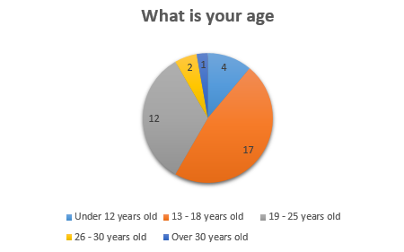

***Survey Results***

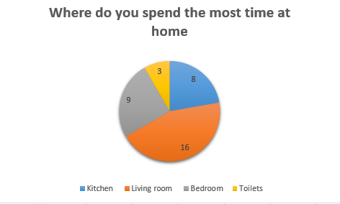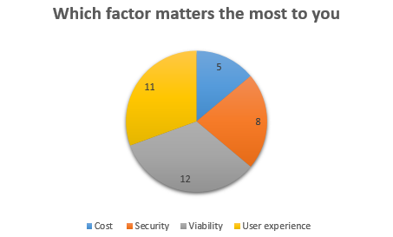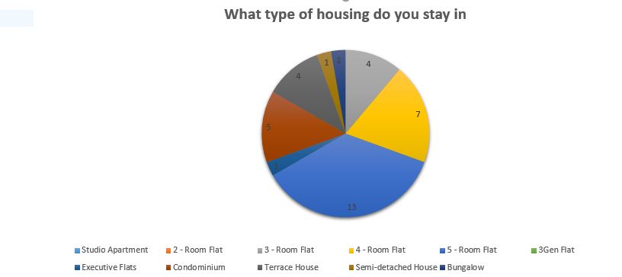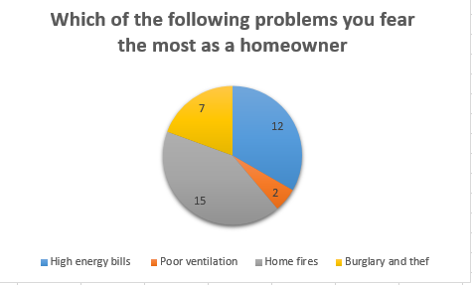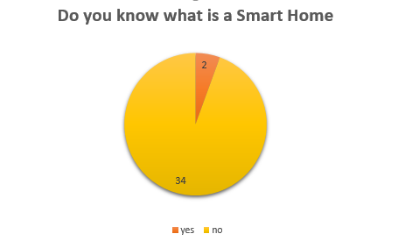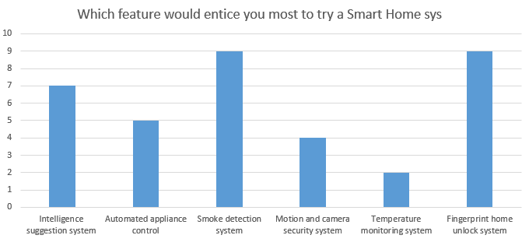

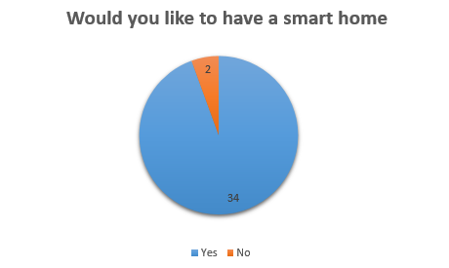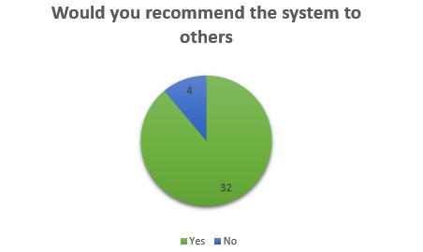

#### Proposed System

* 1. 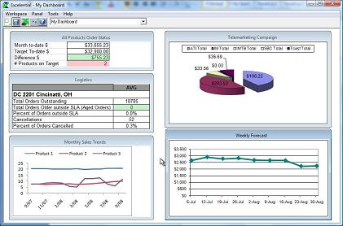**System Overview Diagram**

***SENSORS AND HARDWARE DEVICES***

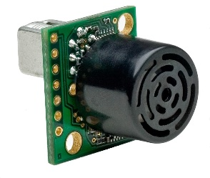

**Sensors**

* Temperature Data, Smoke Data
* Motion Sensor info
* RFID Tag

**Windows Form Sensor Panel**

* User inputs and control (labels, textbox, buttons)
* Displaying sensor information
* Notification toggle
* Display Charts, pie charts, histograms, bar charts of sensor info and data

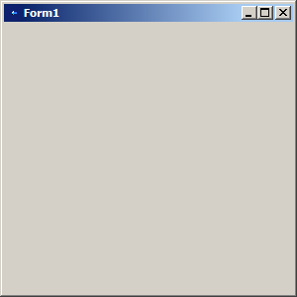

**SQL Server Database**

* Create, retrieve, update and delete data

**Windows Application**

* Sends and receive data using UART
* Store sensor info
* Administrator management
* Login/Logout feature



**Web Application**

* Login, Logout
* Receive and send data to database
* Configuration and adjustment of sensors
* Admin management
* Display sensor data

**Mobile Application**

* Receive and send data to database
* HTTP request to and from sensors and hardware
* Receive and manage notification from sensors
* User Input configuration for sensors



* 1. **Functions**

***Sensors***

Temperature sensors will be setup around the house, to monitor the temperature of multiple rooms at the same time. From the data we will be able to suggest the user whether to turn on the air-conditioner or not. When the room has reached the optimal temperature (can be configured by the user) with air-conditioning, the sensor will prompt the user to change the temperature to keep it at a more energy and cost efficient temperature.

Ultrasonic sensors can be used to allow the user to remotely control the intensity of lights in the house, or fan speeds. This will be a good implementation as the user will not be required to have any physical contact to the switch. Most useful if the user’s hands are dirty or wet, and should not touch any electrical switches.

Smoke sensor will be setup on ceiling of the house. It will be able to detect smoke based on the amount of concentration emitted. Ideally it will be activated when the user is asleep and a fire starts without him knowing. The sensor will activate an alarm system which will awaken the user from his nap. Thereafter, the user will have 10minutes to disable the alarm before the nearby fire station receives a message that a smoke detector has gone off.

Motion sensors with camera will be setup around the house to detect movement when the user is not home. This will act as a home security system for the user, and can be activated when the user leaves the house. It will detect any large movement send an alert via app to the user’s mobile phone. If the user has an expected guest arriving at his house, he can disregard the notification. If not, the user can use the camera setup alongside the motion sensor to snap a photo to see what triggered the sensor. If it is a break-in, the user can send the picture to the nearest police station to notify the authorities.

RFID tags will be placed near the entrance of the apartment. It will act like a system unlock for the user’s home connected to the smart home system. The user will be able to save different configurations when he returns home, all he will have to do is scan his RFID card to turn on the lights, fans and TV. The sensor can also be programmed to recognise more than one RFID card if there is more than one person living in the house.

***Windows Form***

*[Briefly described the functions and features to be catered in your proposed system.]*

The windows form application come with a specialised desktop/server system. It will act as the heart of the entire home system. It will manage all the sensors in the house, where different configurations can be saved. The user will be able to manage administrators whereby administrators can be added, updated, retrieved and deleted. The program will also include a login and logout feature. This adds a layer of security to the system where only authorised users can access the system and its components.

The program will include a sensor panel which will display the data and information collected from the sensors. The panel will also allow configuration and adjustment of notification and sensor configuration.

***Web Forms***

The Web application will allow users to update and manage the sensors remotely from their computers. It will serve as an online web portal for all “smart home” system users to check their sensor status remotely from the website. There will be a login/logout feature, and an administrator management function similar to the windows form.

The sensor panel will also be available on the website for the users to view the data collected from the sensors. The panel will allow configuration and adjustment of notification and sensor configuration settings.

***Android Application***

The function for the android application is to allow users to receive notification form the “smart home” system. The application will give the users the ability to operate and configure the sensor system remotely to an extent. Some features of the sensor will work with the app, such as the motion sensing security system. The application also receives notifications and alerts from the system when data is sent via the sensor system.

The application will require an active internet connection to work as it sends HTTP request over the web to the sensor system located in the user’s home.

**2.3**

***Benefits of Proposed System****[What types of benefits your project will provide to the users.]*

Our smart home solution aims to give all homes a new “touch of genius”. It will upgrade any home in Singapore to become a smart home. We aim to make smart home systems affordable for as many users as possible. The smart home system will help make the user’s life easier.

The temperature sensor will be setup in multiple rooms in the apartment. The user will be able to set an optimal temperature for the apartment. The sensor will suggest to the user whether he should turn on the air-conditioning if he would like the apartment to be at the optimal temperature. If the room is already at optimal temperature the system will prompt the user to turn up to a more energy and cost efficient temperature instead.

The ultrasonic sensor for light and fan intensity control will help in situations whereby the user’s hands are dirty or wet and he does not want to touch the switch or knobs. The ultrasonic sensor will detect the distance between the user’s palm and sensor and that will indicate different settings for the light and fan intensity.

The smoke sensors are useful as they will be able to notify the user if there is a significant amount of smoke detected in the apartment. If the smoke concentration detected in the air exceeds the safety standards, the sensor will set off an alarm to notify the user. Situations whereby a fire starts while the user is asleep, the alarm will then wake the user and he will be able to evacuate or put out the fire. If nobody is home, and the alarm for the smoke sensor is not turned off by the user the local fire department will be alerted.

The motion sensors setup with cameras will be able to detect any large movements in the apartment when the user is not home. This may suggest that there is a break-in and the user will be notified immediately via app and text message. The user will then have the option to snap a photo of the room where the sensor has been triggered. The user will also be able to notify the police via text with the image of the break-in sent to nearest police station.

The RFID tag will allow users to turn on the appliances with a RFID card scan. The users will be able to configure various appliances that they wish to start when they scan their cards. This will reduce the hassle of turning all the necessary appliance on individually.

When a doorbell is pressed and the doorbell chimes, a facial recognition viewer activates and scans faces of people knocking the door of the owner’s home. The owner can save the faces of people he knows along with their names, so when the same people knock on the owner’s door in the future, the owner will know whose face and respective name the person is knocking on his door.

#### Technology Used

*[Provide a list of programming language, database, software tools and special hardware devices used by your project.]*

|  |  |  |  |  |
| --- | --- | --- | --- | --- |
| **Programming languages:** | **Software Tools:** | **Hardware Devices:** | **Netduino modules:** | **Sensors used:** |
| C# | VS 2010 | Netduino Plus 2 | Simple I/O | Temperature sensor |
|  | SQL Server Database | Breadboard | Buzzer | Smoke sensor |
|  |  |  | RFID | Motion sensor |
|  |  |  | Touch shield keypad | Ultrasonic sensor |
|  |  |  |  |  |

**Additional Software Used for Project**

1. Open CV – Facial Recognition library with EMGU.CV for C# Compatibility

2. A-forge – Activate webcam for recording with Motion Sensor Trigger

#### Tasks Allocation Matrix

|  |  |  |  |  |
| --- | --- | --- | --- | --- |
|  |  |  |  |  |
| Tasks | Thomas | Shaun | Wafiy | Clynton |
| Database design |  |  |  |  |
| Admin/User Table for Windows Form |  | **✓** |  |  |
| Admin/User Table for Web Form | **✓** |  |  |  |
| CRUD for Admin/User Table | **✓** | **✓** | **✓** |  |
| Camera, product, order | **✓** |  |  |  |
| Temperature, Motion, RFID, Ultrasonic |  | **✓** |  |  |
| CRUD for Sensors Tables | **✓** | **✓** |  |  |
| Netduino |  |  |  |  |
| UART |  | **✓** |  |  |
| RFID, Temperature, Motion, Ultrasonic, Buzzer |  | **✓** |  |  |
| Programming modules and sensors |  | **✓** | **✓** |  |
| Insert Data from sensors into DB |  | **✓** |  |  |
| Windows Forms |  |  |  |  |
| Sensor DB Form |  | **✓** | **✓** |  |
| Login/Logout |  | **✓** |  |  |
| Admin/User Management |  | **✓** |  |  |
| Retrieving data from sensors and Netduino and deleting data (Temperature, Motion, Ultrasonic) |  | **✓** |  |  |
| Display Charts/Graphs for Temperature and Ultrasonic sensors |  | **✓** |  |  |
| Readings and statuses for sensors |  | **✓** |  |  |
| RFID configuration |  | **✓** |  |  |
| Doorbell |  | **✓** |  |  |
| Facial Recognition Camera (OpenCV) | **✓** |  |  |  |
| Motion Sensor Camera (AForge) |  | **✓** |  |  |
| Datetimepicker |  |  | **✓** |  |
| Debugging/Testing |  |  | **✓** | **✓** |
| Web App |  |  |  |  |
| Login/Logout | **✓** |  |  |  |
| User Registration | **✓** |  |  |  |
| User Sessions | **✓** |  |  |  |
| Website CSS and template | **✓** |  |  |  |
| Website Master pages | **✓** |  |  |  |
| Sensor DB page | **✓** |  |  |  |
| Sensor Management page | **✓** |  |  |  |
| User Management page | **✓** |  |  |  |
| Retrieve data from DB for Motion, Ultrasonic, Temperature | **✓** |  |  |  |
| Interface Design | **✓** |  |  |  |
| Display Charts/Graphs for Ultrasonic, Temperature | **✓** |  |  |  |
| Debugger/Tester | **✓** |  |  |  |
| Product Page |  |  |  | **✓** |
| Shopping Cart | **✓** |  |  |  |
| Android App |  |  |  |  |
| Login/Logout | **✓** |  |  |  |
| Retrieve data from DB | **✓** |  |  |  |
| Designing interface | **✓** |  |  |  |
| Debugger/Tester | **✓** |  |  | **✓** |
| Documentation |  |  |  |  |
| Project Proposal | **✓** | **✓** | **✓** | **✓** |
| Project Ideation | **✓** |  |  |  |
| Project Poster |  |  | **✓** |  |
| User Manual | **✓** | **✓** |  |  |
| Presentation slides | **✓** | **✓** |  |  |
|  |  |  |  |  |

#### Project Plan Overview

Provide an overall draft project plan of your project here.

You need to plan as detailed as you could to ensure you can estimate the time required and time your progress correctly.

You may continue to update as you worked on your project.

(Below is a sample, please make changes according to your project)

|  |  |  |  |  |  |  |  |  |  |  |  |  |  |  |  |  |  |  |
| --- | --- | --- | --- | --- | --- | --- | --- | --- | --- | --- | --- | --- | --- | --- | --- | --- | --- | --- |
|  | | Week No | | | | | | | | | | | | | | | | |
| 1 | 2 | 3 | 4 | 5 | 6 | 7 | 8 | 9 | 10 | 11 | 12 | 13 | 14 | 15 | 16 | 17 | |
| Student A (Leader) | |  | | | | | | | | | | | | | | | | |
| Documentation | |  | | | | | | | | | | | | | | | | |
|  | Project Proposal | **√** | **√** | **√** | **√** |  |  |  |  |  |  |  |  |  |  |  |  |  | |
|  | Project Poster |  |  |  | **√** | **√** |  |  |  |  |  |  |  |  |  |  |  |  | |
|  | Database Diagram |  |  |  |  |  |  |  |  |  |  |  |  |  | **√** | **√** |  |  | |
|  | User Manual |  |  |  |  |  |  |  |  |  |  |  |  |  | **√** | **√** |  |  | |
| Netduino | |  | | | | | | | | | | | | | | | | |
|  | Temperature sensor logics |  |  |  |  | **√** | **√** |  |  |  |  |  |  |  |  |  |  |  | |
|  | RFID sensor logics |  |  |  |  |  | **√** | **√** |  |  |  |  |  |  |  |  |  |  | |
|  | XXX sensor logics |  |  |  |  |  | **√** | **√** |  |  |  |  |  |  |  |  |  |  | |
|  | UART sending of temperature and RFID to Windows Form |  |  |  |  |  |  | **√** | **√** |  |  |  |  |  |  |  |  |  | |
| Windows Forms | |  | | | | | | | | | | | | | | | | |
|  | Receiving data from UART, sending command to UART |  |  |  |  |  |  |  | **√** | **√** |  |  |  |  |  |  |  |  | |
|  | XXX Feature |  |  |  |  |  |  |  |  |  | **√** | **√** | **√** |  |  |  |  |  | |
| Web Forms | |  | | | | | | | | | | | | | | | | |
|  | Login/Logout feature |  |  |  |  |  |  |  |  |  |  |  |  | **√** | **√** |  |  |  | |
|  | Display Sensor Charts |  |  |  |  |  |  |  |  |  |  |  |  |  | **√** | **√** |  |  | |