**User Manual**

**[Touch of Genius Smart Home System]**

**ITP272 (Sensor Technologies and Project)**

**Diploma in Engineering Informatics**

**Academic Year 2016 Semester 2**

|  |  |  |
| --- | --- | --- |
| Role | Admin No | Name |
| Leader | **154433K** | **THOMAS LEE** |
| Member | **151719K** | **SHAUN LIM** |
| Member | **154548K** | **CLYNTON LOH** |
| Member | **152978G** | **WAFIY** |

Table of Contents

1. Introduction3

2. Database Design5

3. Smart Home Windows Application6

3.1 Login6

3.2 Connect to Communication Port of PC6

3.3 Main Screens5

3.4 Temperature Sensor6

3.5 Ultrasonic Sensor6

3.6 Motion Sensor6

3.7 Doorbell6

3.8 RFID Configurations6

4. Smart Home Web Application6

1. Introduction

## Purpose

This documentation serves as a user manual to guide potential users how to properly setup the project and use the different functions of the application.

|  |  |
| --- | --- |
| Hardware | Software |
| Netduino | Visual Studio 2010 Ultimate |
| RFID | “Windows Form Application” |
| Ultrasonic Sensors | “Visual Studio Micro Framework” |
| Temperature Sensors | “ASP.NET Web Form” |
| Motion Sensor | “Aforge.NET library” |
| Piezo Buzzer | “Open CV library” |
| UART |  |

## Environment Setup

Windows Form

Setting up Database

* Open Windows Form from Project folder
* Open Visual Studio 2010, view “Server Explore”
* Right click Data Connection, “add connection”
* Select “Microsoft SQL Server Database File (SqlClient),
* Click “Browse”, select “SensorDatabase” folder from Project folder
* Select “SensorDatabase” SQL Server file
* Click “OK”

Setting up Connection String

* Copy “SensorDatabase.mdf” connection string property
* Open “app.config” file from “Solution Explorer”
* Paste copied text into “<connectionStrings>” property for both

“SensorDB” and “SensorConnectionString”

Web Form

Setting up Database

* Open Web Form from Project folder
* Open Visual Studio 2010, view “Server Explorer”
* Right click Data Connection, “add connection”
* Select “Microsoft SQL Server Database File (SqlClient),
* Click “Browse”, select “SensorDatabase” folder from Project folder
* Select “SensorDatabase” SQL Server file
* Click “OK”

Setting up Connection String

* Copy “SensorDatabase.mdf” connection string property
* Open “Web.config” file from “Solution Explorer”
* Paste copied text into “<connectionString>” property for both

“SensorDB” and “SensorConnectionString”

|  |  |
| --- | --- |
| Sensor Pin | Connection |
| Ultrasonic +5V to Netduino 5V  Ultrasonic GND to Netduino GND  Ultrasonic AN to Netduino A1 | RFID +3.3V to Netduino 5V  RFID GND to Netduino GND  RFID TX to Netduino D0 |
| UART TX0 to Netduino D2  UART RX1 to Netduino D3  UART GND to Netduino GND | Temp Sensor TMP36 to Netduino A0  Temp Sensor +3.3V to Netduino 3V3  Temp Sensor GND to Netduino GND |
| Piezo Electric GND to Netduino GND  Piezo Electric BUZZER to Netduino D5 | Motion Sensor +3.3V to Netduino 3V3  Motion Sensor GND to Netduino GND  Motion Sensor OUTPUT to D1 |

#### 2. Database Design

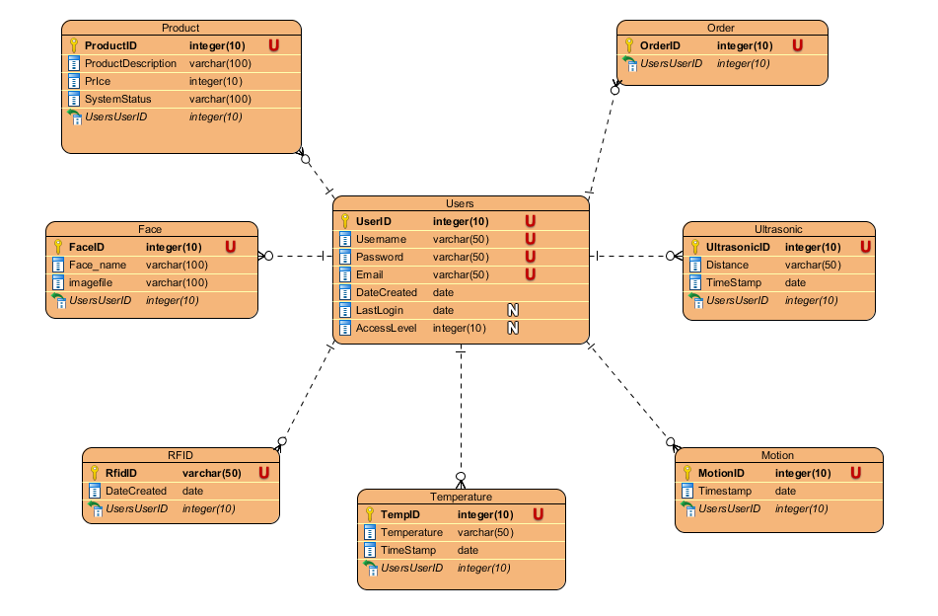

#### 3. Smart Home Windows Application

#### Description:

This application monitors the temperature of the house, monitors user interactions of turning on and off lights using ultrasonic sensors, detects movement around the house and enhances security for homeowners with the use of facial recognition technology, security camera and RFID technology.

* 1. Login

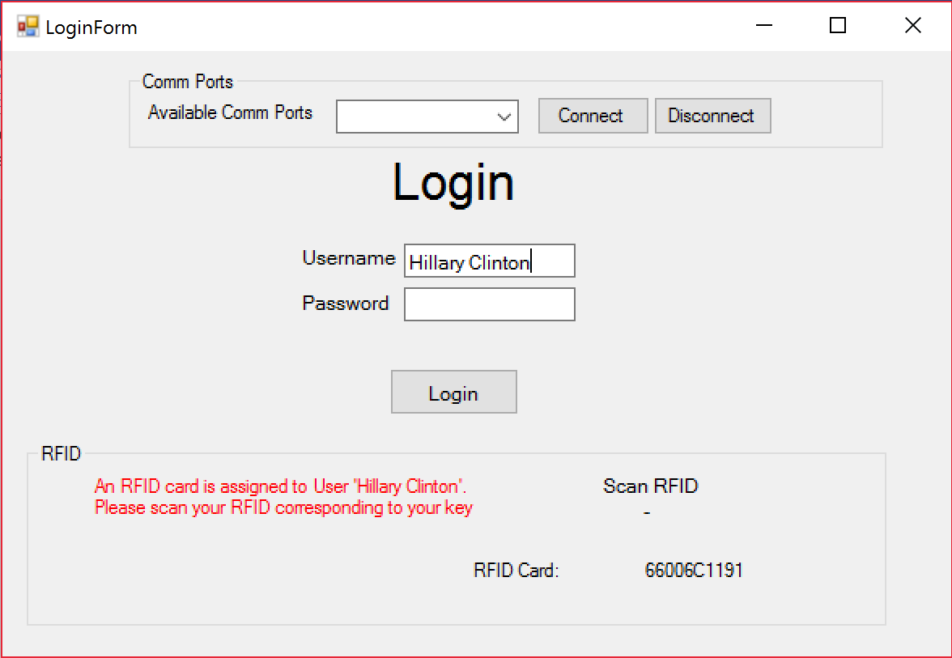

Enter username and password. RFID status will be displayed if RFID card is assigned to username. Tap the correct RFID card corresponding to the assigned RFID for the user to gain access and login.

* 1. Connect to Communication Port of PC.

A list of available com ports will be displayed.

ere

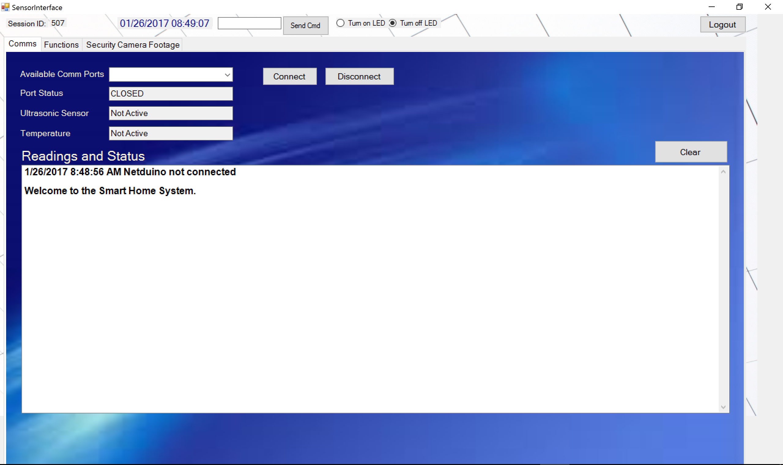

When the system is connected to your PC, a list of available comm ports will be display in the window. Select the appropriate comm port and click connect.

* 1. Main Screens

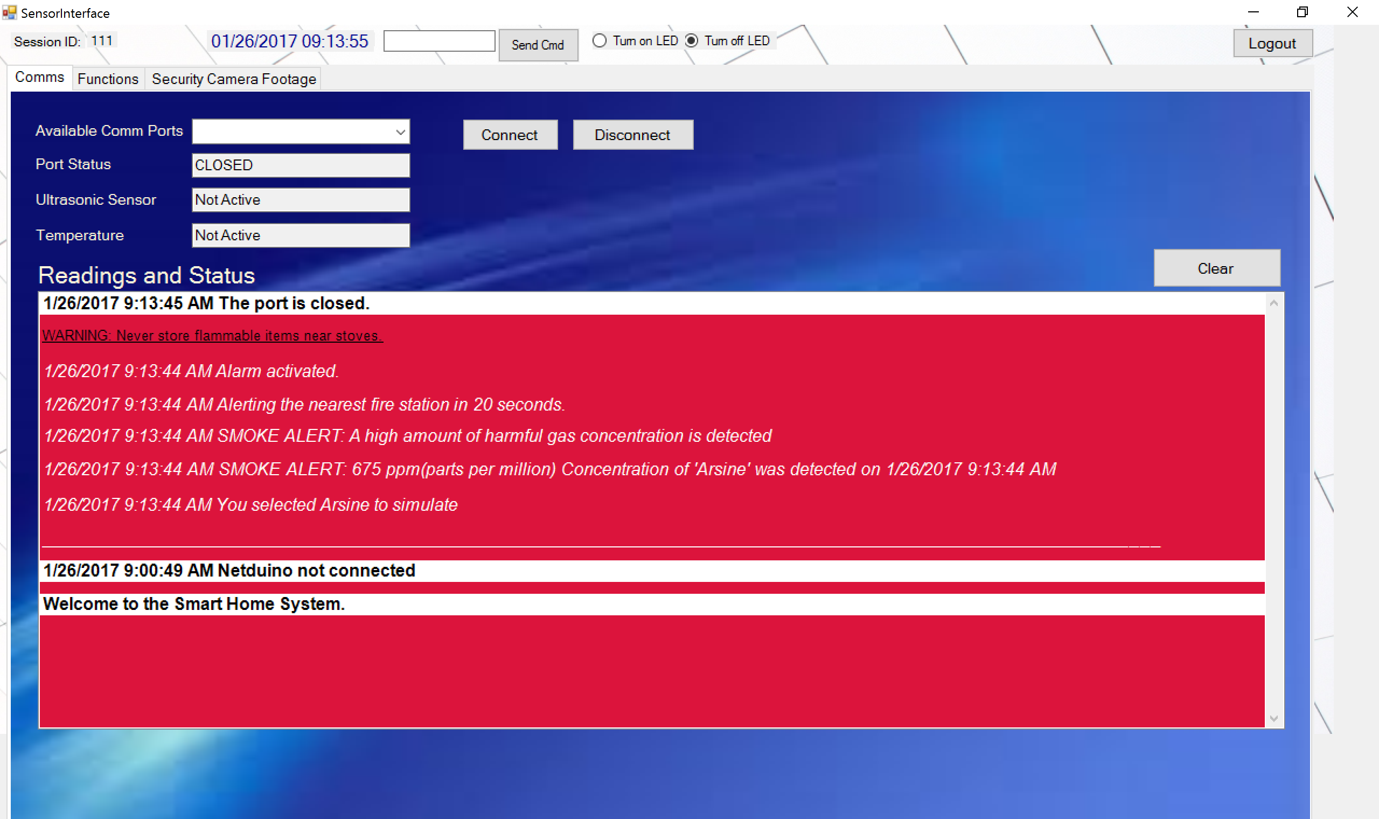

Readings and statuses from simulations and sensors will appear and accumulate in this box

This is the first screen upon loading the Sensor Interface. The most distinctive feature of this screen is this box where readings and statuses from sensors, interactions within the application and simulations will be shown on this box.

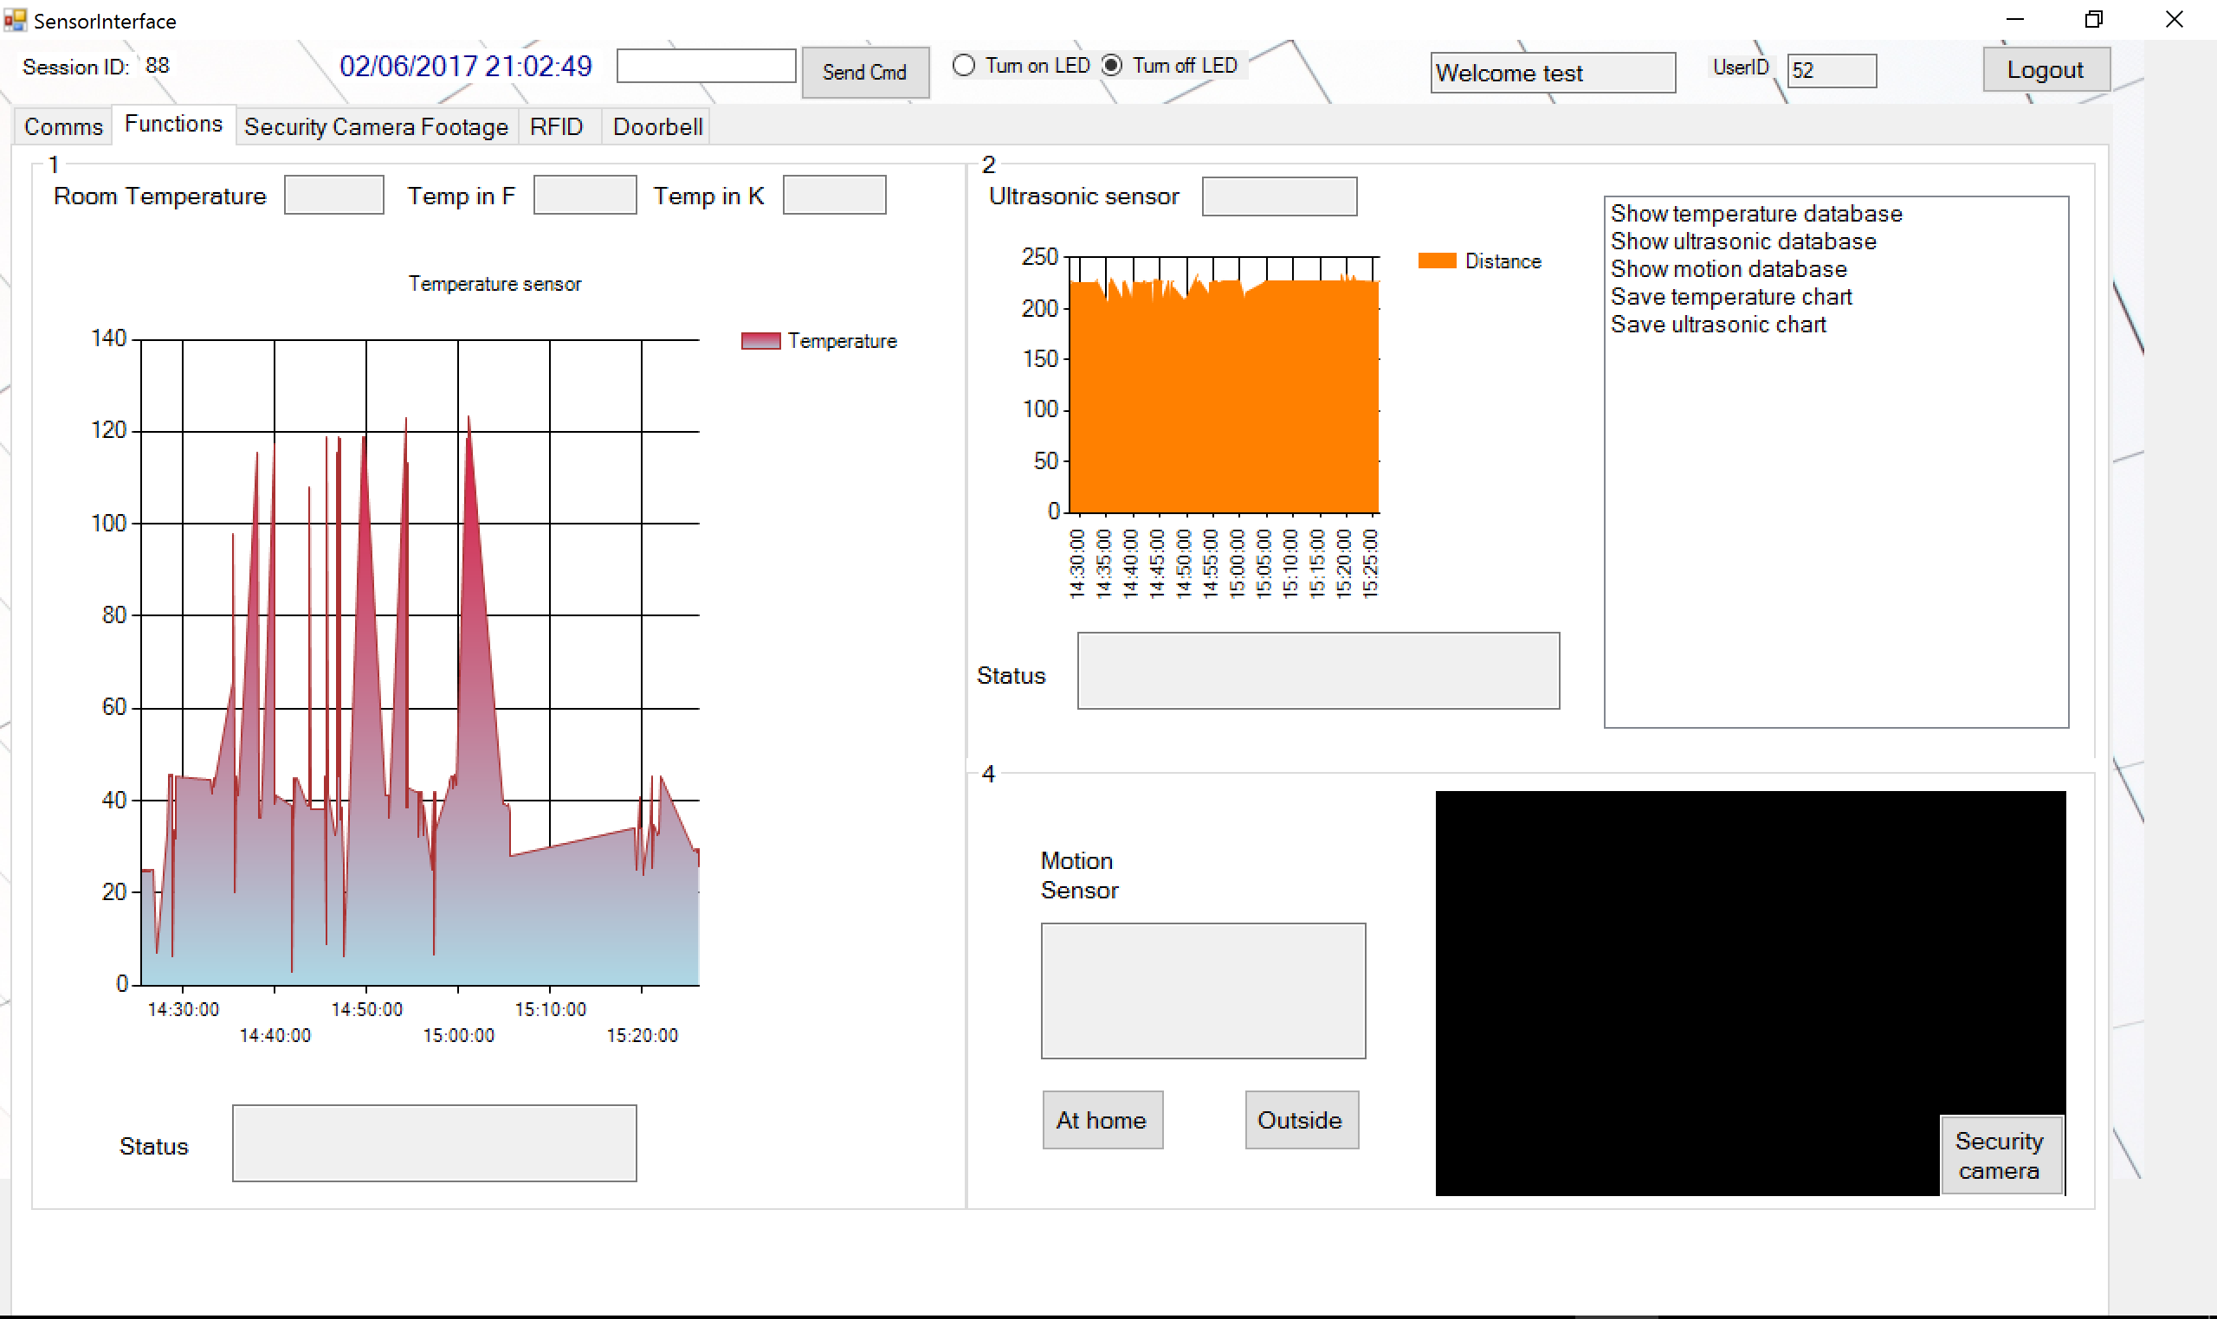

The real time date and time is displayed on top

Ultrasonic Sensor Section

Temperature Sensor Section

Motion Sensor Section

When connected to Netduino hardware and their respective UART programs executed, data will be sent to Windows Form and readings and statuses will be outputted on the Temperature Sensor Section, Ultrasonic Sensor Section and Motion Sensor Section. Data will be sent to database and real time charts will refresh with new data from the database. Run the file in the folder ‘UARTSensor’ for all the respective features, and run ‘UARTTemp&RFID’ for the last feature.

* 1. Temperature Sensor

Readings in C, F and K displayed in the boxes for Temperature Sensor

Real time temperature graph from the database

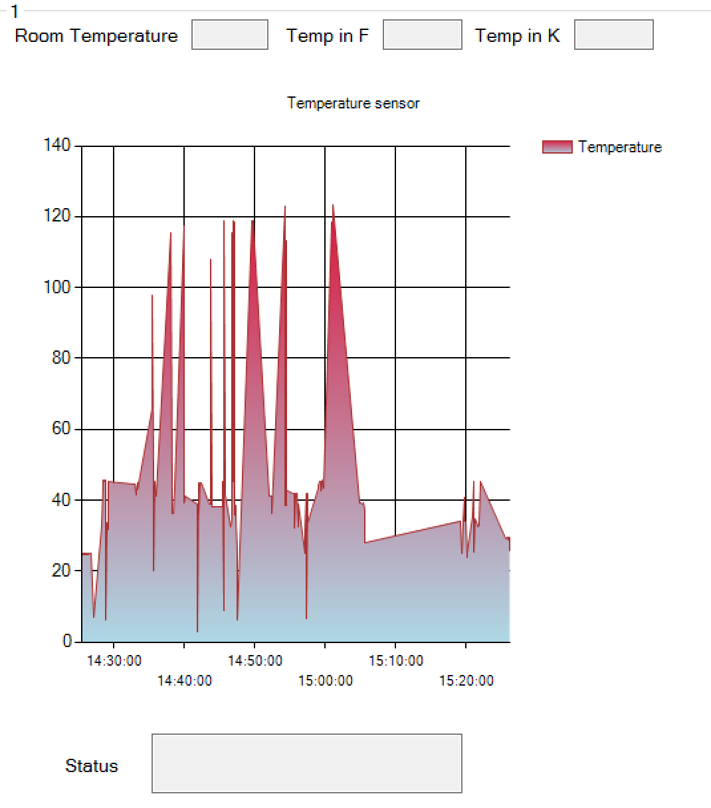

Temperature status corresponds to the temperature readings according to high and low they are

Readings from the temperature sensor will be output on the Temperature Sensor Section’s boxes in Celsius, Fahrenheit and Kelvin. Chart will update periodically as the data sent from temperature sensor is ongoing. The temperature status will correspond periodically with the readings from the temperature sensor.

This box outputs ultrasonic sensor reading

* 1. Ultrasonic Sensor

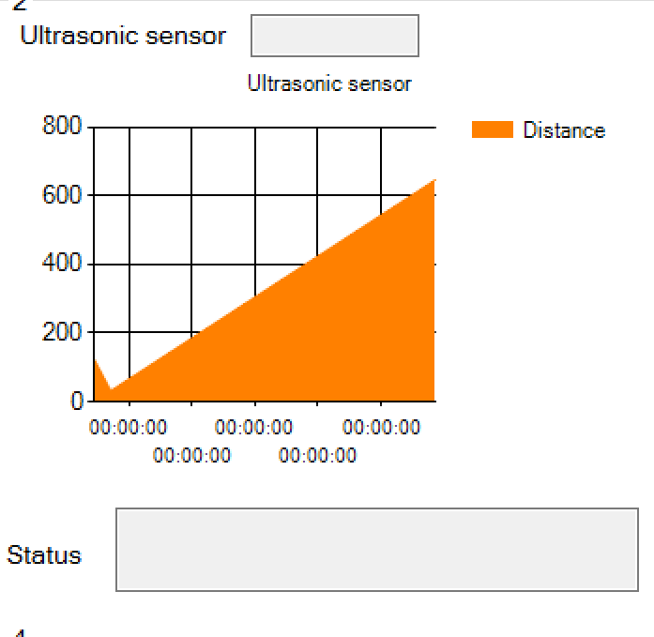

This box outputs ultrasonic statuses according to how close and how far the distance is

to turn on and off lights

Real time ultrasonic graph from database

Readings from the ultrasonic sensor will be output on the Ultrasonic Sensor Section’s boxes. Chart will update periodically as data sent from the ultrasonic sensor is ongoing. The ultrasonic sensor status will correspond periodically with the readings from the ultrasonic sensor.

1.6 Motion Sensor

Security Camera activated when Motion detected

Motion status will be outputted on this box from Motion Sensor

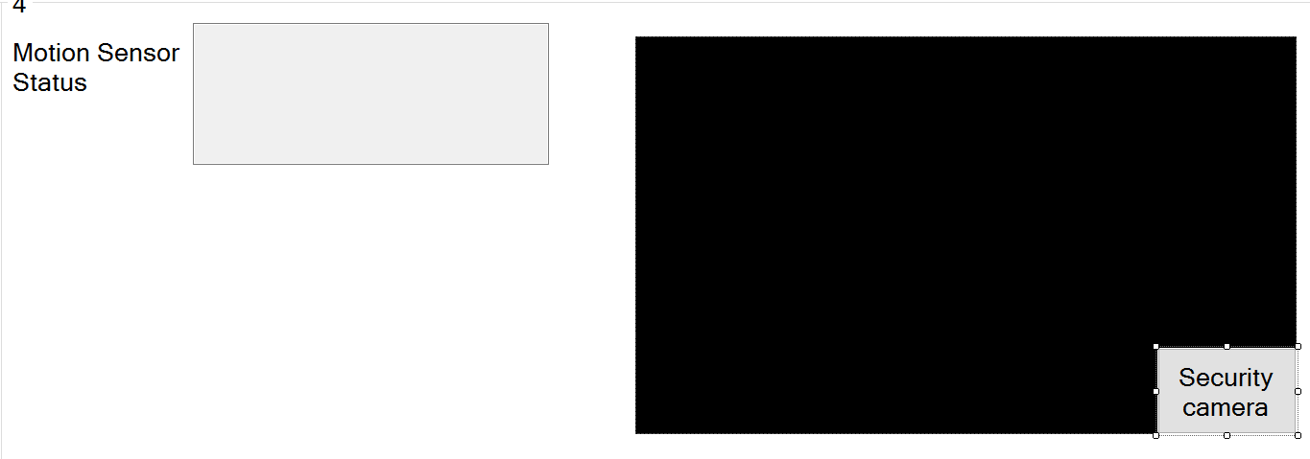

Click this button to view larger camera

Motion reading and status will be output on the Motion Sensor Section’s boxes, every time Motion Sensor detects motion from the surrounding. The camera will be activated and user can click ‘Security camera’ button to redirect to the ‘Security Camera Footage’ tab page to view larger version of the camera. Piezo Buzzer alarm will be activated when motion is detected.

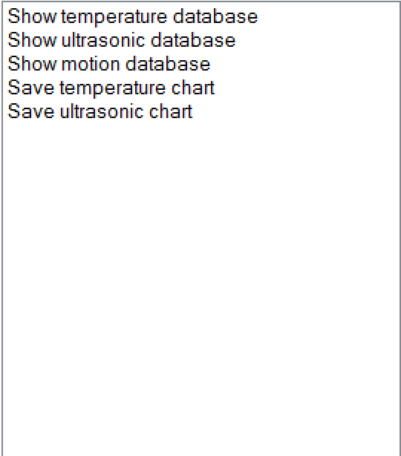

Extra feature to show databases of respective sensors and save charts, mostly for data visualization and presentation purposes

1.7 Door bell

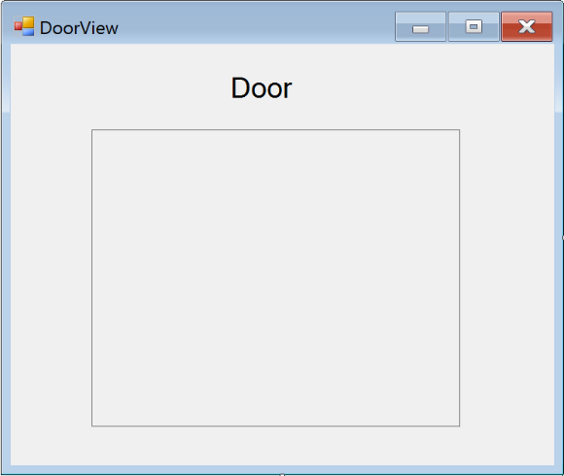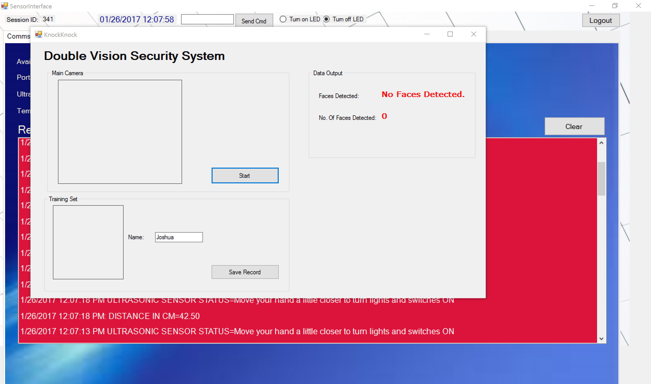

Facial Recognition Camera

Simulate a door bell ring by pressing on Netduino on board push button. Upon pressing the push button, the Facial Recognition Camera will be open and detect faces and names

1.8 RFID Configuration

*Run file ‘UARTTemp&RFID’ for this feature

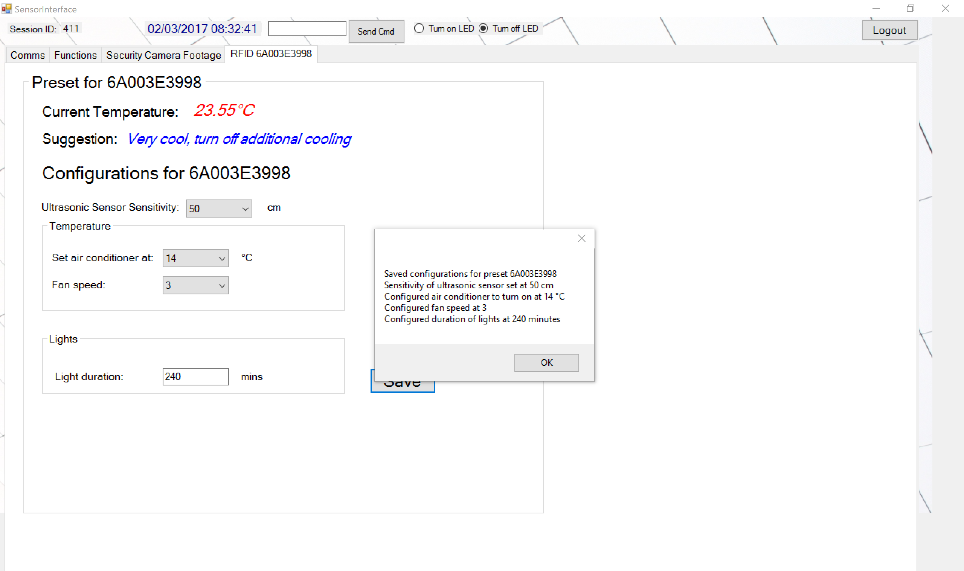

RFID Preset for Card ‘6A003E3998’. Each preset has a different configuration where user can save to the particular RFID

Saved configurations for an RFID Preset popup result

Tap different RFID Cards and presets for different RFID cards will be loaded. Users can configure sensitivity for ultrasonic sensor, set air conditioner at their desired temperature, desired fan speed and set duration of lights to be on for how long they wish.

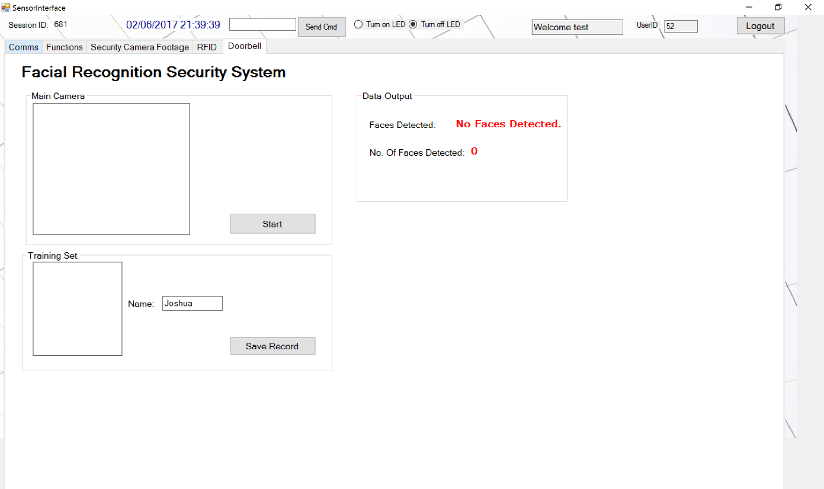1.9 Facial Recognition

#### Touch of Genius Web Application

1. Login screen
   1. Enter account password and username
   2. Validate account
   3. Enter welcome page

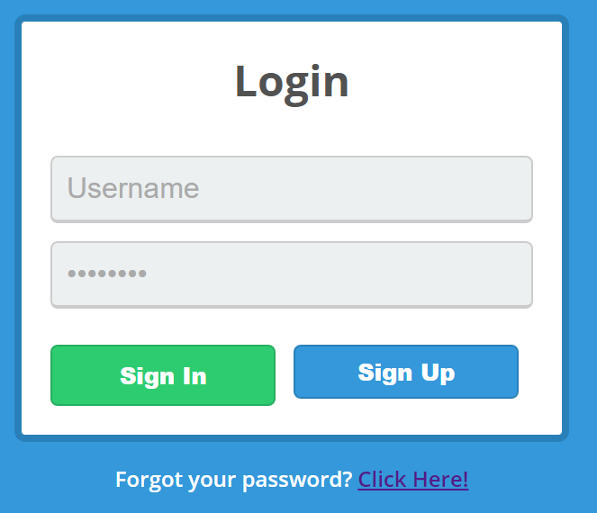

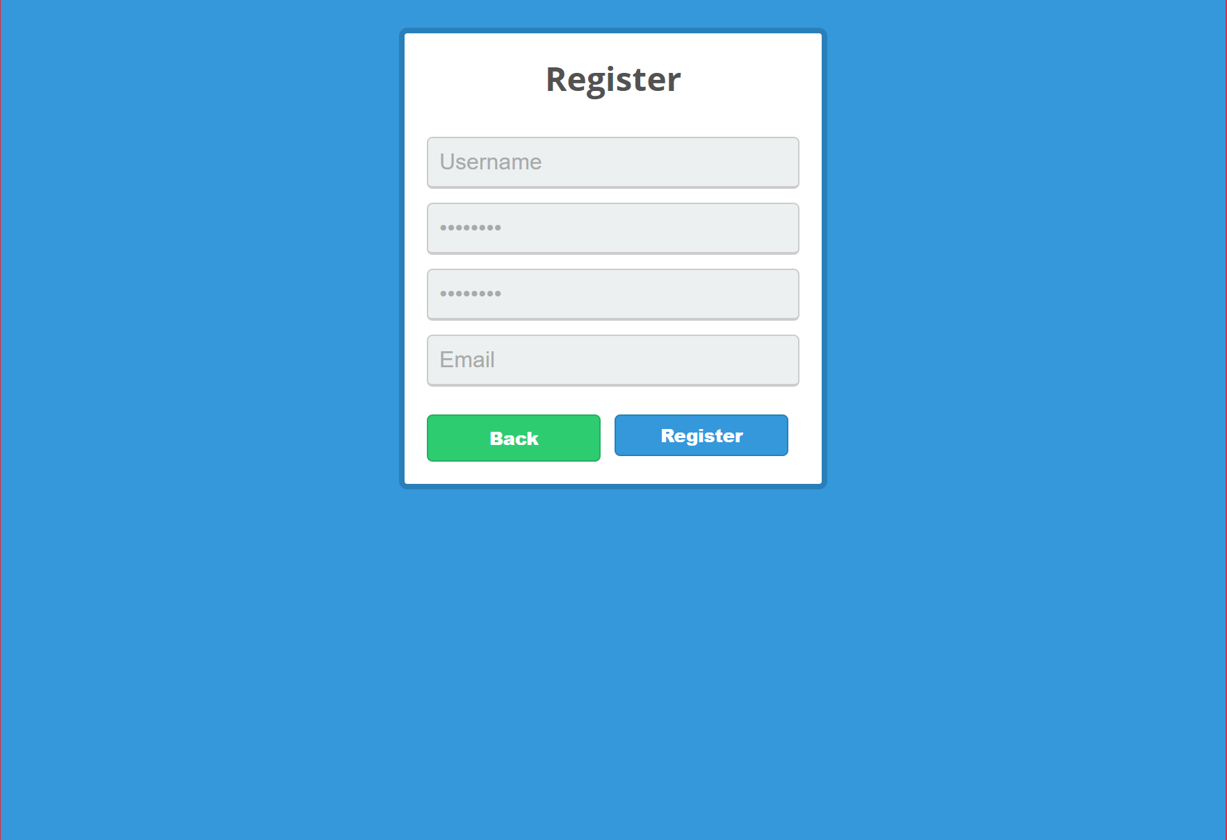

1. Welcome page
   1. Creating account
   2. Able to view sensor statistics

