COS284 Assignment 1

Experimental Set up

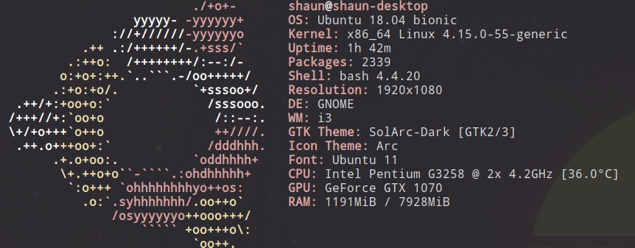
-> This Experiment was conducted on a machine shown below. (This was run natively)

->All programs where run using the script shown below.
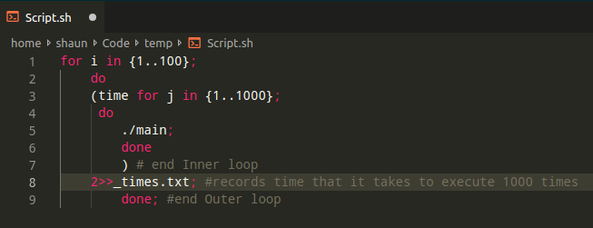
->This script would record the time it took the program to execute 1000 times and it would write that value to a textfile,this process is repeated 100 times for accuracy.
->Averages were Calculated using libreOffice calc.

Results

 | ASM | C++ | Fortran | Python | Lisp | Java
AVG Time (s) | 0.07603 | 0.18069 | 0.11787 | 1.7271 | 2.91298 | 8.89162
Min Time (s) | 0.06321 | 0.16596 | 0.094 | 1.6240 | 2.88501 | 8.36544
File Size (KB) | 1.6 | 8.9 | 8.6 | 0.51 | 0.66 | 0.44

Conclusion
1) As we can see the slowest Languages are the languages that compile into bytecode and then are interpreted, examples of these languages are (Java , Python , Lisp).
2)The faster languages are known as compiled languages, the code in this category of languages is compiled into machine code by the compiler.
3)The fasted test language is assembly, this is the fastest because assembly is assembled, not compiled. The assembly language is the most low level out of the tested languages thus its the fastest.

