#Pandas use for data structures and data analysis  
#Import the necessary libraries  
  
import matplotlib.pyplot as plt  
import pandas as pd  
import seaborn as sns

#Create data_Frame from Array.  
df = pd.DataFrame({  
 'name':['john', 'mary', 'peter', 'jeff', 'bill', 'lisa', 'jose'],  
 'age':[23,78,22,19,45,33,20],  
 'gender':['M','F','M','F','M','F','M'],  
 'state':['CA','DC','CA','DC','VA','NY','NY'],  
 'num_children':[2,0,0,3,2,1,4],  
 'num_pets':[5,1,0,5,2,2,3]  
})

#Scatter plot comparing num_children and num_pets  
df.plot(kind='scatter',x='num_children',y='num_pets',color='red')  
plt.show()

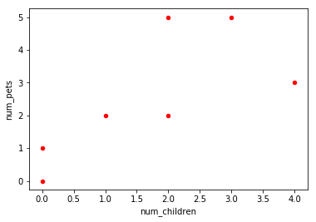

png

#line plot  
df.plot(kind='bar',x='name',y='age')  
plt.show()

#Line plot with multiple columns  
ax=plt.gca()  
df.plot(kind='line',x='name',y='num_children',ax=ax)  
df.plot(kind='line',x='name',y='num_pets',color='red',ax=ax)  
plt.show()

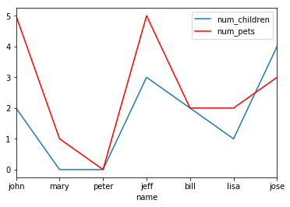

png

#Stacked bar plot with two-level group by  
df.groupby(['state','gender'])['name'].size().unstack().plot(kind='bar',stacked=True)  
plt.show()

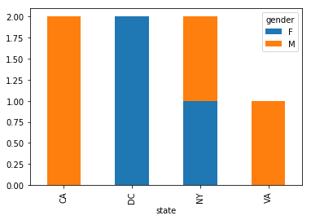

png

#Plot with count of people by gender, splitting by state  
df.groupby(['gender','state'])['age'].size().unstack().plot(kind='bar',stacked=True)  
plt.show()

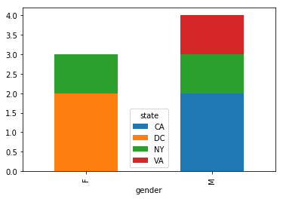

png

#Violinplot  
fig,ax=plt.subplots()  
ax.violinplot(df["age"],vert=False)  
plt.show()

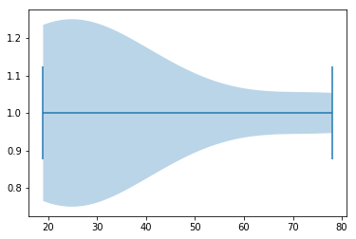

png

#Plot of the distribution of faculty children  
num_bins=10  
plt.hist(df['num_children'],num_bins,normed=1,facecolor='blue',alpha=0.5)  
plt.show()

/anaconda3/lib/python3.7/site-packages/matplotlib/axes/_axes.py:6521: MatplotlibDeprecationWarning:   
The 'normed' kwarg was deprecated in Matplotlib 2.1 and will be removed in 3.1. Use 'density' instead.  
 alternative="'density'", removal="3.1")

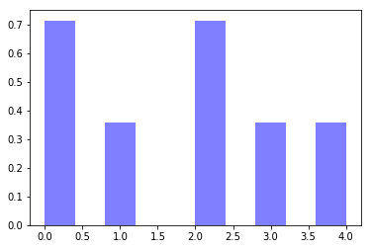

png

#Seaborn Library to construct a pet plot  
sns.set()  
#Set context to "paper"  
sns.set_context("paper")  
#construct pets plot  
sns.swarmplot(x="num_pets",y="age",data=df)  
#Show plot  
plt.show()

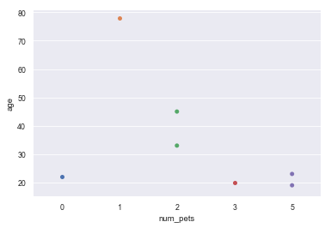

png