A

Minor Project Report on

## Real Estate Investment by Percentages using Python

Submitted in partial fulfillment of the requirements for the degree of

BACHELOR OF ENGINEERING

IN

### Computer Science & Engineering

### Artificial Intelligence & Machine Learning

by

Ayush Bhandari (23106117)

Shaunak Das (23106002)

Anushka Khandar (23106041)

Jayraj Dhole (23106114)

Under the guidance of

## Prof. Yogeshwari Hardas



### Department of Computer Science & Engineering

### (Artificial Intelligence & Machine Learning)

**A. P. Shah Institute of Technology**

**G. B. Road, Kasarvadavali, Thane (W)-400615**

**University of Mumbai**

**2024-2025**

## 

## A. P. SHAH INSTITUTE OF TECHNOLOGY

## CERTIFICATE

This is to certify that the project entitled “**Partial investment in Housing”** is a Bonafide work of Ayush Bhandari (23106117), Shaunak Das (23106002), Anuska Khandar (23106041), Jayraj Dhole (23106114) submitted to the University of Mumbai in partial fulfillment of the requirement for the award of **Bachelor of Engineering** in **Computer Science & Engineering (Artificial Intelligence & Machine Learning).**

|  |  |
| --- | --- |
| ________________ | _______________ |
| Prof. Yogeshwari Hardas | Dr. Jaya Gupta |
| Mini Project Guide | Head of Department |

## 

## A. P. SHAH INSTITUTE OFTECHNOLOGY

## Project Report Approval

This Mini project report entitled “Real Estate Investment by Percentages using Python” by **Ayush Bhandari, Shaunak Das, Anushka Khandar and Jayraj Dhole**is approved for the degree of ***Bachelor of Engineering*** in ***Computer Science & Engineering***, (AIML) ***2024-25.***

##### External Examiner:

##### Internal Examiner:

Place: APSIT, Thane

Date:

**Declaration**

##### We declare that this written submission represents my ideas in my own words and where others' ideas or words have been included, I have adequately cited and referenced the original sources. I also declare that I have adhered to all principles of academic honesty and integrity and have not misrepresented or fabricated or falsified any idea/data/fact/source in my submission. I understand that any violation of the above will be cause for disciplinary action by the Institute and can also evoke penal action from the sources which have thus not been properly cited or from whom proper permission has not been taken when needed

|  |  |  |  |
| --- | --- | --- | --- |
| Ayush Bhandari | Shaunak Das | Anushka Khandar | Jayraj Dhole |
| (23106117) | (23106002) | (23106041) | (23106114) |

#### ABSTRACT

In today's digital era, real estate remains one of the most sought-after investment opportunities. However, traditional property investment requires significant capital, making it inaccessible to many individuals. Additionally, real estate assets are often illiquid, meaning investors cannot easily buy or sell portions of their holdings. These challenges limit participation and create barriers for small-scale investors who wish to enter the market.

This project presents a Partial Investment in Housing model, which enables individuals to invest in fractional ownership of properties, similar to purchasing shares in the stock market. The system allows multiple investors to co-own a property, track their investment growth, and earn proportional rental income based on their ownership percentage. Through a secure digital platform, users can buy, sell, and manage their property shares with ease.

The project also focuses on automated profit distribution and a secondary market for share trading, ensuring that real estate investments become more liquid and accessible. Additionally, the system can integrate blockchain-based smart contracts for enhanced security, transparency, and trust in transactions. This approach democratizes real estate investment, allowing investors to enter the market with smaller capital while benefiting from property appreciation and rental income.

**Keywords:** Fractional Ownership, Real Estate Investment, Digital Property Trading, Smart Contracts, Rental Income Distribution, Investment Liquidity

**Index**

|  |  |  |  |
| --- | --- | --- | --- |
| Index | | | Page no. |
| Chapter-1 | | | 7 |
|  | Introduction | | 8 |
| Chapter-2 | | | 9 |
|  | Literature Survey | | 10 |
|  | 2.1 | History | 10 |
|  | 2.2 | Literature Review | 10 |
| Chapter-3 | | | 13 |
|  | Problem Statement | | 14 |
| Chapter-4 | | | 15 |
|  | Experimental Setup | | 16 |
|  | 4.1 | Hardware Setup | 16 |
|  | 4.2 | Software Setup | 16 |
| Chapter-5 | | | 17 |
|  | Proposed system and Implementation | | 18 |
|  | 5.1 | Diagram of Proposed System | 18 |
|  | 5.2 | Description of Diagram | 18 |
|  | 5.3 | Implementation | 20 |
|  | 5.4 | Advantages | 22 |
|  | 5.5 | Application | 22 |
| Chapter-6 | | | 23 |
|  | Conclusion | | 24 |
| References | | | 25 |

**CHAPTER 1**

**INTRODUCTION**

**1. INTRODUCTION**

In the modern investment landscape, real estate remains one of the most stable and profitable asset classes. However, traditional real estate investment poses significant barriers, primarily due to high capital requirements, illiquidity, and complex legal procedures. Owning a property requires substantial upfront investment, and once purchased, real estate assets cannot be easily divided or sold in smaller portions, making it difficult for small-scale investors to participate in the market. Additionally, investors often face long holding periods before realizing returns, limiting their financial flexibility.

This project seeks to address these challenges by developing a Partial Investment in Housing platform, an innovative solution that allows individuals to invest in fractional ownership of real estate properties, similar to purchasing shares in the stock market. By leveraging digital platforms and automated financial mechanisms, this system enables investors to buy and sell property shares, receive rental income proportional to their ownership percentage, and access real estate investment opportunities without the need for full property ownership.

Beyond making real estate investment more accessible, the system also enhances liquidity and flexibility, allowing investors to trade their shares in a secondary marketplace. Additionally, the project explores the integration of blockchain-based smart contracts to ensure secure, transparent transactions and automated profit distribution.

By combining these functionalities, the Partial Investment in Housing model democratizes real estate investment, providing an efficient, scalable, and secure alternative to traditional property ownership. This project has broad applications in residential and commercial real estate, enabling diverse groups of investors to participate in a once-exclusive market. Through the successful implementation of this system, we aim to bridge the gap between real estate affordability and investment accessibility, creating new financial opportunities for individuals and communities alike.

**CHAPTER 2**

**LITERATURE SURVEY**

**2. LITERATURE SURVEY**

###### 2.1 History

Real estate has long been considered one of the most stable and profitable asset classes. However, traditional real estate investment has remained an exclusive domain, largely accessible only to high-net-worth individuals and institutional investors due to its high capital requirements and illiquid nature. Over the years, attempts have been made to introduce alternative investment models that lower entry barriers while maintaining profitability and security.

The concept of fractional ownership in real estate dates back to timeshare properties, where multiple individuals collectively owned vacation homes. While this model allowed shared usage rights, it did not provide financial liquidity or tradability of ownership stakes. More recently, REITs (Real Estate Investment Trusts) emerged, enabling investors to pool funds and invest in large-scale real estate projects, but without direct property ownership.

With advancements in financial technology (FinTech) and blockchain technology, the idea of partial investment in housing has evolved significantly. Digital platforms now allow investors to buy, sell, and trade fractional shares of properties, making real estate investment more accessible, liquid, and scalable. These developments lay the foundation for this project, which seeks to create a secure and efficient system for fractional home ownership and trading.

#### 2.2 Literature Review

1. **Survey of Existing Solutions**

**Fractional Ownership (Mr. Braam Lowies) ((Research Gate : November 2018, Volume 8, Issue 1):** This study also seeks to understand the motives for engaging with and investing in alternative residential property investments. This study employs a survey-based design via an online questionnaire to gather information on investor age, gender, type, education levels, time horizons and investment history and risk and return expectations. It also gathers information regarding investors’ financial literacy including tax implications of fractional property investment. The findings of this study suggest amongst others, that fractional property investors tend to be younger, although the platform also attracts older investors including older females.

**Partial Homeownership: A Quantitative analysis (Eric Brandsaas) (SSRN: July 2023, Volume 8, Issue 1):**

A convex combination of renting and traditional homeownership—Partial Ownership (PO)—is increasingly popular in many countries. We incorporate an existing for-profit PO contract into a life-cycle model to quantify its impact on investment in housing, households’ welfare, and financial stability. We have the following results: 1) PO makes more households invest in (some) housing. 2) Willingness to pay for PO increases with housing unaffordability and is highest among low-income and renting households.

**2. Analysis of Issues in Surveyed Solutions:**

Despite advancements in real estate investment models, several issues persist:  
**Lack of Liquidity:** Traditional models such as REITs and crowdfunding often restrict the easy buying and selling of ownership stakes, limiting flexibility for investors.  
**Early Adoption of Property Tokenization:** Although property tokenization offers a promising solution for improving liquidity, it is still in the early stages of adoption and has yet to be widely implemented across the industry.

**3. Survey of Users and Potential User Requirements**

Users of the **Partial Investment in Housing** platform, particularly those in the following categories, have specific needs and expectations:

* **Individual Investors:** Seek an easy-to-use platform that offers low entry barriers and flexible investment options, with transparent and secure transactions through blockchain technology.
* **Real Estate Developers:** Need a reliable platform to raise funds for property developments, enabling them to offer fractional ownership and reach a wider pool of investors.
* **Global Investors:** Require a system that allows them to invest in properties across different regions, supporting diverse languages and currencies for a seamless experience.
* **Educational Institutions:** May use the platform as a case study in real estate and blockchain technology, and seek comprehensive resources for teaching innovative investment models.

**4. General Observations**

Overall, the literature and existing solutions highlight a significant gap in the real estate investment market: the lack of a unified platform that combines fractional ownership with liquidity and security. Most real estate investment models, such as REITs and crowdfunding, either focus on accessibility or liquidity but fail to address both simultaneously. As a result, investors are often forced to choose between long-term investment opportunities with limited liquidity or fragmented solutions. The integration of fractional ownership with tokenization and blockchain technology into a single, transparent, and accessible platform could greatly enhance investment flexibility and security. The proposed system aims to bridge this gap by offering a comprehensive solution that provides both accessibility and liquidity to users in a secure and efficient manner

**CHAPTER 3**

**PROBLEM STATEMENT**

#### 3. PROBLEM STATEMENT

In the current real estate market, investing in property often requires significant capital, limiting the ability of small-scale investors to participate. Traditional property ownership involves large upfront investments and long-term commitments, creating barriers for individuals who wish to access the real estate market but lack the necessary funds. Moreover, the lack of flexibility in property ownership—such as the inability to easily buy, sell, or trade shares of a property—further complicates matters. While models like Real Estate Investment Trusts (REITs) and crowdfunding platforms have attempted to democratize real estate investment, they still fail to provide direct ownership, and their liquidity remains limited.

Additionally, existing fractional ownership solutions are often complex, with unclear profit distribution mechanisms and challenges in managing investor exit strategies. This lack of liquidity and flexibility results in difficulties for investors who seek the benefits of property ownership without the high capital risk or long holding periods associated with traditional real estate investment.

Given these challenges, there is a clear need for an accessible and flexible real estate investment model that allows small-scale investors to own a portion of properties while maintaining the ability to easily buy, sell, or trade their shares. This project proposes the development of a Partial Investment in Housing platform, which aims to bridge the gap between traditional property ownership and more accessible, flexible investment solutions. By enabling fractional ownership with seamless trading capabilities, the proposed system will allow users to invest in properties, earn proportional rental income, and have the flexibility to exit their investment more easily than with current models. This innovative solution seeks to make real estate investment more inclusive and efficient for a broader audience

**CHAPTER 4**

**EXPERIMENTAL SETUP**

#### 4. EXPERIMENTAL SETUP

#### 4.1 Hardware Setup

The development and testing of the system were carried out on a computer with the following specifications:

* **Processor:** Intel Core i5 or higher
* **RAM:** 8 GB or more
* **Storage:** 256 GB SSD or higher
* **Operating System:** Windows 10 or Linux Ubuntu 20.04 LTS

#### 4.2 Software Setup

#### The project utilized the following software tools and libraries:

#### Programming Language: Python 3.8

#### ****Web Framework:**** Django, used for developing the backend of the platform, enabling seamless communication between the server and user interface for transactions, property data management, and user interactions.

#### ****Data Storage:**** MySQL, employed to store user data, transaction history, and property information, ensuring data integrity and availability.

#### ****Payment Integration:**** Stripe, integrated for secure, real-time payment processing, allowing users to make investments and track returns

#### ****User Interface Framework:**** Html,javascript used for creating a dynamic, user-friendly frontend interface that allows users to interact with the platform and view real-time updates on their investments.

**CHAPTER 5**

**PROPOSED SYSTEM & IMPLEMENTATION**

#### PROPOSED SYSTEM &IMPLEMENTATION

#### Diagram of Proposed System

#### 

#### Description of Diagram

### ****User Registration & Authentication****

* All users must **register** on the platform to access features.
* Upon logging in, users select their **role (Admin, Seller, or Buyer),** which determines their permissions and dashboard layout.
* The system employs **role-based authentication** to ensure users only access relevant features.

1. **Seller Workflow – Listing Properties for Fractional Investment**
2. **Property Listing Process**

A Seller (Property Owner) submits a new property listing for sale on the platform.

The Seller provides essential property details, including:

i) Property Title & Description

ii) Location & Valuation

iii) Ownership Documents

iv) Images & Additional Information

1. **Admin Verification & Approval**

Before the property is made available for fractional investment, the Admin reviews and verifies the listing.

i) If approved, the property is listed on the marketplace for investors to purchase fractional shares.

ii) If rejected, the Seller receives a notification to modify or remove the listing.

### ****Buyer Workflow – Purchasing Fractional Property Ownership****

**Investors (Buyers)** browse through **verified property listings** available on the platform.

They can **purchase a percentage (e.g., 10%)** of a property instead of buying the entire asset.

The system calculates the **investment cost based on the total property value** (e.g., if a property is valued at ₹1,00,00,000, a 10% share costs ₹10,00,000).

Once the purchase is completed:

i) The **Investor’s ownership share** is recorded in the database.

ii) The **property’s available percentage for sale** is updated dynamically

1. **Resale of Fractional Ownership (Buyer Selling Property Shares)**

i) Buyers can choose to resell their fractional ownership at any time.

ii) The system calculates the resale value based on market conditions, ensuring fair pricing.

iii) When an Investor lists their share for resale:

iv) The property fraction is made available for other buyers.

v) Funds are credited to the original seller’s wallet.

vi)A new Investor can purchase the available share.

#### 5.3 Implementation

1) Login Page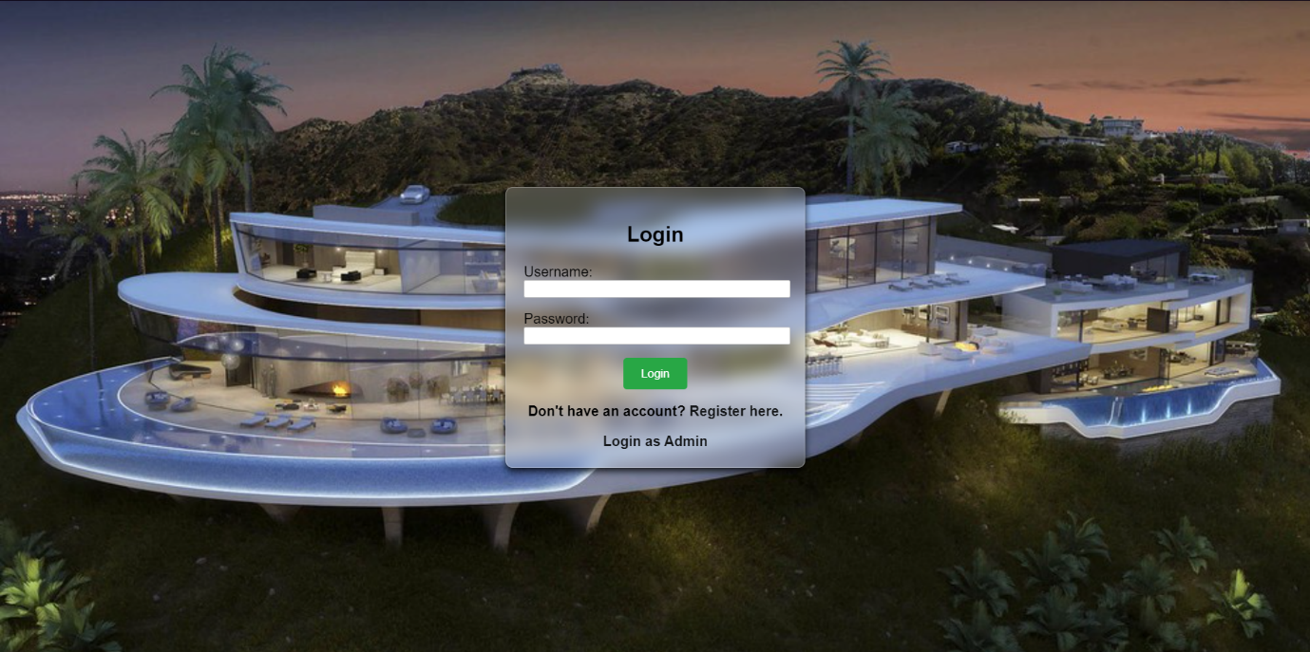

2)Buyer Dashboard

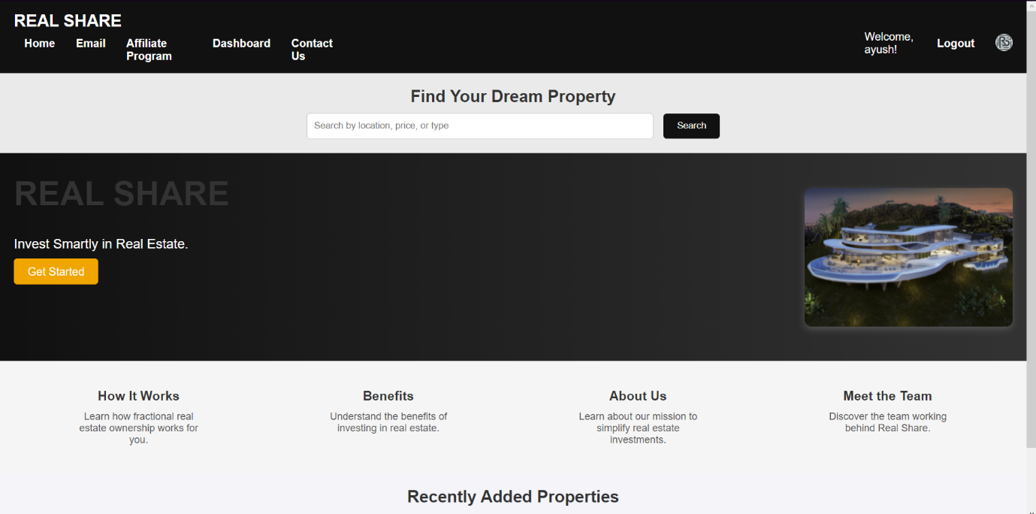

3) Seller Dashboard

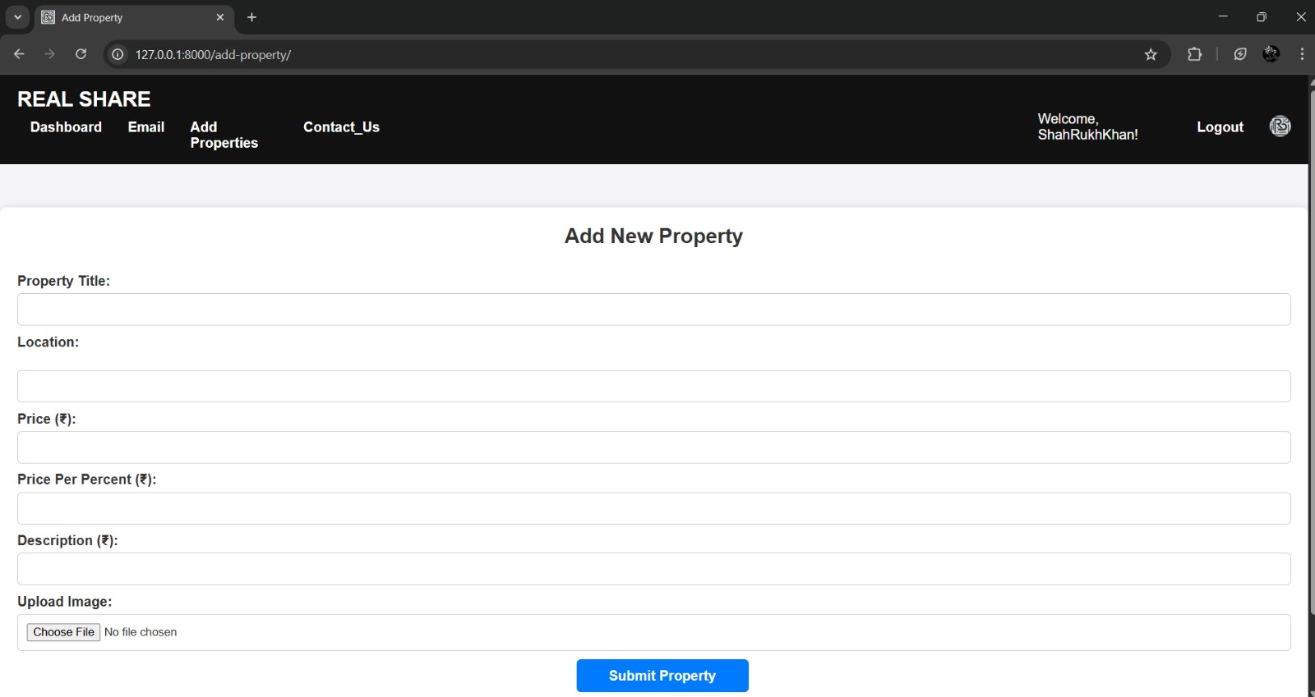

4) Admin Dashboard

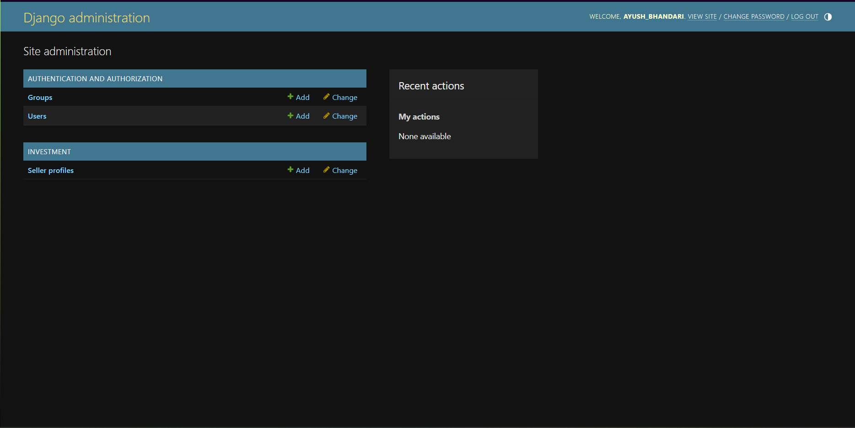

**5.4** **Advantages**

The **Partial Investment in Housing** platform makes real estate investment accessible by lowering capital requirements and offering flexible, secure, and transparent fractional ownership. Its integration of blockchain ensures safe transactions and provides liquidity, making it a practical solution for diverse investors.

#### ****5.5 Application****

This platform is ideal for individual investors looking for affordable real estate opportunities, real estate developers seeking to raise funds, and educational institutions as a case study in innovative investment models. It also supports global accessibility, making property investment possible in regions with limited market access.

**CHAPTER 6**

**CONCLUSION**

1. **CONCLUSION**

### ****6.1 Summary of Work****

This project successfully developed a **Partial Investment in Housing** platform that aims to democratize real estate investment by enabling individuals to own fractional shares in properties. The system provides a seamless solution for users to invest in real estate with low capital, while also ensuring flexibility in buying, selling, or trading ownership shares. By integrating blockchain technology for secure transactions and utilizing smart contracts for property share management, the platform offers an innovative approach to property investment. Additionally, the system provides a user-friendly interface for easy navigation and investment tracking. This project addresses key challenges in the real estate sector by making property ownership more accessible, transparent, and manageable for a broader audience.

### ****6.2 Future Scope****

Future developments of the **Partial Investment in Housing** platform could include:

* **Expansion to Additional Markets:** Extending the platform’s reach to more countries and regions, enabling global access to fractional property investments and expanding the scope of available properties.
* **Integration of AI for Property Valuation:** Implementing machine learning algorithms to predict property values and investment returns more accurately, offering personalized investment recommendations based on market trends.
* **Mobile Application Development:** Creating a mobile app version of the platform to enhance user experience, enabling on-the-go access for investment tracking and management.
* **Increased Liquidity Options:** Introducing more flexible exit strategies for investors, including the ability to trade property shares within the platform to improve liquidity and reduce investment risks.
* **Sustainability Integration:** Incorporating sustainability ratings for properties, allowing users to make environmentally conscious investment decisions.

# REFERENCES

* Fractional Ownership (Mr. Braam Lowies) ((Research Gate : November 2018, Volume 8, Issue 1)
* Partial Homeownership: A Quantitative analysis (Eric Brandsaas) (SSRN: July 2023, Volume 8, Issue 1)
* Dr. Manish R. (2019). Real Estate Investment Trusts (REITs). International Research Journal of Real Estate (IRJRE), Volume 15, Issue 3.

* <https://shreebalajiconstruction.com/fractional-property-investment/#:~:text=Understanding%20Fractional%20Property%20Investment%20Definition,rent%20or%20appreciation%20in%20value>.
* Partial ownership, control, and investment in vertical relationships (Wiley Blackwell )(IDEAS: January 2024,Volume 31)