OSTutorLLM Project Report
  - An Adaptive Tutor for Learning and Teaching Operating Systems
  - Design Implementation Evaluation and Research Roadmap
Project report
24 October 2026
OSTutorLLM combines curated Operating Systems lessons, Groq generated teaching notes, short quizzes and a controlled review workflow. The report documents the implemented application and evaluates its behavior using local tests and a real provider request.
The main finding is that the prototype supports a functioning learn–check–review–advance cycle. The available evidence establishes software behavior for the tested cases; it does not establish improved student learning, comprehensive syllabus coverage or independently verified answer accuracy.
The report follows the requested sequence of introduction, literature review, problem statement, objectives, methodology, results and discussion, conclusion, limitations, future work and references. Planned document retrieval and institution-specific fine-tuning are discussed separately from the working system.
Implementation reviewed: FastAPI backend, browser interface, 19 knowledge records, 38 lesson parts, authored quizzes and optional cloud generation.
Evidence baseline: project source and test artifacts available on 24 October 2026.

Abstract
Operating Systems education requires students to connect definitions with process behavior, resource constraints and practical examples. A general answer generator can explain terminology, but it does not automatically structure a lesson, assess understanding or decide whether a learner is ready to continue. OSTutorLLM addresses this design problem through a small, inspectable tutoring application.
The implemented system contains 19 curated topics across six categories. Each topic has two lesson parts, giving 38 parts in total. A learner reads an explanation and example before answering two questions. Both answers must be correct to unlock the next part. Otherwise, the application provides feedback and a simpler explanation before another attempt. Groq optionally expands the lesson notes and revision points; local content remains available when generation cannot be used.
The backend uses FastAPI and Pydantic, while a responsive HTML, CSS and JavaScript interface presents the learning workflow. The separate question-answer endpoint uses weighted lexical retrieval over the bundled records. This endpoint is distinct from the Groq lesson generator. The application does not yet ingest institutional documents, create semantic embeddings, maintain a vector database or perform custom model fine-tuning.
Evaluation combines a 30-query retrieval diagnostic, 14 automated regression tests and 11 live integration checks for a Round Robin lesson. Direct-topic retrieval succeeded on 12 of 12 cases, paraphrase retrieval on 7 of 12, and unrelated-question rejection on 1 of 6. The real Groq request completed in 2.07 seconds in the final recorded run. All recorded automated and live functional checks passed after corrections.
These findings support the feasibility of the implemented tutoring workflow while exposing weaknesses in retrieval, citation precision, coverage and evaluation. Future development should prioritize document-grounded generation, checked numerical exercises, richer assessments and instructor-reviewed learning studies. The project is presented as an adaptive tutoring prototype rather than a completed retrieval-augmented and fine-tuned educational model.
Keywords: Operating Systems; adaptive tutoring; Groq; language models; formative assessment; lexical retrieval; educational software.

Table of Contents
Abstract 2
1 Introduction 4
Background and educational context 4–5
Scope and implementation boundaries 6
2 Literature Review 7
Retrieval and external knowledge 7
Instruction following and adaptation 8
Assessment and learning design 9
Synthesis and project positioning 10
3 Problem Statement 11
4 Objectives 12
5 Methodology 13
Architecture and curriculum 13–14
Retrieval and Groq generation 15–16
Adaptive lesson workflow and API 17–18
Interface and reliability 19–20
Test design and reproducibility 21–22
6 Results and Discussion 23
Functional and retrieval results 23–24
Live generation and browser evidence 25–26
Interpretation of findings 27
7 Conclusion 28
8 Limitations 29
Technical and educational limitations 29–30
9 Future Work 31
Document RAG and research extensions 31–32
10 References 33
Pagination includes the title page, abstract, contents and references. References continue on page 34. The report records the current implementation; proposed components are identified in the relevant chapters.

1 Introduction

1 1 Project background
An Operating System coordinates computation, memory, devices and stored information. Students must understand both the abstractions visible to a program and the mechanisms that make those abstractions work. Introductory courses therefore move between conceptual explanations, algorithms, numerical exercises and practical laboratory tasks. A student may memorize the definition of a page fault yet still be unable to explain why a particular reference string causes repeated replacements.
This gap motivates a teaching assistant that presents a manageable concept, checks an immediate learning goal and offers another explanation when the learner struggles. OSTutorLLM implements that interaction for a selected introductory topic set. The project emphasizes the sequence of teaching and assessment instead of treating every student interaction as an isolated question.
The application has two related pathways. Ask OSTutor supports short questions against a curated knowledge base. Guided learning starts from a selected topic and follows a fixed sequence of lesson parts. The first pathway is implemented with weighted lexical retrieval and response templates. The second can use Groq generated notes while preserving local lesson structure, question keys and progression rules.
The distinction is important when interpreting the project name. A language model is integrated into note generation, but the application has not trained a new Operating Systems model. It also lacks the document-ingestion and semantic-search pipeline required by the proposed institutional RAG design. The report therefore describes the present artifact accurately and places larger research ambitions in future work.
The central engineering question is whether these components can form a reliable learning interaction: choose a topic, read one part, answer a small check, receive useful review, and advance only after success. A second question concerns evidence: which conclusions are justified by software tests, and which would require an educational study? Keeping those questions separate prevents implementation success from being reported as a learning-outcome claim.

1 Introduction

1 2 Teaching and learning context
Several properties make OS concepts difficult to teach through prose alone. Scheduling introduces a timeline shared by competing processes. Memory management distinguishes logical addresses from physical locations. Synchronization requires reasoning about possible interleavings rather than a single sequential execution. Deadlock combines resource ownership with waiting relationships. Effective instruction must explain the vocabulary and help the learner trace a concrete case.
The conceptual organization of Operating Systems around virtualization, concurrency and persistence provides a useful reference for curriculum planning [1]. OSTutorLLM uses a smaller implementation-oriented grouping: CPU Scheduling, Memory Management, Process Management, Deadlocks, Synchronization and File Systems. These categories organize the interface, but they do not yet represent a complete institutional syllabus.
Consider Round Robin scheduling. A first lesson can introduce the quantum and show how much work remains after a turn. A later lesson can address re-queuing and the relationship between quantum size and switching overhead. Splitting the explanation creates a specific target for each short check. It also makes a failed answer more actionable than a low score on a broad end-of-course quiz.
The project adopts this structure without claiming that two questions establish mastery. The interface uses a completion indicator to show progress through the authored material. In research terms, completion is an application state. A learner who answers both questions correctly may still struggle with a new process set, a delayed test or an explanation that requires free recall.
The intended users are students revising core concepts and faculty examining a prototype for classroom support. Students receive a readable lesson and immediate feedback. Faculty can inspect the topic definitions and question keys in code. The present build offers no faculty dashboard, course-authoring interface or automatic grading of submitted programs. Those capabilities would require additional design and evaluation.
The resulting role is supplementary. The tool can organize practice around selected concepts, while lectures, reviewed course notes and practical laboratories provide the broader learning environment. This positioning also guides the interpretation of the generated content: clear prose is useful, but it remains subject to verification.

1 Introduction

1 3 Scope and implementation boundaries
The reviewed artifact is a local web application with a Python backend and a browser frontend. Its 19 knowledge records are manually authored and stored with topic IDs, keywords, category labels and short explanations. A separate curriculum supplies two parts per topic. Groq can expand the prose, but the underlying scope remains the selected topic outline.
The current implementation is intentionally described in layers. Presentation includes topic selection, notes, progress and quizzes. Application logic handles validation, lesson sessions and progression. Content logic includes lexical retrieval, deterministic answer formatting and authored question keys. Generation is an optional external service with validation and local fallback.
Capability | Present scope
Content | 19 topics, 38 parts, six categories
Lesson assessment | Two authored questions per part; both correct to advance
Generation | Expanded notes, key points and simpler explanations through Groq
General questions | Weighted lexical retrieval and prepared answer formatting
Persistence | Tab resume with server memory; no long-term learner database
Research extensions | Document RAG, fine-tuning and learning studies are not implemented

This scope excludes automatic shell-lab generation, a secure code execution sandbox, semantic indexing and model training. It also excludes verified passage citations: the source labels in the current dataset are broad descriptions rather than exact page references. Readers should not interpret a source card as evidence that an external textbook passage was retrieved.
The report uses current source files and recorded test artifacts as the implementation record. Earlier project reports describe an older lexical-only build. Where those reports differ from the present system, the current source and latest test evidence take precedence. Performance values remain tied to their specific local measurements.

2 Literature Review

2 1 Retrieval and external knowledge
Retrieval-augmented generation links a generator with external information selected for a question. Lewis and colleagues describe a framework that combines parametric language-model knowledge with retrieved non-parametric information [2]. The relevance to an OS tutor is the ability to ground an explanation in course-specific material rather than relying entirely on the model’s internal knowledge. That connection motivates the proposed document RAG extension; it is not evidence that the current application implements the research architecture.
Dense Passage Retrieval represents questions and passages in a learned vector space and uses retrieval to find candidates for question answering [3]. Such methods address a different matching problem from exact keyword overlap. They offer a possible route for retrieving a memory-management passage when the student uses a paraphrase. Whether that route improves this project must be established with an OS-specific evaluation set.
The existing retriever is useful as a baseline because its scoring process can be inspected directly. It rewards overlap with topic titles, keywords and content, then adds phrase bonuses. A student-facing advantage is predictable topic matching when the wording is close to the authored record. The main weakness is that common words can raise a score without establishing relevance, while a useful paraphrase can be ranked behind a related concept.
A future comparison should hold the course corpus and test queries fixed while varying retrieval strategy. The lexical baseline, a dense retriever and a hybrid approach can then be compared using the same labels. The study should include unsupported questions as well as relevant ones. Otherwise a system that returns an answer to everything may appear capable while failing to recognize when the corpus offers no support.
The literature therefore suggests a design direction, not a substitute for local evidence. For OSTutorLLM, the first practical step is a corpus with precise passage identifiers. Retrieval quality, citation correctness and generated answer quality can only be evaluated coherently when the relationship between a response and its supporting material is observable.

2 Literature Review

2 2 Instruction following and model adaptation
Instruction-following research studies how models can be shaped to respond more closely to user intentions. Ouyang and colleagues describe training with demonstrations and human preferences [4]. The relevant lesson for this project is that model behavior depends on how a system specifies the task and how that behavior is evaluated. A fluent model response should not be treated as evidence that the model follows every pedagogical requirement.
OSTutorLLM applies instructions at inference time. Its prompt asks for two lesson parts, beginner-friendly explanations, revision points and an easier analogy. It also supplies the topic outline and facts needed by the quiz. This is prompt-based configuration of an existing hosted model. The project does not collect a new training set or update the model’s parameters.
LoRA introduces a parameter-efficient adaptation approach using trainable low-rank updates rather than changing all model weights [5]. It is relevant to the proposed educational fine-tuning phase because an institution may want a consistent explanation style or structured question generation. The present report does not claim that LoRA was applied, that any adapter exists or that an adapted model outperforms the hosted baseline.
The choice between better prompts, document retrieval and custom training depends on the failure being addressed. Missing course facts point toward a better corpus and retrieval. An inconsistent output structure points toward prompting and validation. A persistent teaching-style problem across many reviewed examples may justify investigating fine-tuning. Treating every failure as a training problem would obscure simpler interventions.
The implementation also shows why provider configuration is part of practical model selection. The original configured model returned a model-not-found error during live testing. Selecting an available model restored generation. This is operational compatibility evidence, not a benchmark comparing model families. No claim is made that the selected model is the best OS teacher.
A credible adaptation study would define a held-out set of teaching tasks and compare baseline prompts with the adapted model under the same constraints. Instructor review should assess factual accuracy, clarity and alignment with the intended learning objective before reporting gains.

2 Literature Review

2 3 Assessment and learning design
A tutor must do more than deliver text. It needs a way to collect evidence of understanding and use that evidence to decide what happens next. Black and Wiliam examine assessment and classroom learning, emphasizing the educational role of evidence and feedback [6]. This supports the design principle of linking a check to a subsequent teaching action. It does not establish that the particular threshold used in this application is educationally optimal.
Roediger and Karpicke report research on the role of retrieval tests in later retention [7]. Their work provides a reason to investigate testing as part of learning rather than using a quiz only for final grading. Applying that finding to OSTutorLLM would require a separate study, because its current checks are short multiple-choice items with immediate retries and visible corrective information.
The project uses each quiz as a local decision point. An incorrect answer retains the learner on the same part and reveals a simpler explanation. A correct pair allows continuation. This produces an observable feedback loop: the answer changes the next available teaching action. It is a stronger interaction design than presenting notes and an unrelated quiz, but it remains a limited form of adaptation.
Two choices per question simplify the initial interface but weaken the evidence supplied by a correct attempt. Under an independent random-guessing assumption, the chance of getting both binary questions right is one quarter. Repeated attempts and answer feedback further reduce the value of eventual completion as a measure of durable understanding. The system should therefore describe completion as progress through the lesson rather than a validated mastery classification.
Future assessment can include varied examples, numerical working, short explanations and delayed questions. A student who explains why a process returns to the ready queue provides different evidence from one who recognizes a correct phrase. Combining question formats may reveal misconceptions that binary checks miss.
The literature informs the purpose of the learning loop, while project evaluation must determine whether learners benefit from it. Software tests can verify that feedback appears and advancement is gated. They cannot show whether students retain the concept a week later or transfer it to an unfamiliar problem.

2 Literature Review

2 4 Synthesis and project positioning
The reviewed work suggests three distinct concerns: locating relevant knowledge, shaping explanations and responding to learner performance. OSTutorLLM addresses parts of the latter two and retains a simple baseline for the first. Its contribution at this stage is the integration of a controlled lesson sequence with optional generated prose, transparent scoring and failure-tolerant delivery.
The project does not present a new language-model architecture, retrieval algorithm or training method. The novelty that could be investigated lies in the educational workflow and its evaluation for OS topics. This distinction matters when framing a research contribution: integrating known tools can produce a useful system, but its value must be demonstrated with evidence appropriate to the claimed outcome.
Research strand | Implication for the project | Current boundary
External knowledge [2,3] | Retrieve approved passages before answering | Only bundled outlines and lexical records
Instruction following [4] | Specify teaching tasks and evaluate adherence | Prompting rather than new training
Efficient adaptation [5] | Investigate reviewed teaching-style examples | No custom adapter or training run
Formative assessment [6] | Use responses to guide feedback | A fixed two-question progression rule
Retrieval practice [7] | Study retention through repeated recall | No delayed retention study

A suitable research progression starts with the current application as a reproducible baseline. A document-grounded version can then be introduced without simultaneously changing every component. If learner outcomes improve, the study design should help identify whether the benefit came from better source material, explanation quality, assessment or additional practice time.
For reporting purposes, the current title is an adaptive OS tutor. A title claiming a retrieval-augmented and fine-tuned domain model would require further implementation and corresponding evaluation. The literature review establishes the rationale for those extensions while preserving a clear account of what was actually built.

3 Problem Statement
Students studying Operating Systems need explanations that connect terminology with concrete behavior. Existing notes may be concise but difficult to interpret without a teacher’s example. A general chatbot can provide a longer explanation, yet it may not follow the course sequence, identify the learner’s immediate difficulty or check readiness before moving to the next concept. The engineering problem is to make these teaching decisions explicit and inspectable.
For this prototype, the problem is defined as follows: design and implement a browser-based tutor that teaches a selected OS topic in small parts, checks understanding after each part and provides simpler review when the learner does not satisfy a stated criterion. The system must remain usable when the external note-generation service fails, and it must grade against a stable question key rather than depending on model-generated scoring.
The problem has a content dimension and a workflow dimension. Content must be understandable, relevant and consistent with the assessed facts. Workflow must prevent premature advancement, preserve the current part and handle retries without mixing question versions. A correct interface sequence is not sufficient if the explanation contains an incorrect numerical example; equally, accurate notes do not produce an adaptive tutor unless answers affect the teaching flow.
The current evidence also identifies a retrieval problem. Weighted lexical matching retrieves direct topic names well but struggles with paraphrases and unsupported questions. This affects the separate Ask OSTutor pathway. Improving that pathway requires a better relevance decision and stronger source grounding; adding an external model to topic notes alone does not solve those retrieval weaknesses.
The research problem is broader than the implementation problem. It asks whether the interaction improves learning compared with a reasonable alternative, such as reviewed static notes with equivalent practice. That question remains open. No student participant study, instructor-rated answer benchmark or delayed assessment has been completed.
The report therefore evaluates a working software prototype and defines the remaining research task. It does not infer educational effectiveness from the presence of a model, a quiz score or a successful API response.

4 Objectives
The primary objective is to provide a coherent learning cycle for selected OS concepts. The learner should be able to start a topic, understand the next action, receive a check on the current part and continue or revise according to the result. Supporting objectives address content delivery, correctness of state transitions and evidence for evaluation.
Objective | Implementation criterion | Status
Organize OS content | 19 topics across six categories, two parts per topic | Implemented
Generate richer notes | Server-side Groq generation with validated output | Implemented
Check each lesson part | Two questions; both correct to continue | Implemented
Provide simpler review | Feedback and easier explanation after mistakes | Implemented
Preserve grading integrity | Question IDs, attempt checks and local answer keys | Implemented
Remain usable on failure | Curated fallback after provider or validation errors | Implemented
Ground in course documents | Ingest approved files and cite exact passages | Future work
Demonstrate learning gains | Instructor review and controlled learner study | Not evaluated

The implemented objectives are evaluated using functional criteria. A failed check must not unlock the next part. A retry must use the current attempt version. The final successful part must produce a completion state. An unavailable provider must not stop the learner from accessing the bundled lesson. These criteria are observable and can be exercised repeatedly.
Longer-term objectives concern source quality and educational impact. They require different evidence from regression tests. A model may produce valid JSON yet make a factual error; a learner may complete a quiz without retaining the material. Future acceptance criteria should therefore include expert review, transfer questions and delayed retention alongside technical performance.

5 Methodology

5 1 System architecture
The application separates browser presentation from teaching state and external generation. FastAPI exposes routes for questions, topics, quizzes and guided lessons. Pydantic models define accepted request shapes. The browser renders returned content and submits choices; the server owns the answer keys and progression decisions. This division allows the same state rules to be tested without manually operating the interface.
Starting a lesson selects the authored curriculum and optionally enriches it through Groq. The returned content becomes a session snapshot, so a later provider request cannot silently change the lesson that the student is answering. The lesson service then manages checks and advancement against that snapshot.
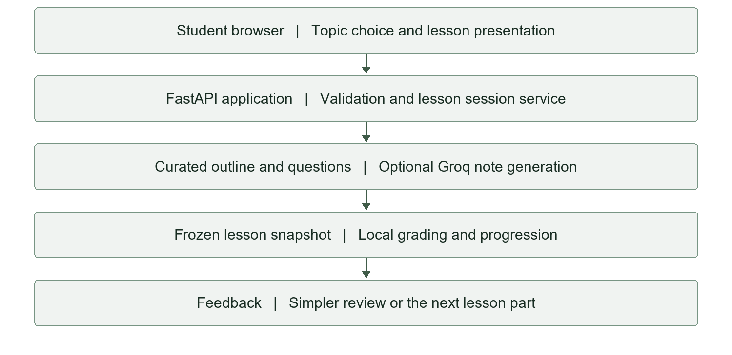
Figure 1 Implemented guided learning architecture
The general question endpoint follows a separate path: validated question, category filter, lexical ranking, threshold decision and formatted response. It does not call Groq. Both paths share the same topic catalog, but they should not be conflated when describing the implementation. A full document retrieval layer is a proposed addition, not a hidden component of the present architecture.

5 Methodology

5 2 Curriculum and data representation
The bundled knowledge base contains 19 records. Each record has a stable ID, topic, category, keyword list, source label and content string. Stable IDs connect the topic catalog with the guided curriculum and reduce ambiguity when the display title changes. The lesson curriculum adds a title, standard explanation, simpler explanation, example and two question tuples for each part.
A question tuple contains a prompt, correct choice and distractor. The server shuffles the choices and retains the resulting answer index. It also shuffles the two questions. The presented order therefore varies, while the identity of each question remains available for grading. There are 76 authored lesson questions across the 38 parts, in addition to the eight-question general quiz.
Category | Topics | Lesson parts
CPU Scheduling | Round Robin, FCFS, SJF, priority | 8
Memory Management | Paging, segmentation, virtual memory, replacement, First Fit | 10
Process Management | States, threads, context switching, fork | 8
Deadlocks | Conditions; prevention and avoidance | 4
Synchronization | Critical sections; semaphores and mutexes | 4
File Systems | Allocation methods; file-system basics | 4

The data is authored demonstration content rather than an imported academic corpus. Source labels such as OS Faculty Notes describe a category of material, not a verified document and page. A formal course deployment would need reviewed content, provenance and explicit alignment with learning outcomes.
The representation favors inspectability. Faculty can trace a quiz answer to the part that teaches it, and tests can compare all topic IDs with the curriculum keys. The trade-off is limited authoring support: updates currently require editing source content rather than using a course-management interface.

5 Methodology

5 3 Lexical question answering
The Ask OSTutor pathway begins by validating the question and requested response mode. Tokenization lowercases the text and extracts unique alphanumeric tokens. The retriever filters the knowledge records when a specific category is chosen. It then compares the query tokens with each eligible record’s title, keywords and body.
The unnormalized score assigns weight 4 to each overlapping title token, weight 3 to each keyword token and weight 1 to each body token. It adds a five-point bonus when an eligible topic or keyword phrase of at least four characters occurs in the normalized query. The score is divided by the square root of the number of query tokens. Records with positive scores are ranked and up to three candidates are returned.
Normalized score = (4 × title overlap + 3 × keyword overlap + body overlap + phrase bonuses) / √query token count
The answer endpoint rejects the retrieved set when no record exists or the top normalized score is below 0.35. Otherwise, it formats the leading record in the selected style. A second record can be added as a related concept if its score reaches 72 percent of the leading score. The four styles are Beginner, Exam Revision, Viva and Interview, and Practical Lab.
These modes currently modify the introductory and closing guidance rather than creating four independently generated explanations. A score below 2 is labelled medium confidence after it passes the rejection threshold; higher values are labelled high. These labels are heuristics. They are not calibrated probabilities and should not be interpreted as a likelihood that the answer is correct.
There is no stopword removal, semantic embedding, spelling correction or numerical reasoning stage in this path. The evaluation therefore includes both direct queries and paraphrases, plus unrelated questions. The algorithm’s transparency helps explain errors: shared common words and overlapping concepts can dominate a short query even when its intended meaning is different.
This retriever provides a useful baseline for future improvement. A revised method should be evaluated on a held-out set containing unsupported examples as well as relevant OS questions, so improved coverage does not come at the cost of answering irrelevant requests.

5 Methodology

5 4 Groq generated teaching notes
Groq integration enriches a selected topic rather than replacing the local curriculum. The server sends the topic title, short reference content, the two lesson outlines and their assessed facts to the chat-completions endpoint. No student answers are included in that generation request. The selected configuration uses openai/gpt-oss-20b through Groq, with low reasoning effort and reasoning excluded from the returned content [8,9].
The prompt asks for exactly two parts in the original order. Each generated part contains an explanation, a simpler explanation, an example field and three to five revision points. The request uses JSON object mode. Because JSON syntax alone does not establish the expected structure, Pydantic validates the response before the application uses it [10,12].
Validation rejects missing fields, unexpected fields, blank or overly long text, an incorrect number of parts and an invalid revision-point count. A completion whose finish reason indicates truncation is also rejected. These checks enforce a data contract; they do not verify the educational truth of each statement. Factual review remains a separate concern.
A live browser inspection revealed an inconsistent generated Round Robin example. The implementation was corrected so generated content cannot overwrite the checked curriculum example. The request now asks the model to copy that example, and the merge step preserves the original regardless of the model’s response. This creates a numerical anchor without pretending that all generated prose is automatically verified.
Successful topic notes are cached in memory for one hour per topic and model. A session receives its own copy of the merged parts. Provider failures, invalid responses and missing credentials return the curated lesson with a clear notice. Failed requests are not cached as successful generation results.
The API key is loaded on the server from the environment or local configuration. It is not placed in JavaScript, prompts or public API responses. A fixed HTTPS endpoint and disabled redirects reduce accidental credential forwarding. The client uses a five-second connection timeout and a 30-second timeout setting for other network phases; this is not a strict total wall-clock deadline.

5 Methodology

5 5 Adaptive lesson workflow
Guided learning uses an explicit state machine. A new session begins in learn. The student reads the part and chooses to reveal its short quiz. Submission is evaluated locally. If both answers are correct, an intermediate part becomes passed; if the final part is passed, the session becomes complete. Otherwise, the phase becomes review and the interface shows corrective feedback and the easier explanation.
Current phase | Action or result | Next phase
learn or review | Fewer than two correct answers | review
learn or review | Two correct answers on an intermediate part | passed
passed | Learner chooses Learn next part | learn on the next part
learn or review | Two correct answers on the final part | complete
complete | Choose another topic or restart | New session

The server checks the submitted part index and attempt number before grading. A stale attempt or a duplicate submission receives a conflict response. Question IDs must exactly match the current check, and each selected choice must be one of the two allowed integer indices. These conditions prevent an answer from one displayed check being interpreted as a different version.
A failed check increments the attempt and prepares another randomized presentation of the same authored questions. It does not generate new assessment content. The simpler explanation is associated with the current part; it is not produced from the learner’s specific mistaken choice. This makes the flow predictable but limits the depth of personalization.
Progress is kept in a server-memory dictionary protected by a lock. Each session has a random identifier and a last-touched timestamp. Inactive sessions expire after one day. The browser stores the latest session ID in tab session storage, allowing a refresh to resume while the server state still exists. Restarting the server clears progress.
External generation occurs outside the global lesson-state lock. One learner’s network request therefore does not hold that lock while another learner is submitting a check. A separate per-topic lock prevents repeated simultaneous generation of the same cached topic.

5 Methodology

5 6 API and assessment integrity
The API separates lesson creation, retrieval, grading and advancement. This avoids coupling a student’s answer submission with an automatic move to content they have not yet chosen to read. Explicit advancement also makes the successful-check feedback visible before the next lesson part appears. FastAPI provides the route framework and interactive API documentation [11].
Route | Purpose
GET /api/health | App status, record count and generation configuration flag
GET /api/topics | Topic catalog and category list
POST /api/ask | Lexical question answering
POST /api/lessons/start | Start a topic and prepare a lesson snapshot
GET /api/lessons/{session_id} | Resume the current lesson state
POST /api/lessons/{session_id}/check | Grade the current attempt locally
POST /api/lessons/{session_id}/next | Advance only from a passed part
GET /api/quiz | Return the general quiz without answer keys
POST /api/quiz/submit | Grade the general quiz using submitted IDs
GET /api/metrics | Read in-memory runtime counters

The general quiz previously shuffled questions for display but graded the submitted choice indices against the original order. The correction adds question IDs to the frontend submission and reconstructs the grading order from those IDs. Duplicate or missing IDs are rejected when IDs are supplied. The legacy answers-only API remains compatible with canonical order, while the current browser always supplies IDs.
Assessment integrity here means that the server grades the displayed question against its intended key. It does not mean the quiz is a validated examination instrument. The code still requires content review and stronger assessment design before scores should be used for consequential academic decisions.

5 Methodology

5 7 Frontend design and interaction
The frontend uses a white and green visual style selected during development. White surfaces, green actions, readable text and restrained borders replace the earlier dark appearance. Topic buttons start guided learning directly. The lesson section presents part progress, an explanation, revision points when available, a checked example and a provenance notice.
Teaching content appears before the quiz. The learner reveals the questions when ready, and the form requires a choice for both items. After submission, the interface displays the score and corrective information. A review result exposes an easier explanation and retry action. A passed result exposes the next-part action. Completion offers a restart or another topic.
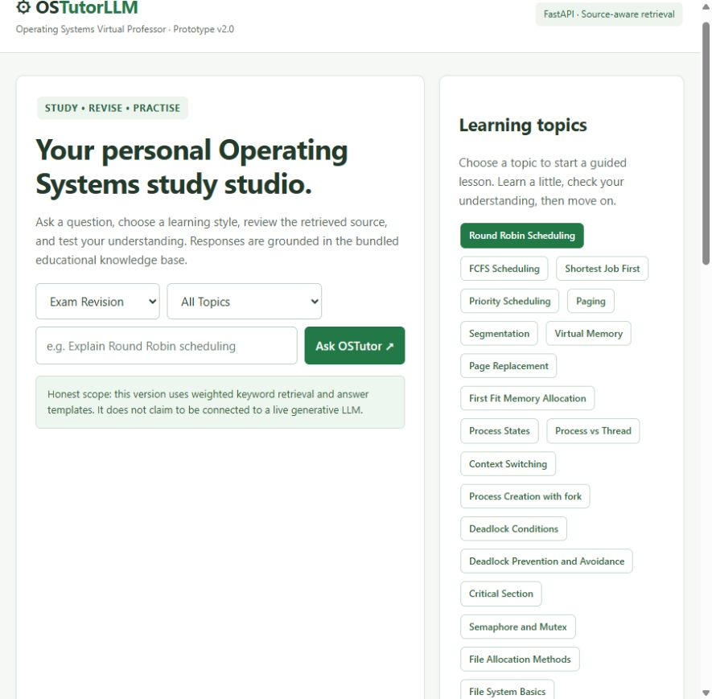
Figure 2 White and green interface captured during frontend verification
The layout switches its main grids to one column on narrower screens. Labels, fieldsets, keyboard focus outlines and status text support basic access. Generated prose is inserted as text rather than executable markup. Desktop browser inspection was completed; this report does not claim a full mobile-device or accessibility compliance audit.

5 Methodology

5 8 Reliability and data handling
A teaching tool should fail in a way that preserves the learning interaction. The generation service may reject a model, rate-limit a key, return malformed content or fail to respond. OSTutorLLM catches the expected provider and validation failures and returns the local curriculum. A notice distinguishes generated notes from built-in material, so fallback is visible rather than silently presented as successful generation.
Only successful generations enter the cache. A later request can therefore recover after a transient failure. Cache entries are copied before being used in a session, which prevents accidental mutation of shared cached content. Session snapshots also ensure that the explanation and the local check remain stable during a lesson.
Credential handling is kept separate from browser content. The local environment file is ignored by Git, and the example configuration contains no real key. Provider exceptions are not logged verbatim because request or response details could expose sensitive information. The logs record a generic fallback message and topic identifier instead. Public health information reports configuration state but never returns the secret.
The present application processes only the bundled topic outline when generating notes. It does not upload student identity, answers or a full institution document collection. Future document ingestion would change the information flow and require an explicit policy for permitted material, access rights and storage. Those requirements should be designed before a corpus is connected.
Local hosting is also a boundary. The tested service listens on the local loopback address. There is no authenticated course account system, public deployment hardening, durable database or production load study. A random session ID is useful for separating demonstration progress, but it is not a replacement for an authorization design in a deployed educational service.
Reliability claims are therefore restricted to tested application behavior. Provider fallback, local grading and state checks have regression coverage. Availability under high concurrency, recovery after machine failure and confidentiality in a multi-user deployment remain untested concerns rather than completed guarantees.

5 Methodology

5 9 Evaluation design
Evaluation uses three evidence layers. First, regression tests verify deterministic application behavior without real provider calls. Second, a small query set characterizes the lexical retrieval baseline. Third, an explicit live check exercises real generation through the running local application. Browser inspection adds evidence about what the learner actually sees.
The regression suite uses Python unittest and the FastAPI test client. One curriculum test iterates through every topic and both lesson parts, forcing a failed check, reviewing the simpler explanation, retrying correctly and completing the topic. Other tests cover one-correct-answer behavior, invalid choice types, stale attempts, independent sessions, expiry and general-quiz ordering.
Provider tests replace outbound HTTP with controlled responses. Cases include a valid generation, missing key, expired cache, mutable-copy isolation, unauthorized response, rate limit, server error, timeout, malformed JSON, incorrect structure and incomplete completion. A model-specific request test checks the chosen reasoning settings. These tests do not incur live generation charges or measure model quality.
The retrieval diagnostic contains 12 direct topic questions, 12 paraphrases for corresponding topics and six unrelated questions. A supported case is correct when the expected topic ranks first and is accepted. A separate top-three indicator records whether the expected topic appears among the candidates. An unrelated case is correct when the retriever falls below the acceptance threshold.
The live integration script starts Round Robin, verifies the provider field, checks that answers are hidden, attempts to skip a part, deliberately answers incorrectly, retries correctly, advances and completes the topic. It starts the topic again to confirm reuse of generated content. This is a functional scenario for one topic, not an evaluation of all generated notes.
No learner sample was recruited and no instructor-scoring protocol was executed. Accordingly, the design does not estimate knowledge gain, retention, engagement or comparative educational effectiveness. Those outcomes require a separate study with defined participants, tasks and scoring criteria.

5 Methodology

5 10 Execution and reproducibility
The reviewed application was run locally with Python 3.10.11. The installed development environment included FastAPI 0.133.0, Uvicorn 0.41.0, Pydantic 2.12.5 and HTTPX 0.28.1 during the initial inspection. Requirements use compatible version ranges rather than a fully locked environment, so future installations may resolve different versions. These versions describe the observed setup, not minimum-performance recommendations.
A reproducible application run requires the source files, installed dependencies and the configured Groq model if live generation is to be exercised. The API key should remain outside the report and repository. The server loads the environment at startup, so configuration changes require a restart. Restarting also clears lesson sessions and cached notes.
The standard regression command is python -m unittest -v test_lessons test_groq_notes. It exercises the local contract without a real provider. The explicit live command is python .report_qa/live_groq_test.py while the application is running. The live script makes a generation request when the topic cache is empty and saves its observations in a JSON artifact.
The lexical diagnostic is generated by report_evaluate.py. It extracts the retrieval-related definitions and evaluates the fixed 30-case set. It also measures 1,200 local retrieval calls after warm-up. This timing excludes HTTP, browser rendering and generation. The live generation timing instead measures a request through the running application; it should not be compared as if both numbers measured the same operation.
Evidence artifacts include evaluation.json, groq_live_test.json and the saved browser screenshots. The report uses the final recorded values rather than inventing repeated-run averages. The source tests show the conditions being asserted, while the artifacts record the observations of a particular run.
For a formal research release, the project should add a dependency lock, versioned curriculum, source revision identifier and evaluation dataset version. Provider model IDs and availability should also be recorded per run. This would make later comparisons more meaningful when code, prompts, models or institutional materials change.

6 Results and Discussion

6 1 Functional test results
The final recorded regression run passed all 14 test methods. This count should not be confused with 14 topics or 14 learner observations. Several methods contain multiple assertions and subcases. In particular, the curriculum test exercises failure, review, retry and completion across all 19 topics and 38 parts. The result supports consistency of the implemented state rules for the tested cases.
Test area | Observed outcome | Interpretation
Curriculum progression | Passed for all 19 topics | The authored flow completes under correct local answers
Review and retry | Passed | Misses retain the part and reveal simpler teaching content
Validation and stale attempts | Passed | Malformed and outdated checks are rejected
Session independence and expiry | Passed | Progress is separated and expiration is enforced
General quiz ordering | Passed | Submitted IDs preserve grading order
Provider success and failures | Passed with mocks | Generation contract and fallback branches behave as tested
Real integration scenario | 11 of 11 live checks passed | One topic works through the configured provider

These findings resolve the earlier general-quiz ordering defect. They also show that the adaptive feature is more than a visual change: a failed check prevents next-part access at the API level, and a successful check changes the available state. Attempt validation protects this behavior from repeated or stale submissions.
The evidence has a defined boundary. Mocked provider tests verify handling of response shapes and failures; they cannot confirm the quality of future model outputs. Likewise, a completed simulated lesson does not measure a real student’s understanding. The results establish an operational baseline from which content and learning quality can be studied separately.

6 Results and Discussion

6 2 Retrieval baseline results
The fixed retrieval diagnostic contains 30 cases. Direct topic wording produced correct first-ranked matches in all 12 cases. Paraphrased wording produced correct first-ranked matches in seven of 12 cases. The expected topic appeared among the top three results for 23 of the 24 supported queries. Unsupported-question rejection was weak: only one of six unrelated cases was rejected.
Metric | Recorded result
Direct topic first-rank accuracy | 12/12 = 100%
Paraphrase first-rank accuracy | 7/12 = 58.3%
Combined supported first-rank accuracy | 19/24 = 79.2%
Expected topic in top three | 23/24 = 95.8%
Unrelated questions correctly rejected | 1/6 = 16.7%
Retrieval timing sample | 1,200 timed calls after warm-up
Median local retrieval latency | 0.332 ms
95th percentile local retrieval latency | 0.559 ms

The results suggest that the retriever often finds a relevant candidate but does not always rank it first. For example, a question about removing a page when no free frame remains ranked Paging above Page Replacement. The answer formatter uses the first result, so a high top-three hit rate alone does not ensure an appropriate answer.
The question about the capital of France incorrectly returned an OS topic above the acceptance threshold. Common-word overlap and the low threshold explain why an unrelated request can look like a match. This is a material limitation of the general question pathway. Adding Groq notes to guided topics does not correct it.
These percentages describe a small diagnostic set with author-assigned expected topics. They are not a general model accuracy score and do not measure student learning. The low retrieval timing reflects a tiny in-memory corpus and local function calls; it does not predict document-scale search or end-to-end response time.

6 Results and Discussion

6 3 Live Groq integration results
The first live attempt after key configuration returned built-in content because the original model ID was not available to the account. The provider returned a model-not-found classification. The authenticated model list showed openai/gpt-oss-20b as available. The configuration and default were updated, and a model-specific regression test was added for the request settings.
The final live scenario passed all 11 checks. The initial Round Robin request completed in 2.07 seconds and returned provider=groq. Part one contained 178 explanation words and three revision points. Starting the topic again from the populated cache took 6.55 ms in that run. These values are individual observations, not medians across repeated network tests.
Live check group | Recorded behavior
Generation and structure | Groq output used; expanded notes and key points present
Assessment exposure | No answer keys in public quiz questions
Progression gate | Attempt to skip the current check rejected
Incorrect answers | Review phase and distinct simpler explanation returned
Correct retry | Part one passed and next part unlocked
Second part | Generated lesson snapshot retained; correct answers passed
Completion and cache | Topic completed; subsequent start reused notes

The model-selection correction demonstrates why a working credential is not sufficient proof of a functioning generation path. A provider response, schema validation and actual lesson content must be inspected. The application’s fallback preserved usability, but the provider label was needed to distinguish fallback success from generation success.
No conclusion about model superiority follows from this test. Only one selected topic and one provider configuration were exercised live in the final scenario. Generated explanations still require subject review, and latency can vary with network conditions, provider load, prompt size and cache state.

6 Results and Discussion

6 4 Browser evidence and worked example review
Browser verification confirmed that the real generated notes appear in the guided lesson, accompanied by revision points and the preserved curriculum example. The visible workflow was also exercised earlier through an incorrect check, simpler review, correct retry and topic completion. This provides interface evidence in addition to API results.
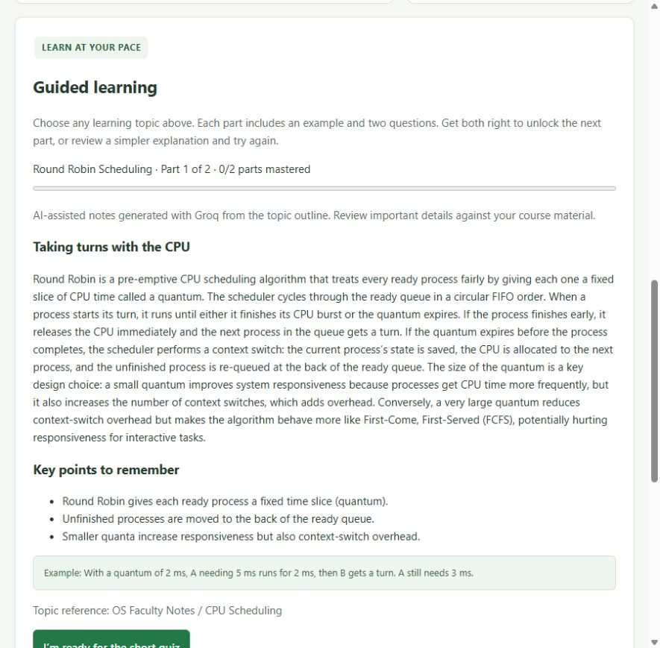
Figure 3 Real Groq notes for Round Robin with revision points and the checked example
An earlier generated example placed an already completed process back in the queue and described the remaining execution unclearly. The response was structurally valid, so JSON validation did not detect the issue. The correction preserves the authored example during merging. This finding illustrates the difference between a valid response format and a correct teaching example, and motivates independent checks for numerical OS exercises.

6 Results and Discussion

6 5 Interpretation of findings
The strongest result is the consistency of the learning workflow. The system connects teaching, an immediate check and a subsequent action in an observable way. The server enforces advancement rather than relying only on a hidden or disabled frontend button. Local answer keys keep grading stable even when prose is generated externally.
The strongest content warning is that good formatting does not establish factual correctness. A generated example passed structural validation but contained a process-state inconsistency. Preserving checked examples reduced that particular risk. It does not verify every sentence in the explanation or every analogy in simpler review. Future review should therefore evaluate factual content independently from software contracts.
The retrieval diagnostic exposes a separate weakness. Direct names work well, but paraphrase ranking and rejection of unrelated requests remain unreliable. These failures belong to Ask OSTutor, which still uses lexical matching. The guided path avoids open-ended retrieval by starting from a known topic ID, so its successful live generation should not be used to imply that arbitrary question answering is now reliable.
Cache reuse improves repeated topic starts in the recorded run, but the two timing values represent different operations. A first request includes provider generation; a cached request retrieves an existing result. The speed difference is expected from the architecture and should not be reported as an optimization benchmark without repeated controlled measurements.
The educational contribution remains a hypothesis supported by a working artifact. Smaller parts, examples and corrective review create a plausible environment for practice. Yet the checks contain only two binary items, offer retries and reveal correct information after failure. Completion can therefore reflect recognition or memorization of the options rather than transfer to a new problem.
The next research step is to compare the tutor with a fair baseline under matched content and study time. Instructor-rated answers and delayed transfer questions would help determine whether the adaptation provides value beyond additional exposure to the same facts. Until then, the report’s conclusion is operational feasibility with documented limitations, not demonstrated improvement in learning outcomes.

7 Conclusion
OSTutorLLM provides a working prototype for guided learning of selected Operating Systems concepts. Its main implemented contribution is a controlled sequence in which the learner studies a short part, answers two questions and either advances or receives simpler review. The content catalog covers 19 topics and 38 lesson parts across six categories.
Groq integration expands teaching explanations and revision points while preserving local assessment and checked examples. Generated output is validated before use, successful notes are cached, and built-in content remains available when the provider cannot be used. The integration is therefore optional for continued access to the authored curriculum rather than a single point at which all learning stops.
The final regression suite passed 14 test methods, and the real Round Robin integration scenario passed 11 checks. The live run verified generation, review, retries, progression, completion and cache reuse. Browser inspection confirmed the rendered notes and identified a numerical-example inconsistency that was corrected by preserving curated examples.
The project also retains a lexical question-answer baseline. Its diagnostic results show strong direct-topic matching but weaker paraphrase ranking and poor rejection of unrelated questions. These limitations demonstrate that adding a model to one application pathway does not automatically resolve problems in another.
The evidence supports the claim that the implemented tutoring interaction functions under the tested conditions. It does not support claims of comprehensive course coverage, verified answer accuracy, improved examination results or durable learning gains. No student study, institution-specific fine-tuning or full document RAG pipeline was completed.
Further work should build on this explicit boundary. Approved course documents and precise citations can improve grounding. Checked solvers and richer assessment can improve the quality of examples and evidence of understanding. Persistent progress and instructor review can support a more complete teaching process. These additions should be evaluated as separate changes so that future claims remain tied to reproducible observations.

8 Limitations

8 1 Technical and content limitations
The knowledge base is small and hand-authored. Nineteen short records cannot represent the range of an OS course, and two parts per topic cannot cover every conceptual dependency. Several syllabus areas lack dedicated lessons, including Linux commands, shell and Bash programming, disk scheduling, producer-consumer and dining philosophers. Linux system-call coverage is mainly fork, while Banker’s algorithm is introductory rather than a full matrix-based exercise.
There is no document-ingestion pipeline. The application cannot currently upload a faculty PDF, extract its sections, build an index and cite the passage used to answer a question. Source labels are descriptive placeholders. This limits both academic traceability and the ability to demonstrate alignment with a particular institution’s notes or prescribed textbook.
The lexical retriever lacks stopword removal, semantic matching and calibrated relevance decisions. The diagnostic set already shows that unsupported questions can receive OS answers. The response modes mostly change surrounding guidance, so they should not be presented as four separately optimized teaching models.
Generated notes depend on a cloud provider, a valid key, model availability and network access. The fallback supports continued use, but it returns the local notes rather than an equivalent generated explanation. Schema validation checks the shape of a response, not its truth. Preserving examples reduces one identified failure mode without proving the correctness of all prose.
Sessions and caches are in memory. They expire or disappear on restart, and the current design expects a single server worker. There is no durable learner database, coordinated cache across machines or recovery of progress after a process failure. The local tests do not establish behavior under sustained concurrent demand.
The frontend was inspected on a desktop browser, and its layout contains responsive rules. A full mobile-device matrix, screen-reader study and accessibility audit were not performed. There is also no public-deployment authentication layer or safe program-execution environment. These are deployment and scope limitations, not features implied by the existing interface.

8 Limitations

8 2 Evaluation and educational limitations
The evaluation is primarily functional. Passing a test means the application produced an expected state or response in a defined case. It does not indicate that a student learned more effectively, that all generated notes are correct or that the system can replace instructor feedback. The distinction is especially important for a project whose interface uses progress and completion language.
The retrieval dataset contains only 30 manually labelled queries. Its direct questions resemble the topic names and may favor the lexical baseline. The paraphrases and unrelated questions reveal important defects, but their small count does not support broad statistical generalization. There is no independent held-out corpus, inter-rater agreement measure or instructor-adjudicated relevance set.
The final live provider check covers a single topic. It verifies a complete software path, including the correct provider field, but it does not sample all possible model outputs. The reported 2.07-second generation and 6.55-ms cached request are single-run measurements. They should not be treated as service-level guarantees or comparative speed results.
The lesson check is also a weak assessment instrument for research purposes. Each question has two options, and feedback exposes the correct information after a miss. Repeated retries can lead to completion without a corresponding ability to explain the concept or solve a new case. The fixed two-correct threshold has not been validated against instructor judgments.
Personalization is limited to an application branch. The simpler explanation is prepared for the part, not generated from an individual misconception. There is no learner model, prerequisite diagnosis, confidence tracking or long-term record of errors. A more advanced adaptive system would need evidence about the type of difficulty as well as whether the last attempt passed.
No participants, learning-gain data, delayed tests or comparison group are reported. A future educational study should use equivalent content and study time, reviewed assessments and appropriate institutional procedures. It should report both learning outcomes and system errors. The current functional results are a foundation for that study, not a substitute for it.

9 Future Work

9 1 Institutional document RAG
The first major extension should connect teaching to approved course material. An ingestion pipeline can accept selected documents, extract text, preserve headings and pages, and divide content into meaningful passages. Every passage should retain its source file, section and page information. This metadata is needed before the interface can make precise citation claims.
Retrieval can then be compared across lexical, dense and hybrid methods. Dense retrieval is a candidate for paraphrases, while lexical search remains useful for exact commands, algorithm names and technical identifiers. A reranking stage could improve the choice among related passages. The design should also include a relevance decision so unsupported questions are not answered merely because something was retrieved.
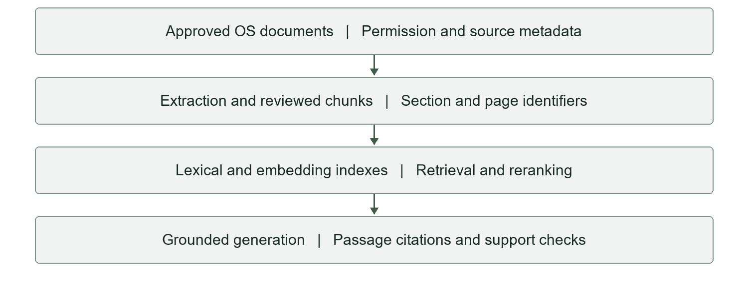
Figure 4 Proposed institutional document RAG pipeline not yet implemented
A useful evaluation would keep questions fixed and compare the present baseline with the new pipeline. Measures should include expected-passage retrieval, answer support, citation correctness and unsupported-question rejection. Instructor review should assess whether cited evidence actually supports the statement being taught. Adding a vector database alone would not establish a successful educational RAG system.

9 Future Work

9 2 Curriculum assessment and research extensions
Curriculum expansion should first address missing syllabus areas. Dedicated Linux-command and Bash units can teach practical interpretation, while disk scheduling and synchronization problems can add worked traces. Numerical solvers for scheduling, page replacement and Banker’s algorithm would allow examples to be checked independently of the generator. Their outputs should expose intermediate steps so students can understand the calculation.
Assessment can progress from binary recognition to varied problems. New MCQs should be generated from retrieved course passages, validated for a single defensible answer and reviewed before high-stakes use. Viva questions can ask the learner to justify a decision. Shell labs can request a program and expected behavior. Executing submitted code would require a separate sandbox design rather than running arbitrary commands on the application host.
Persistent progress can support targeted review. A database could record completed parts, error categories and assessment history with a clear retention policy. The tutor could then revisit prerequisites or select another example for a recurring misconception. Such adaptation should be evaluated against a simpler rule-based baseline rather than assumed to be beneficial.
Custom fine-tuning is a later research option. Faculty-reviewed explanation, lab and feedback examples could define the desired teaching style. Training and test sets must be separated, and an adapted model should be compared with the same base model using a strong prompt and the same retrieved material. Fine-tuning should not be used to hide gaps in corpus quality or source attribution.
An educational evaluation can compare the tutor with reviewed notes and matched practice. Immediate tests, delayed retention and transfer tasks would provide different evidence of learning. The study should report factual error rates alongside outcomes, since a convenient tool can still teach an incorrect explanation. Accessibility and learner experience should also be investigated with actual users.
Finally, deployment work should add authentication, durable storage, controlled provider usage and reproducible environments. Documentation must evolve with the implementation so report titles and architecture diagrams continue to describe what is built. A research claim of document RAG or fine-tuning should follow implementation and evaluation, rather than precede them.

10 References

10 1 Research and educational sources
[1] R. H. Arpaci-Dusseau and A. C. Arpaci-Dusseau, Operating Systems: Three Easy Pieces. Online textbook, University of Wisconsin–Madison.
https://research.cs.wisc.edu/wind/OSTEP/
[2] P. Lewis et al., “Retrieval-Augmented Generation for Knowledge-Intensive NLP Tasks,” Advances in Neural Information Processing Systems, vol. 33, 2020.
https://arxiv.org/abs/2005.11401
[3] V. Karpukhin et al., “Dense Passage Retrieval for Open-Domain Question Answering,” Proceedings of EMNLP, 2020.
https://arxiv.org/abs/2004.04906
[4] L. Ouyang et al., “Training language models to follow instructions with human feedback,” Advances in Neural Information Processing Systems, 2022.
https://arxiv.org/abs/2203.02155
[5] E. J. Hu et al., “LoRA: Low-Rank Adaptation of Large Language Models,” arXiv:2106.09685, 2021.
https://arxiv.org/abs/2106.09685
[6] P. Black and D. Wiliam, “Assessment and Classroom Learning,” Assessment in Education: Principles, Policy & Practice, vol. 5, no. 1, pp. 7–74, 1998. DOI: 10.1080/0969595980050102.
https://doi.org/10.1080/0969595980050102
[7] H. L. Roediger III and J. D. Karpicke, “Test-Enhanced Learning: Taking Memory Tests Improves Long-Term Retention,” Psychological Science, vol. 17, no. 3, pp. 249–255, 2006. DOI: 10.1111/j.1467-9280.2006.01693.x.
https://doi.org/10.1111/j.1467-9280.2006.01693.x
Online research and documentation references were checked on 24 October 2026. These sources provide theoretical and technical context; their findings are not presented as measurements of OSTutorLLM.

10 References

10 2 Technical documentation and project evidence
[8] Groq, “Quickstart” and “GPT OSS 20B,” official documentation.
https://console.groq.com/docs/quickstart ; https://console.groq.com/docs/model/openai/gpt-oss-20b
[9] Groq, “Reasoning,” official documentation.
https://console.groq.com/docs/reasoning
[10] Groq, “Structured Outputs,” official documentation.
https://console.groq.com/docs/structured-outputs
[11] FastAPI, official framework documentation.
https://fastapi.tiangolo.com/
[12] Pydantic, “Models,” official validation documentation.
https://docs.pydantic.dev/latest/concepts/models/
[13] HTTPX, “Timeouts,” official client documentation.
https://www.python-httpx.org/advanced/timeouts/
[14] Linux man-pages project, “fork(2),” system call manual.
https://man7.org/linux/man-pages/man2/fork.2.html
[15] OSTutorLLM project source, reviewed 24 October 2026: app.py; lessons.py; groq_notes.py; static/index.html; static/lessons.js; README.md; requirements.txt.
[16] OSTutorLLM evaluation evidence, recorded 24 October 2026: test_lessons.py; test_groq_notes.py; report_evaluate.py; .report_qa/evaluation.json; .report_qa/groq_live_test.json; live integration script and browser screenshots.
Evidence note: results in Chapter 6 come from project artifacts [15,16]. References [13,14] support the timeout interpretation and the fork teaching context respectively. No student dataset or custom training corpus was created for this report.

