**Part A**

2)

Array based strategy

|  |  |  |  |  |  |
| --- | --- | --- | --- | --- | --- |
| Operation/Index | 0 | 1 | 2 | 3 | 4 |
| push(‘e’) | e |  |  |  |  |
| push(‘s’) | e | s |  |  |  |
| push(‘c’) | e | s | c |  |  |
| pop() | e | s |  |  |  |
| push(‘u’) | e | s | u |  |  |
| push(‘a’) | e | s | u | a |  |
| pop() | e | s | u |  |  |
| push(‘o’) | e | s | u | o |  |
| push(‘t’) | e | s | u | o | t |
| pop() | e | s | u | o |  |
| push(‘h) | e | s | u | o | h |

If we now popped 5 times we would get the word house

the initial pop operations result in the output: cat

Linked list based strategy

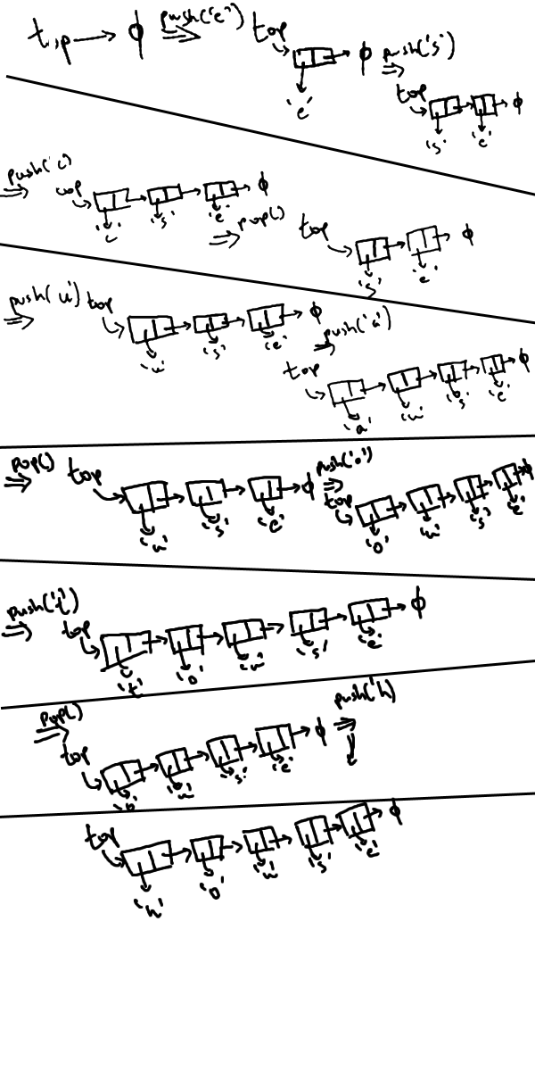

3)

Array based strategy

|  |  |  |  |  |  |
| --- | --- | --- | --- | --- | --- |
| Operation/Index | 0 | 1 | 2 | 3 | 4 |
| push(‘Ireland’) | Ireland |  |  |  |  |
| pop() |  |  |  |  |  |
| push(‘England’) | England |  |  |  |  |
| pop() |  |  |  |  |  |
| push(‘Wales’) | Wales |  |  |  |  |
| pop() |  |  |  |  |  |
| push(‘Scotland’) | Scotland |  |  |  |  |
| pop() |  |  |  |  |  |
| push(‘France’) | France |  |  |  |  |
| push(‘Germany’) | France | Germany |  |  |  |

Popped countries: Ireland England Wales Scotland

Stack has countries(After popping two more times): Germany France

PartB,C

refer to code.

Linked list based strategy

