MongoDB Injection Query Classification Model using MongoDB Log files as Training Data

Shaunak S. Perni^{a*}, Minal Naresh Shiroadkar^{b}

ª Goa Business School, Goa University, Taleigao, Durgavado, Goa, 403206, India
^{b}Goa Business School, Goa University, Taleigao, Durgavado, Goa, 403206, India

Abstract
With previous studies creating models to classify MongoDB queries as benign or injection attack
queries using only the query statement as input data. This study attempts the same problem of
classifying queries using a model trained on query statements as well as additional variables found in
the log files of an attacked MongoDB server
Since we did not find named log file data for training, an attack was simulated by randomly sending
queries from a dataset containing an equal share of injection and benign queries to an empty MongoDB
database. We extracted the log file, extracted all its features, and converted it into tabular form, thus
creating an artificial dataset for the classification of injection queries on MongoDB log files.
The same dataset was then processed, cleaned, and explored, where we removed constant variables. We
then tested the remaining variables for statistical significance in discriminating between injection and
benign queries. Hence, we created a dataset of significant variables and trained machine learning
models using an AutoML library, “FLAML”, as well as 6 manually programmed models , which were
then cross validated and evaluated. The study found that the best model was the “XGBoost limited
depth” model with an accuracy of 71% that was produced by “FLAML”
All datasets and python notebooks are saved on the following git repository:
https://github.com/ShaunakPerniUniGoa/NoSQLInjectionDetection

Generative AI content disclaimer
This paper has utilized generative AI tools, including ChatGPT-4, Grammarly, and Codium, for specific purposes such as code generation, debugging, and linguistic enhancements (e.g., grammar and style corrections). However, the authors affirm that the research, findings, and core content of this paper are solely their own work.

Background
The study of injection queries in NoSQL databases began in 2013 with the introduction of
DIGLOSSIA, a tool capable of detecting both SQL and MongoDB NoSQL injection queries. Despite
its innovation, DIGLOSSIA was limited by its rigid code format expectations, rejecting any user-based
queries that deviated from this format. This constraint rendered it less adaptable across diverse business
models (Son et al., 2013).
In 2015, a novel automata-based analysis approach was proposed to detect injection queries directed at
MongoDB. While theoretically achieving a 100% detection rate, the methodology was confined to
specific types of attacks, such as time-based and blind boolean attacks, thus offering limited security
enhancements (Joseph and Jevitha, 2015)
By 2016, research had expanded to a comparative analysis of NoSQL and SQL databases against web-
based vulnerabilities. The study, focusing on MongoDB and NoSQL, concluded that no effective solution had yet been developed to mitigate attacks on MongoDB, largely due to its widespread
deployment in complex projects involving various tools and libraries (Abdalla et al., 2016)
In 2017 Methods were devised to measure the level of security of NoSQL databases from such attacks rather than detect injection queries on specific NoSQL databases or attack types, however the study concluded that the theoretical performance of this method is not applicable to protect against unique attacks that will be developed in the future (Algarni et al., 2017). In the same year a new parse tree based method called DND was proposed it was able to judge if an attack was an injection query or not and was able to store new attacks if it successfully detected them, the paper said it had achieved a test performance of 100% detection, however the training dataset was generated by the researchers hence the application is limited only to attacks discovered by the study (Ma et al., 2021)
In 2018 A study presented basic methods to identify vulnerabilities in NoSQL database to injection attacks for developers for (at the time’s) current injection attacks, as the method was only developed for current day injection attack methods it was not guaranteed to be applicable to future attack methods (Sachdeva and Gupta, 2018). Another study presented a review of security and performance of MongoDB and other NoSQL database systems, it provide various insights in security and performance however for injection attacks it only recommend input cleaning as the only way to defend against injection attacks (Saxena and Sachdeva, 2018)
In 2019 the first ML/AI neural network based model was developed for MongoDB and CouchDB injection query detection, the model surpassed the current product Sqreen which had a detection rate of 236.25% compared to this model’s 91.87% detection rate on MongoDB and 88.67% detection rate on CouchDB with a maximum error of 8% and 11% respectively with an F1 of 0.88, the input data was just the injection query statement (Ul Islam et al., 2019). Following this in 2021 a study proposed the use of AI based solutions specifically neural network based apporach to detect injection attacks in SQL and NoSQL based database systems, the study showed that their model had out performed most black list based models made in the previous decade (Alizadehsani, 2021) In the same year a new study came out with a model that had a maximum detection rate of 97.6% on any NoSQL database system using various low resource ML models (Mejia-Cabrera et al., 2021) a study conducted a study review of 3 database systems MongoDB, Redis and Cassandra (popular database systems at the time), it had concluded that MongoDB although the most popular of the 3 was the most vulnerable system due to it’s simplicity (which also attributed to it’s popularity), it also provided insights into how attacks can be conducted on each database system provided more insights in developing security solutions (Sanchez et al., 2021)
In 2022 MURLi a tool was developed which stop malicious URLs to be sent to various NoSQL databases, stopping injections queries to even reach the database server before they could attack over the web, however direct queries were still able to reach the database server with an accuracy rate of 99.01% for NoSQL URLs, but it used deep learning models which were slow and costly to use. Alternatively another method was devised to stop occurrence of NoSQL injection attacks using encryption method specifically RSA and key pair values, however the study also mentions that this method has the aptitude and can be implemented on database systems, however no NoSQL database system including MongoDB has implemented such methods (Imam et al., 2022) Another study presented the SECURE-D a framework for web applications to detect and stop injection attacks on database servers and was able to detect in both SQL and NoSQL databases (Jithin and Subramanian, 2022). In the same year a new study had constructed a model with a higher performace of 0.92 F1 score improving over the previous studies in the field of low cost machine learning models (Praveen et al., 2022)
Finally, in 2024, an open dataset of 400 NoSQL queries for MongoDB was released, comprising 221 malicious and 179 benign queries. This dataset provided a valuable resource for future researchers aiming to develop AI and ML-based solutions for detecting injection queries in MongoDB (D․ l․ et al., 2024)

Introduction
This study attempts to advance the detection of MongoDB injection queries by employing deep learning models trained on a newly available open dataset. By integrating discovered system-based metrics with text-based features, the research aims to observe the accuracy and precision of injection query classification using log based data. These advancements seek to enhance the automation of data collection and classification, contributing significantly to NoSQL, specifically MongoDB’s database security.

Data Collection
We created a MongoDB 6.0.15 server on a Fedora 39 Linux Machine Kernel ver. 6.5 with an AMD Ryzen 7 57000U Processor with 8.0 GiB Memory on 1TB storage, using Mongosh 2.25 to send instructions to the database. We then set the profiling level on the server to 2 using the following command
db.setProfilingLevel(2,0.1)
Using the dataset (D․ l․ et al., 2024), referred to as the “Query Dataset”, in this paper, we sent each query from the dataset to the database in this paper. Then, after executing all queries, we extracted the log file. We preserved log lines corresponding to the queries sent and removed the remaining variables from the file. We converted the remaining data to a tabular form, which will be called “log data” in this paper.
Each nested variable was expanded into individual columns. We joined the target attribute “label” from the Query Dataset to the log data using the column “Text” from the Query Dataset and the column “filter” from the log data.
Based on the filter column we engineered the variables based on
- Category of operator present in the filter as per MongoDB
- Type of selector present in the filter as per MongoDB
- Presence of a null operand
- Length of the query
- The query with only the MongoDB keywords present and the database variable names removed and the length of the same
After adding these engineered variables all constant variables were removed
The final structure of the collected data is shown in the following table (Table 1).
Field | Display Name | Data Type | Description
t | Timestamp | Timestamp | Timestamp of the log message in ISO-8601 format.
planSummary | Plan Summary | String | Plan used to execute the query.
planningTimeMicros | Planning Time in Microseconds | Float | Time taken to develop a query plan in microseconds.
cpuNanos | CPU Nanoseconds | Integer | CPU processing time in nanoseconds.
filter | Filter | String | Filter used in the query.
$eq | $EQ | Boolean | Whether the $eq operator is present in the query filter.
$gt | $GT | Boolean | Whether the $gt operator is present in the query filter.
$in | $IN | Boolean | Whether the $in operator is present in the query filter.
$ne | $NE | Boolean | Whether the $ne operator is present in the query filter.
$nin | $NIN | Boolean | Whether the $nin operator is present in the query filter.
$type | $TYPE | Boolean | Whether the $type operator is present in the query filter.
$mod | $MOD | Boolean | Whether the $mod operator is present in the query filter.
$regex | $REGEX | Boolean | Whether the $regex operator is present in the query filter.
$where | $WHERE | Boolean | Whether the $where operator is present in the query filter.
$elemMatch | $ELEM_MATCH | Boolean | Whether the $elemMatch operator is present in the query filter.
$size | $SIZE | Boolean | Whether the $size operator is present in the query filter.
$ | Positional Operator | Boolean | Whether the positional $ operator is used.
>= | Greater Than or Equal To | Boolean | Whether the query uses a >= comparison.
<= | Less Than or Equal To | Boolean | Whether the query uses a <= comparison.
< | Less Than | Boolean | Whether the query uses a < comparison.
> | Greater Than | Boolean | Whether the query uses a > comparison.
selector_comparision | Selector Comparison | Boolean | Whether comparison selectors are used in the query.
selector_logical | Selector Logical | Boolean | Whether logical selectors are used in the query.
selector_element | Selector Element | Boolean | Whether element selectors are used in the query.
selector_evalutaion | Selector Evaluation | Boolean | Whether evaluation selectors are used in the query.
selector_array | Selector Array | Boolean | Whether array selectors are used in the query.
selector_bitwise | Selector Bitwise | Boolean | Whether bitwise selectors are used in the query.
projection | Projection | Boolean | Whether projection selectors are used in the query.
misc | Miscellaneous | Boolean | Whether misc selectors are used in the query.
selector | Selector | Boolean | Whether any selector operators are used in the query.
standard_logical | Standard Logical | Boolean | Whether standard logical operators are used in the query.
all_operators | All Operators | Boolean | Whether all operators are covered in the query analysis.
null_operand | Null Operand | Boolean | Whether null operands are used in the query.
regex_null_operand | Regex Null Operand | Boolean | Whether regex-based null operands are used.
text | Text | String | The filter query as it is
query_length_raw | Query Length (Raw) | Integer | Length of the query string as above.
keywords_only | Keywords Only | String | The query string but with only MongoDB query keywords
query_length_keywords_only | Query Length (Keywords Only) | Integer | Length of the query after extracting keywords only.
label | Label | Boolean | Label assigned to the query for identification or categorization.
Table 1: Final structure of the collected data
Please note due to technical limitations some constant columns remained after automated processing namely “cursorExhausted”, “queryFramework” and “reslen” and were removed on manual evaluation

Data Exploration
After collecting and pre processing the data the data’s features were separated into 3 types of variables binary, numerial and text. The timestamp variable was removed from the training dataset since it did not contribute meaningful or predictive information, including it in the model would have added noise rather than value. Due to the limitations of machine learning models, only the numerical and boolean variables were kept and the text variables were removed.

Significance Testing

Numerical Features
On the numerical variables, the histograms and KDE densities were visualized
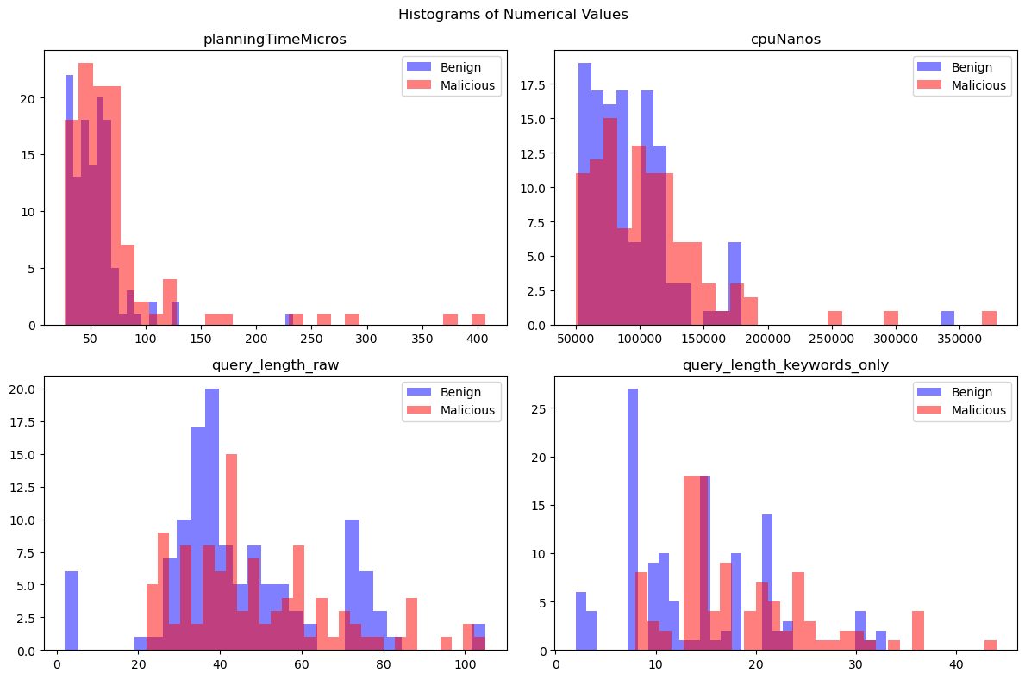Figure 1: Histograms of numerical variables, blue represents Benign queries sample and red represents Injection queries sample, clockwise from Top left corner, planningTimeMicros, cpuNanos, query_length_raw, query_length_keywords_only
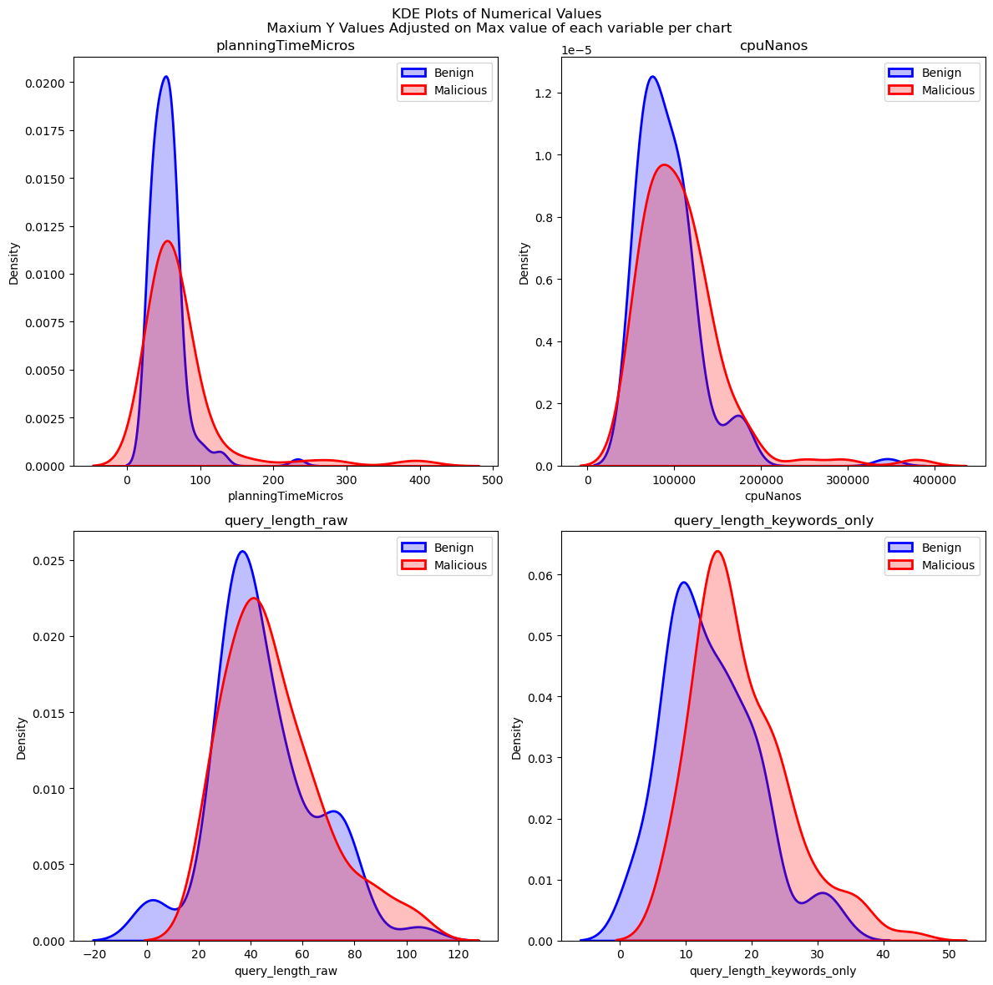Figure 2: Kernel density estimation plots of numerical variables, blue represents Benign queries sample and red represents Injection queries sample, clockwise from Top left corner, planningTimeMicros, cpuNanos, query_length_raw, query_length_keywords_only
And then conducted a Mann-Whitney U test of significance on the numerical columns (Table 2)

Variable | U Statistic | P-Value | Alternate Hypothesis Accepted at 0.01 Significance
planningTimeMicros | 4926.5 | 0.006628 | True
cpuNanos | 5013.0 | 0.011288 | False
query_length_raw | 5589.0 | 0.178336 | False
query_length_keywords_only | 3397.0 | 0.000003 | True
Table 2: Mann-Whitney U Test Results and Statistical Significance at 0.01 Significance for Numerical Variables
As observed in table 2, only planningTimeMicros and query_length_keywords_only were found to be significant at 0.01 signifance hence these 2 variables were kept and the rest were removed

Boolean Features
On the boolean variables we conducted a ChiSq test to determine the significant variables (Table 3)
Variable | Phi Value | P Value | Alternate Hypothesis Accepted at 0.01 Significance
$eq | 0.08613523235361699 | 0.1973445139252078 | False
$gt | 0.055968356591591495 | 0.4022229995323431 | False
$in | 0.07056089519199879 | 0.2909413614822473 | False
$ne | 0.1727185665577534 | 0.009737481705364296 | True
$nin | 0.004795459889571529 | 0.9427834582253255 | False
$type | 0.09504298325597839 | 0.15488894901564945 | False
$mod | 0.004795459889571529 | 0.9427834582253255 | False
$regex | 0.08006523405673249 | 0.23079764009860607 | False
$where | 0.11104504640461153 | 0.09651877524572479 | False
$elemMatch | 0.11104504640461153 | 0.09651877524572479 | False
$size | 0.0369145423668659 | 0.5806152315243337 | False
$ | 0.32600281665209946 | 1.0653678148033842e-06 | True
>= | 0.004795459889571529 | 0.9427834582253255 | False
<= | 0.05437649268574571 | 0.4157407293669543 | False
< | 0.05437649268574571 | 0.4157407293669543 | False
> | 0.05437649268574571 | 0.4157407293669543 | False
selector_comparision | 0.12672397767463786 | 0.05787667883941351 | False
selector_logical | 0.12672397767463786 | 0.05787667883941351 | False
selector_element | 0.12672397767463786 | 0.05787667883941351 | False
selector_evalutaion | 0.12672397767463786 | 0.05787667883941351 | False
selector_array | 0.12672397767463786 | 0.05787667883941351 | False
selector_bitwise | 0.12672397767463786 | 0.05787667883941351 | False
projection | 0.12672397767463786 | 0.05787667883941351 | False
misc | 0.12672397767463786 | 0.05787667883941351 | False
selector | 0.12672397767463786 | 0.05787667883941351 | False
standard_logical | 0.12672397767463786 | 0.05787667883941351 | False
all_operators | 0.12672397767463786 | 0.05787667883941351 | False
null_operand | 0.12672397767463786 | 0.05787667883941351 | False
regex_null_operand | 0.12672397767463786 | 0.05787667883941351 | False
Table 3: Phi Coefficients and Statistical Significance for Boolean Variables in Relation to Target “Label”
as observed in Table 3, only the variables $ne, ‘$’ were found to be significant at 0.01 significance hence these 2 variables were kept and the rest were removed

Separability Analysis
After determining the significant variables the columns were combined into 1 table which will now be referred to as the “final dataset” included with the target “label” variable. This dataset was then used for separability analysis
The following separability analysis methods were carried out and visualized
- Linear Discriminant Analysis (LDA)
- Principal Component Analysis (PCA)
- t-distributed Stochastic Neighbor Embedding (t-SNE) set at 2 Components or 2 Dimensions

LDA
The following figure shows the LDA visualization
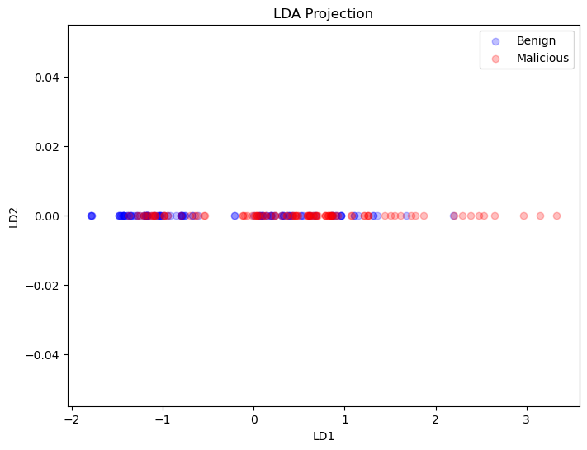Figure 3: LDA Projection Graph , Blue circles represent benign query data points and Red circles represent injection query data points
No satisfactory separability was observed in the LDA projection, suggesting that the data may not be linearly separable

PCA
The following figure shows the PCA visualization
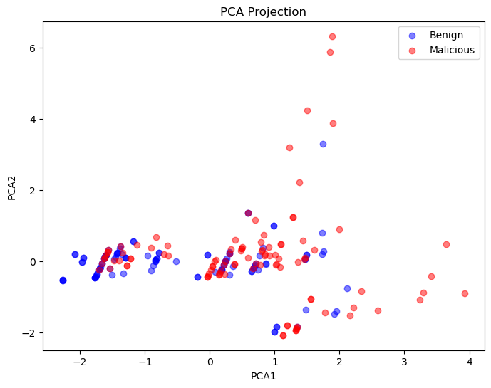Figure 4: PCA Projection Graph , Blue circles represent benign query data points and Red circles represent injection query data points
While the separability in the PCA projection was slightly better than in the LDA projection, it was still not satisfactory, indicating that the data may not be linearly separable.

t-SNE
The following figure shows the t-SNE visualization
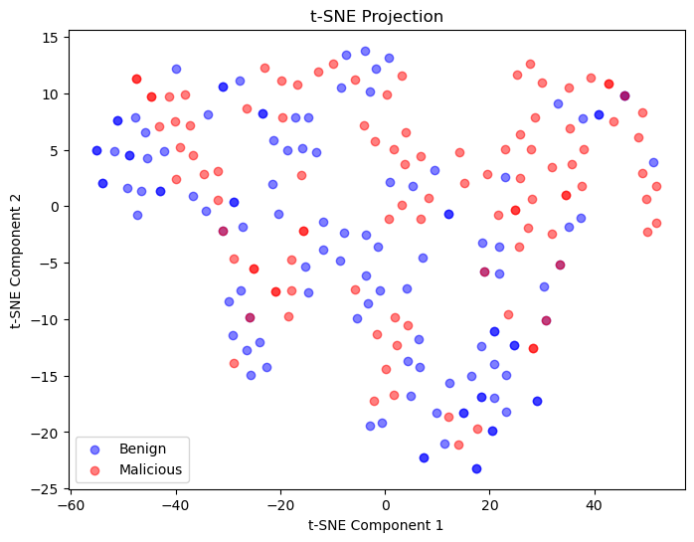Figure 5: t-SNE Projection Graph , Blue circles represent benign query data points and Red circles represent injection query data points
The t-SNE projection showed favorable separability, indicating that the data is separable in a non-linear manner, at least in the 2D reduced space

The final dataset’s structure is as follows
Field | Display Name | Data Type | Description
$ne | $NE | boolean | If a $ne operator exists in the query filter
planningTimeMicros | Planning Time Microseconds | float | Time taken to develop a query plan in microseconds.
$ | $ | boolean | If the $ character exists in the query filter
query_length_keywords_only | Query Length with only Keywords | int | The length of the query filter string if only variables names are removed
label | Label | boolean | If the query is a injection query or not
Table 4: Structure of data only with statistically significant variables

Model Formulation
The general formula for the model is as follows
Lable ~ $ne + planningTimeMicros + $ + query_length_keywords_only
The model would be a classification model, i.e. to classify if given query properties such as the above if the query is an injection query or a benign query
6 model algorithms and FLAML’s chosen model were trained and tested against this data
The algorithms chosen were:
- Logistic Regression
- Random Forest
- Support Vector Machine
- K-Nearest Neighbors
- Decision Tree
- Naive Bayes
FLAML AutoML model was configured to classification with a time budget of 60 seconds with 5 dataset splits for cross validation

Model Training and Testing
The final dataset was divided into 3 parts of Training , Testing and Validation which respectively were 60%, 20%, 20% of the dataset. Model 1-6 except the FLAML AutoML model were trained on these sets with a random seed going from 1 – 51 using cross validation , for each iteration the following results were recorded.
- The name of the Model in column “Classifier”,
- The Accuracy,
- Precision,
- Recall
- and F1 Score
Each metric was cross validated with 5 dataset splits and recorded. After all iterations the average Accuracy, Precision, Recall and F1 Score from each iteration was calculated
For the FLAML AutoML model, it was given the training dataset and set to 5 dataset splits

Evaluation
After training and testing and cross validation of the results the following results were recorded (Table 5)
Model | Accuracy (in %) | Precision (in %) | Recall (in %) | F1 Score (in %)
Logistic Regression | 65.45% (avg) | 67.73% (avg) | 66.73% (avg) | 66.64% (avg)
Random Forrest | 67.23% (avg) | 68.38% (avg) | 70.36% (avg) | 67.97% (avg)
Support Vector Machines | 55.97% (avg) | 59.55% (avg) | 46.36% (avg) | 50.00% (avg)
K-Nearest Neighbors | 53.25% (avg) | 53.59% (avg) | 63.27% (avg) | 56.66% (avg)
Decision Tree | 66.32% (avg) | 67.49% (avg) | 66.91% (avg) | 66.71% (avg)
Navie Bayes | 59.87% (avg) | 72.00% (avg) | 39.27% (avg) | 49.28% (avg)
FLAML Best Estimator (XBG Limited Depth) | 73.00% | 75% | 73% | 74%
Table 5: Cross Validated and average evaluation metrics of models (1-5) and cross validated and best evaluation metrics of FLAML AutoML model against tested data of different randomization samples

Hence it was concluded that the XBG Limited Depth algorithm has performed the best with the highest accuracy, precision, recall and F1 score among all other models.

Conclusion
The outputs of this project demonstrates that it is possible to make a model to classify injection queries sent to a MongoDB server based on metrics found in log and engineered features from the query statement. Hence such models may assist in
- Investigation of an attack postfacto by deploying the model on log data generated after a suspected attack
- Generation of dataset by picking log lines identified by this model as injection attacks
- Any other use case a researcher may identified
In addition the paper determined significant variables which may discriminate injection queries sent to a MongoDB database, as these variables were found to be significant in an empty database

Limitations
The data collected and used for this paper is artificial and may not reflect data found in the real world

* Corresponding Author Email Address: msci.2105@unigoa.ac.in (Shaunak Perni) Phone No: (+91) 8625946258

