Name: Shaunak Sensarma Registration Number: 18BCE2527

Web Mining Lab (CSE-3024)

Web Content Mining, Web Usage Mining – Assessment – 4

Faculty: Dr. Shashank Mouli Satapathy.

**Question No.1:**



**Code:**

# -*- coding: utf-8 -*-

@author: Shaunak_Sensarma

"""

import pandas as pd

from sklearn.model_selection import cross_val_score

from sklearn.tree import DecisionTreeClassifier

print("Dataset\n")

absent_data = pd.read_excel("absent.xls", names=[i for i in range(21)])

print(absent_data.head())

print()

print()

#**Agglomerative hierarchical clustering...**

from matplotlib import pyplot as plt

from sklearn.datasets.samples_generator import make_blobs

from sklearn.cluster import KMeans

import numpy as np

data_part = absent_data[[0, 1]]

kmeans = KMeans(n_clusters=2, init="k-means++", max_iter=300, n_init=10, random_state=0)

pred_y = kmeans.fit(data_part)

cross_val_score(kmeans, data_part, cv=5)

plt.scatter(data_part[0], data_part[1])

plt.scatter(kmeans.cluster_centers_[:, 0], kmeans.cluster_centers_[:, 1], s=50, c="red")

plt.show()

print("Dictionary format..\n")

mydict = {i: np.where(kmeans.labels_ == i)[0] for i in range(kmeans.n_clusters)}

print(mydict)

**#clustering..**

from scipy.cluster import hierarchy

Z = hierarchy.linkage(data_part, "single")

plt.figure()

dn = hierarchy.dendrogram(Z)

hierarchy.set_link_color_palette(["m", "c", "y", "k"])

fig, axes = plt.subplots(1, 2, figsize=(8, 3))

dn1 = hierarchy.dendrogram(Z, ax=axes[0], above_threshold_color="y", orientation="top")

dn2 = hierarchy.dendrogram(

Z, ax=axes[1], above_threshold_color="#bcbddc", orientation="right"

)

hierarchy.set_link_color_palette(None) # reset to default after use

plt.show()

Z = hierarchy.linkage(data_part, "complete")

plt.figure()

dn = hierarchy.dendrogram(Z)

hierarchy.set_link_color_palette(["m", "c", "y", "k"])

fig, axes = plt.subplots(1, 2, figsize=(8, 3))

dn1 = hierarchy.dendrogram(Z, ax=axes[0], above_threshold_color="y", orientation="top")

dn2 = hierarchy.dendrogram(

Z, ax=axes[1], above_threshold_color="#bcbddc", orientation="right"

)

hierarchy.set_link_color_palette(None) # reset to default after use

plt.show()

Z = hierarchy.linkage(data_part, "average")

plt.figure()

dn = hierarchy.dendrogram(Z)

hierarchy.set_link_color_palette(["m", "c", "y", "k"])

fig, axes = plt.subplots(1, 2, figsize=(8, 3))

dn1 = hierarchy.dendrogram(Z, ax=axes[0], above_threshold_color="y", orientation="top")

dn2 = hierarchy.dendrogram(

Z, ax=axes[1], above_threshold_color="#bcbddc", orientation="right"

)

hierarchy.set_link_color_palette(None) # reset to default after use

plt.show()

**OUTPUT:**

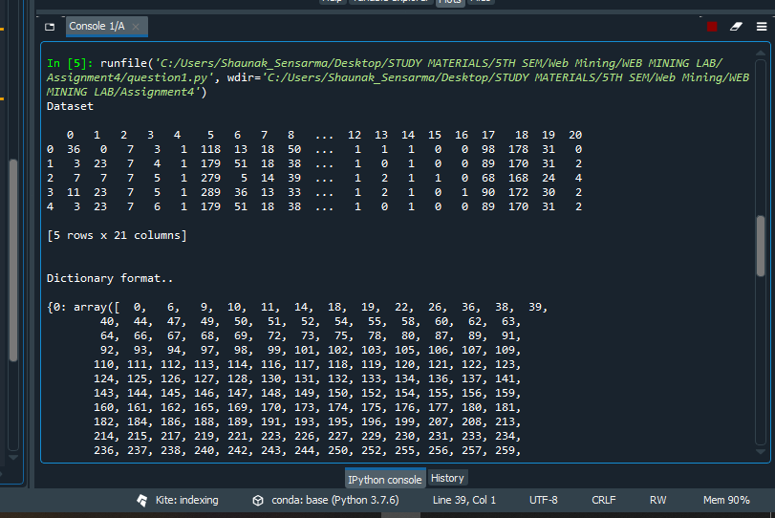

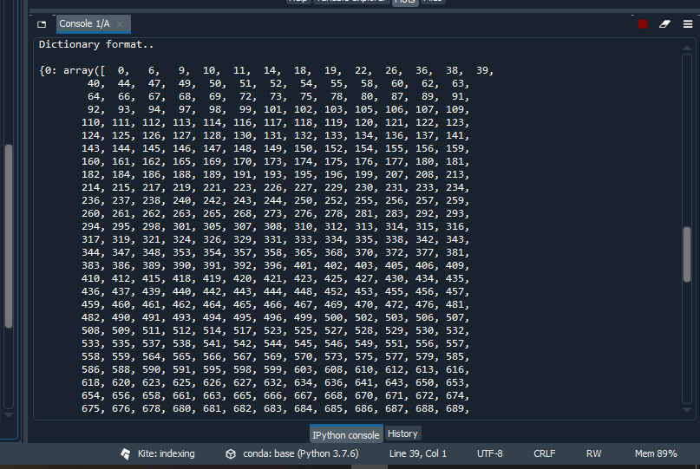

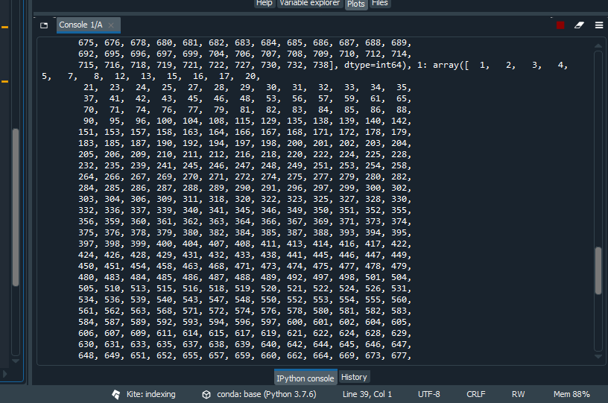

**PLOTS:**

K-Means Clustering….

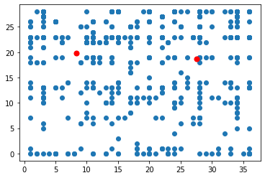

Single Clustering….

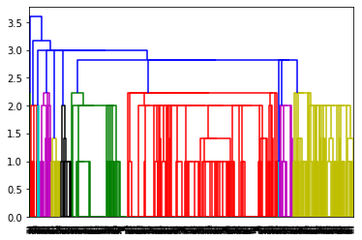

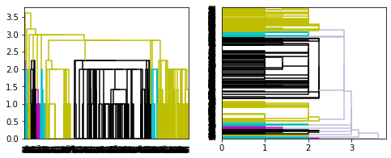

Complete Clustering..

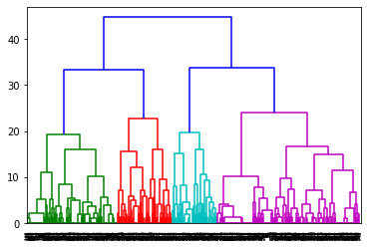

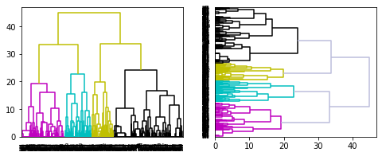

Average Clustering..

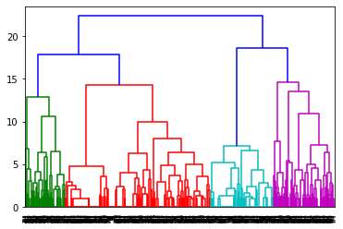

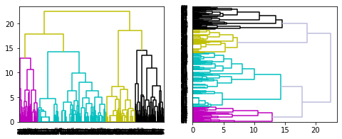

**Question No.2:**

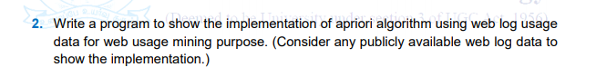

**Code:**

# -*- coding: utf-8 -*-

"""

Created on Wed Oct 14 19:40:17 2020

@author: Shaunak_Sensarma

"""

import pandas as pd

df = pd.read_csv("weblog.csv")

print(df.head(3))

print()

print(df.columns)

print()

new_df = df[["IP", "URL"]]

print(new_df.tail(3))

def extract_name(x):

p1 = x.find("/")

p2 = x.find(".php")

return x[p1 + 1 : p2]

print()

print(extract_name("GET /showcode.php?id=309&nm=ham05 HTTP/1.1"))

print()

new_df["URL"] = new_df["URL"].apply(extract_name)

print("\nLength of URL....")

print(len(new_df["URL"].unique()))

print("\n\nLength of IP...")

len(new_df["IP"].unique())

print()

print(new_df.head(3))

ips_final = list(new_df["IP"].unique())[:5]

print("\n\nFinal IP's..\n")

print(ips_final)

print()

print(list(set(new_df[new_df["IP"] == ips_final[0]]["URL"].values))[:10])

dict_visited = {x: [] for x in ips_final}

print()

print(dict_visited)

print("\n\n\n")

for a in range(len(ips_final)):

dict_visited[ips_final[a]] = list(

set(new_df[new_df["IP"] == ips_final[a]]["URL"].values)

)

print(dict_visited["10.128.2.1"][:4])

print("\n\n")

print("Visited length..")

for a in dict_visited:

print(len(dict_visited[a]))

size = 56

for a in dict_visited:

temp = dict_visited[a]

temp.extend(["0" for a in range(size - len(temp))])

dict_visited[a] = temp

for a in dict_visited:

print(len(dict_visited[a]))

df_visited = pd.DataFrame(dict_visited)

print("\n\n")

print(df_visited.tail(5))

print("\n\n")

print("Visited Shape..")

print(df_visited.shape)

dataset = []

for x in range(df_visited.shape[1]):

dataset.append(df_visited[df_visited.columns[x]].values)

from mlxtend.preprocessing import TransactionEncoder

te = TransactionEncoder()

te_ary = te.fit(dataset).transform(dataset)

df_ml = pd.DataFrame(te_ary, columns=te.columns_)

print("\n\n")

print(df_ml.head(3))

df_ml = df_ml.replace(True, 1)

print("\n\n")

print(df_ml.head(3))

lis_cls = df_ml.columns

print()

print(lis_cls[0])

from itertools import combinations

combs = list(combinations(lis_cls, 2))

print("\n\n\nCombinations..")

print(combs[100])

print("\n\n\n Shape..")

df_ml.shape

print("\n\n\n Value Counts....")

print(df_ml["/home"].value_counts()[1])

temp_df = df_ml[["/home", "fonts/fontawesome-webfont.woff2 HTTP/1."]]

print(temp_df.head(1))

len(

temp_df[

(temp_df["/home"] == 1.0)

& (temp_df["fonts/fontawesome-webfont.woff2 HTTP/1."] == 1.0)

]

)

def support(tup, tup1):

support = 0.80

x1, x2 = tup,tup1

# print(x1, x2)

supportx1 = df_ml[x1].value_counts()[1]/5

# print(supportx1)

if supportx1<support:

return 0

else:

# supportx2 = df_ml[x2].value_counts()[1]

temp_df = df_ml[[x1, x2]]

supportBoth = len(temp_df[(temp_df[x1] == 1.0) & (temp_df[x2] == 1.0)])

conf = supportBoth/supportx1

return conf

combs[1][1]

print("\n\n\nSupport Combination...")

print(support(combs[1][0],combs[1][1]))

threshold = 0.9

print("\n\n\nLength of combination....")

print(len(combs))

list_deci = []

for a in range(len(combs)):

sup_store = support(combs[a][0],combs[a][1])

# print(sup_store)

if sup_store>threshold:

list_deci.append(combs[a])

print("\n\n\nLength of list of set..")

print(len(list(set(list_deci))))

**OUTPUT:**

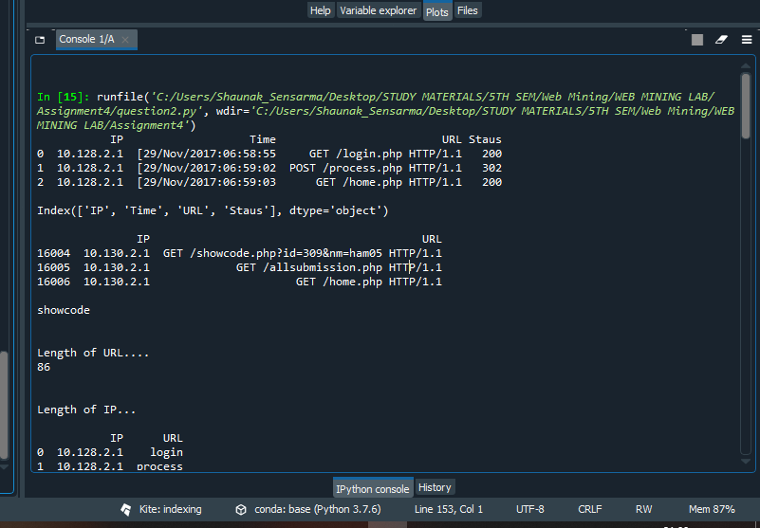

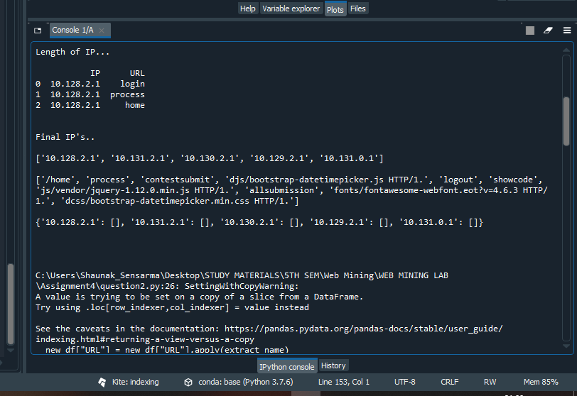

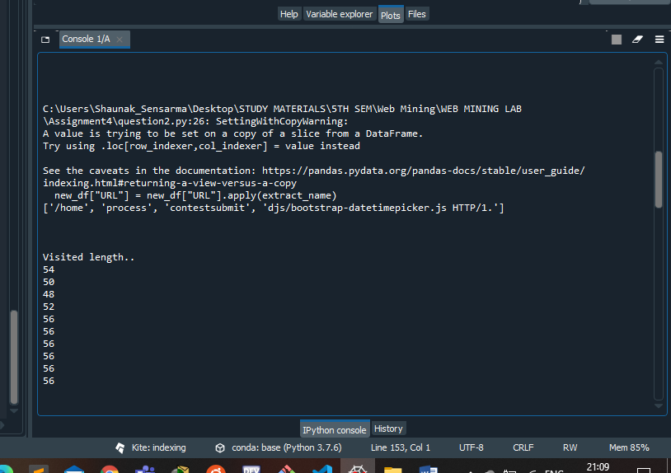

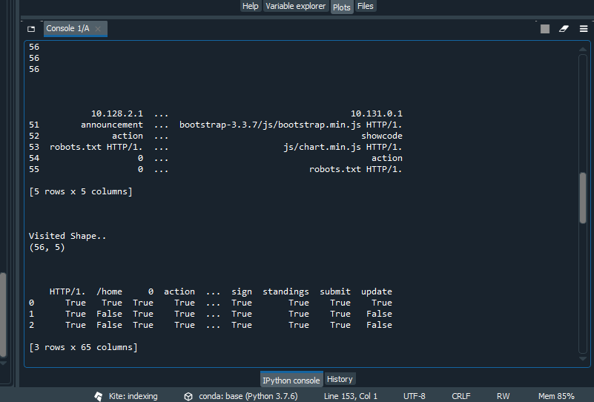

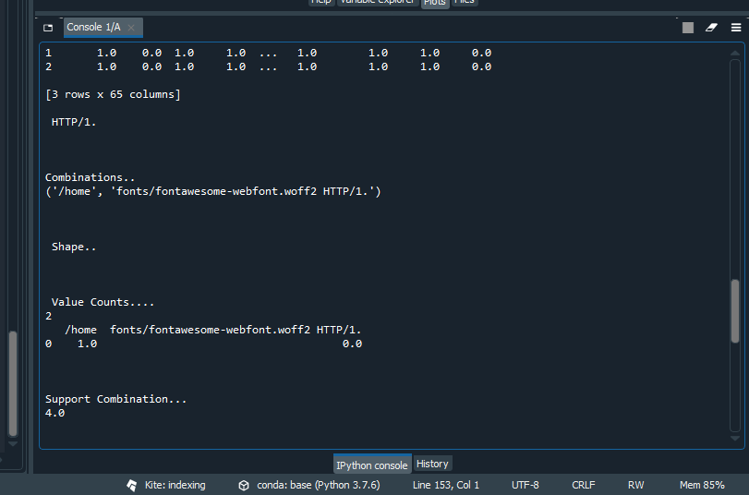

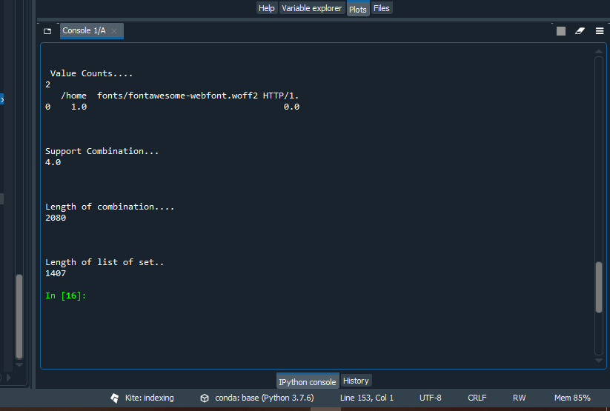

**Question-3:**

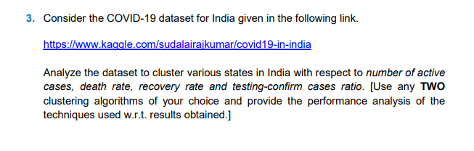

**Code:**