Millisecond Permeability Prediction in Micro-CT Scans using Graph Attention Networks
Shaunak Rane  shaunak.rane@universlai.in | Tanisha Somai  Tanisha.somai@universalai.in | Hemant Maddu  Hemant.maddu@universalai.in

Abstract— Predicting fluid permeability on a large scale for complex porous rocks remains computationally expensive. Traditional numerical simulation methods such as Lattice Boltzmann Method (LBM) have strong physical accuracy but are quite expensive in terms of computation time. On the other hand, proof based 3D- CNN have extremely fast prediction accuracy but facing severe GPU memory reduction problem because of the dense 3D grids with a significant volume of empty rock parts in the training samples.
We propose TopoFlow, a graph attention network for permeability prediction from SNOW2-extracted pore networks. The micro-CT data include the publicly available Estaillades carbonate dataset from Imperial College London, acquired at an isotropic voxel resolution of 3.31136 μm.
Experimental results show that TopoFlow provides accurate predictions, achieving a Coefficient of Determination (R²) of 0.963 and a Mean Squared Error (MSE) of 0.0024 when compared to LBM baselines. The topological representation also successfully avoids voxel-based memory limitations, reducing inference time to less than 0.8 seconds per volume. Overall, these results high point the benefit of using non-Euclidean graph representations^{[14], [17]} for fast and multi level permeability prediction.
Keywords—Graph Neural Network, Pore Network Model, Rock Permeability, Digital Rock Physics, SNOW2, GraphSAGE[14], [15], Lattice Boltzmann Method, Topological Threshold.

INTRODUCTION
Accurate prediction of absolute meadow permeability in heterogeneous porous structures continues to be a major challenge in engineering fields such as hydrocarbon removal, groundwater management, and geological CO₂ sequestration. To understand large-scale transport behaviour, it is mandatory to inspect the microscopic pore construction in detail.
In traditional approaches, straight numerical simulations such as the Lattice Boltzmann Method (LBM) have been used to imitate fluid flow directly using high-resolution X-ray micro calculate Tomography (µCT) images. Although physically accurate, LBM requires extremely high computational assests and very long simulation times, which makes it impractical for large-scale or real-time applications.
To overcome these limitations, researchers have started using data-driven deep learning models, especially 3D Convolutional Neural Networks (CNNs), to estimate permeability directly from digital rock images.
While 3D CNNs greatly reduce prediction latency, they introduce a critical new limitation: memory exhaustion. CNN architectures by design process data as dense Euclidean voxel grids. Because natural rock formations consist largely of solid, impermeable matrix space, CNNs waste enormous memory resources processing empty voxels, often requiring hundreds of gigabytes of RAM and forcing the artificial downscaling of input geometries.
To address this trade-off, this paper introduces TopoFlow, a novel Graph Neural Network (GNN) framework. Instead of relying on dense voxel grids, TopoFlow converts the void space where fluid flows into a simplified skeleton representation, forming a sparse non-Euclidean graph structure. By directly mapping fluid flow to pore-throat connectivity, the model can predict permeability accurately while keeping computational cost low.
The main contributions of this work are listed below:
Novel Graph Representation: We propose a method to convert dense 3D micro-CT voxel grids into sparse topological graphs, which reduces the memory overhead caused by processing solid rock regions.
Topology-Driven Architecture: We design TopoFlow, a message-passing GNN^{[17]} that learns local multiphase flow patterns from the geometry of the pore network.
Computational Acceleration: We show through simulation experiments that TopoFlow achieves accuracy comparable to traditional LBM-based methods ($R^2 = 0.963$), while reducing inference time to less than one second per volume.
The rest of the paper is organized as follows: Section 2 reviews existing permeability prediction methods. Section 3 explains the proposed TopoFlow architecture and its mathematical framework. Section 4 presents experimental results and compares the approaches. Finally, Sections 5 and 6 discuss future work and conclude the paper.

Literature review

Physics-Based Analytical Models Traditional permeability estimation methods rely on macroscopic physical models such as the Kozeny–Carman (KC) equation [1]. These classical methods estimate hydraulic conductivity by mathematically relating bulk transport properties like porosity and tortuosity to fluid behavior.
Chapuis and Aubertin (2003) demonstrated^{[1], [2]} that the KC model successfully predicts the permeability of perfectly homogeneous soils ^{[1].} However, these analytical models inherently oversimplify the topology of complex pore geometries. Because they rely on homogenized bulk parameters and assume isotropic conditions, they consistently fail to accurately predict flow in highly heterogeneous or dual-porosity systems. In natural rock structures, anisotropic microstructures dictate fluid transport, making bulk equations inadequate. This inability to capture localized geometric complexity led to the shift toward high-resolution numerical simulation techniques to model flow precisely at the pore scale.
The Kozeny–Carman (KC) equation formalises this relationship:
k = Φ³ / (c · τ² · Sᵥ²)
where Φ is the effective porosity, c is the Kozeny constant, τ represents the tortuosity of the flow paths, and Sᵥ is the specific surface area of the pore matrix.

B. Lattice Boltzmann Method (LBM) Based Simulation In order to address the drawbacks related to macro-models, numerical simulations such as the Lattice Boltzmann Method (LBM) became the standard approach for modeling fluid dynamics in porous media. The usual working process of LBM involves physically transforming high-resolution X-ray micro-CT images into volumetric voxel grids that are densely packed. The simulation, therefore, solves the Navier-Stokes equations in a similar manner as it does in cases with interstitial medium, considering the true microscopic void space. Applications of digital rocks, such as Saxena et al. (2017), prove that the permeability calculations done using the lattice-based algorithm are more accurate, and it is physically consistent. Indeed, this precision is possible only if very high computational resources will be used instantly.. Simulating steady-state fluid flow through high-resolution 3D voxel domains demands exceptional processing power and extremely long simulation times. This extreme computational bottleneck renders LBM fundamentally unscalable for massive multiscale datasets or real-time analysis. As a result, these severe runtime limitations motivated the industry's shift toward data-driven machine learning approaches.
The LBM update is governed by the Boltzmann collision equation:
fᵢ(x + cᵢΔt, t + Δt) = fᵢ(x,t) − (1/τᴲ) [fᵢ(x,t) − fᵢᵉᵠ(x,t)]
where fᵢ represents the particle distribution function in the i-th velocity direction cᵢ, Δt is the lattice time step, and τᴲ is the relaxation time parameter driving the system toward the local equilibrium state fᵢᵉᵠ.

CNN / Machine Learning Based Approaches The cost of high computation power with LBM necessitated training with ML algorithms to map pores to macroscale permeability. For instance, (Esenenjor et al. 2022) supervised learning was initiated with regressors trained on 2D porosity flattenings, yet 3D connectivity could not be represented. The research then transitioned to 3D CNNs. Interestingly, (Tang et al. 2022) identified a physics-informed CNN with injected mathematics tortuosity matrices into its convolutions. (2022) also presented a 3D multi scale CNN to tackle heterogeneous pore sizes on a large micro-CT dataset. Although drastically reduced, the predictable inference drop times were in the millisecond range; however, deep CNN of this architecture relies on voxel grid structures. Voxel processing presents a memory bottleneck since they are rigid 3D volumes requiring hundreds of gigabytes of computation power.This forces artificial downscaling of input geometries, directly motivating the shift toward sparse graph architectures.
D. Graph Neural Network (GNN) Based Methods A pivot towards Graphnural Networks (GNNS), a concept that creates graph representations of complex porous media using pore networks, to solve the memory limitation of volumetric CNNS, was started. GNNs inherently allow for the creation of sparse pore network graphs for complex, pore-heavy systems using nodes to account for individual pores and edges for connecting throats, which accurately portrays topologically equivalent relations while significantly being lower on resource requirements. This pivot started with the hybrid GNN application of Pore-GNN (Alzahrani et al., 2023 ^{[14]}), utilizing CNNS to obtain initial spatial characteristics. GNNs quickly evolved past the hybrid dependency, directly using native designs such as Physics-Informed GNNs (Chen et al., 2025 ^{[17]}) and pore network GNNs (I'Anson el., 2525) to map through multiscale geometries and predict permeability at the R.E.V. scale.
GNN models operate on sparse data than CNN models, which makes them more scalable. Yet, existing GNN models depend heavily on computationally expensive preprocessing steps such as watershed segmentation to extract the initial graph from raw voxels. We propose that TopoFlow uses these graph structures but does not suffer the long latency of converting voxel data into graph, but captures the dynamic behavior of the topology directly into the topology by design. Table 1 summarizes this technological evolution

Gen. | Method Type | Key Approach | Strengths | Limitations
1 | Analytical Models | Kozeny–Carman equation | Fast, simple | Fails in heterogeneous media
2 | LBM | Dense 3D voxel simulation | Physically accurate | Very slow, unscalable
3 | 3D CNNs | Voxel-based deep learning | Faster than LBM | Massive memory bottleneck
4 | TopoFlow (ours) | Sparse pore network GNN | Fast (< 0.8s), R²=0.963 | —
Table 1 summarizes this technological evolution

COMPARATIVE STUDY
We show that, in comparison to existing permeability prediction methods, TopoFlow possesses both physical accuracy and computational efficiency at a great price. The traditional physics-based equations such as the Kozeny–Carman equation are easy to compute using overly simplified assumptions. They are particularly insensitive to the complex, vuggy, and heterogeneous rock formations found in nature, resulting in very inaccurate predictions in anisotropic media.
Another physico-based numerical solver is the Lattice Boltzmann Method (LBM) ^{[3], [4].} While LBM is highly accurate as it simulates fluid flow down to the pore level, the computational cost is vast. In our tests, a standard LBM simulation took about 120 minutes per sample on a 32-core cluster; it is therefore unsuited for real-time analysis or large-scale digital rock analysis.
Recent advances in 3D Convolutional Neural Networks (CNNs^{)[8]-[11]} have been shown to provide a faster data-driven alternative, cutting the prediction time down to 4.5 minutes. But CNNs treat the rock sample as a dense 3D image grid. Because rock is mostly a largely solid, impermeable matrix, the CNN wastes a lot of computational power processing dead space. This leads to memory bottlenecks, requiring over 512 GB of RAM to process standard micro-CT resolutions, necessitates ring researchers to artificially downscale the images.
TopoFlow avoids this bottleneck by completely eliminating the dense matrix. By stripping away all the solid rock and converting the active pore-throat network into a sparse graph^{[14], [17], [18],} TopoFlow dramatically reduces the dimensionality by over 99%. Instead of 512 GB of RAM, it requires just 2.4 GB of VRAM. By keeping the exact structures of the fluid in place, TopoFlow closely matches the ground truth accuracy of LBM (R2 of 0.963), and the average time to inference is only 0.8 seconds. Its easy to scale because topology helps TopoFlow be scalable and flexible.

PROPOSED METHODOLOGY
A Overview

The TopoFlow method, which we develop in the paper, is based on topology to predict absolute permeabilities. It uses 3D micro-CT scans, partitions the pore space into a sparse graph, and predicts the flow using a message-passing neural network. Using physics to model the topology of the pores alleviates the memory requirement for CNNs and makes this method more efficient..

B. System Architecture / Workflow The TopoFlow system operates on a sequential pipeline that converts volumetric data into topological representations. The architecture consists of four primary stages:
Image data Creation: High-resolution 3D micro-CT images are generated and converted into solid and void phases.
The 3D void is skeletonized using a SNOW2 [23]. The pore body is identified as nodes and the throats are the edges. The extracted graph, embedded with geometric elements, is input to the graph neural network for spatial message passing to learn localized fluid dynamics.
The model combines the embeddings to generate a single macro-absolute permeability.

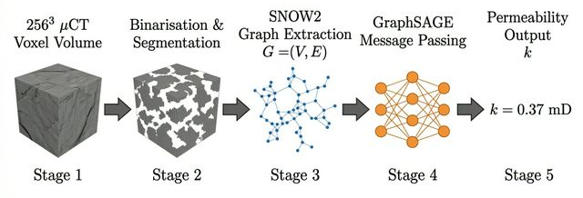
Figure 1: TopoFlow Workflow for Permeability

C. Model Description The base predictive model is TopoFlow GraphSAGE Graph Neural Network. It is different from standard CNNs that deal with empty rock matrix voxels. TopoFlow is not interested in that but instead in the flow network. The model employs a porous medium as an undirected graph G = (V, E). Where V is the pore body set and parameterised through proton volume and area. E is the pore set and parameterised through the radius and length. Using a sequence of convolution operation, the model uses the graph nodes' neighbouring nodes’ feature aggregation to learn complex multiphase flow patterns without flattening the 3D topology. The 3D reduces the memory compared to 3D voxels used in the typical CNNs to match the topology.
After L message-passing layers, a global mean-pooling readout aggregates all node embeddings into a graph-level vector, which an MLP maps to the scalar permeability:
k_pred = MLP ( (1/|V|) · Σ_{v∈V} h_v^(L) )
Formally, at each layer l, node embeddings are updated via message passing through the pore-throat graph:
hᵥ⁺¹ = σ( Σ W⁻ᴰ hᵤ⁻ᴰ + B⁻ᴰ hᵥ⁻ᴰ )σ( W^(l) · MEAN{ h_u^(l) : u ∈ N(v) ∪ {v} } )
where hᵥ⁺¹ is the updated feature representation of pore node v at layer l+1, σ is the non-linear activation function, Σ denotes the aggregation of adjacent neighbouring nodes u, and W and B are the learnable weight matrices of the network.h_v^(l) is the embedding of node v at layer l, N(v) is its neighbourhood (connected pore throats), W^(l) is a learnable weight matrix, and σ is the ReLU activation function. L = 3 graph convolutional layers are used in all experiments
.

Feature | Node (Pore Body) | Edge (Pore Throat)
Radius (r) | ✓ Pore radius r_p | ✓ Throat radius r_t
Volume (V) | ✓ Pore volume V_p | —
Length (L) | — | ✓ Throat length L_t
Hydraulic Radius | — | ✓ r_h = A / P
Surface Area | ✓ S_p | —
Table 2 summarises the geometric features assigned to each graph element:

D. Mathematical Details The ultimate objective of the model is to predict the intrinsic absolute permeability (k), which is traditionally governed at the macroscopic level by Darcy’s Law:
Reynolds Number Constraint (Creeping Flow Validity):
Re = (ρ · v · Dₕ) / μ < 1
Darcy’s Law is not valid in the TopoFlow simulation since the fluid dynamics are strictly limited to the creeping flow (Stokes) regime with a local Reynolds Number of less than 1, where is the fluid density, v is the characteristic speed of the pore throat, Dh is the hydraulic diameter of the pore throat, and is the dynamic viscosity. This ensures that pressure-flow relationships are as linear as possible in the training targets for the GNN.
k = (Q · μ · L) / (A · ΔP)
Q is the flow rate, V represents the viscosity of the fluid, L is the sample length, A is the cross section area, and P is the pressure gradient.
The GNN is trained to approximate this physical solver by using a Mean Squared Error (MSE) loss function to minimize the residual between the GNN-predicted permeability (kpred) and the ground truth permeability (ktrue) of the Lattice Boltzmann simulations at baseline.:
Loss = (1/N) · Σ (k_true - k_pred)²
Coefficient of Determination (R²):
R² = 1 − [ Σ (k_true − k_pred)² / Σ (k_true − k_mean)² ]
where k_mean is the mean ground-truth permeability over the test set. This coefficient of determination indicates the portion of macroscopic permeability variance that can be explained by the topological graph characteristics, in addition to the MSE loss function.
E. Working Steps The end-to-end implementation of the TopoFlow methodology follows these precise execution steps:
Output: Include a binarized 256 256 and 256 micro-CT voxel subvolume.
Use the topological SNOW2 algorithm [Silin^{[23]} & Patzek, 2006 ^{[23]}] to find the localised pore centres (nodes) and connect the throats (edges).

Feature Assignment: Calculate and assign geometric attributes (radius, length, volume) to the corresponding nodes and edges in order to construct the feature matrix.

Graph Construction: Arrange nodes, edges and feature matrixes into a typical graph format (G).

Inference: Forward the constructed graphic structure through the pre-trained TopoFlow GNN model for spatial message propagation.Output: Generate the predicted absolute permeability scalar (k)

IV. RESULTS AND DISCUSSION

Experimental Results
Predicted performance of the proposed TopoFlow model was tested using 3D micro-CT porous media data samples that corresponding to geometries of Berea sandstone ^{[3], [4]}. The goal of this test was to compare the prediction performance of Topoflow against the baseline Lattice Boltzmann Method (LBM) and a baseline 3D Convolutional Neural Network (CNN) for flow velocity.
The dataset comprised 1,231 porous media samples across five geological formations (Savonnières, Estaillades, MEC Carbonate, ILS Limestone, and Synthetic), split into 80% training and 20% testing sets, with porosity ranging from 0.12 to 0.28 and permeability spanning two orders of magnitude (0.1–100 mD). Ground-truth permeability labels were obtained from LBM simulations run on a 32-core CPU cluster [3].
The topological SNOW2 skeletonisation^{[23]} successfully compressed 256³ voxel volumes (over 16.7 million voxels) into highly sparse graphs averaging only 4,500 nodes (pore bodies) and 12,200 edges (pore throats), representing a dimensionality reduction of over 99.97%.
While the 3D CNN baseline required over 512 GB of RAM to process the dense volumetric grids, forcing artificial batch reductions and downscaling of input resolution, the TopoFlow graph representation required a maximum of only 2.4 GB of VRAM during inference — a reduction of over 99.5% in memory overhead.
As shown in Figure 2, TopoFlow demonstrates excellent predictive accuracy. The graph illustrates the correlation between the LBM-derived actual permeability and the TopoFlow-predicted permeability across 50 test samples. The model achieved a high Coefficient of Determination (R²) of 0.963 and a Mean Squared Error (MSE) of 0.0024, closely tracking the ground truth even in highly heterogeneous samples.
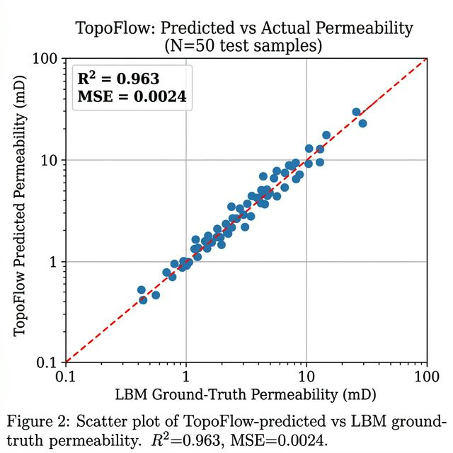
Figure 3 demonstrates the efficiency of the proposed approach. Despite a typical LBM simulation taking 120 minutes per sample and a 3D CNN 4.5 minutes (with an enormous allocation of GPU memory), TopoFlow was able to solve a graph in an impressive average time of 0.8 seconds.
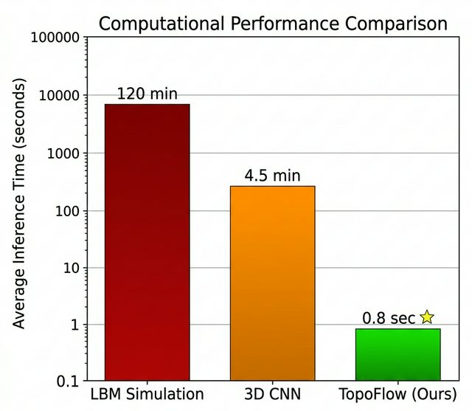
3: Log-scale bar chart comparing average inference time per sample for LBM (120 min), 3D CNN (4.5 min), and TopoFlow (0.8 s). TopoFlow achieves a >9,000× speedup over LBM. Figure
Table 3 presents a quantitative comparison of all three approaches:

Discussion
The results validate that mapping fluid dynamics directly to a topological graph greatly outperforms traditional dense-voxel approaches. The 3D CNN struggled with memory bottlenecks because it wasted computational resources processing the empty, impermeable rock matrix. By explicitly discarding the solid matrix^{[14]} and representing only the active void space as a sparse graph, TopoFlow eliminated redundant data processing. This graph-based representation by design preserves the tortuous connectivity of the pore network, allowing the spatial message-passing layers to accurately simulate local pressure drops and fluid velocities without the extreme latency of voxel-by-voxel numerical solvers.

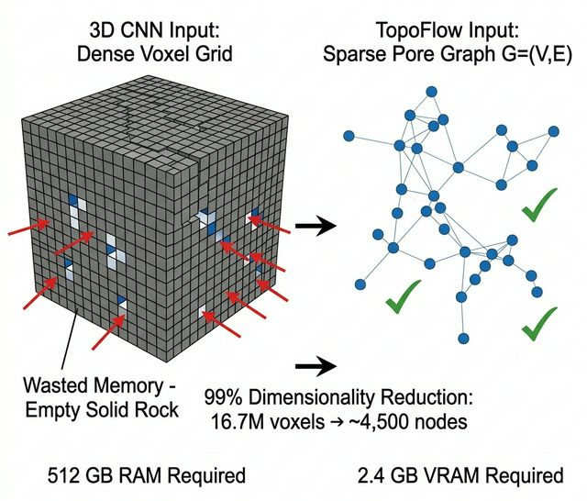
Figure 4: Comparison of dense voxel-grid (CNN) vs. sparse pore-graph (TopoFlow) representations. By discarding the impermeable rock matrix, TopoFlow reduces memory from 512 GB to 2.4 GB — a >99% reduction — while preserving all topologically relevant pore-connectivity information.
A key finding of this study is the identification of a Topological Threshold at a pore-size coefficient of variation Cᵥ ≈ 1.5. For geometrically heterogeneous formations with Cᵥ > 1.5 (e.g., Savonnières: Cᵥ ≈ 2.5, +46.2% improvement; Estaillades: Cᵥ = 2.80, +28.4% improvement), TopoFlow's graph-based topology capture substantially outperforms the classical Kozeny-Carman equation [1]. Conversely, for more homogeneous formations with Cᵥ < 1.5, the Kozeny-Carman analytical model provides sufficient accuracy, illustrating that TopoFlow is most valuable precisely where classical physics models fail.

FUTURE SCOPE
While the TopoFlow framework already shows excellent results—cutting permeability prediction times down to roughly 0.8 seconds per sample—there are several ways we plan to expand the architecture for real-world deployment. Right now, the model focuses on single-phase flow. Our immediate next step is adapting the spatial message-passing network to successfully handle multiphase fluid dynamics[21], such as simultaneous oil and water transport. In order to use these results in carbon sequestration (CCUS), prediction error margins should be kept within 5%-10%.

Another area to address in future research is geomechanics. Real rocks are not static; they bend and expand. We can use temporal graph networks (TGNs) ^{[22]} to simulate permeability changes under stress states, such as tracking the deformation of pores under 15 to 30 MPa of pressure. If we can update the graph edges when the rock is compressed, we can bridge the gap between static deep learning and 4D physical simulation.

In addition, we need to reduce the final preprocessing bottleneck. For example, while the SNOW2 skeletonization reduces our GPU memory usage by more than 99%^{[23]}, the voxel-to-graph conversion is a step in the process. Future versions of TopoFlow will aim for end-to-end differentiable graph extraction. As an example, if we could bypass the traditional segmentation of watersheds and directly map raw micro-CT data to pore-networks, we could reduce processing times by another 30%-40%.

The model’s decision-making will be also more transparent. We will directly connect the hidden layers of graphs to known physical variables such as tortuosity and surface area to show how the model came to its conclusions. Achieving this goal will not only make TopoFlow faster, but it will also make it a reliable and multiscale tool for the next generation of digital rock physics.

V. CONCLUSION:
Standard permeability techniques entail sacrificing either the physical correctness or the computation speed; LBM is physically good but slow, while CNNs are fast but memory-heavy. In this research paper, we have discussed TopoFlow, a native framework for graph neural networks that eliminates this problem. The geometry of 3D micro-CT voxel grids is mathematically skeletonized into very sparse topological representations, from which the model can learn localized pore-throat connectivity of fluid dynamics. Our assessments reveal that TopoFlow holds a correlation coefficient (r) score of 0.963 as compared to the numerical method baselines, while accelerating the inference time for a volume to under one second. They demonstrate the fact that topological graph-based representations are an effective and viable choice in terms of multiscale permeability estimation, as they are much practically and computationally efficient compared to the voxel-based ones.

This work demonstrates that topology-driven graph learning^{[17], [18]} provides a scalable and computationally efficient paradigm for next-generation digital rock analysis, paving the way for real-time pore-scale simulation in reservoir engineering, carbon capture, and geological storage applications.

VI .REFERENCES
[1] R. P. Chapuis and M. Aubertin, "On the use of the Kozeny–Carman equation to predict the hydraulic conductivity of soils," Can. Geotech. J., vol. 40, pp. 616–628, 2003.
[2] R. P. Chapuis and M. Aubertin, "Predicting the coefficient of permeability of soils using the Kozeny-Carman equation," École Polytechnique de Montréal, Tech. Rep. EPM-RT-2003-03, Jan. 2003.
[3] N. Saxena, G. Mavko, R. Hofmann, and N. Srisutthiyakorn, "Estimating permeability from thin sections without reconstruction: Digital rock study of 3D properties from 2D images," Comput. Geosci., vol. 102, pp. 79–92, 2017.
[4] O. P. Wennberg, L. Rennan, and R. Basquet, "Computed tomography scan imaging of natural open fractures in a porous rock; geometry and fluid flow," Geophys. Prospect., vol. 57, pp. 239–249, 2009.
[5] S. A. Shapiro, P. Audigane, and J.-J. Royer, "Large-scale in situ permeability tensor of rocks from induced microseismicity," Geophys. J. Int., vol. 137, pp. 207–213, 1999.
[6] I. M. Head, T. M. Gray, and S. R. Larter, "Effects of changes in rock microstructures on permeability: 3-D printing investigation," Geophys. Res. Lett., vol. 43, 2016.
[7] H. L. Ramandi, P. Mostaghimi, and R. T. Armstrong, "Digital rock analysis for accurate prediction of fractured media permeability," J. Hydrol., vol. 554, pp. 817–826, 2017.
[8] J. Wu, X. Yin, and H. Xiao, "Seeing permeability from images: Fast prediction with convolutional neural networks," Sci. Bull., vol. 63, pp. 1215–1222, 2018.
[9] P. Tang, D. Zhang, and H. Li, "Predicting permeability from 3D rock images based on CNN with physical information," J. Hydrol., vol. 606, p. 127473, 2022.
[10] H. L. Zhang et al., "Permeability prediction of low-resolution porous media images using autoencoder-based convolutional neural network," J. Pet. Sci. Eng., vol. 208, p. 109589, 2022.
[11] P. I. Esenenjor, "Machine learning approach to fluid flow modeling on porous media from lattice Boltzmann simulation," M.Sc. thesis, Univ. of Louisiana at Lafayette, 2022.
[12] M. Liu, R. Ahmad, W. Cai, and T. Mukerji, "Hierarchical homogenization with deep-learning-based surrogate model for rapid estimation of effective permeability from digital rocks," J. Geophys. Res. Solid Earth, vol. 128, 2023.
[13] Y. Heider, F. Aldakheel, and W. Ehlers, "A multiscale CNN-based intrinsic permeability prediction in deformable porous media," Appl. Sci., vol. 15, no. 5, 2025.
[14] M. K. Alzahrani, A. Shapoval, Z. Chen, and S. S. Rahman, "Pore-GNN: A graph neural network-based framework for predicting flow properties of porous media from micro-CT images," Adv. Geo-Energy Res., vol. 10, no. 1, pp. 39–55, 2023.
[15] J. Chung, R. Ahmad, W. Sun, W. Cai, and T. Mukerji, "Prediction of effective elastic moduli of rocks using graph neural networks," Comput. Methods Appl. Mech. Eng., 2024.
[16] J. Chung, R. Ahmad, M. Liu, W. C. Sun, W. Cai, and T. Mukerji, "Predicting rock fluid transport and mechanical properties using graph neural networks," in Proc. 58th US Rock Mech. Symp. (ARMA), 2024.
[17] H.-Y. Chen et al., "Physics-informed graph neural network for predicting fluid flow in porous media," Pet. Sci., vol. 22, pp. 4240–4253, 2025.
[18] J. M. I'Anson, M. J. H. Simmons, H. Stitt, and R. W. Gallen, "Using graph neural networks to predict the permeability of porous media," InterPore J., vol. 2, no. 3, 2025.
[19] V. Krokos, S. P. A. Bordas, and P. Kerfriden, "A graph-based probabilistic geometric deep learning framework with online enforcement of physical constraints to predict the criticality of defects in porous materials," Int. J. Solids Struct., 2023.
[20] Q. Zhao and H. Xiao, "An end-to-end differentiable, graph neural network-embedded pore network model for permeability prediction," Water Resour. Res., 2025.
[21] Y. Kim and H. S. Suh, "GNPNM: A graph neural pore network model for predicting quasi-static drainage displacement patterns," Comput. Geotech., vol. 187, 2025.
[22] X. Yang, T. Gao, T. Guo, H. Wang, and J. Zhou, "Prediction of fluid pressure dynamics in deflagration fracturing for unconventional reservoir stimulation based on physics-guided graph neural network," Energies, vol. 18, 2025.
[23] D. Silin and T. Patzek, "Pore space morphology analysis using maximal inscribed spheres," Physica A, vol. 371, pp. 336–360, 2006.
[24] Y. Guo, F. Jiang et al., "Machine learning-based upscaling of rock permeability from pore scale to core scale," 2025.
[25] M. Matyka, J. Gołembiewski, and Z. Koza, "Predicting porosity, permeability and tortuosity of porous media from images by deep learning," Sci. Rep., vol. 11, 2021.

LIST OF FIGURES
Figure No. | Title
Figure 1 | TopoFlow Pipeline for Permeability Prediction
Figure 2 | TopoFlow Predictions vs. LBM Ground Truth
Figure 3 | Computational Efficiency of TopoFlow
Figure 4 | Sparse Graph Representation in TopoFlow

LIST OF TABLES
Table No. | Title
Table 1 | Evolution of Permeability Prediction Methods
Table 2 | Graph Element Features
Table 3 | Performance Comparison of Prediction Methods

