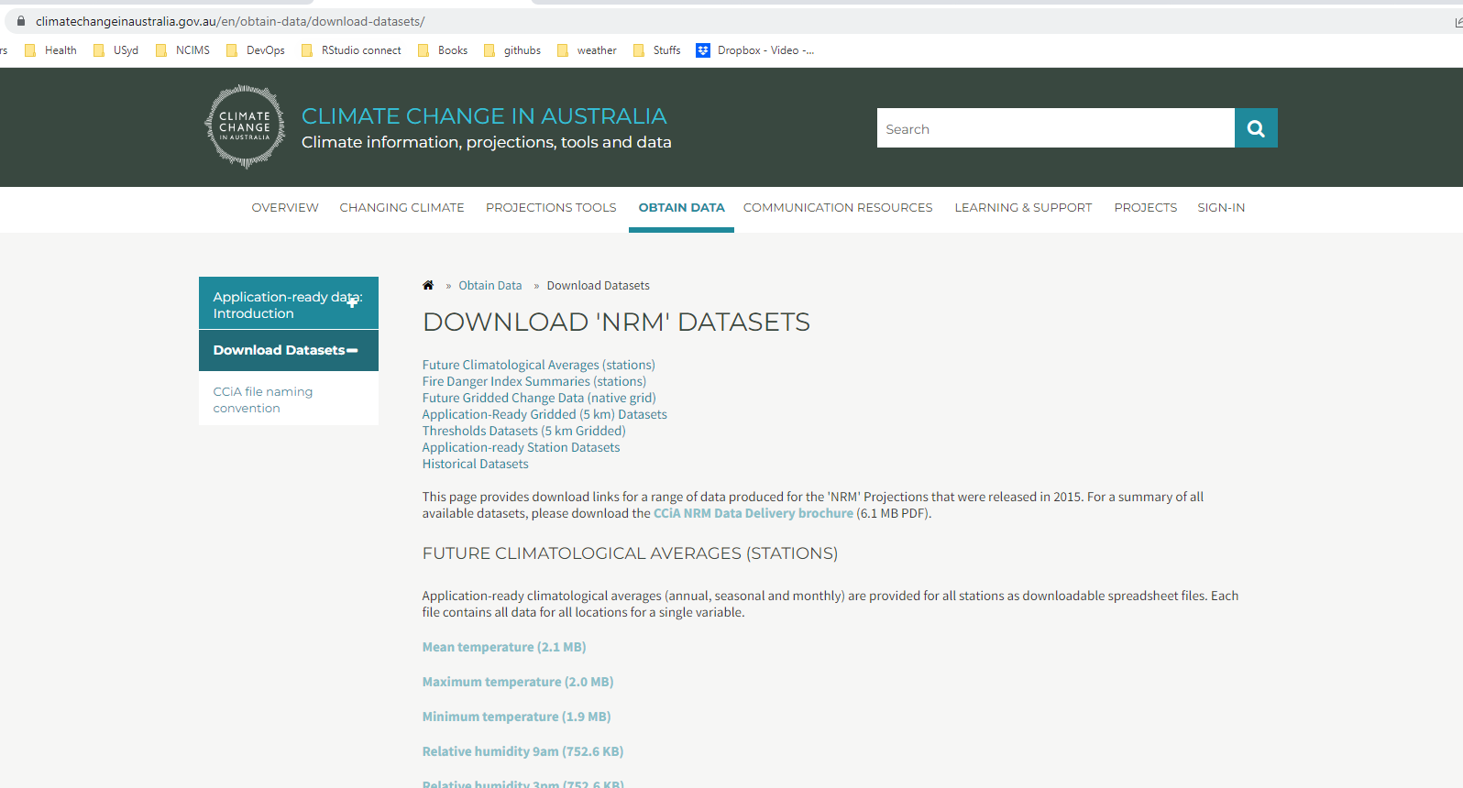

Application-ready gridded 5 km

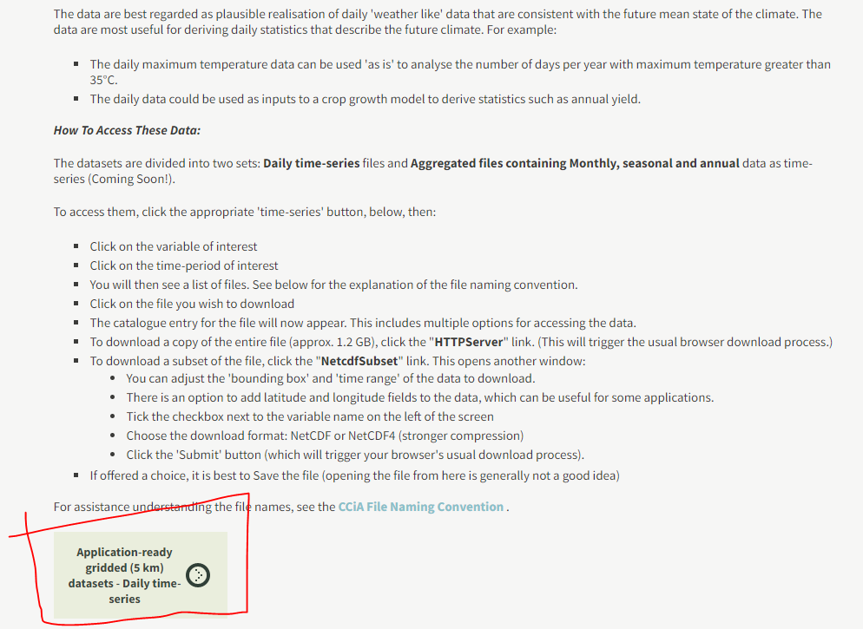

Choose a dataset

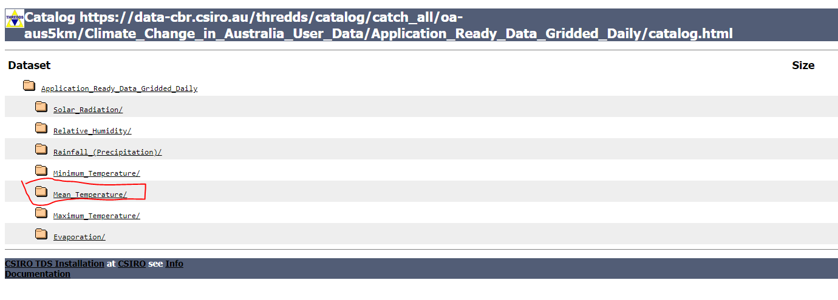

Choose a year

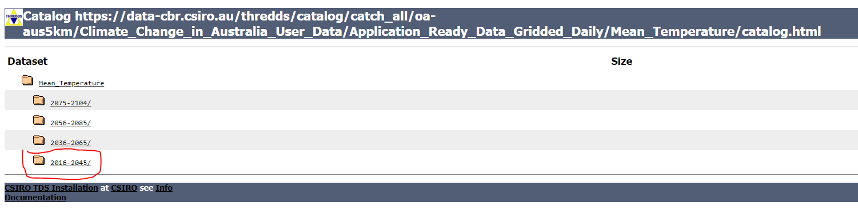

Choose a model and RCP .. don’t be fooled into thinking this is the download part!

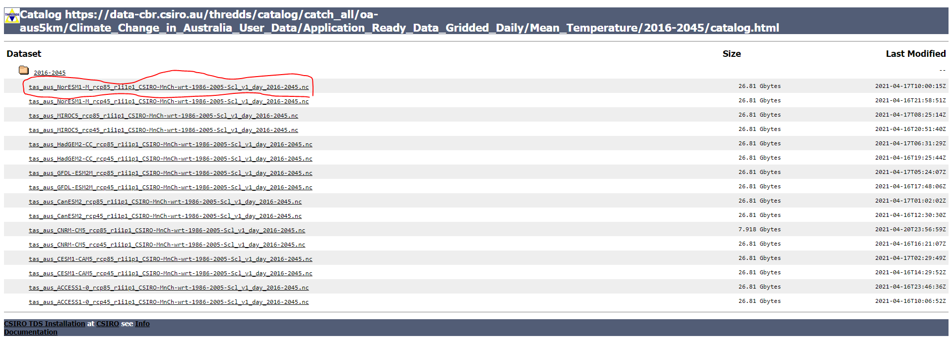

There are various types of access to the data … we could download the whole thing (25 Gb) or use NetcdfSubset which has a REST API (highlighted below)

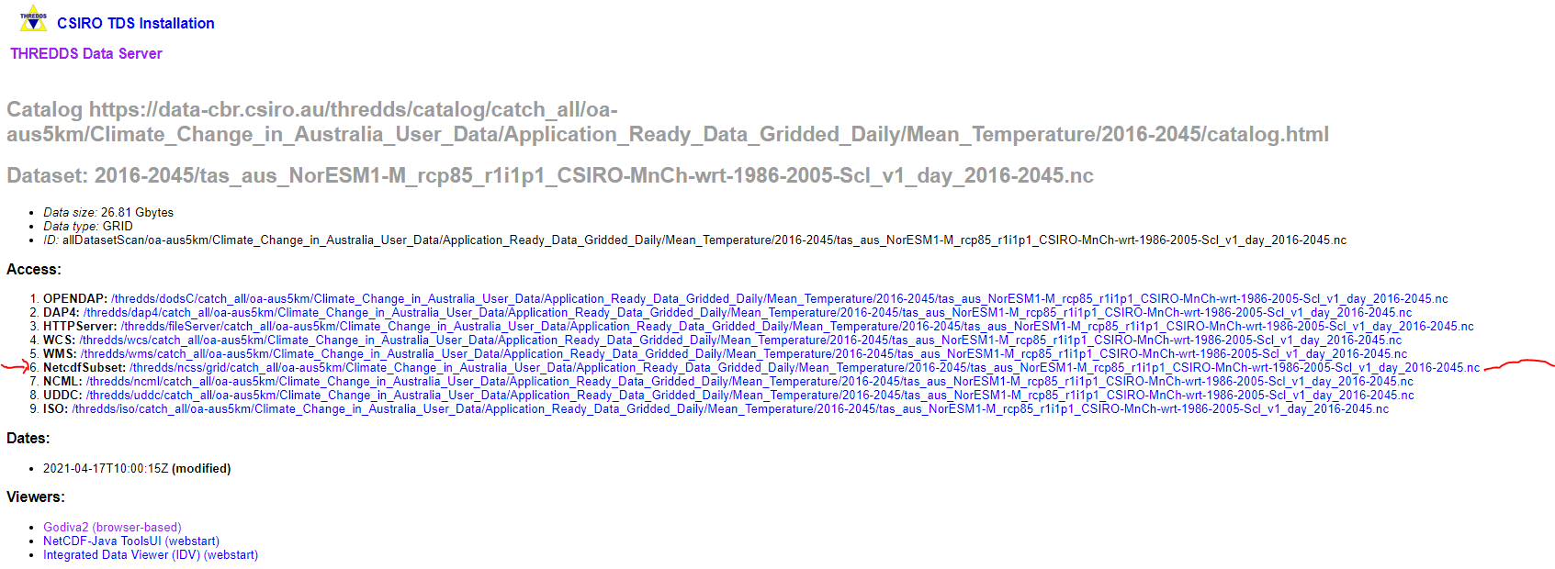

After some loading time, we see the variables we subset by; lat/lon, time and output type

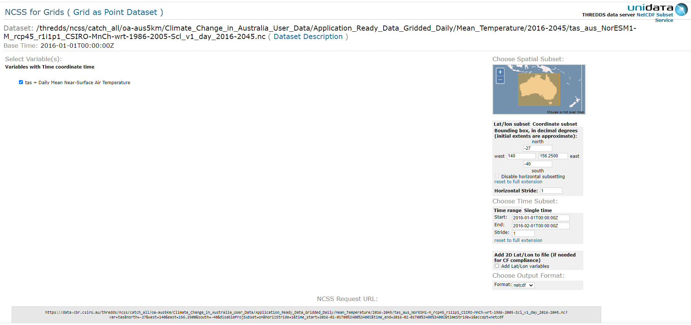

https://data-cbr.csiro.au/thredds/ncss/catch_all/oa-aus5km/Climate_Change_in_Australia_User_Data/Application_Ready_Data_Gridded_Daily/Mean_Temperature/2016-2045/tas_aus_NorESM1-M_rcp45_r1i1p1_CSIRO-MnCh-wrt-1986-2005-Scl_v1_day_2016-2045.nc?var=tas&north=-27&west=140&east=156.2500&south=-40&disableProjSubset=on&horizStride=1&time_start=2016-01-01T00%3A00%3A00Z&time_end=2016-02-01T00%3A00%3A00Z&timeStride=1&accept=netcdf

Netcdf Subset reference material - <https://docs.unidata.ucar.edu/tds/current/userguide/netcdf_subset_service_ref.html>

