
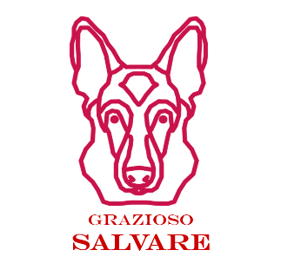

README

Overview
This dashboard completes Phase 2 of the Grazioso Salvare application. It provides a user-friendly interface for exploring the Austin Animal Center (AAC) Outcomes dataset, filtering candidate dogs by rescue profile, and visualizing selected animals on an interactive map. The design follows an MVC pattern:
- Model: MongoDB
- Controller: Python CRUD module
- View/Controller: Dash, dash-leaflet, and Plotly

FUNCTIONALITY
Start (unfiltered) – Branded header with Grazioso Salvare logo (linked), unique identifier (name + UID), the filter widgets, an interactive DataTable, a geolocation map, and a second chart
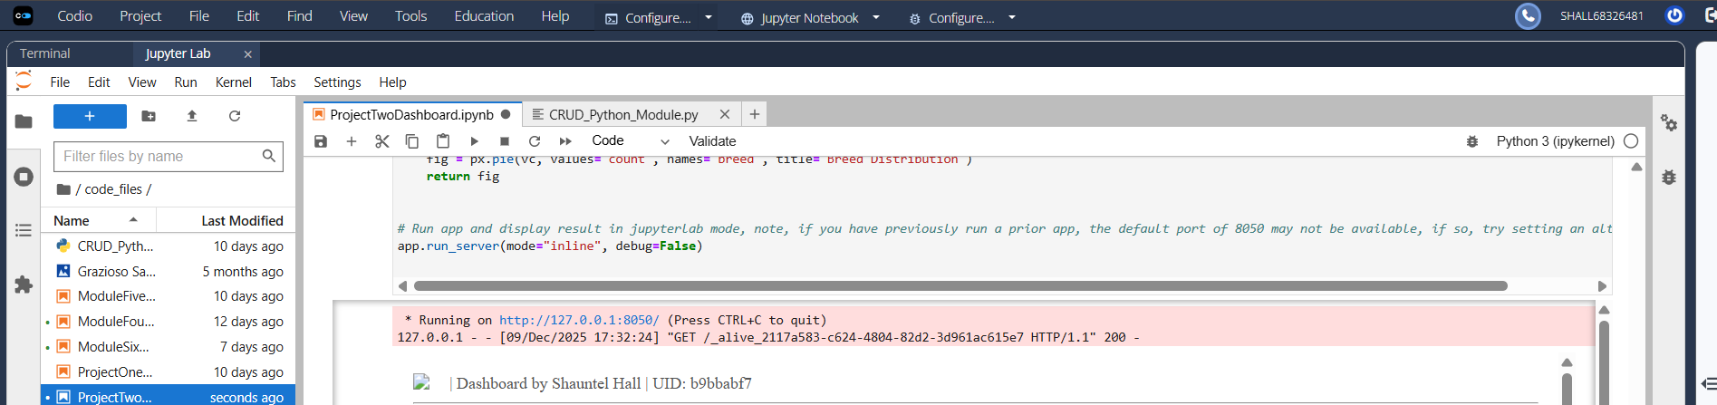
Water Rescue filter – Applies breed + sex + age constraints; table, map, and chart update dynamically.
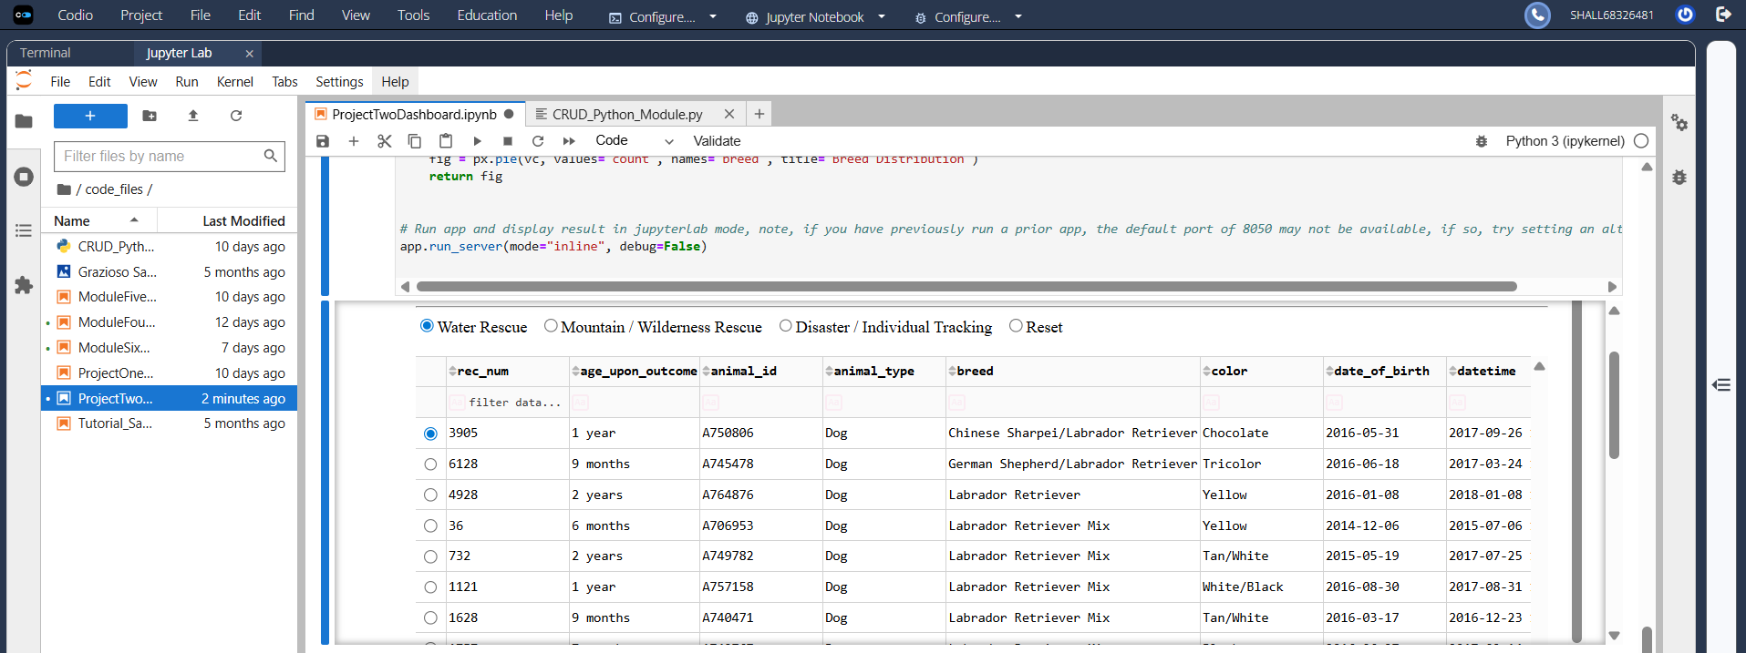
Mountain/Wilderness filter – Applies breed + sex + age constraints; table, map, and chart update dynamically.
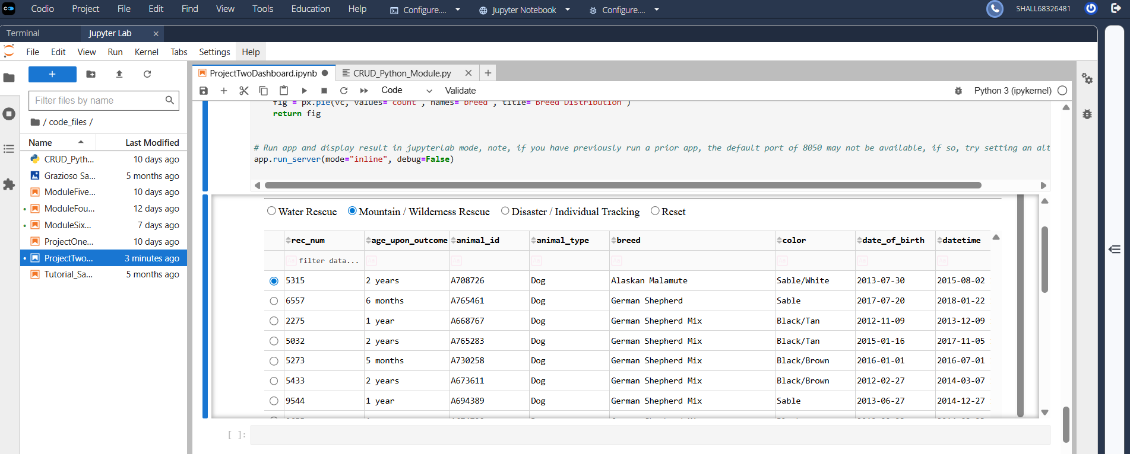

Disaster/Individual Tracking filter – Applies breed + sex + age constraints; table, map, and chart update dynamically.
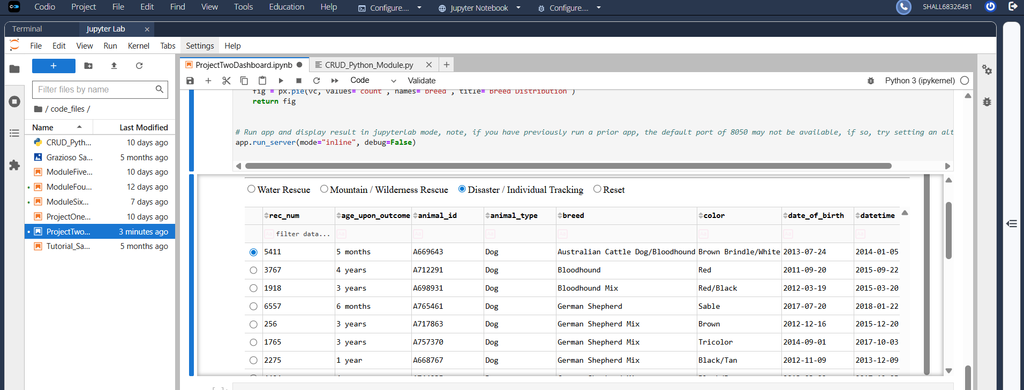

Reset – Returns all widgets to their original, unfiltered state.
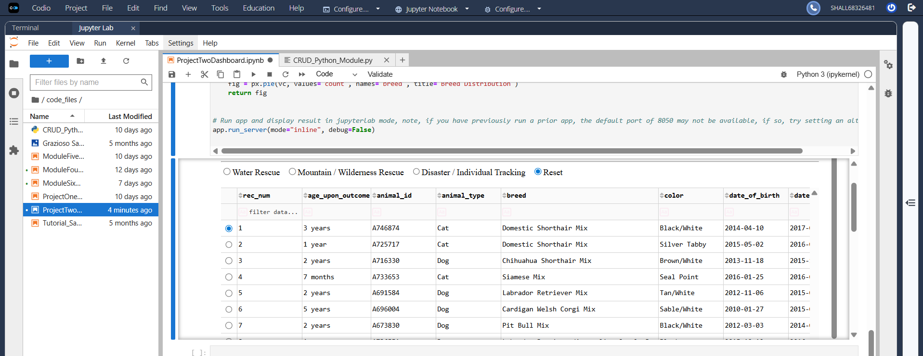
Geolocation map - shows selected row’s location; tooltip = breed; popup = name.
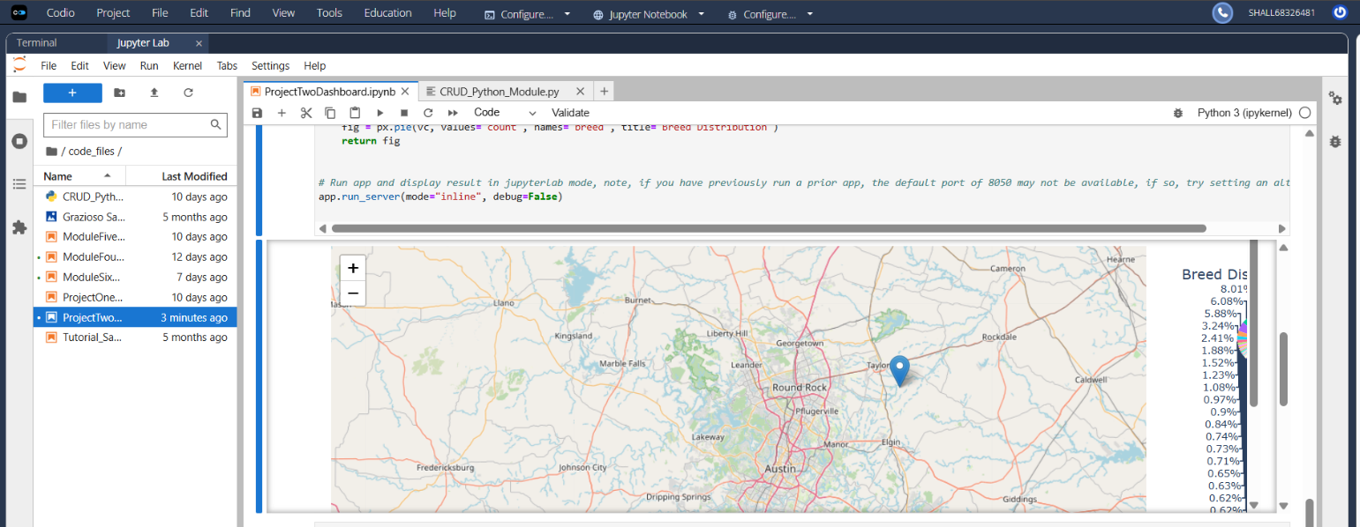

Pie Chart – separated by breed, updates with filters.
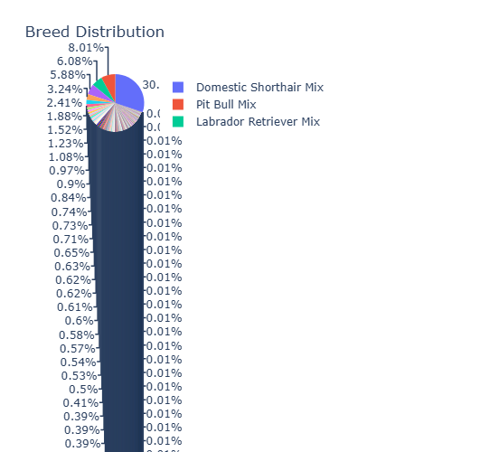

TOOLS USED
- MongoDB + PyMongo (Model): Official driver; simple authentication, fast document queries, flexible document schema that maps naturally to Python dicts, indexing for performance, and straightforward aggregation when needed. MongoDB handles small differences across shelter data without migrations.
- Python 3.x: Primary implementation language; strong data ecosystem.
- Dash / JupyterDash (View/Controller): Pure-Python, declarative UI with reactive callbacks.
- Dash Core Components & dash_table: Interactive inputs and an interactive DataTable with sorting/filtering/pagination.
- dash-leaflet: Geolocation with OpenStreetMap tiles; simple markers, tooltips, and popups.
- Plotly Express: Quick, expressive charting.

HOW TO REPRODUCE
- Run MongoDB: cd ./datasets, mongoimport --db aac --collection animals --type csv --headerline --drop ./aac_shelter_outcomes.csv
- Authenticate in mongosh: use admin, db.createUser({ user: "aacuser", pwd: "<PASSWORD>", roles: [{ role: "readWrite", db: "aac" }] })
- Set Credentials in ProjectTwoDashboard.ipynb: AAC_USER = "aacuser", AAC_PASS = "ILoveAnimals92!"
- Execute the program ProjectTwoDashboard.ipynb

IMPLEMENTATION
- Query builder: build_query(filter_key) encodes the Rescue Type & Preferred Dog Breeds rules for Water, Mountain/Wilderness, and Disaster/Individual Tracking (breed lists, sex, and age-in-weeks windows).
- Data flow: The DataTable drives the Leaflet map (selected row → marker at latitude/longitude with tooltip for breed and popup for name) and a second chart (e.g., breed distribution pie) via callbacks.
- Single-row selection: row_selectable="single" and selected_rows=[0] ensure the map renders even before the user clicks a row.
- Column handling: The map function tolerates reasonable column-name differences for lat/long; if missing, it defaults to Austin center.

CHALLENGES
Throughout my work on this project, I encountered several issues. First, authentication failed errors appeared when the dashboard tried to connect. This was resolved by verifying the aacuser in mongosh, ensuring authSource="admin", and passing the raw credentials to MongoClient. I also hit duplicate key errors when re-running insert tests with the same _id. To fix this, I ommited _id to let MongoDB auto-generate it or delete the prior test record before reinserting. Performance-wise, rendering the full dataset in Jupyter could feel heavy, enabling DataTable pagination/sorting and using a modest page_size kept the UI responsive. Finally, I ran into a file not found error when displaying the Grazioso Salvare logo. I could not resolve this error, as the image continues to not display. I tried loading the PNG via a base64 data URI which did not work, as well as using referencing in my HTML code block. Neither of these options proved successful, however, I’m still proud of my finished product.

RESOURCES USED/NECESSARY
- MongoDB: https://www.mongodb.com/docs/
- PyMongo: https://pymongo.readthedocs.io/
- Dash: https://dash.plotly.com/
- dash-leaflet: https://dash-leaflet.herokuapp.com/
- Plotly Express: https://plotly.com/python/plotly-express/
- AAC Outcomes dataset: Provided by course (aac_shelter_outcomes.csv), courtesy of Austin Animal Center in Austin, Texas.

*THIS README WAS CREATED UTILIZING A FREE TEMPLATE FOUND IN MICROSOFT WORD, THE CONTENTS WERE THEN EDITED BY ME FOR PROJECT 2*

