1.INTRODUCTION:   
  
A Database project on photogallery using oracle sql. Or a database for containing elements of photogallery.  
  
2.PROJECT IDEA:  
  
This project is about photogallery websites. A photogallery usually contains images against many users which needed to saved and to be found in optimized way. So for this purpose this database project is done.

3.PROJECT DESCRIPTION:  
  
The project contains three main tables containing user1, image and gallery. The tables with their attributes are given below:

User1:  
 1.userid(pk)  
 2.name  
 3.password  
 4.userimage  
 5.about  
 6.role

Gallery:  
 1.galleryid(pk)  
 2.galleryname

Image:  
 1.imageid(pk)  
 2.img  
 3.description  
 4.upload_date  
 5.filename  
 6.rank  
 7.userid(fk)  
 8.galleryid(fk)

In this project the image table is linked up with both user1 table and gallery tables both are linked to image table with the foreign keys userid and galleryid. The user’s profile image is saved in userimg attribute in User1 and uploaded image files are saved in img attribute in Image. Image files are saved using the BLOB datatypes. This project contains query on login, query for showing images in one gallery, query on showing images by ranking, query on showing images of particular user, trigger for auditing and procedure for updating userimage.

4.Entity Relationship Diagram:

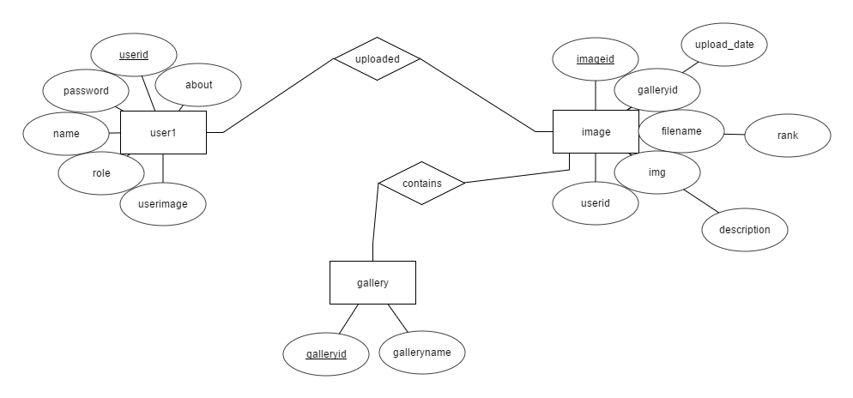

Fig: 4.1- ERD  
  
5.Schema Diagram:

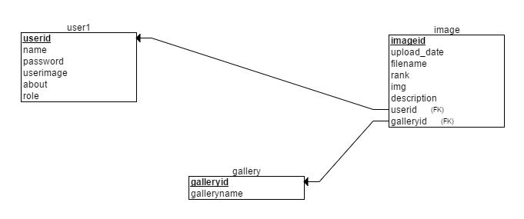

Fig:5.1 Schema Diagram

6.CONCLUSION:

This project is helpful for learning oracle database management system. In future oracle sql will help us build more complex system efficiently.  
  
  
7.REFERENCES:

* Wikipedia
* Stackoverflow