DEERWALK INSTITUTE OF TECHNOLOGY

Tribhuvan University

Faculties of Computer Science



Bachelors of Science in Computer Science and Information Technology (B.Sc. CSIT)

Course: Database Management Systems (CSC 265)

Class of 2027/Semester: IV

A Lab Report On:

**INTRODUCTION TO MYSQL**

**Submitted by:**

Name: Shaurav Bhandari

Roll No: 1333

**Submitted to:**

Er Satya Ram Suwal

Faculty, Department of Computer Science

**Database Management System Lab 1**

**1.** Write a MySQL query to create a simple table countries including columns country_id, country_name and region_id.

qn1


**2.** Write a MySQL query to create a simple table countries including columns country_id, country_name and region_id which is already exists.

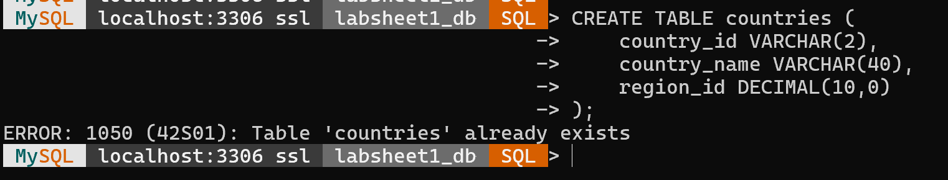

**3.** Write a MySQL query to create the structure of a table dup_countries similar to countries.



**4.** Write a MySQL query to create a duplicate copy of countries table including structure and data by name dup_countries.

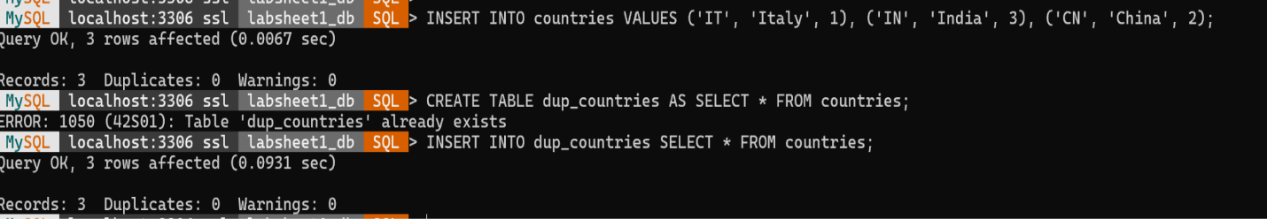

**5.** Write a MySQL query to create a table countries set a constraint NULL.

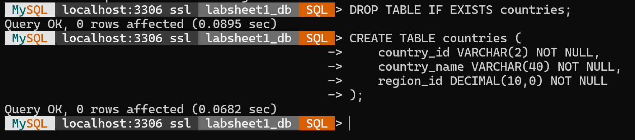

**6.** Write a MySQL query to create a table named jobs including columns job_id, job_title, min_salary, max_salary and check whether the max_salary amount exceeding the upper limit 25000.

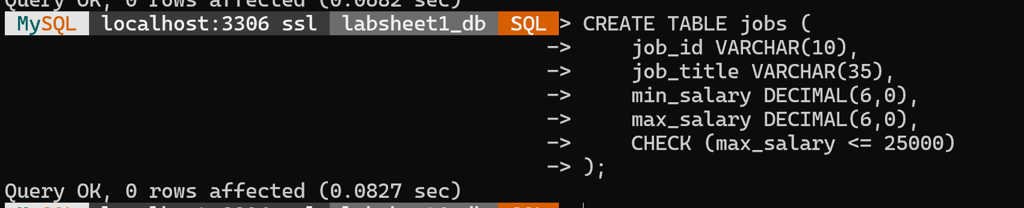

**7.**Write a MySQL query to create a table named countries including columns country_id, country_name and region_id and make sure that no countries except Italy, India and China will be entered in the table.

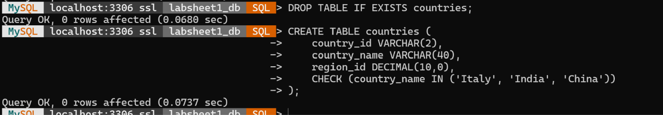

**8.**Write a MySQL query to create a table named job_histry including columns employee_id, start_date, end_date, job_id and department_id and make sure that the value against column end_date will be entered at the time of insertion to the format like '--/--/----'.

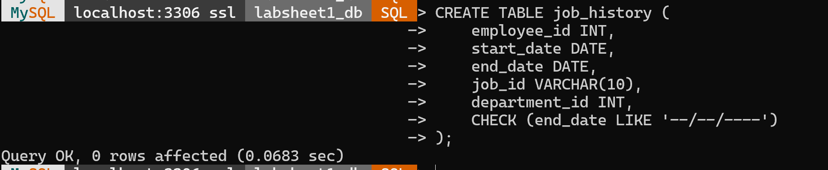

**9.**Write a MySQL query to create a table named countries including columns country_id,country_name and region_id and make sure that no duplicate data against column country_id will be allowed at the time of insertion.

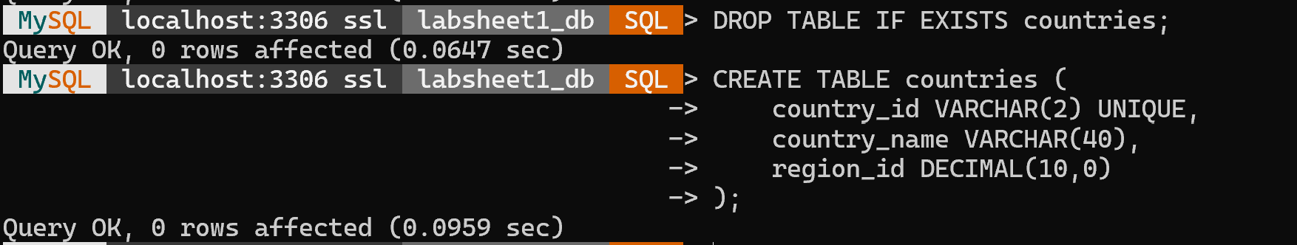

**10.**Write a MySQL query to create a table named jobs including columns job_id, job_title, min_salary and max_salary, and make sure that, the default value for job_title is blank and min_salary is 8000 and max_salary is NULL will be entered automatically at the time of insertion if no value assigned for the specified columns.

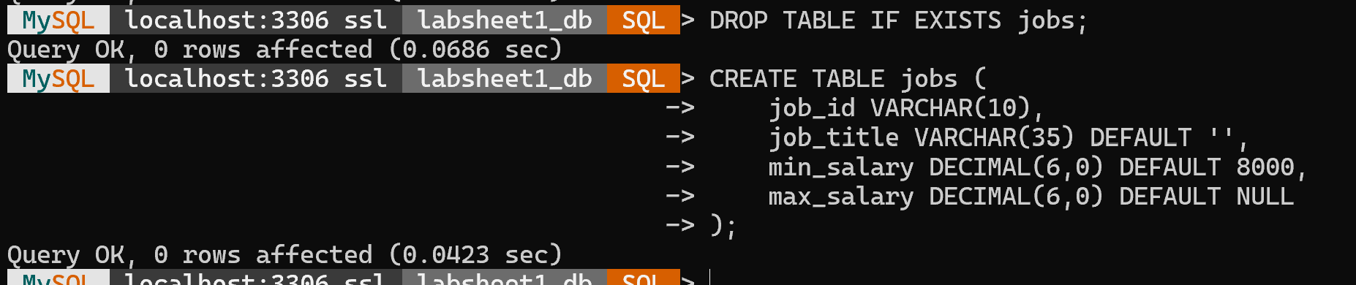

**11.**Write a MySQL query to create a table named countries including columns country_id, country_name and region_id and make sure that the country_id column will be a key field which will not contain any duplicate data at the time of insertion.

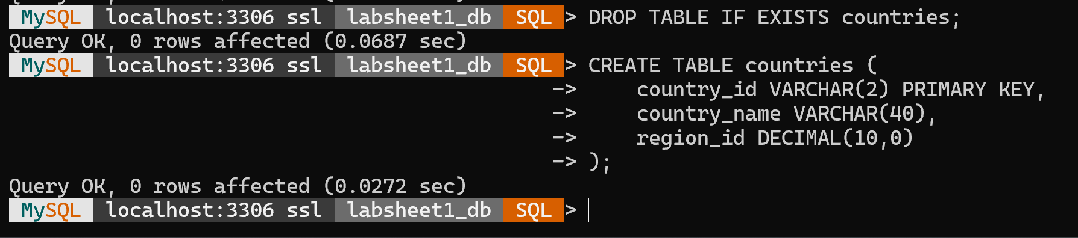

**12.**Write a MySQL query to create a table countries including columns country_id, country_name and region_id and make sure that the column country_id will be unique and store an auto incremented value.

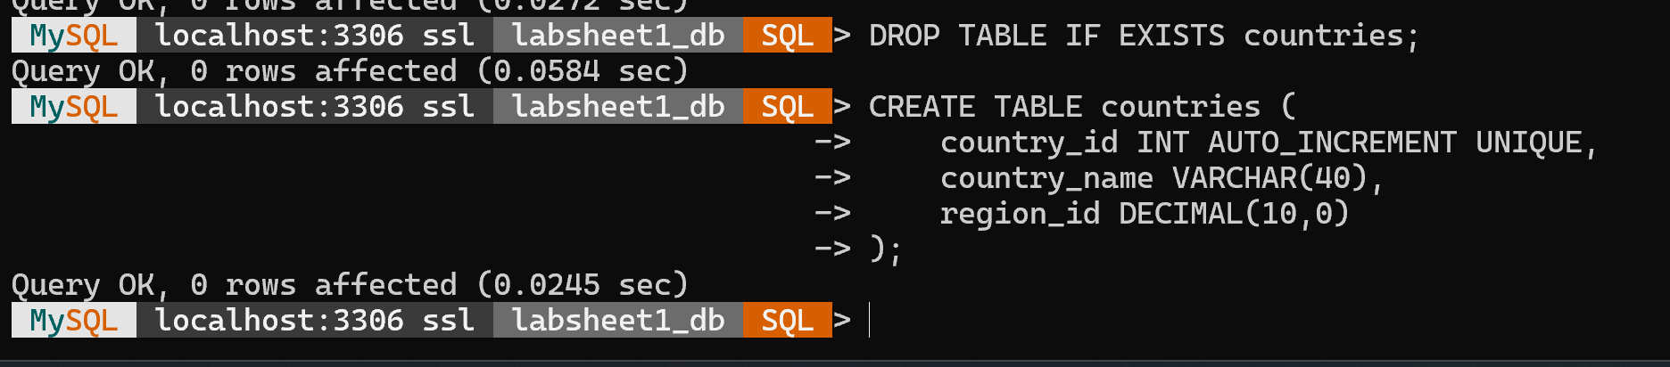

13. create a table **first_table** and then insert the values, and then create **Second_Table** in which we want to insert the multiple rows with the existing table.

