DEERWALK INSTITUTE OF TECHNOLOGY

Tribhuvan University

Faculties of Computer Science



Bachelors of Science in Computer Science and Information Technology (B.Sc. CSIT)

Course: Database Management Systems (CSC 265)

Class of 2027/Semester: IV

A Lab Report On:

**IMPLEMENTATION MYSQL QUERIES**

**Submitted by:**

Name: Shaurav Bhandari

Roll No: 1333

**Submitted to:**

Er Satya Ram Suwal

Faculty, Department of Computer Science

**Definition of tables and insertion of all data for First part:**

CREATE TABLE Products (

product_id INT PRIMARY KEY,

product_name VARCHAR(100),

category VARCHAR(50),

unit_price DECIMAL(10, 2)

);

-- Insert sample data into Products table

INSERT INTO Products (product_id, product_name, category, unit_price) VALUES

(101, 'Laptop', 'Electronics', 500.00),

(102, 'Smartphone', 'Electronics', 300.00),

(103, 'Headphones', 'Electronics', 30.00),

(104, 'Keyboard', 'Electronics', 20.00),

(105, 'Mouse', 'Electronics', 15.00);

-- Create Sales table

CREATE TABLE Sales (

sale_id INT PRIMARY KEY,

product_id INT,

quantity_sold INT,

sale_date DATE,

total_price DECIMAL(10, 2),

FOREIGN KEY (product_id) REFERENCES Products(product_id)

);

-- Insert sample data into Sales table

INSERT INTO Sales (sale_id, product_id, quantity_sold, sale_date, total_price) VALUES

(1, 101, 5, '2024-01-01', 2500.00),

(2, 102, 3, '2024-01-02', 900.00),

(3, 103, 2, '2024-01-02', 60.00),

(4, 104, 4, '2024-01-03', 80.00),

(5, 105, 6, '2024-01-03', 90.00);

**Queries:**

1. **Retrieve all columns from the Sales table:**

**Code:**

**SELECT \***

**FROM Sales;**

**Output:**

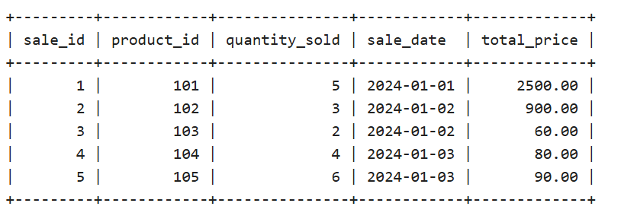

1. **Retrieve the product_name and unit_price from the Products table:**

**Code:**

**SELECT product_name, unit_price**

**FROM Products;**

**Output:**

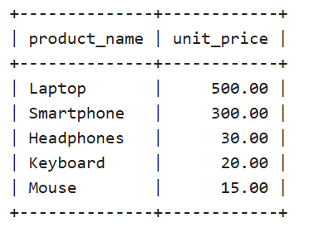

1. **Retrieve the sale_id and sale_date from the Sales table.**

**Code:**

**SELECT sale_id, sale_date**

**FROM Sales;**

**Output:**

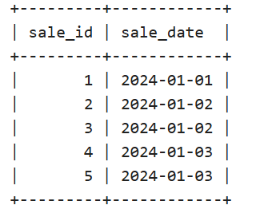

1. **Filter the Sales table to show only sales with a total_price greater than $100.**

**Code:**

**SELECT \***

**FROM Sales**

**WHERE total_price > 100;**

**Output:**

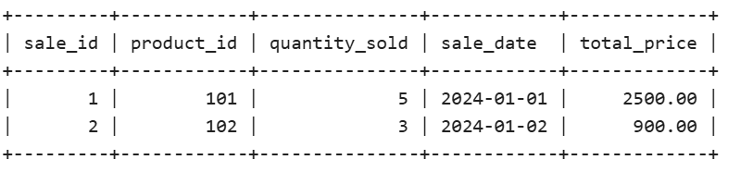

1. **Filter the Products table to show only products in the 'Electronics' category.**

**Code:**

**SELECT \***

**FROM Products**

**WHERE category = 'Electronics';**

**Output:**

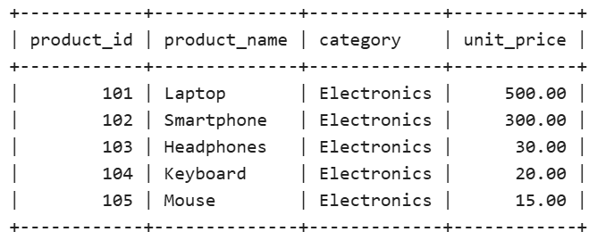

1. **Retrieve the sale_id and total_price from the Sales table for sales made on January 3, 2024.**

**Code:**

**SELECT sale_id, total_price**

**FROM Sales**

**WHERE sale_date = '2024-01-03';**

**Output:**

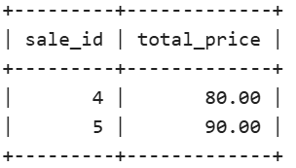

1. **Retrieve the product_id and product_name from the Products table for products with a unit_price greater than $100.**

**Code:**

**SELECT product_id, product_name**

**FROM Products**

**WHERE unit_price > 100;**

**Output:**

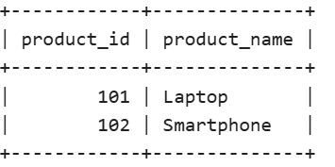

1. **Calculate the total revenue generated from all sales in the Sales table.**

**Code:**

SELECT SUM(total_price) AS total_revenue

FROM Sales;

**Output:**

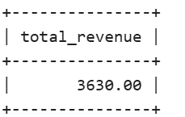

1. **Calculate the average unit_price of products in the Products table.**

**Code:**

SELECT AVG(unit_price) AS average_unit_price

FROM Products;

**Output:**

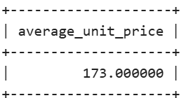

1. **Calculate the total quantity_sold from the Sales table.**

**Code:**

SELECT COUNT(*) AS total_sales_count

FROM Sales**;**

**Output:**

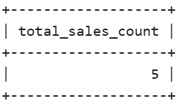

1. **Count Sales Per Day from the Sales table.**

**Code:**

SELECT sale_date, COUNT(*) AS sales_count   
FROM Sales   
GROUP BY sale_date   
ORDER BY sale_date;

**Output:**

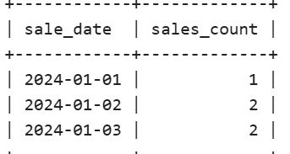

1. **Retrieve product_name and unit_price from the Products table with the Highest Unit Price.**

**Code:**

SELECT product_name, unit_price   
FROM Products   
ORDER BY unit_price DESC   
LIMIT 1;

**Output:**

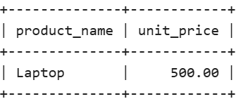

1. **Retrieve the sale_id, product_id, and total_price from the Sales table for sales with a quantity_sold greater than 4.**

**Code:**

SELECT sale_id, product_id, total_price   
FROM Sales   
WHERE quantity_sold > 4;

**Output:**

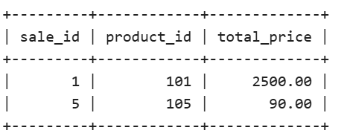

1. **Retrieve the product_name and unit_price from the Products table, ordering the results by unit_price in descending order.**

**Code:**

SELECT product_name, unit_price   
FROM Products   
ORDER BY unit_price DESC;

**Output:**

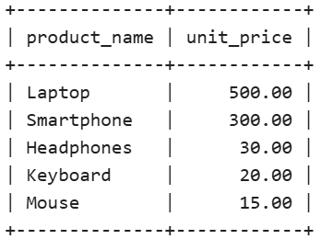

1. **Retrieve the total_price of all sales, rounding the values to two decimal places.**

**Code:**

SELECT ROUND(SUM(total_price), 2) AS total_sales   
FROM Sales;

**Output:**

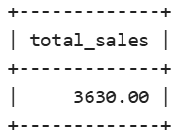

1. **Calculate the average total_price of sales in the Sales table:**

SELECT AVG(total_price) AS average_total_price   
FROM Sales;

**Output:**

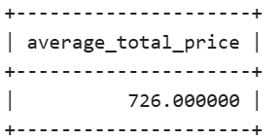

1. **Retrieve the sale_id and sale_date from the Sales table, formatting the sale_date as 'YYYY-MM-DD'.**

**Code:**

SELECT sale_id, DATE_FORMAT(sale_date, '%Y-%m-%d') AS formatted_date   
FROM Sales;

**Output:**

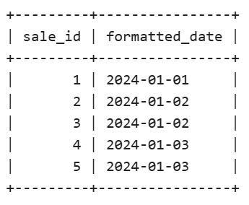

### **Calculate the total revenue generated from sales of products in the 'Electronics' category:**

**Code:**

SELECT SUM(Sales.total_price) AS total_revenue   
FROM Sales   
JOIN Products ON Sales.product_id = Products.product_id   
WHERE Products.category = 'Electronics';

**Output:**

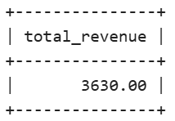

**CONCLUSION:**

**Hence, various practices of implementation of DDL, DML, etc. were implemented using MYSQL.**