Word Embeddings Comparison Report
Word2Vec (CBOW & Skip-Gram), FastText, and GloVe

1. Dataset Description
IMDb Movie Reviews Dataset was used for this experiment. The dataset consists of approximately 50,000 movie reviews labeled as positive or negative, along with an additional unsupervised dataset. The dataset is widely used for sentiment analysis tasks and provides a rich source of textual data to evaluate word embeddings.
Files used:
- - train.parquet: labeled training data
- - test.parquet: labeled test data
- - unsupervised.parquet: unlabeled data for training embeddings

2. Preprocessing Steps
The following preprocessing steps were applied to clean and prepare the text data:
- - Converted all text to lowercase
- - Removed HTML tags
- - Removed punctuation and special characters
- - Normalized whitespace
- - Tokenized text using simple whitespace splitting

3. Implementation Details
Word2Vec (CBOW & Skip-Gram):
- - Vector size: 100
- - Window size: 5
- - Minimum word count: 20
- - CBOW predicts a word from context; Skip-Gram predicts context from a word

FastText:
- - Same configuration as Word2Vec
- - Uses subword information for better handling of rare words
GloVe (Pretrained):
- - 100-dimensional pretrained vectors
- - Captures global co-occurrence statistics

4. Word Similarity Analysis
Cosine similarity was used to measure semantic similarity between words.
Example similarity scores:
- CBOW (good vs bad): ~0.80
- Skip-Gram (good vs bad): ~0.76
- FastText (good vs bad): ~0.76
- GloVe (good vs bad): ~0.77
Top similar words for 'good' included terms such as 'great', 'decent', and 'nice'.

5. Visualization
t-SNE was used to reduce high-dimensional word vectors into 2D space. The visualization showed that words with similar meanings clustered together. Positive words formed one cluster while negative words appeared in a different region.
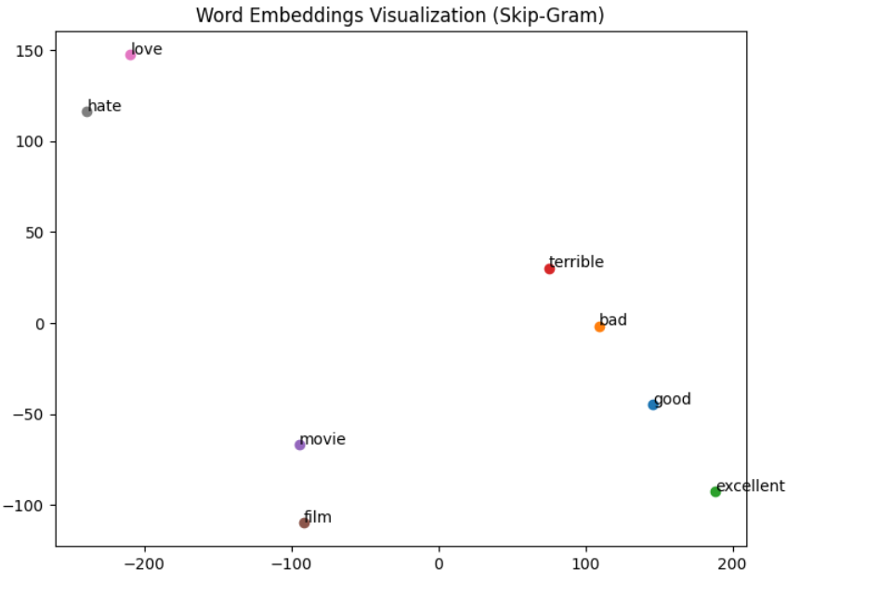

6. Comparison and Discussion
Observations:
- - CBOW is faster but less precise
- - Skip-Gram captures semantic relationships better
- - FastText handles rare and subword tokens effectively
- - GloVe captures global statistical relationships
A key observation is that words like 'good' and 'bad' show high similarity scores. This occurs because word embeddings capture contextual similarity rather than sentiment polarity. Both words often appear in similar contexts within reviews.

7. Conclusion
Overall, Skip-Gram and FastText provided strong semantic representations, while GloVe offered a robust global perspective. The study demonstrates that different embedding techniques capture different aspects of language semantics.

8. GitHub Repository
GitHub Link: https://github.com/Shauravparajuli123/word-embeddings-imdb

